 | Schola Europaea  Office of the Secretary-General  General Secretariat
Ref.: 2009-D-421-en-1
Orig.: En

SURVEY LEARNING SUPPORT IN THE NURSERY AND PRIMARY CYCLES 2005 - 2008
Teaching Committee (Nursery and Primary)

Meeting on 19th February 2009

Introduction

The current Learning Support programme was introduced into the European Schools in 1997. Since then it has proved to be an important support system for pupils encountering learning difficulties on various levels. Despite its undisputed benefit little data on Learning Support (LS) has been available so far across the schools to compare and evaluate the impact of LS and to develop the programme further. Thus the Working Group LS worked out a questionnaire to carry out a three year survey for all schools and sent out the first forms in 2005/2006.

The following document presents and compares the situation of LS based on

- the data gathered from the school years 2005/2006, 2006/2007 and 2007/2008 and also
- additional information gathered in 3 meetings with LS coordinators or their representatives from all schools.

Due to the fact that Brussels IV was started at the beginning of 2007/2008 only data for this school year can be included in the survey, for reasons of comparison and viability small and new language sections (e.g. Lithuanian) are not incorporated.

- Method

Data for all schools by class and language section level has been collated by the Deputy Heads and/or LS coordinators and compiled into the excel file attached in appendix 6. The format of the questionnaire (Appendix 1) has remained identical over the three year survey with only minor changes regarding user friendliness and clarity.

- School population

Total number of pupils in all Primary schools during the survey was:

 | Alic | Berg | Bru1 | Bru2 | Bru3 | Bru4 | Culh | Frank | Karlsr | Lux1 | Lux2 | Mol | Muc | Var | Total
Total 0506 | 510 | 277 | 1262 | 1453 | 1242 |  | 423 | 482 | 455 | 1078 | 915 | 180 | 773 | 605 | 9655
Total 0607 | 503 | 236 | 1490 | 1260 | 1119 |  | 335 | 539 | 424 | 1161 | 947 | 250 | 821 | 620 | 9705
Total 0708 | 499 | 243 | 1438 | 1033 | 1061 | 188 | 392 | 531 | 436 | 1176 | 901 | 257 | 842 | 603 | 9600

- Data Learning Support

  - Percentage of LS pupils in all Primary schools

On the whole the percentages of LS pupils per school are similar over the 3 year period with a noticeable drop in 2 schools. The percentage of pupils taking part in the LS programme varies from school to school and between different language sections.

The language background of pupils seems to be more important in smaller schools with fewer language sections, where LS often has to function as language support in the first year. In these schools LS is also used as additional help for SWALS pupils for whom the fixed SWALS hours are not sufficient when they start their schooling at the European Schools.

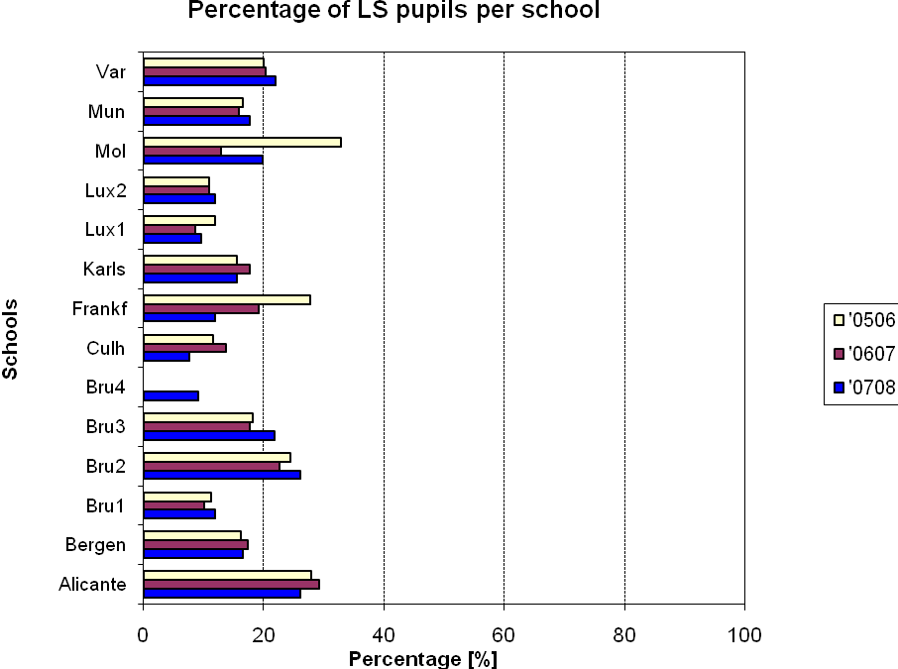
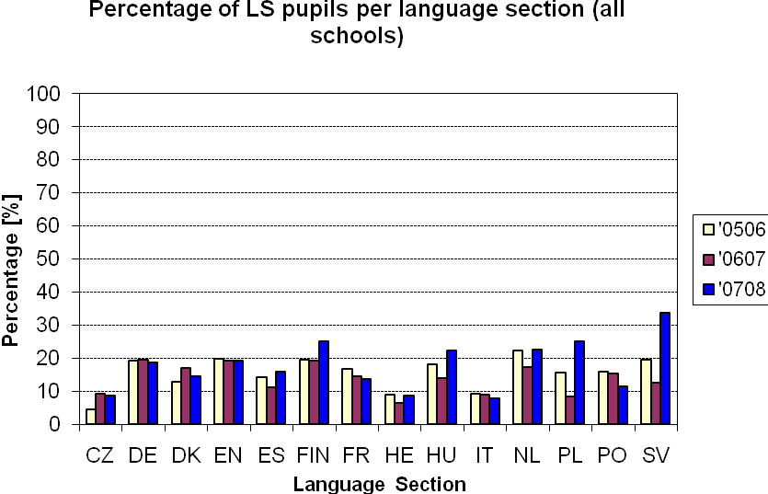

  - Percentage of LS pupils on different year levels in all schools

The percentages of pupils receiving LS on different year levels differ only slightly, but the number on the Nursery cycle is much lower. The fact is that a substantial number of pupils do not attend the ES Nursery Cycle but start directly in the first class. In additional Nursery class teachers try to support children’s learning difficulties in an integrative and inclusive way at first hand in the class (especially in the first year of Nursery) before children address LS.

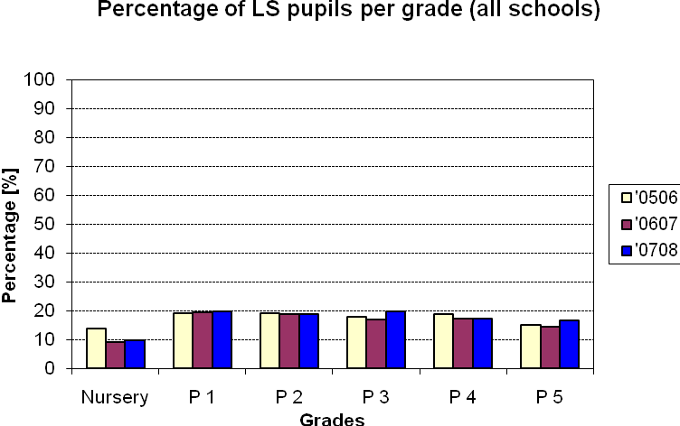

- Resources of Learning Support

  - LS Teachers

The ratio of LS teaching staff (allocation of LS hours to seconded teachers or locally recruited teachers) changed significantly over the three year period without any clear tendency. A substantial number of seconded teachers leave the system every year and cannot be fully replaced, especially in the English speaking sections. Locally recruited teachers have to step in then. Furthermore, not all countries can second teachers with specific qualifications for LS and then locally recruited teachers have to take over LS in the school.

Nevertheless, the class teachers, who know their pupils best, are often seen as the first choice to give LS. Some schools replace class teachers for a few hours by locally recruited teacher to enable them to give LS in their class.

  - Budget of LS

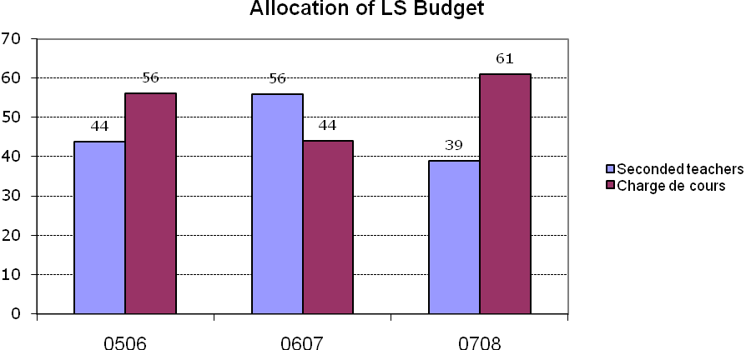

Frequently SEN teachers (most of the locally recruited) who work with SEN children, provide LS for the same class. They are used because they are already familiar with the situation in the class and learning environment

- Reasons for entering the Learning Support programme

The most frequent reasons for entering the LS programme were defined from the
list below by LS teachers, coordinators or other representative of the schools:

- Specific difficulties in literacy.
- Difficulties in mathematics.
- Social skills hinder the learning process.
- Behavioural skills hinder the learning process.
- Attention/concentration difficulties.
- Learning strategies are not appropriate.
- Work rate is slow
- Newcomers
- Lack of maturity
- Cross-curricula competences are insufficient
- Other (please name under point 11)

The results show that the main reasons for entering the LS programme are similar through all schools and over the three years.

05/06 – 07/08 | CZ | DE | DK | EN | ES | FIN | FR | HE | HU | IT | NL | PL | PO | SV
Most frequent
1. | A | A | A | A | A | A | A | B | B | A | A | A | I | A
2. | * | B | * | B | B | B | B | A | A | B | B | B | A | B
3. | * | E | * | E | E | E | * | * | * | E | E | * | * | *
* There is no clear tendency for the further reasons entering the LS programme.

Specific difficulties in literacy and mathematics have been indicated as main reasons both in schools and in nearly all language sections. Especially LS pupils enrolled in classes to one of the three vehicular languages (English – French – German) seem to encounter similar difficulties which then are tackled by the LS teachers.

Total schools
1. | A |  | A | Specific difficulties in literacy
2. | B |  | B | Difficulties in mathematics
3. | E |  | E | Attention/concentration difficulties

On the whole defining the reasons for entering LS is more multifaceted than shown above. The increasingly complex linguistic background of numerous ES pupils (e.g. children without a clearly dominant language, children without a language section where SWALS support is not sufficient) is often the first and basic reason for the following learning difficulties.

- Duration and types of Learning Support

  - Duration of LS

About 50 % or more of LS interventions last longer than 1 year through during the time monitored.

Duration of Learning Support
 | 05-06 | 06-07 | 07-08
More than a year (%) | 46 | 42 | 56
up to 1 year (%) | 40 | 47 | 32
less than semester (%) | 13 | 11 | 12
 | 99 | 100 | 100

The small percentage of LS shorter than a semester has to be seen together with the fact, that on many occasions, the class teacher is the first LS teacher when differentiating or individualising teaching to the child’s needs. This intervention does not show up in the figures above where only the “real” LS support is shown following the procedures set out in the current LS document.

In addition LS in the Primary Cycle is not seen as a short and sharp intervention filling gaps or a lack of knowledge but more in a behaviouristic way and as a process which should help the pupils to overcome their learning obstacles to become competent and independent learners. Thus LS is often a means for pupils’ encouragement rather than a simple support strategy.

  - Types of intervention

The types of intervention and LS teaching methods vary, but the three predominant forms are:

- pupil is integrated in his/her class (joint work with class teacher and LS Teacher)
- one to one basis outside the classroom (often in special rooms designated for LS with special material and equipment including ICT)
- small learning groups outside the classroom often in specially equipped rooms

Types of intervention
 | 05-06 | 06-07 | 07-08
Small group (%) | 47 | 45 | 50
1 to 1 (%) | 29 | 27 | 26
in class (%) | 24 | 28 | 24
 | 100 | 100 | 100

- Success of the LS programme

Defining the success of LS is more complex than a mere quantitative analysis. The following table gives an overview of 3 fields of LS success.

  - Quantitative analysis

Success of the LS program
 | 05-06 | 06-07 | 07-08 | Varies from school to school
Class level reached - no longer need of LS (%) | 23 | 24 | 20 | 5-35 %
Reaches class level with continued LS (%) | 46 | 47 | 45 | 6-64 %
Class level not reached but benefits from LS (%) | 22 | 21 | 28 | 10-64 %
Needs more than LS (%) | 7 | 8 | 9 | 2-22 %
 | 98 | 100 | 102

Nearly 70 % of LS pupils benefit in a way that they can reach class level or stay on it with continued LS. For 7 % to 9 % of the LS pupils, the LS given is insufficient and does not meet their needs.

  - Qualitative analysis

Other indicators of the success of LS programme were included. The information is got from LS coordinators or their representatives orally and is not presented in order of priority.

Improvement has been documented in pupils’:

  - learning strategies
  - processing instructions
  - concentration
  - presentation of work
  - general Organisation
  - behaviour
  - social integration
  - independent learning.
  - raised self-concept and self-esteem
  - ability to transfer learning skills to all curricula areas
  - increased cooperation with parents
  - better communication and cooperation with all parties involved.
  - higher pupil motivation

- Limitations to the Learning Support Programme

Although the data above illustrate the positive impact of LS on pupils’ learning, a number of factors limit the success and effectiveness of the LS programme. The comments below were mentioned by the LS coordinators or their representatives:

- communication between Learning Support Teachers and Class Teachers varies greatly within/across language sections and schools.
- in-service training is inadequate
- time-table constraints
- difficulty recruiting appropriately trained staff
- stigma (could this be expressed more clearly)? attached to Learning Support .
- insufficient space and resources for Learning Support
- the complex linguistic background of many pupils.

Over the three years survey it has become increasingly apparent that the number of hours (1 hour per 14 pupils) allocated to Learning Support is insufficient.

- Open questions

This document should form the basis for discussion and further improvement of the Learning Support policy and practice for all stakeholders.

Despite the evident success and positive impact of LS several fields for further scrutinizing and development have already become visible in the fields of:

- The lack of coordination time for LS coordinators
The time available at many schools is not sufficient to coordinate and
harmonized LS at school level.

- Better coordination and communication especially between LS Teachers and Class Teachers
Due to the tight timetable of many LS and class teachers finding proper time to liaise is often difficult. LS teachers often work in several classes.

- Time-tabling and organization of LS lessons has to be reconsidered
Not always can LS be provided at the most appropriate time slots and pupils missed important input when LS is given outside class

- Targeted LS in-service training at school level is needed
According to the current LS document schools organise LS in-service training on school level. Yet the model of in-service training, which is following the Mathematic inspection, is seen as more effective and beneficial - centrally planned and locally applied

- Clarification between LS and SEN support
Though the current documents for LS depict a clear distinction between LS (learning difficulties) and SEN (learning disabilities) the school reality can frequently not differentiate in this clear way.

- Complex linguistic background of children
This is an increasing challenge for the whole system and LS and should be developed with tight cooperation with SWALS support..

- LS resources and materials
The quantity and quality of support materials available differ greatly from school to schools and across the language sections. The coordination in school should be developed and on the system level the The Learning Gateway should function as a tool to overcome this inequality.

- Basic qualification of LS Teachers both seconded and locally recruited
When recruiting teachers LS qualification should play an important role.

- Follow-up

A few steps for development are already in progress:

- With the LS document of 2006 LS co-coordinators or their representatives of each school have been foreseen to facilitate the LS activities and communication at each school.
- LS co-ordinators meet centrally and regularly to exchange practices and harmonise LS strategies across grades, sections and levels (Nursery – Primary, Primary – Secondary).
- Closer liaison with the Secondary as LS is a key element in the transition process, a joint inspection on Transition also focussed on the issue of Learning Support and its follow-up in Secondary.
- LS in-service training for LS teachers is shifted from the central to the school level where school and individual needs can be tackled in a more efficient way.
- The Learning Gateway should be used a basis for central resources and platform for communication, information and exchange for LS.
- A joint in-service training of coordinators or school representatives for Learning Support and SEN for both Primary and Secondary was carried out in the school year 2007/2008.

Appendix 1

Questionnaire and data

The attached questionnaire has been the basis for the survey in 2005/2006. For reasons of comparison its overall structure will not be changed for the next year. Only minor changes for easier application are planned for 2007/2008.

APPENDIX 2
SCHOOL POPULATION – basis for survey

  - Total number of pupils per language section (all schools)

05/06 | CZ | DE | DK | EN | ES | FIN | FR | HE | HU | IT | NL | PL | PO | SV | Total
Nursery | 19 | 283 | 67 | 373 | 144 | 94 | 418 | 49 | 20 | 171 | 127 | 16 | 37 | 88 | 1906
P 1 | 5 | 263 | 61 | 283 | 96 | 42 | 318 | 49 | 7 | 132 | 112 | 10 | 19 | 35 | 1432
P 2 | 7 | 250 | 52 | 309 | 109 | 53 | 342 | 50 | 6 | 154 | 121 | 11 | 40 | 38 | 1542
P 3 | 3 | 277 | 49 | 326 | 120 | 50 | 357 | 47 | 6 | 153 | 124 | 8 | 33 | 32 | 1585
P 4 | 5 | 276 | 48 | 334 | 107 | 37 | 364 | 67 | 7 | 143 | 146 | 7 | 32 | 38 | 1611
P 5 | 5 | 284 | 53 | 324 | 108 | 39 | 367 | 61 | 4 | 138 | 120 | 6 | 39 | 31 | 1579
Total | 44 | 1633 | 330 | 1949 | 684 | 315 | 2166 | 323 | 50 | 891 | 750 | 58 | 200 | 262 | 9655

06/07 | CZ | DE | DK | EN | ES | FIN | FR | HE | HU | IT | NL | PL | PO | SV | Total
Nursery | 22 | 358 | 56 | 383 | 121 | 86 | 438 | 35 | 19 | 146 | 114 | 17 | 46 | 88 | 1929
P 1 | 6 | 236 | 47 | 320 | 110 | 55 | 318 | 49 | 18 | 155 | 99 | 7 | 25 | 46 | 1491
P 2 | 7 | 270 | 64 | 282 | 99 | 43 | 338 | 52 | 9 | 134 | 106 | 11 | 21 | 34 | 1470
P 3 | 6 | 262 | 55 | 301 | 108 | 54 | 358 | 47 | 11 | 147 | 117 | 13 | 38 | 38 | 1555
P 4 | 4 | 287 | 47 | 333 | 122 | 47 | 348 | 53 | 9 | 152 | 124 | 13 | 29 | 34 | 1602
P 5 | 9 | 272 | 53 | 342 | 111 | 39 | 392 | 64 | 6 | 140 | 150 | 11 | 31 | 38 | 1658
Total | 54 | 1685 | 322 | 1961 | 671 | 324 | 2192 | 300 | 72 | 874 | 710 | 72 | 190 | 278 | 9705

07/08 | CZ | DE | DK | EN | ES | FIN | FR | HE | HU | IT | NL | PL | PO | SV | Total
Nursery | 20 | 330 | 62 | 416 | 136 | 74 | 439 | 48 | 34 | 145 | 121 | 17 | 41 | 39 | 1922
P 1 | 15 | 252 | 37 | 286 | 96 | 55 | 340 | 29 | 6 | 142 | 84 | 6 | 31 | 15 | 1394
P 2 | 6 | 245 | 51 | 335 | 108 | 50 | 339 | 51 | 19 | 168 | 111 | 8 | 21 | 23 | 1535
P 3 | 8 | 278 | 55 | 298 | 102 | 42 | 372 | 53 | 9 | 144 | 113 | 9 | 19 | 17 | 1519
P 4 | 5 | 270 | 50 | 318 | 103 | 47 | 385 | 51 | 11 | 153 | 129 | 9 | 35 | 22 | 1588
P 5 | 4 | 287 | 48 | 363 | 125 | 44 | 365 | 58 | 11 | 157 | 129 | 11 | 28 | 12 | 1642
Total | 58 | 1662 | 303 | 2016 | 670 | 312 | 2240 | 290 | 90 | 909 | 687 | 60 | 175 | 128 | 9600

APPENDIX 3 DURATION OF LS IN DIFFERENT LANGUAGE SECTIONS.

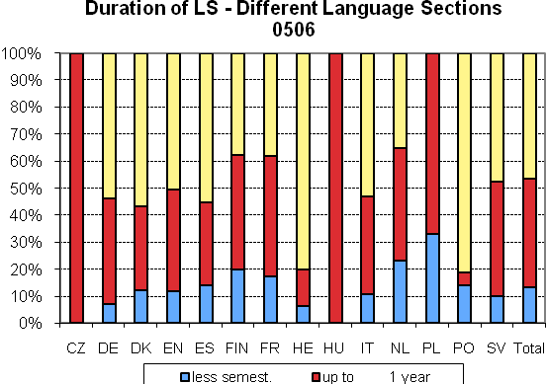
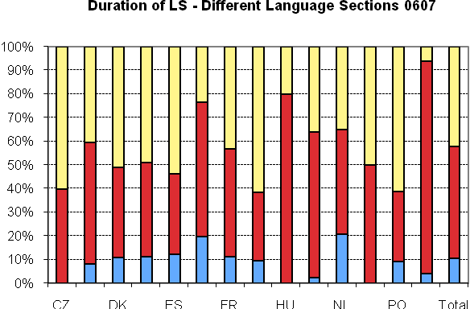
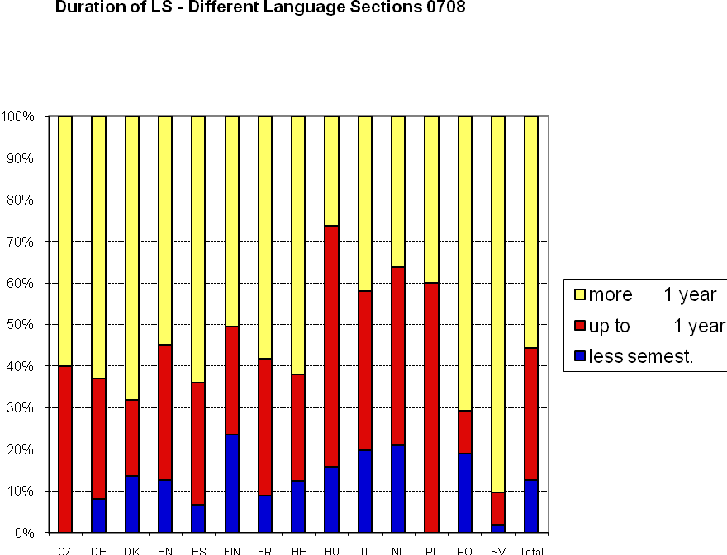
APPENDIX 4 TYPE OF INTERVENTION

