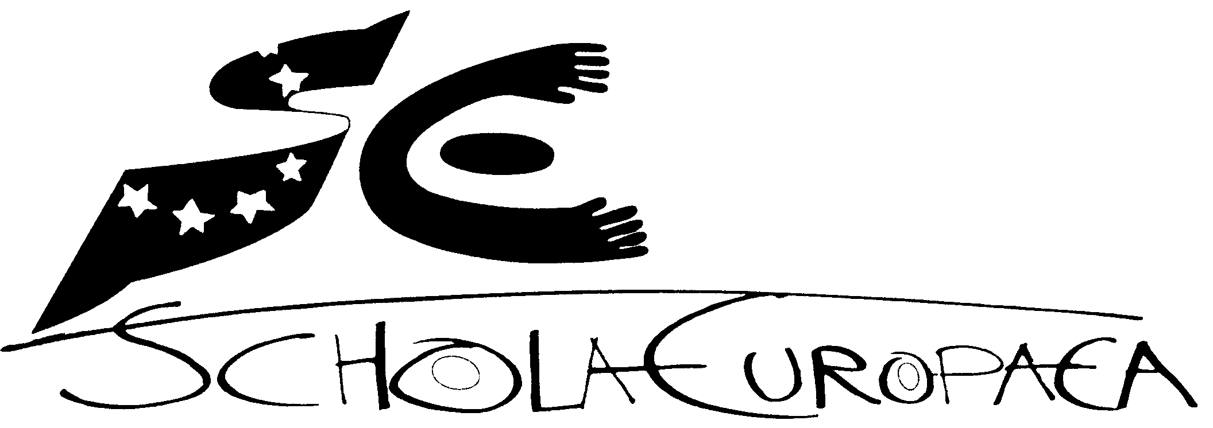 | Schola Europaea  Office of the Secretary-General  General Secretariat
Ref.: 2006-D-296-en-7
Orig.: En

Induction of New Inspectors
BOARD OF GOVERNORS OF THE EUROPEAN SCHOOLS
Meeting on 15 and 16 April 2008 – Helsinki

European Schools - Induction of New Inspectors

Background
Each new inspector brings a range of experience and expertise from a variety of educational contexts to the Boards of Inspectors of the European Schools. Members of the Boards of Inspectors take on additional roles and responsibilities and various levels of support are required to enable them to become familiar with the European Schools system in order to fulfil their new functions. In order to provide support for new inspectors, the Boards of Inspectors set up a working group to design an appropriate induction programme. This document sets out a framework for induction practices for new inspectors.

The Framework for the Induction Programme:
It is hoped that within the framework outlined here, the Boards of Inspectors will continue to develop approaches to induction which are designed to enable inspectors to effectively meet their specific role and responsibilities in the European Schools system.

The framework consists of three key areas:

- The key principles of induction;
- The elements of induction; and
- The responsibilities for the induction process.

The purpose of the induction
At the early stages of an inspector’s appointment new inspectors require a range of different supports in order to acquire the knowledge and skills needed to adjust to the specific work of the Boards of Inspectors and to take on the role and responsibilities of an inspector in the European Schools system. This enables new inspectors to integrate into the work of the Boards of Inspectors. Induction will motivate new inspectors to take an active part in the further development of the European Schools system.

The principles of the induction process

- The induction process will communicate the culture, values and ethos of the Board of Inspectors and the European Schools system;
- The induction process will give information on the structure, practices and policies of the European School system;
- The induction process will identify and address appropriate training and individual development needs;
- The induction process will include formal and informal training where appropriate.

Methods of induction
Responsibility for induction is shared by the Office of the Secretary General of the European Schools (OSGES) and the Boards of Inspectors.
The President of the Boards of Inspectors will make contact with inspectors who have joined the system with a view to organising an induction day each year. As far as possible, this meeting should coincide with other meetings or visits to schools in order to incur no extra costs to the OSGES.

The framework for induction consists of a combination of formal and informal approaches. The formal approach consists of the presentation of information about the system.
This takes place on an induction day when new inspectors are presented with appropriate information about the system and about their new role and responsibilities. The programme is interactive with opportunities for new inspectors to ask questions and seek clarification on relevant aspects of the system.

The informal approach invites the new inspectors to work in collaboration with colleagues in schools or on working groups. A partnership approach between a new inspector and more experienced colleagues is most effective. Mentoring arrangements can be put in place to facilitate a new inspector acquiring experience in different types of learning situations and may include school visits and observation of team inspections. Conscious efforts to expose new inspectors to appropriate learning situations relevant to European Schools, demonstration of skills required, creating a climate where questions are encouraged, providing access to information sources and mentoring arrangements are some of the ways in which informal induction in the European Schools can be fostered.
Informal induction training supplements the formal approach.

Topics such as the following may be explored on the induction day:

The Administrative Organs of the European Schools
- The Board of Governors enlarged and non -enlarged;
- The Pedagogical Committees
- The Administrative and Financial Committee

The Office of the Secretary General of the European Schools
- The Organisation of the OSGES
- The Personnel of the OSGES and their functions
- Contact details of the OSGES

The Board of Inspectors
- Contact Details
- Practical information relevant to the role of the inspector
- Issues being discussed at Board of Inspectors meetings

Information about Structures and Education in the European schools
(Guidelines for Primary Education, ref: 2006-D-105-en-5)
  - Structures:
- Schools
- Language sections
- Categories
- Table of equivalence of compulsory schooling in the different Member States
  - Education
- Subjects taught, syllabuses
- Timetable and lesson preparation
- Approach to teaching and methodologies
- Assessment
- Pupils with difficulties: learning support, SEN

Additional information about Secondary Education

* European Baccalaureate

The Regulations for the European Baccalaureate, chapter E, article 5,
(ref. 84-D-68-en)

Arrangements for implementing the regulations for the European Baccalaureate, ref. 2007-D-227-en-1)

Information about School Visits
- Practical information about school visits e.g. advance notice, meeting the Deputy Director, the bursar and the teachers.
- Filling in travel expense forms.
- How to access schools
- Where to stay when visiting schools.
- Information about Team inspections

Directors and Deputy Directors
- Contact details
- Giving feedback to Directors and Deputy Directors
- Reporting on teachers for prolongation of contracts.

The Website of the European Schools
- Information to be found on the website e.g. Digest of Decisions of the Board of Governors, Statutes and syllabi
- Information to be found on The Learning Gateway.

DADEE
- Background information about DADEE
- How documents are named ;and
- How to access documents on the system.

This information is presented to new inspectors by a representative of the OSGES supported by members of the Board of Inspectors at the appropriate stage.

Technology provides increasingly flexible options for learners to access information as and when it is required. However, social interaction is an important element of the induction process and provides a dimension which technology based training does not provide. Therefore, a variety of approaches designed to meet the needs of individual inspectors and members of inspection teams over given time periods is required.

This is a development document which may be revised and adapted to the changing needs of new inspectors.
OPINION OF THE JOINT BOARD OF INSPECTORS
At its meeting of 22 November 2007, the Joint Board of Inspectors approved the document ‘Induction of New Inspectors’. The purpose of the document is the induction of new inspectors, those from the new Member States in particular, and it is designed in particular to facilitate their new job as inspector of the European Schools. The Joint Board of Inspectors emphasised the need for regular organisation of an induction day to that end.

A list of useful documents concerning the European schools is distributed regularly

