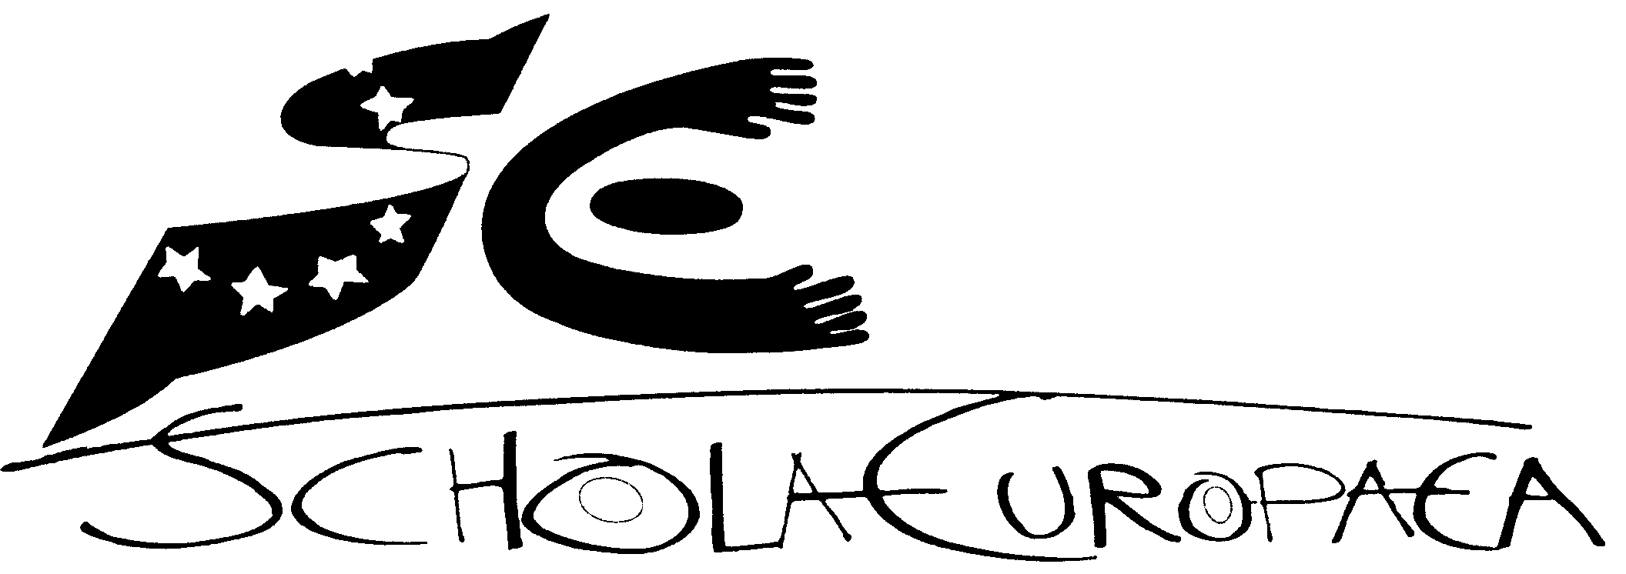 | Schola Europaea  Office of the Secretary-General  General Secretariat
Ref.: 2008-D-386-en-2
Orig.: En

ANALYSIS OF FOLLOW-UP REPORT OF MATHEMATICS AND PROPOSITION OF A COMMON FRAME WORK FOR THE FOLLOW-UP OF THE TEAM INSPECTIONS
Teaching Committee (Nursery and Primary)

Meeting on 19th February – OSGES

Overall report from Inspectors’ follow-up visits concerning progress in schools since the inspections of mathematics

1.0 Introduction

Between 2004 and 2006 all schools had a mathematics inspection. A report was written for each school and a final composite report for the Board of Governors summarised the main findings and made recommendations (annexe 1).

Following the inspections, a programme of in-service training in 2006-7 was coordinated by the Intermath Commission taking into account the overall inspection recommendations and individual school’s needs. Nearly all class teachers attended the training and overall it received very good evaluations (annexe 2). The training enabled teachers to hear from experts about how children learn mathematics, consider different approaches to teaching mathematics, to attend practical workshops and to update themselves on the use of Intermath

The Primary Board of Inspectors then organised follow-up visits to all schools in 2007–8 to find out what had been achieved in developing and improving teaching and learning in mathematics. Their findings have been summarised in this document.

2.0 Management of mathematics

All schools had carefully considered the recommendations made in their reports. Following the inspections and training the profile of mathematics was successfully raised in all schools. Schools developed a range of activities to address the recommendations from inspections. In most schools this has been an on-going development. Where schools had written action plans the profile of mathematics was higher, interest was maintained and the evaluation of progress was easier and more precise.

Most schools now have a designated coordinator with a range of tasks to promote and develop mathematics. In two of the larger schools a small group of teachers has been formed to manage improvements and oversee development. In one of these schools it is a general school development group and in the other it is a specific mathematics group.

Examples of good practice observed in the different schools include:

    - A clear action plan that addressed the recommendations and ideas from the inspection and in-service training.

    - A meeting at the beginning of the school year where the mathematics coordinator informs teachers, especially those new to the system, about Intermath, implementation of the syllabus, curriculum organisation, and available resources.
    - Further in-service training to meet specific needs of teachers for example ICT in mathematics, including using the interactive whiteboards and workshops in geometry, using games and calculators.
    - An increased focus on transition between phases; nursery to primary and primary to secondary.
    - Improvement of key learning resources for example access to ICT and increasing the range of practical materials for pupils to use.

- Planning and programming

There are indications that schools are making more of the opportunities to link mathematics with other subjects for example discovery of the world and art. Some schools are trialling a common format for planning which standardises what key information must be included. This has helped the harmonisation of planning and expectations between language sections. There is a more consistent approach to using the Intermath books and greater awareness of the importance of the teachers’ handbooks.

4.0 Pedagogical activities

ICT plays an increasingly important role in the teaching and learning process. More classrooms have been fitted with interactive whiteboards and most schools have developed a wider range of software to support pupils’ learning. All schools use ICT suites and/or laptop computers to add to pupils’ experiences. However there remains an inequality between schools with regard to ICT resources and pupils’ use of it.

In several schools there has been increased collaboration between teachers to develop and organise more systematically practical resources for lessons. Mathematics coordinators usually have responsibility for organising and purchasing resources.

Other examples of interesting practice include:

- more opportunities for group and collaborative activities
- maths competitions
- more use of mathematics games
- associating mathematics with everyday life
- use of international mathematics contests eg ‘kangaroo maths’
- a mathematics marathon.

5.0 Assessment

Assessment continues to be underdeveloped both as a diagnostic tool and to measure progress although all schools complete the “Carnet Scolaire”. Several schools use national tests for example the Dutch sections use the “Cito tests” and some others use nationally standardised assessments. One school has identified a group of gifted mathematicians and organises special activities for them. Other schools are considering the development of a test for Year 5 to help in the transfer of information between primary and secondary phases.

6.0 Recommendations

- Further improvements are required in the use of assessment to help measure progress more accurately and identify gaps and difficulties in learning

- All schools should have a mathematics coordinator or development group with clear objectives and an annual plan of what they are going to do to improve teaching and learning in mathematics

- Ensure schools continue to embed the initiatives that have been undertaken so far and evaluate their effectiveness each year

- Following all inspections an action plan proforma identifying key recommendations is attached to all reports to aid schools’ self -evaluation and to harmonise the findings of the follow-up visit. (annexe 3)

Annexe 1 – extracts from the recommendations of the composite mathematics report 2006-D-276-en-1

- Consider that the mathematics syllabus approved by the Board of Governors must be the starting point for the planning and programming of lessons.
- Develop general guidelines for the implementation of the syllabus through the cooperation amongst the language sections, in order to create a common planning an programming format which can be used and a model for the pedagogical process.
- Increase harmonisation geared to the different areas at each level:
    - planning and programming
    - assessment
    - sharing of good practice

- Seek a better balance between the different pedagogical approaches, in order to include ,in practice, more active, diversified and integrated learning methods going beyond, upfront, whole-class teaching.
- Pay very particular attention to the needs of pupils of different levels of ability and consequently engage in deeper reflection on differentiated learning objectives in the classroom.
- Devise a common policy for ICT use in mathematics
- Specify the in-service training needs of teachers in school and arrange an induction programme in the use of Intermath for new teachers.
- Step up coordination of primary/secondary transition to ensure pupils’ easy integration and smooth continuity of learning.
- Determine precisely how the role of the mathematics coordinator can be strengthened.

Annexe 2 – extracts from the evaluation of the mathematics in service training – 2007-D-277-en-2

3. Evaluation Summary

- It is clear that most teachers found the training days to be a positive and helpful experience. Many teachers had picked out one aspect of the day that they found particularly interesting or helpful.
- A very few teachers had nothing positive to say about the training believing it to be of little relevance to them.
- The reaction to the guest speakers was very mixed. Teachers preferred the speakers who engaged them in debate and small practical activities. This was easier to achieve where there were smaller numbers of teachers involved.
- Nearly all teachers enjoyed the afternoon practical workshops and praised the inputs of their colleague teachers. Teachers liked these activities because they could readily use the ideas in their classrooms.

4. Future activities

- The Primary Board of inspectors agreed to follow-up the outcomes of training and previous inspection findings by engaging in discussion with the deputy directors in each school.
- The Board decided that the inspector who led the original inspection or who liaised for the training would discuss with the deputy director how the school was developing and improving mathematics teaching and learning. These discussions would take place during visits to the school and could be combined with other activities to prevent any unnecessary travel.
- Relevant developments in European School mathematics and updates to the Intermath books will continue to be brought before the Board of Inspectors and published to schools through a regular mathematics newsletter.
Area of inspection | Inspection Recommendations | School action plan  activities | School self evaluation of  impact of actions taken | Findings from follow –up visit by inspector
Management

Planning and programming

Etc, etc,……..

Annexe 3

Subject: ……………… Inspection Dates…………… Inspector………………..

