 | Schola Europaea  Office of the Secretary-General  General Secretariat
Ref.: 2007-D-139-en-3
Orig.: DE
Version: EN

Financing by/Cooperation between the City of Karlsruhe and the Land of Baden-Württemberg concerning the ES, Karlsruhe
BOARD OF GOVERNORS
Meeting in Brussels on 23 and 24 October 2007

1. Background

In 2004 the European Commission announced its intention to engage consultants to conduct an evaluation of the European Schools at Culham, Mol, Bergen and Karlsruhe and make proposals for the future of these schools.

The terms of reference of this study were agreed by the Board of Governors by written procedure in 2004. Bureau Van Dijk Management Consultants was chosen by the European Commission to conduct the study. A Steering Committee was appointed by the European Commission and the Secretary-General was a member of this body.

Bureau Van Dijk presented its final report in August 2006.

This report was tabled at the meeting of the Board of Governors held in October 2006 and some preliminary remarks were made by some delegations. The Report was discussed more fully at the Board of Governors’ meeting in January 2007. The remarks made by the members of the Board were recorded in the minutes (See document 2007-D-272). Members were also invited to make remarks in writing and to send them to the Secretary-General. The positions taken can be gathered from reading Annex 2 to document 2007-D-373-en-3.
Author’s note: The aforementioned document is not appended as it was on the agenda for the April 2007 meeting of the Board of Governors.

PROPOSALS

It is proposed as follows:
1.
2…..

6. that the proposals for part-financing and cooperation by the City of Karlsruhe and the Land of Baden-Württemberg be explored by the Director of the Karlsruhe School and presented to the October meeting of the Board of Governors.
7…..

At its meeting in Lisbon on 17 and 18 April 2007, the Board of Governors gave the above mandate to the Director of the ES, Karlsruhe, Mr Tom Høyem.

2. Report by Mr Tom Høyem, Director of the ES, Karlsruhe

A. Karlsruhe
After many years of close contacts and numerous negotiations with the authorities and politicians in Karlsruhe, I discharged this mandate by holding

- meetings with each of the political parties on Karlsruhe City Council.
- meetings and negotiations with all the Mayors of Karlsruhe, including the Lord Mayor, Mr Heinz Fenrich. The results (Annex 1) were confirmed by the City Council during its meetings on budget matters for 2007/2008.

In the negotiations one of the conditions was that the European School, Karlsruhe be kept as a Type 1 European School, as stated in document 2007-D-373-en-3:
“1. That the Board of Governors should formally confirm that the European Schools of Bergen, Karlsruhe and Mol will be maintained as classic Type 1 European Schools.”

Karlsruhe stressed the importance of the European School, Karlsruhe for international companies, science and educational institutions in the Karlsruhe Technology Region, also taking into consideration the fact that the University of Karlsruhe, together with the Forschungszentrum Karlsruhe, where our parent organisation, the Institute of Transuranium Elements is situated, has been named one of three elite Universities in the whole of Germany.
It was, of course, also stated that it is in the interest of the City of Karlsruhe that the school should accept Category III Karlsruhe pupils.

B. Baden-Württemberg
After many years of close contacts and numerous negotiations with the authorities and politicians with the Baden-Württemberg Government and Parliament, I discharged this mandate by holding

1) meetings with representatives of each Party represented in the Baden Württemberg Parliament
2) meetings and negotiations with the Ministers concerned, including Ministerpräsident Günther Oettinger, Dr Helmut Rau, Minister of Education, Youth and Sport, and Mr Ernst Pfister, Minister of Industrial Affairs.
3) Meetings with the relevant civil servants in the Ministry of Education, Youth and Sport in Stuttgart.

The Baden-Württemberg Government realises the importance of the school, not only
for Karlsruhe, but also for international companies, institutions and organisations located in all parts of Baden-Württemberg, taking into consideration the fact that the European School, Karlsruhe has pupils coming from a huge catchment area, including Stuttgart, Mannheim, Heidelberg and Strasbourg.
The result of the meetings (Annex 2) has already been implemented in one respect. The contribution from Baden-Württemberg for 2007 covers all school fee reductions, therefore improving the revenue side of the budget substantially. The full financial

consequences will gradually become apparent, when the Category III pupils currently on roll leave the school. Starting from 2008, Category III pupils will pay the full school fees decided by the Board of Governors, without school fee support from Baden-Württemberg. The total amount of the Baden-Württemberg contribution will remain the same. The amount no longer used for school fee support will go directly into the budget of the European School, Karlsruhe.

In Annex 3 we have tried to illustrate the financial development of the European School, Karlsruhe from 2000 to 2010 (the last two years as projections). The significant increase in Category II pupils and the contribution from Karlsruhe and Baden-Württemberg have reduced the Commission’s contribution to the budget of the European School, Karlsruhe from almost €8m in 2000 to a projected €2.2m in 2010, i.e. down from 61% to 19%! At the same time the number of Category I pupils has increased from 114 in the year 2000 (9.79%; Source: RAPEE 2006/2007) to 182 in the year 2008 (18.26%; Source: budget for 2008). The forecast for 2010 is 200 (20%). In all modesty, the European School, Karlsruhe is quite proud of this result and thanks all concerned, inside and outside the school, and the European School system for the support given.

Tom Høyem
Director of the ESK (from 2000 to 2010 (under the present contract))

3. Opinion of the Administrative and Financial Committee

The Administrative and Financial Committee scrutinised the report.
It welcomes the financing commitments given by the Land of Baden-Württemberg and the City of Karlsruhe.

The Administrative and Financial Committee wants to examine this file again in December in order to give its opinion to the Board of Governors with respect to budgetary use of the financial contributions from the Land of Baden-Württemberg and the City of Karlsruhe.

Annex 1
City of Karlsruhe
The Lord Mayor
City of Karlsruhe, 76124 Karlsruhe
The Lord Mayor

European School, Karlsruhe

For the attention of

Mr Tom Høyem, Director

Albert-Schweitzer-Str. 1

76139 Karlsruhe

12.06.2007

Dear Mr Høyem,

In connection with the safeguarding of the European School, Karlsruhe, I promised the Secretary-General of the European Schools, Mr Michael Ryan, that I would discuss with you the question of how the European School’s budget burden can be eased. During talks with the Mayor, Mr Denecken, you submitted a range of proposals as to how the City can contribute to the European School’s budget. As reported, this would primarily involve the School’s staff and operating costs. In the context of the 2007/08 double budget, I accordingly arranged for a subsidy amounting to approximately €65,000 per budget year to be entered, especially for pupils resident in Karlsruhe. I have since heard that this amount is not what you imagined would be forthcoming. In view of the particular importance of the European School for the City of Karlsruhe and the entire region, I would therefore be prepared – notwithstanding the outstanding arrangement regarding the construction of a ‘four-group’ facility for children under three years of age – to increase the amount of approximately €65,000 entered in the budget by €100,000. However, this amount would be the maximum which the City of Karlsruhe can afford as an additional subsidy. Kindly let me know what you think of this proposal.

Yours sincerely,

(Signature)

Heinz Fenrich

Annex 1

City of Karlsruhe
The Lord Mayor
■&&

City of Karlsruhe, 76124 Karlsruhe – The Lord Mayor

European School, Karlsruhe
Mr Tom Høyem, Director
Albert-Schweitzer-Str. 1
76139 Karlsruhe
14.08.2007
European School, Karlsruhe

Dear Mr Høyem,

As the Lord Mayor, Mr Fenrich, is currently on holiday, he has requested me to answer your letter of 29 June 2007.

As you know, in the context of this year’s budget discussions, the City Council entered a subsidy amounting to approximately €65,000 per budget year for the European School, Karlsruhe, especially for pupils resident in Karlsruhe. In agreement with the City Finance Department, this subsidy has now been increased by €100,000, making a total of €165,000. As soon as the extra-budgetary expenditure has been approved and the budget is ready for implementation, this sum will be transferred to the European School, Karlsruhe.

Yours sincerely,

(Signature)
pp. Harald Denecken
Mayor

Annex 2

Baden-Württemberg
MINISTRY OF EDUCATION, YOUTH AND SPORT THE MINISTER
Ministry of Education, Youth and Sport Baden-Württemberg
PO Box 10 34 42 * 70029 Stuttgart
18 July 2007
Mr Tom Høyem, Director _{Stuttgart}
European School, Karlsruhe Ref. 24-6419.350/52
Albert-Schweitzer-Str. 1 (Please quote in all correspondence)
76139 Karlsruhe

Subsidy for the budget of the ES, Karlsruhe

Encl.:

1

Dear Mr Høyem,

Many thanks for your letter of 3 July. As requested, I have pleasure in sending you a copy of the summary minutes of the meeting which you had at my ministry on 13 June.

However, I would ask you to understand the reasons why I myself have not signed these summary minutes, but the Head of Department who had invited you to the meeting and engaged in talks with you.

We willingly used the draft minutes which you kindly appended to your letter as a basis for the definitive version to be submitted to the European Council [sic] [Board of Governors?]. Only in the last paragraph did we – as agreed on 13 June – opt for a somewhat more cautious form of words, for budgetary law reasons, chiefly out of consideration for the legislator.

Department 2
24-6419.350/50
15.06.07

Annex 2

Memo for the files

Subject: Subsidy from the Land of Baden-Württemberg towards school fees for the European School, Karlsruhe
Determination of the general arrangements for the coming years

Date of the meeting held at the Ministry of Education, Youth and Sport, Baden-Württemberg:

Wednesday 13 June 2007, 14.00

Participants: Tom Høyem, Director of the European School, Karlsruhe
Thierry Quere, Deputy Director for the Nursery [sic] of the European School, Karlsruhe
Brigitte Braunschweig, Assistant to the Director of the European School, Karlsruhe
Sonja Furtak, Bursar of the European School, Karlsruhe
Manfred Hahl, Head of Department 2, School Organisation, Teacher Training, International Affairs
Ministry of Education, Youth and Sport, Baden-Württemberg
Bock, Private Schools Desk
Obermüller, Budget Desk
Nuding, International Affairs Desk

In a letter of 11 May 2007, the European School, Karlsruhe requested an appointment with the Ministry of Education, Youth and Sport to discuss, amongst other things, the point ‘Financial support from Baden-Württemberg and further cooperation with the European School, Karlsruhe’. The purpose of the meeting was to clarify and determine the general arrangements whereby in future the voluntary subsidy from the Land of Baden-Württemberg of a maximum of €741,400, paid as a contribution towards the school fees of so-called Category III pupils, would gradually be converted into a fixed subsidy payable into the School’s budget.

The Director, Mr Høyem, explained in his presentation that at present, so-called Category III pupils paid school fees reduced (in comparison with all other European Schools) by €732 in the case of primary pupils and by €1,004 in the case of secondary pupils. School fee levels were decided annually for all European Schools by the Board of Governors. The reduced amounts applicable to the European School, Karlsruhe were decided for each school year by the members of the School’s Administrative Board at its annual meetings in June. In addition, the subsidy from the Land of Baden-Württemberg was used at the present time to offset the cost of school fee reductions for low-income families and, to some extent, those for siblings also.

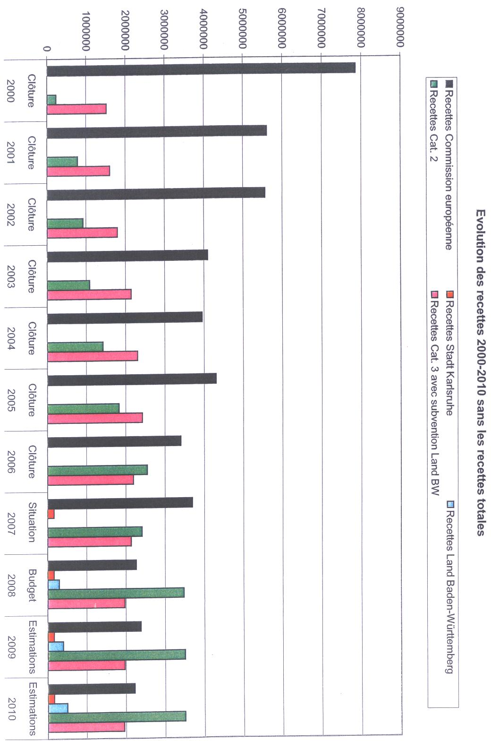

KEY TO CHART ON PREVIOUS PAGE

Development of revenue 200-2010 without total revenue

Revenue European Commission Revenue City of Karlsruhe Revenue Land B-W
Revenue Cat. 2 Revenue Cat. 3 with subsidy Land B-W

Closing of accounts … Situation Budget Estimates Estimates
2000 … 2007 2008 2009 2010

