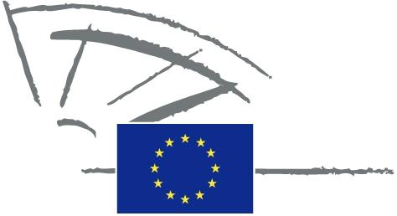
 | EUROPEAN PARLIAMENT | 2009 - 2014

<Commission>{JURI}Committee on Legal Affairs</Commission>

<RefProc>2011/2036(INI)</RefProc>
<Date>{08/04/2011}8.4.2011</Date>
<TitreType>DRAFT OPINION</TitreType>
<CommissionResp>of the Committee on Legal Affairs</CommissionResp>
<CommissionInt>for the Committee on Culture and Education</CommissionInt>
<Titre>on the European Schools' system</Titre>
<DocRef>(2011/2036(INI))</DocRef>
Rapporteur: <Depute>Cecilia Wikström</Depute>

PA_NonLeg
SUGGESTIONS
The Committee on Legal Affairs calls on the Committee on Culture and Education, as the committee responsible, to incorporate the following suggestions in its motion for a resolution:
A. whereas the preamble to the 1994 Convention defining the Statute of the European Schools states that the European Schools system is ‘sui generis’ and constitutes a form of cooperation between the Member States and between them and the European Communities while fully acknowledging the Member States' responsibility for the content of teaching and the organisation of their educational system, and for their cultural and linguistic diversity,
B. whereas the reform of the European Schools system was approved by the Board of Governors in April 2009,
C. whereas the experience of over 50 years of functioning of the European Schools has shown the system and its educational model to be unique and attractive; whereas one of the aims of the reform is to open up that system and the European Baccalaureate to other pupils in the Union; whereas the aims of the reform cannot be attained successfully without a fundamental change in the legal status on which the whole system is based,
D. whereas the Commission report on the European Schools' system in 2009 pointed to persisting and worsening systemic problems, such as the lack of seconded teachers or delays in, or non-provision of, sufficient infrastructure at the schools’ locations, which have a direct effect on the quality of education, enrolment policies, the quality of life of students, parents and teachers and financial aspects of the functioning of the Schools,
1. Considers that the current intergovernmental legal status of the European Schools has reached its limits and requires profound change; considers that this change should be of such a nature as to allow Union action to support, coordinate or supplement the actions of the Member States, without superseding their competence, and to adopt legally binding acts to that end within the meaning of Articles 2 and 6 TFEU;
2. Considers that many of the systemic problems amount to non-fulfilment of the obligations of the Member States; points to the non-existent legal guarantees of Member States' fulfilment of their obligations under the Convention;
3. Emphasises that the European Schools are currently in a legal limbo, which manifests itself in the unclear legal and jurisdictional status of acts adopted by the Schools' bodies, insufficient possibilities to challenge those acts before national courts, no possibility of recourse to the European Ombudsman;
4. Emphasises that the Union's involvement in the European Schools is disproportionately little compared to the financial contribution from its budget;
5. Considers that the European Schools should be brought under the umbrella of the Union; considers that an appropriate legal basis in this regard could be Article 165 TFEU, which reads: ‘The Union should contribute to the development of quality education by encouraging cooperation between Member States and, if necessary, by supporting and supplementing their action, while fully respecting the responsibility of the Member States for the content of teaching and organisation of education systems and their cultural and linguistic diversity’ and further specifies the aims of the Union's action, which correspond to the aims of the European Schools.

OJ L 212, 17.08.1994, p. 3.
COM(2010) 595 final.

