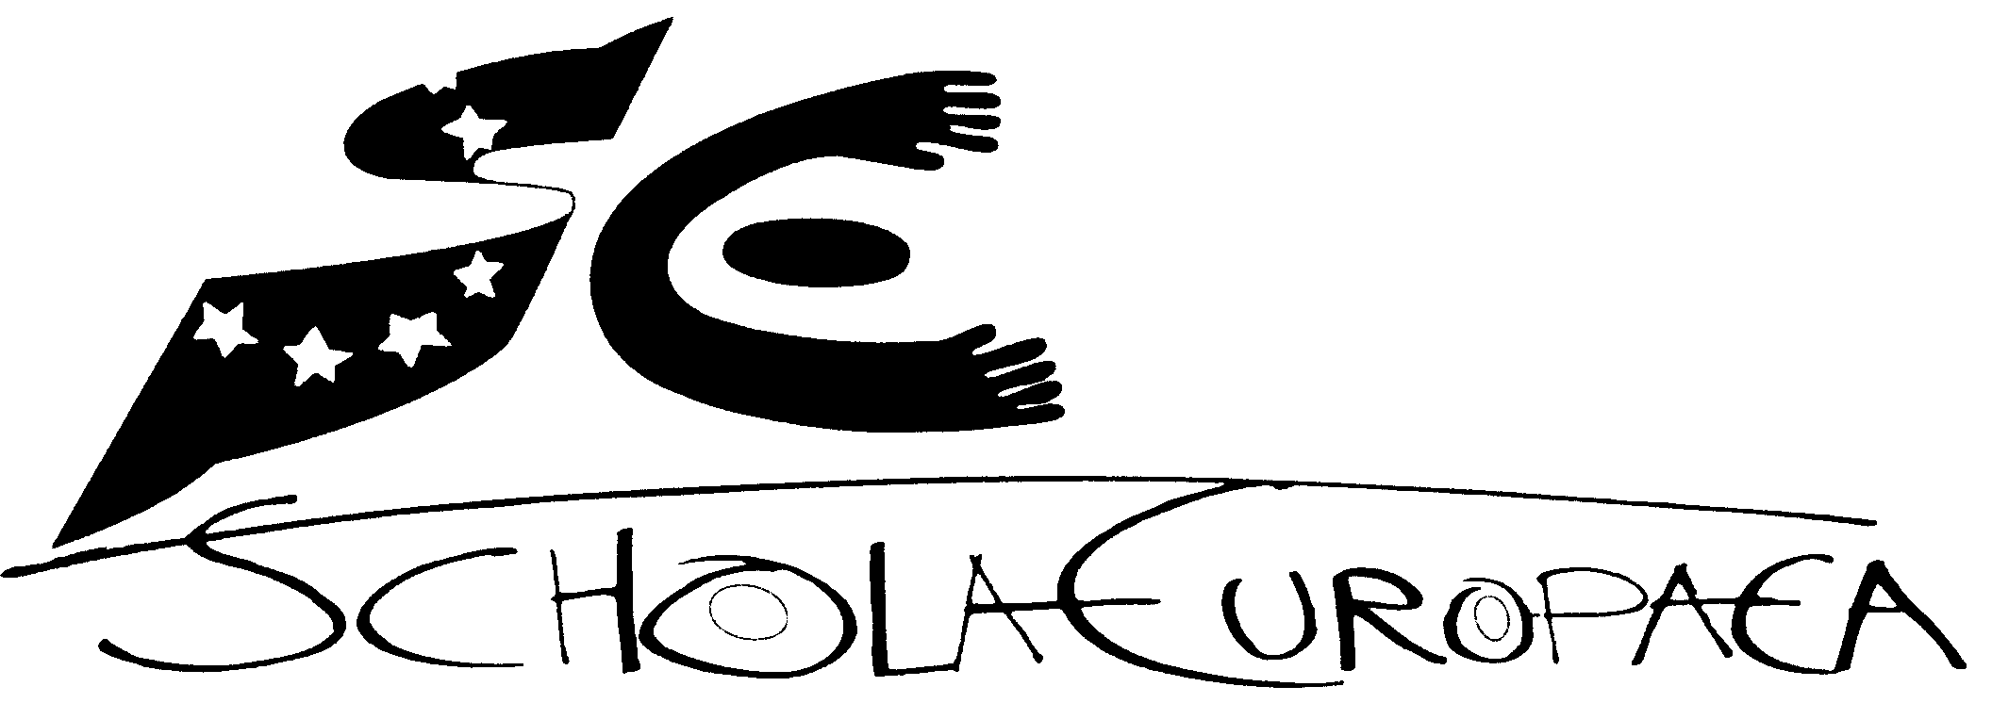 | Schola Europaea  Office of the Secretary-General  General Secretariat
Ref. : 2006-D-174-en-1
Orig. : EN
Version : EN

WRITTEN COMMUNICATION CONCERNING THE WORKING GROUP ON THE FUTURE OF THE EUROPEAN SCHOOLS
Board of Governors
25 and 26 April 2006 in Den Haag

The two annexes give a résumé of the conclusions of the Working Group on the Future of the European Schools which was created by the Board of Governors at its meeting of October 2005.
The conclusions outlined in Annexe 2, however, are a draft version pending their approval by the group.

Annex I
CONCLUSIONS OF THE MEETING OF THE WORKING GROUP ON THE FUTURE OF THE EUROPEAN SCHOOLS HELD IN BRUSSELS 15 DECEMBER 2005.
1. Procedure:
The Group agreed to first consider the document summarising the reactions of the members of the Board of Governors to the Communication of the Commission. The resolution of the European Parliament will then be considered by the Group.
When the Group has articulated its views on these two documents it will seek, on the basis of these views, to formulate proposals to the Board of Governors
2. The Views of the Group concerning the issues mentioned in the Communication of the Commission, paying attention in particular to the summary of the views of the delegations of the Board of Governors in their regard.
(a). Governance.
The Group agrees that
i. the autonomy of the schools should be enhanced. It notes that certain decisions of principle have been taken by the Board in this regard. The AFC has been asked to formulate detailed proposals. Convinced that this implies considering a reform of the Financial Regulations, the AFC has invited the Commission and the Central Office to establish bi-lateral contacts with a view to formulating proposals.
In arriving at the necessary proposals the Group underlines the need
- to ensure clarity of lines of responsibility for the Directors, the Secretary General and the Administrative Boards for the proper execution of the budgets which should serve the objectives of the system
and
- to develop a clear and objective formula for budget allocation for each school.
The purpose of such autonomy should be to facilitate better management, more flexibility and innovation.
ii. giving ultimate responsibility to the schools themselves for recruitment would be a fundamental change. The Boards of Inspectors should be asked to consider whether the rules of application of evaluation of teachers should be reviewed and to make special recommendations regarding the evaluation of part time teachers.
iii. no proposal should be made to increase the degree of representation of the EU institutions in the Board of Governors.
iv. there should not be a separation of the financial and administrative functions from the educational ones in the European Schools system.
v. the board of Inspectors should discuss the possibilities of constituting a middle management in the European Schools.
vi. a common statute of EU employee for the employees of the European Schools is not desirable.
(b). Finance.
The Group agrees that
i. modernised and more transparent budget preparation and execution as well as multi-annual budget planning is desirable but must be linked to the multi-annual budget planning of the EU.

ANNEX II
DRAFT CONCLUSIONS OF MEETING OF THE WORKING PARTY ON THE FUTURE OF THE EUROPEAN SCHOOLS 8/3/06 _ a.m.
The Group agrees that
1. That point 2 (a) ii. of the Draft Conclusions of the meeting of 15 December ’05 should be amended by replacing the last sentence with the following
The Boards of Inspectors should be asked to consider whether the rules of application of evaluation
of teachers should be reviewed and to make special recommendations regarding the evaluation of
part time teachers.
2. That the rules concerning the admission of non EU staff children should be published on the schools’ website.
While being careful to respect the rules established by the Board of Governors, the Directors should be invited to consider drawing up their own provisions for the implementation of these rules in each school.
3. It has no proposals for changing the method of financing the budget of the European Schools but the question of the relative contributions of individual member states remains an issue for those delegations which consider that they make a disproportionately large contribution to the budget.
4. The Secretary General should be invited to draw up an inventory of the work already done or being done by various groups in the following areas
- External evaluation of the European School system.
- Evaluation and inspection of the quality of the service rendered by the schools.
- Evaluation and improvement of special provision for SEN and SWALS
- Provision of alternative certification.
- Offering of European School programmes outside the European Schools.
- Expanding the educational offer of the schools and including a broad modern curriculum.
5. More power and responsibility should be given to Directors to determine when to split a class taking account of cost within the context of the budget of the school and taking account of such factors as the presence of SEN and SWALS pupils.

