 | Schola Europaea  Office of the Secretary-General  Administration  Accountancy
Ref. : 2006-D-153-en-1
Original

STUDY ON SCHOOL FEES AT THE EUROPEAN SCHOOLS
Administrative and Financial Committee
Meeting on 28, 29 and 30 March 2006 at Brussels
1. BACKGROUND
At its meeting in April 2005 in Luxemburg the Board of Governors adopted the following text:
“It is proposed that an independent economist should by 1 September 2005 estimate the highest optimal level of fee for each European School. The fee should be calculated in such a way as to take into account the costs involved while ensuring a population in the region of 20 pupils per class at each level in the school (considering the size of Language II and Language III classes and the carrying capacity of the school in terms of sports and canteen facilities, laboratories and so on).Due consideration should be given also to the cost driving factors involved. The fee proposed should be such as to insure that it would not give rise to an increase of the current financial contribution of the Commission or of the Member States to the budget of the European School in question”
In Summer 2005 a convention on such a study was negotiated between the Secretary General and Rector of the “Universtité Libre de Bruxelles”, in accordance with which a study should be carried out under the responsibility of Professor Françoise THYS-CLEMENT, by the “Centre de l’Economie de l’Education de l’Université Libre de Bruxelles” .
An accompanying committee was created and was convoked on three occasions. Its members were :
Mrs Professor F. Thys- Clement
Directeur du Centre de l’Economie de l’Education

Mrs I. Chaara,
Chercheuse au Centre de l’Economie de l’Education

Mr V. Verardi,
Chercheur auprès de l’ European Center for Advanced Research Research in Economics and Statistics (ECARES)

Mr. M. Ryan, Secretary general of the European Schools and Chairman of the meeting
Mrs R. Christmann Deputy Secretary general of the European Schools
Mr. A. Kuhn – Head of Accounts in the Office of the Secretary general
Mr. P. Krekel – President of the Administrative and Financial Committee
Mrs. Chr. Bardoux, Head of Unit “European Schools” at the European Commission
Mrs G. Lapitajs : Parents’ representative.

2. RESULTS OFFERED BY THE STUDY
On 15 March the final report was presented. The original version was placed on DADEE and a translation into English is being prepared. Five different scenarios were advanced with up to 7 different variations imaginable in each scenario.
The seven variations within the different scenarios are:
1 all categories pay the same fees
2 category I does not pay, category II and category III pay the same fee
3 category I does not pay, category II pays the double of category III
4 category I does not pay, category II pays three times the amount of category III
5 category I does not pay, category II pays four times the amount of III
6 category I does not pay, category II pays the average price per pupil at the relevant school and category III pays the fee determined by the programme of optimisation
7 category I does not pay, II pays the average price per pupil all over the system and category III pays the fee determined by the programme of optimisation

(In scenario 5 (see below) there are only three variations - 5, 6 and 7)
The different scenarii are as follows
Scenario 1
All the Schools are taken as one single unit and the fees are the same all over the system and the same for each cycle.

Scenario 2.1
Each School is taken individually and the fees are subject to the correction coefficient applicable to the salaries

Scenario 2.2
Each School is taken individually and the fees are subject to the index of purchasing power applicable to the salaries

Scenario 3
The Schools are arranged in three groups of schools with a high, a middle and a low population of category I pupils. Here three sub scenarii are presented.
Scenario 3.1
Based on expenditures of the individual Schools
Scenario 3.2
Bases on expenditures of the individual Schools increased by the expenditures of the Central Office
Scenario 3.3
Based on revenues of the individual Schools

Scenario 4
The Schools are taken as one single unit and the fees are the same all over the system but different for each cycle

Scenario 5
This scenario is a combination of Scenario 3 with the characteristics of the different Schools and Scenario 4 with different fees for the three cycles.
Scenario 5.1. which is confined to Annexe I in the report envisages payment of fees by Category I pupils and is not considered here.

In 5.2., it is proposed that category II pupils should pay a multiple of the amount paid by Category III pupils based on the programme of optimisation for each individual schools. However, this too (as is the case with a number of other scenarii) is a very significant departure from the present system which guarantees admission to pupils for whom the real cost is paid. It has therefore been decided not to consider so radical an idea in this paper.

In 5.3., Category II pupils pay the average cost per pupil at each individual school and Category III pupils pay the fee determined by the programme of optimisation for the school in question.

In 5.4., Category II pupils pay the average cost per pupil all over the system taking account of the costs of the Central Office and Category II pupils pay the fee determined by the programme of optimisation for each school.

However, in seeking to fulfil the part of the mandate which stipulates the need to ensure a population in the region of 20 pupils per class in each level in each school – even when interpreting the phrase in the region of 20’ as 15 - the economists base their optimal fee estimations on the situation which would prevail if up to 124 classes and 5 language sections were closed. This, it seems, is the kind of measure needed to ensure such a minimum of pupils per class.

3. EVALUATION OF THE RESULTS IN TERMS OF FEASIBILITY
The objective of the programme to determine the optimal fees is to fix school fees which will attract sufficient pupils to create classes with something in the region of about 20 pupils in all sections and at all levels. This implies charging lower fees in small schools where small classes are the rule and high fees in bigger schools where the classes already have 20 or more than 20 pupils. (The lowest possible interpretation of the phrase in the region of 20 pupils was taken to be 15 pupils).
The economists, in accordance with their mandates, conclude that to charge different fees in different schools should be envisaged.
It would seem at first sight that Scenarii 4 and 5 are closest to the situation obtaining at the moment.
It would also seem that as in the past the School fees should be different for the different cycles in order to take into account the expenditures of each cycle in line with the “causation principle”.
In the tables below the Scenarii 4 and 5 are shown with the results expressed in values to be charged.

Scenario 4
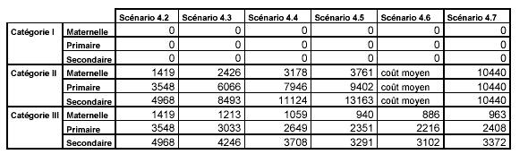
In Scenario 4 the variations 4.6 and 4.7 seem to be closest to our present arrangements.
In Scenario 4.6 it is envisaged that the amount of Category II fees should be such as to cover the cost per pupil in the European School system as a whole. The fees for Category III are different for the different cycles. In 4.7 the expenditures for the Central Office are included and taken into account to determine the prices for Category II and for Category III.

Scenario 5.3
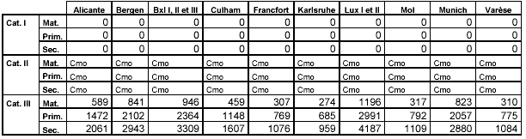

Scenario 5.4

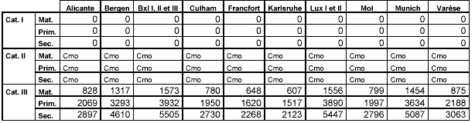

Cmo : coût moyen de l’école individuelle - Average cost of the individual school
4. CURRENT CATEGORY II & III FEES
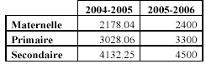

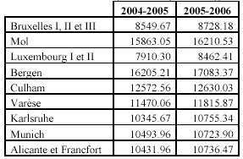

5. PROPOSAL
Given the radical nature of the suppositions (closure of 124 classes and 5 language sections) upon which the various scenario referred to above are based – and it should be remembered that these scenario are included in this paper because they are the ones closest to be present situation – it is proposed that for the year 2007/8 the following fee levels would be more realisable.
Category II –
Contribution fixed to cover the cost per pupil for system as a whole incl. costs of C. Office :
€10 142.15 in 05/06
€ 10 432.00 estimate for 06/07
{Note : The category II fees for the school year 2007/2008 depend on real budget expenditures of 2006 and the number of pupils enrolled in September 2007}
This proposal is a significant departure from present practice whereby Category II fees are different for each school and are based on the costs in the individual school. However the proposal to have one Category II fee for all based on global costs appears in the report and would bring an end to that aspect of our present system which leads to higher Category II fees being charged in those schools which have most difficulty to attract such pupils.
The net result will be that Category II fees will be higher in the big schools which have large numbers of Category I pupils and lower in the smaller schools.
A simulation exercise conducted on the basis of fee levels for 20025/2006 (see Annex) indicates that with the same number of Category II pupils the proposed fees would yield € 228 760.1 less than in 2005/6. This is the equivalent of c 22 pupils. It is expected that the schools with larger numbers of Category III pupils at present will attract more Category II pupils and more them compensate for this.
Category III
Kindergarten € 2 496. 96 i.e. status quo (2006/7) + 2 % inflation
Primary € 3 433.32 idem
Secondary € 4 681.80 idem

It is evident that in the long term this report requires considerably more study than it has been possible to devote to it for purposes of this paper.
CAF is invited to consider how we should proceed further with it.

