 | Schola Europaea  Office of the Secretary-General
Ref.: 2012-03-D-4-en-1
Orig.: EN

Draft Conclusions of the ‘Cost Sharing’ Working Group
Budgetary Committee

Meeting on 13 and 14 March 2012

I. Introduction
The Board of Governors mandated the Office of the Secretary-General to revitalise the ‘Cost Sharing’ Working Group in order to provide the Board with forward-looking concepts to maintain a funding mechanism of the European Schools which is able to deal with the challenges the system has to face and which provides a fair share of the financial burden.
In this context it should also be reminded that the European Parliament in its ‘Resolution of 27 September 2011 on the European Schools system’ considered “that the current funding system places a disproportionate burden as regards secondment and supply of infrastructure on certain Member States, and calls on the Board of Governors to review the way in which the Schools are funded and the recruitment of teachers”.
Until now, the newly composed Working Group met twice (on 6 February 2012 and on 6 March 2012).
Delegates agreed on the main facts and challenges illustrated under chapter II and to focus in the next meetings on two different models illustrated under chapter IV.

II. Main facts and challenges
Delegates agreed on the following main facts and challenges presented by the Secretary-General:
- A constant increase of category I pupils in the last years;
- an increase of SWALS students with a particular pressure in the English sections;
- a high demand of English as the second language;
- an increasing lack of seconded teachers (in the 2011/2012 school year 85 non-filled posts);
- A quite stable amount of EU contributions which do not correspond with the increase of pupils from the EU institutions.
The described facts lead to budgetary and structural problems which have to be addressed by the Working Group.

III. Points of discussion so far
In the following discussion in particular the following possible solutions were briefly marked out:
- The Irish proposal to create a Central Appointment Board (2012-01-D-66-en-1);
- an increase of the funding by the European Institutions;
- different pro-rata models;
- the creation of a new intergovernmental cost sharing mechanism;
- the development of a modified ‘Munich Model’ which foresees the reimbursement of the salaries of the seconded teachers;
- the increase of the category 3 fees;
- the additional funding via fees for category 1 pupil;
- the additional funding via other external sources;
- the prolongation of the 9-year-rule (Article 29 of the Staff Regulations).

IV. Focus of the next meetings
Based on partly controversial discussion of the different solutions, delegates agreed in the second meeting that the working group should focus its discussions in the next meeting on the ‘Modified Munich Model’ and the model of a ‘Central Recruitment Service’ (CRS).
Both models try to address the lack of seconded teachers either
- by motivating Member States to second more teachers (‘Modified Munich Model’) or
- by replacing seconded teacher posts by full time fixed term Charge de Cours who have been recruited within a centralised approach (‘Central Recruitment Service’).
Moreover, both models provide elements to deal with the financial challenge either
- by providing a new mechanism of cost sharing including the reimbursement of Member States for their secondments (Modified Munich Model’) or
- by creating a budgetary mechanism which will allow the Member States who do not fulfil their quota of secondments to make a financial contribution to a centralised fund (‘Central Recruitment Service’) which could be used to finance the recruitment of locally recruited teachers.
Finally, delegates underlined that also ways of creating further revenues (review of the school fees, looking for external sources) should be elaborated.

- Scenario based on the principles of the ‘Munich Model’
- Main elements of the proposal
The proposal is based on one of the principles of the financing arrangements of the Munich school; namely that the school reimburses to the Member States the gross salaries that they have paid to their seconded teachers.
The proposal is intended as a pragmatic approach aimed at resolving the financial difficulties of those Member States who second significantly more teachers than the number required by the “indicative reference” established by the Board of Governors in its decision of Stockholm.
The central idea is to motivate these Member States to continue to second the additional teachers. As “over quota” posts become vacant through staff turnover, the Member State would be able to request that it should receive reimbursement of the national salaries of the posts in question, rather than leaving the posts unfilled. The cost would be met by using income collected from other Member States that were under quota if they were willing to make a direct financial contribution.
Contributions from those other Member States would be based on the number of “under quota” posts and the national salaries of staff in the Member State concerned. The cost to the contributing Member State would thus be the same as the cost of increasing its secondments up to the indicative reference.
An illustration of the financial implications suggested that these contributions could be more than enough to cover the reimbursement of national salaries in the first year of such a scheme. However, the costs would increase year on year (since they are linked to staff turnover) and there could be a shortfall by the fifth year.

- Discussions so far
Members of the working group had a number of reservations about the proposal, highlighting that
- some Member States are not willing to make direct financial contributions as an alternative to seconding staff;
- differences in national salaries meant that financial contributions from “under quota” Member States would not necessarily cover the reimbursement of the national salaries of staff from other Member States;
- such an approach could not be more than a transitional measure, but it might be useful on an interim basis while other more comprehensive solutions are explored;
- some elements of the approach could perhaps be combined with the ‘CRS’ proposal outlined below;
- in order to know whether such an approach would be feasible, it would be necessary to know which Member States would be willing to make a financial contribution on this basis.

- ‘Central Recruitment Service’ (CRS)
- Main elements of the proposal
The central idea of the proposal, which also reflects on consideration N° 35 of the ‘European Parliament resolution of 27 September 2011 on the European Schools system’, is to fill in the gap of seconded teachers by Charges de Cours who have been recruited by a ‘Central Recruitment Service’ and to finance these teachers by Member States who do not fulfil their quota of secondment.
The teachers could either be recruited by creating a data base or – in particular in the interest of the quality of the recruitment procedure – by following a more comprehensive approach providing pre-selection procedures in the host of the schools and/or the target countries of the potential candidates.
These teachers would be in general treated like other locally recruited teachers and would be covered by the same Service Regulations. The main difference with respect to other locally recruited would be that these teachers, in order to attract qualified personnel coming from abroad, would receive a fixed term contract (for example 5 years) with a fixed amount of hours/periods.
The salaries of the teachers concerned would be paid out of a particular budget line to be created within the budget of the Central Office. Member States who do not fulfil their quota of secondments would have to contribute to this centralised pot by either paying the average costs of a locally recruited teacher or by paying the average costs caused in case they would have provided the system with a seconded teacher (national salary + national social charges).

- Discussions so far
Members of the working group welcomed in principle the proposal but highlighted that
- such an approach should only be followed where no secondment is possible;
- Member States which fulfil their quota of secondment would have no obligation to contribute to the fund;
- no third category of teaching staff should be created;
- the principle of equal salary for equal work should be respected;
- the quality of the recruited staff must be observed.

The crucial question in both models is linked to the Member States agreement to make a direct financial contribution, in lieu of the secondment of staff, if they were below the ‘indicative reference’. The Working group proposed that the Secretary General should explore the willingness of the Member States to take part in the proposed cost sharing process.

V. Proposal
The Budgetary Committee is invited to express its views in particular on the two models and to give further guidance to the ‘Cost Sharing’ Working Group.

Annex
Scenario based on the ‘Munich Model’

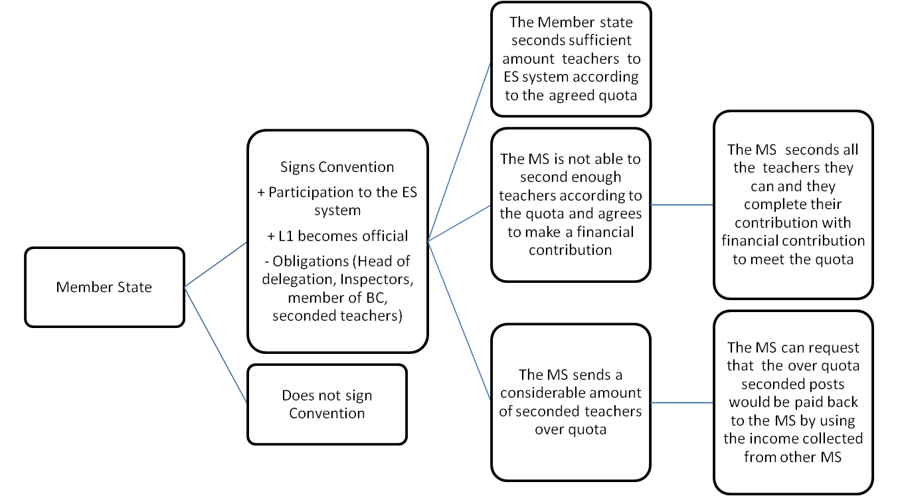
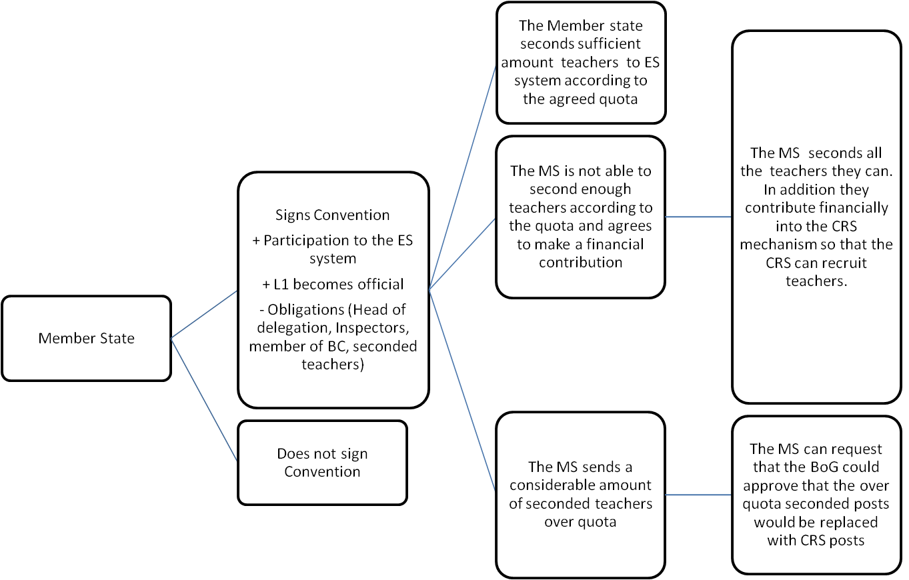
‘CRS MODEL’

2011/2036(INI)
Consideration N° 35: ’Notes with concern that the lack of seconded staff must be compensated by local recruitment of staff whose salaries are paid by the Schools; calls on the Board of Governors to ensure that the Member States who do not contribute financially by seconding teachers pay an equivalent financial contribution to the Schools' budget’ (2011/2036(INI).

