 | Schola Europaea  Office of the Secretary-General  General Secretariat
Ref.: 2019-11-D-17-en-1
Original: EN

Situation of the European Schools in Brussels
Board of Governors of the European Schools
Meeting from 3 to 5 December 2019 – Brussels

- BACKGROUND
In 2010, by written procedure, the Board of Governors approved the setting-up of a fifth European School in Brussels and requested the Belgian Government to make the necessary arrangements for a school with capacity for 2500 pupils to be made available in September 2015, requesting the European Commission to keep the Budgetary Authorities (Council and European Parliament) informed of this proposal.
On 18 December 2015, the Council of Ministers of Belgium’s Federal Government agreed to make a fifth European School available by 2019-2020, with the temporary Berkendael site continuing to operate until the new school opens.
At its meeting of 1-3 December 2015, the Board of Governors approved temporary use of the Berkendael site as an extension to the European School, Brussels I, pending opening of the European School, Brussels V.
The Berkendael site’s intake consists of French language section pupils and of Latvian and Slovakian language section pupils, the creation of the latter two sections in the nursery and primary cycles also having been approved by the Board of Governors at its December 2015 meeting.
II. The infrastructure and the current pupil population of the Brussels Schools
There are currently four European Schools (ES) in Brussels: the ES, Brussels I, the ES, Brussels II, the ES, Brussels III and the ES, Brussels IV, in addition to which there is the Berkendael temporary site as an extension to the ES, Brussels I.
For some years now, the total pupil population in Brussels has been regularly increasing, at a rate of around 400 pupils per year; this year the increase is closer to 500 pupils. It should be noted that last year the figure was abnormally low. It is as if the situation had reverted to balance one year later.
It can thus be seen that on 15 October 2019, the pupil population of the Brussels European Schools is continuing to grow:

This overall situation also needs to be taken into consideration in relation to the theoretical capacity of each school and their respective pupil numbers on 15 October 2019, appearing below:

Details of the situation of the different Schools was already given in December 2018 (2018-11-D-31) and in April 2019 (2019-04-D-5-en-1).

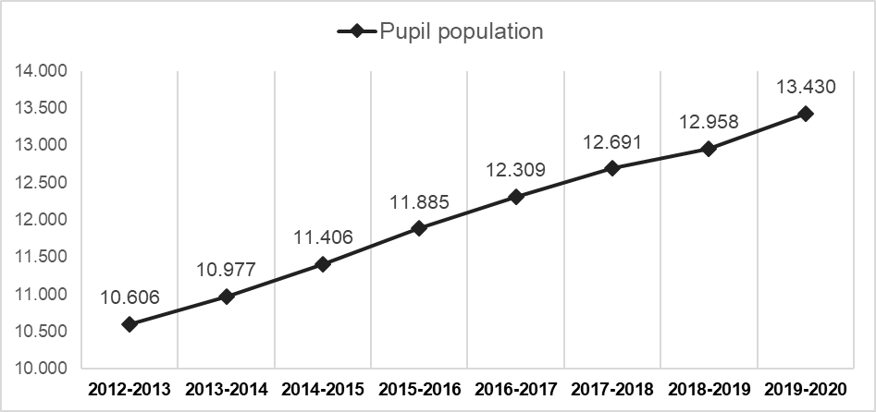
At the level of each school, the situation is as follows:
- At the Brussels I School, on the Uccle site, the total number of pupils – 3 349 – is still as large, despite a slight fall of 41 pupils on 2018 (for the record, the school’s theoretical capacity is 3 100 pupils).
On the Berkendael site, whose capacity is 1 000, the number of pupils is up from 559 on 15 October 2018 to 730 pupils on 15 October 2019. On that site, the French language section accounts for 66% of pupil numbers (71% in 2018 – 81% in 2017), whilst the satellite classes are developing, since an additional year group is opened each year, but the initial year group has to be kept because of the enrolment of siblings. Thus, this year P4 DE and year P1 EL, EN and IT classes have been opened.
- The number of pupils on roll at the Brussels II School (3 175 pupils on 15 October 2019 / theoretical capacity of 2 850 pupils) rose by 100 pupils.
- The overcrowding of the Brussels III School has worsened, with 103 more pupils on roll (3 202 pupils on 15 October 2019 / theoretical capacity of 2 650 pupils). It should be noted that the number of pupils in the EL language section is still very large (609 pupils in 2019, as compared with 584 in 2018 and 581 in 2017).
- The Brussels IV School has reached its capacity of 2 800 pupils (2 974 pupils on 15 October 2019), with 139 more pupils than last year. The secondary cycle and certain recently created sections are continuing to develop.

It should be noted that on 15 October 2019, the overcrowding of the Brussels Schools already corresponded to more than 1000 pupils. This situation is ever worsening, particularly at a time when a great deal of attention is being paid to the safety and security of the Schools’ sites. A few places remain available in the secondary cycle of the ES, Brussels IV, but they need to be used for development of the existing sections, the year groups in which are gradually being opened each year.
There is still some capacity on the Berkendael site, but the development of the satellite classes might well become a source of concern in the near future.
The figures on pupil numbers in the four schools show that it is absolutely essential to have additional infrastructure available as soon as possible. In any event, no later than September 2021, ideally for September 2020 already

III. Communications from the Belgian Authorities on the making available of a fifth European School in Brussels
As a reminder, at its last meeting in December 2018, the Board of Governors was informed that the making available of a fifth European School would be a minimum of five years behind schedule in relation to the undertaking given by the Council of Ministers of the Belgian Federal Government, which was to make such a school available to the system by September 2019 (2018-11-D-31).
As regards the location of the fifth School, it was confirmed that at its meeting of 5 October 2018 and on a proposal from the Ministry of Defence, the Council of Ministers of the Belgian Federal Government approved a note providing for assignment of a 4-hectare plot of land on the site of NATO’s former headquarters for the construction of a fifth European School.
In February 2019 already, the Secretary-General was told that on a proposal from the Minister charged with the Régie des Bâtiments (RdB) (Belgian Public Buildings Authority), the Council of Ministers of the ‘caretaker’ Government could have approved:
– the planned construction of a fifth European School on the aforementioned plot of land;
– the making available to the European Schools on a definitive basis of the Berkendael site;
– the implementation of a temporary solution pending construction of the fifth European School because the political decision has already been taken.
Unfortunately, since then, no progress has been made, despite repeated requests.
As far as the temporary solution is concerned, in December 2018, only one possibility had been proposed, namely the ‘La Trésorerie’ (‘Finances’) building (Rue du Commerce), currently being rented by the Régie des Bâtiments until 2027 and conveniently located in relation to the European institutions. Given that this building currently houses offices, the possibility of converting it into a school had been studied and a change of intended use would be necessary. That building would be made available by June 2020 at the latest. The conversion work on the building to enable the European Schools to organise teaching there would have been completed by that date. The objective was to be able to use the building in question as from the beginning of the school year on 1 September 2020.
In response to a query from the Secretary-General, the Régie des Bâtiments had said at the time that the idea of erecting prefabricated buildings on the piece of land where the fifth School was expected to be built was not feasible, for at least two reasons:
- The cost of construction of a prefabricated school was the same as that of a school proper.
- It would take at least three years to make these temporary buildings available.
During the meetings of the Brussels Steering Committee organised in March 2019, the Representatives of the RdB pointed out that the expected date of availability of the temporary site at the ‘Finances’ building location (September 2020) might not be respected, should a decision by the Council of Ministers of the Belgian Federal Government not have been taken by the end of April 2019. Moreover, the building’s landlord had requested reassurances regarding the possibility of the building’s reverting to its current intended use at the end of its transitional use by the European Schools. The Regional authorities, which are in charge of issuing permits, have refused to give the landlord a guarantee that the building’s intended use could revert to ‘offices’ after its temporary use as a school has ended. This project has not been mentioned again since.
The RdB, without a clear political mandate, have inquired into the possibility of having a temporary site on a piece of land on the former NATO site. It was confirmed by the Defence Ministry, the owner of the land, that it would be feasible to use a well-located piece of land. The RdB Management has been exploring this avenue and has received from the Secretary- General a set of requirements for the facilities needed for a Primary and Nursery site for 1500 pupils.
During the meeting of the Steering Committee Brussels organised in November 2019, the RdB confirmed that the project could still be submitted to the Council of Ministers before the end of the calendar year. They have, however, voiced concerns about the cost of the project.
The proposal is to build a temporary school using prefabricated units, on part of the old NATO premises. This is also to be the site of the fifth European School (EEB5), meaning that this is an ideal location as pupils could eventually transfer easily from the prefabricated units to EEB5, once construction is complete. The RdB has informed us that although there are existing prefabricated units on that land, they are not suitable for conversion into a school, so they will be completely removed and replaced by a structure purpose-built for schooling.
The Steering Committee welcomed this proposal and agreed to accept it. It was felt to be a better solution than the Rue du Commerce site, because it can be built to meet all the requirements of a school and could act as the kernel from which the fifth school can grow and develop. It is also easily accessible by school bus transport, since according to the RdB, the piece of land is large enough to accommodate a bus park. According to the RdB, NATO sports facilities could be made available to pupils, so that there would be no need to build sport facilities. The Steering Committee agreed that the NATO temporary site would be suitable to accommodate Nursery and Primary level pupils.
The RdB did, however, issue a caveat; the NATO temporary site will not be ready until September 2021. The 2020 horizon for a temporary site is already critical for enrolments; 2021 would merely exacerbate the situation.
The RdB also announced that the date for the making available of the EEB5 had now become September 2026, at the earliest.
Each year there is a need for some 400 additional places in the Brussels Schools, so by 2026, when EEB5 is now scheduled to open, there will most probably be 2800 additional pupils. Some 300 pupils can still be enrolled at Berkendael: there is possibly no space left for the remainder, unless additional capacity is provided.
It is highly regrettable that in over a year later (from 5 October 2018, decision of the Council of Ministers on the EEB5’s location), it has not been possible for any real steps forward to be taken and that even the date for the EEB5 has been deferred by two years (from September 2024 to 2026).
Should the present ‘caretaker’ Government unfortunately not take a decision, we will need to wait for a new Government to be in place, which may lead to further delays for the temporary site, hopefully not beyond September 2021.
For the record, a table and graphs can be found below, showing the pattern of development of the pupil population in the European Schools in Brussels, based on its growth as recorded this year and up to September 2026, the date scheduled for the EEB5 to be made available:

Development by + 300 pupils per year with temporary site available in 2021

 | EEB1- UCC | EEB1-BK | EEB2 | EEB3 | EEB4 | Temporary site | TOTAL
Capacity until 2021 | 3 100 | 1 000 | 2 850 | 2 650 | 2 800 |  | 12 400
Capacity as from Sept. 2021 | 3 100 | 1 000 | 2 850 | 2 650 | 2 800 | 1 500 | 13 400

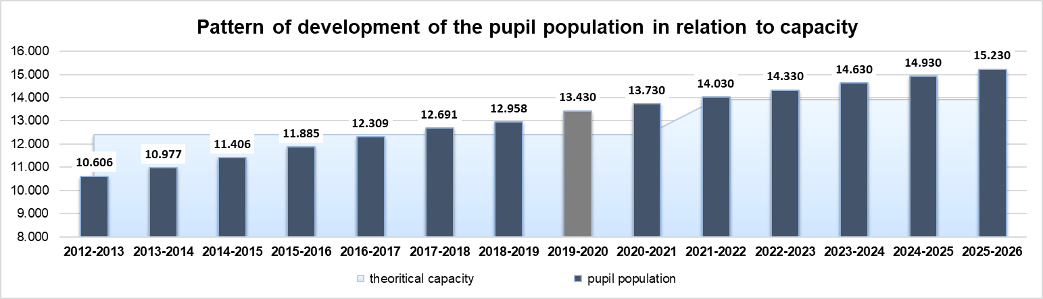
Theoretical capacity Pupil population
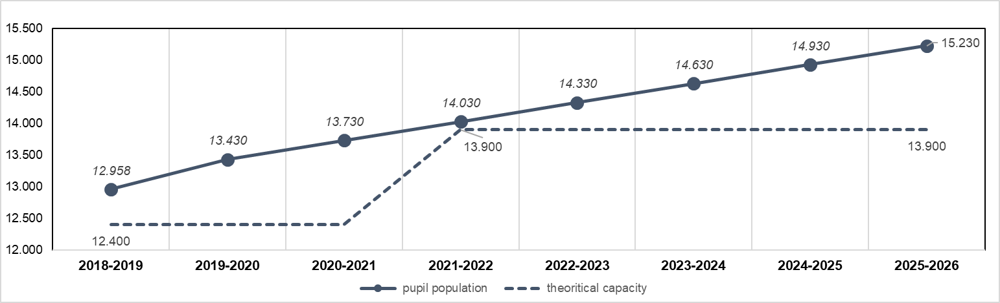

Pupil population Theoretical capacity

Development by + 400 pupils per year with temporary site available in 2021

