|  |  |
| --- | --- |
| C:\Users\helene.matundu_luzol\AppData\Local\Microsoft\Windows\Temporary Internet Files\Content.Outlook\8MKC54EL\Logo Schola Europaea - pour documents (2).jpg | **Schola Europaea**  Office of the Secretary-General  General Secretariat |

Ref.: 2019-04-D-5-en-1

Original: FR

ORAL COMMUNICATION

Situation of the European Schools in Brussels

**Board of Governors of the European Schools**

Meeting from 9 to 12 April 2019 – Athens

1. **BACKGROUND**

In 2010, by written procedure, the Board of Governors approved the setting-up of a fifth European School in Brussels and requested the Belgian Government to make the necessary arrangements for a school with capacity for 2500 pupils to be made available in September 2015, requesting the European Commission to keep the Budgetary Authorities (Council and European Parliament) informed of this proposal.

On 18 December 2015, the Council of Ministers of Belgium’s Federal Government agreed to make a fifth European School available by 2019-2020, with the temporary Berkendael site continuing to operate until the new school opens.

At its meeting of 1-3 December 2015, the Board of Governors approved temporary use of the Berkendael site as an extension to the European School, Brussels I, pending opening of the European School, Brussels V.

The Berkendael site’s intake consists of French language section pupils and of Latvian and Slovakian language section pupils, the creation of the latter two sections in the nursery and primary cycles also having been approved by the Board of Governors at its December 2015 meeting. The site also accommodates a growing number of satellite classes.

**II. The infrastructure and the current pupil population of the Brussels Schools**

There are currently four European Schools (ES) in Brussels: the ES, Brussels I, the ES, Brussels II, the ES, Brussels III and the ES, Brussels IV, in addition to which there is the Berkendael temporary site as an extension to the ES, Brussels I.

For some years now, the total pupil population in Brussels has been regularly increasing, at a rate of around 400 pupils per year; this year, for the first time, the increase is less than 300 pupils.

It can thus be seen that on 15 October 2018, the pupil population of the Brussels European Schools is continuing to grow, even though this increase is lower than in previous years, as attested by the following data:



This overall situation also needs to be taken into consideration in relation to the theoretical capacity of each school and their respective pupil numbers on 15 October 2018, appearing below:



Details of the situation of the different Schools was already given in December (2018-11-D-31).

It should be noted that on 15 October 2018, the population of the Brussels European Schools already exceeded by more than 550 pupils the total capacity of the sites available. This situation is really not ideal, especially at a time when a great deal of attention is being paid to the safety and security of those Schools’ sites.

It remains absolutely essential to have additional infrastructure available as soon as possible.

**III. Communications from the Belgian Authorities on the making available of a fifth European School in Brussels**

As a reminder, at its last meeting in December 2018, the Board of Governors was informed that the making available of a fifth European School would be a minimum of five years behind schedule in relation to the undertaking given by the Council of Ministers of the Belgian Federal Government, which was to make such a school available to the system by September 2019 (2018-11-D-31).

As regards the location of the fifth School, it was confirmed that at its meeting of 5 October and on a proposal from the Ministry of Defence, the Council of Ministers of the Belgian Federal Government approved a note providing for assignment of a 4-hectare plot of land on the site of NATO’s former headquarters for the construction of a fifth European School.

On a proposal from the Minister charged with the *Régie des Bâtiments* (*RdB*) (Belgian Public Buildings Authority), the Council of Ministers would have to approve:

– the planned construction of a fifth European School on the aforementioned plot of land;

– the making available to the European Schools on a definitive basis of the Berkendael site;

– the Memorandum of Understanding between Commissioner Oettinger and the Belgian Minister, Mr Geens;

– the implementation of a temporary solution pending construction of the fifth European School.

As far as the temporary solution is concerned, in December, only one possibility had been proposed, namely the ‘*La Trésorerie*’ (‘Finances’) building (Rue du Commerce), currently being rented by the *Régie des Bâtiments* until 2027 and conveniently located in relation to the European institutions. Given that this building currently houses offices, the possibility of converting it into a school had been studied and a change of intended use would be necessary. That building would be made available by June 2020 at the latest. The conversion work on the building to enable the European Schools to organise teaching there would have been completed by that date. The objective was to be able to use the building in question as from the beginning of the school year on 1 September 2020.

In response to a query from the Secretary-General, the *Régie des Bâtiments* had said at the time that the idea of erecting prefabricated buildings on the piece of land where the fifth School was expected to be built was not feasible, for at least two reasons:

* The cost of construction of a prefabricated school was the same as that of a school proper.
* It would take at least three years to make these temporary buildings available.

During two recent meetings of the Brussels Steering Committee organised in March, the Representatives of the *RdB* pointed out that the expected date of availability of the temporary site at the ‘Finances’ building location (September 2020) might not be respected, should a decision by the Council of Ministers of the Belgian Federal Government not have been taken by the end of April 2019. Moreover, the building’s landlord has requested reassurances regarding the possibility of the building’s reverting to its current intended use at the end of its transitional use by the European Schools. The Regional authorities, which are in charge of issuing permits, have refused to give the landlord a guarantee that the building’s intended use could revert to ‘offices’ after its temporary use as a school has ended. Although the *RdB* will continue negotiations with the Brussels-Capital Region and the landlord, there is a real risk of failing to obtain the ‘Finances’ building for the temporary site.

So, the *RdB*, without a clear political mandate, have inquired into the possibility of having a temporary site on a piece of land on the former NATO site. It was confirmed by the Defence Ministry, the owner of the land, that it would be feasible to use a well-located piece of land. The *RdB* Management has started exploring this avenue, in parallel with the ‘Finances’ building one.

The proposal is to build a temporary school using prefabricated units, on part of the old NATO premises. This is also to be the site of the fifth European School (EEB5), meaning that this is an ideal location as pupils could eventually transfer easily from the prefabricated units to EEB5, once construction is complete. The *RdB* has informed us that although there are existing prefabricated units on that land, they are not suitable for conversion into a school, so they will be completely removed and replaced by a structure purpose-built for schooling.

The Steering Committee welcomed this proposal and agreed to accept it. It was felt to be a better solution than the Rue du Commerce site, because it can be built to meet all the requirements of a school and could act as the kernel from which the fifth school can grow and develop. It is also easily accessible by school bus transport, since according to the *RdB*, the piece of land is large enough to accommodate a bus park. According to the *RdB*, NATO sports facilities could be made available to pupils, so that there would be no need to build sport facilities. The Steering Committee agreed that the NATO temporary site would be more suitable to accommodate Nursery and Primary level pupils.

The *RdB* did, however, issue a caveat; the site will not be ready until September 2021 and will, like Rue du Commerce, be for a total population of 1000 pupils. The 2020 horizon for a temporary site is already critical for enrolments; 2021 would merely exacerbate the situation.

So the Steering Committee recommended that the capacity be increased to 1500 pupils.

Each year there is a need for some 300 additional places in the Brussels Schools, so by 2026, when EEB5 is now scheduled to open, there will most probably be 2100 additional pupils. Some 500 pupils can still be enrolled at Berkendael, if the ‘Halsdorf’ building (with a capacity of around 120-150 pupils) could be used; there is no space for the remainder, unless additional capacity is provided.

I have also been requested to provide a set of requirements for the facilities needed for a Primary and Nursery school on the NATO site.

The *RdB* also announced that the date for the making available of the EEB5 had now become September 2026, since a decision could not be taken by the Council of Ministers by the end of March 2019.

The Steering Committee regrets that in six months (from the 5 October 2018 decision of the Council of Ministers on the EEB5’s location), it has not been possible for any real steps forward to be taken and that even the date for the EEB5 has been deferred by two years (from September 2024 to 2026).

The *RdB*  now has to produce a detailed analysis of the two options (the ‘Finances’ and the ‘NATO’ temporary sites) by the end of March 2019, for the use of its internal hierarchy.

Reassurance has been given by the *RdB* that the temporary site will be accessible to the disabled.

The Council of Ministers of the Belgian Federal Government had already decided (October 2018) that the fifth school would be located on a piece of land on the former NATO site. A technical study on the EEB5 must follow, together with one on the making available of a temporary site and another on the definitive use of Berkendael: all have yet to be officially validated.

The *RdB* indicated that these issues are closely linked with the October 2018 Council of Ministers’ decision and should be presented together to the Council of Ministers.

Should the present ‘caretaker’ Government unfortunately not take a decision, we will need to wait for a new Government to be in place, which may lead to further delays for the temporary site, even beyond 2021.

For the record, a table is to be found below:

**Pupil population on 15 October 2018 // Theoretical capacity**

|  |  |  |
| --- | --- | --- |
|  | Pupil numbers | **Theoretical capacity** |
| 2018 |  |
| **EEB1-UCC** | **3 390** | **3 100** |
| **EEB1-BK** | 559 | **1 000** |
| **EEB2** | **3 075** | **2 850** |
| **EEB3** | **3 099** | **2 650** |
| **EEB4** | **2 835** | **2 800** |
| **Total** | **12 958** | **12 400** |

as are a table and graphs showing the pattern of development of the pupil population in the European Schools in Brussels, based on its growth as recorded this year and up to September 2026, the date scheduled for the EEB5 to be made available:

**Development by + 300 pupils per year with temporary site available in 2021**

|  |  |  |  |  |  |  |  |
| --- | --- | --- | --- | --- | --- | --- | --- |
|  | **EEB1- UCC** | **EEB1-BK** | **EEB2** | **EEB3** | **EEB4** | **Temporary site** | **TOTAL** |
| **Capacity until 2021** | 3 100 | 1 000 | 2 850 | 2 650 | 2 800 |  | **12 400** |
| **Capacity as from Sept. 2021** | 3 100 | 1 000 | 2 850 | 2 650 | 2 800 | 1 000 | **13 400** |

**Pattern of development of the pupil population in relation to capacity**

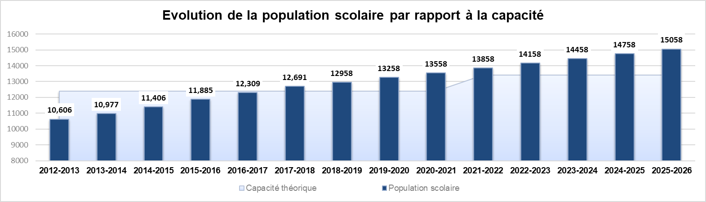

Theoretical capacity Pupil population

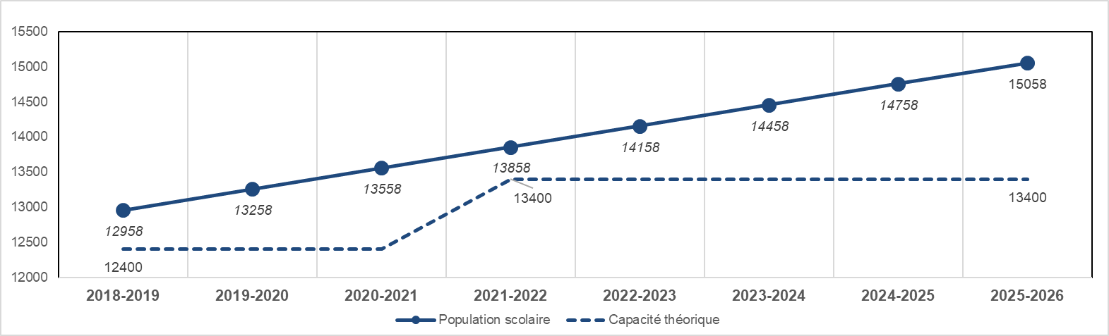

Pupil population Theoretical capacity