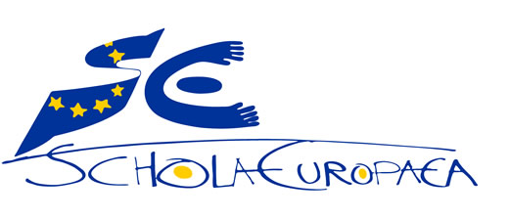 | European Schools  Office of the Secretary-General

Ref.: 2017-09-D-40-en-2
Orig.: FR

Edward Steichen International School: General Interest File
BOARD OF GOVERNORS
Meeting on December 5-7, 2017 – Brussels

Luxembourg, 18 September 2017

THE GOVERNMENT
OF THE GRAND DUCHY OF LUXEMBOURG
Ministry of Education, Childhood and Youth

Secondary Education Department – VR
Tel.: 247-85131 Fax: 247-85129
viviane.rhein@men.lu The Secretary-General of the
European Schools
23, rue de la Science

B-1040 BRUSSELS

Dear Sir,

With the aim of widening, diversifying and making more flexible the range of state (public sector) schooling offered in the Grand Duchy of Luxembourg, and in view of the huge success of the Differdange and Esch/Alzette International School, I intend to extend the range of state European schooling offered in the Grand Duchy of Luxembourg. It is the State’s responsibility to offer a state education system in which each pupil has a chance to succeed, irrespective of the language spoken at home.

Over and above efforts to integrate foreign pupils who will remain in the country, the offer of new international schools matches the needs of children and teenagers residing temporarily in the Grand Duchy and set to continue their education in another country.

A high-quality schooling offer is an important factor in the decision of a company, a foreign investor or scientific experts as to whether or not to move to Luxembourg. That is why I find it important for international schools to be set up in geographical areas of the country from which pupils cannot easily access the International School at Differdange and Esch, which is located in the south of the country.

I am therefore taking the liberty of appending hereto three general interest files concerning the setting up of three International Schools which will operate as Accredited European Schools. Linked to the European School system by an accreditation agreement, they will offer an education based on the European Schools’ curricula. The education provided will lead to the European Baccalaureate. The Luxembourg Ministry of Education will take responsibility for their administration, funding and staff in their entirety.

These three European schools, which will be located in the centre-east, the north and the south- east of the country respectively, are intended to provide a response to the growing heterogeneity of the Luxembourg pupil population. They will also target the inhabitants of those regions who do not necessarily have previous multilingual experience but who wish to offer their children a varied linguistic and cultural education. They will be operational as from the beginning of the 2018-2019 school year.

Junglinster International School, an Accredited European School located in the centre-east of the country, near Luxembourg-City and Luxembourg Airport, will operate with two language sections, an English section and a German section.
- Edward Steichen International School, an Accredited European School at Clervaux, located in the Luxembourg Ardennes in the north of the country, will operate with two language sections, a French section and a German section.
- Mondorf-les-Bains International School, an Accredited European School at Mondorf-les-Bains, the town which hosted the meeting of the Board of Governors under the Luxembourg presidency in April 2005, will operate with three language sections, an English section, a French section and a German section.
I would request you to submit the three general interest files appended hereto to the Joint Board of Inspectors at its forthcoming meeting on 11 October 2017.
I remain at your disposal should you have any questions concerning this matter.
Yours faithfully,
(signature)

Claude MEISCH
Minister of Education,
Childhood and Youth


THE GOVERNMENT
OF THE GRAND DUCHY OF LUXEMBOURG
Ministry of Education, Childhood and Youth

Edward Steichen Accredited European School
Clervaux

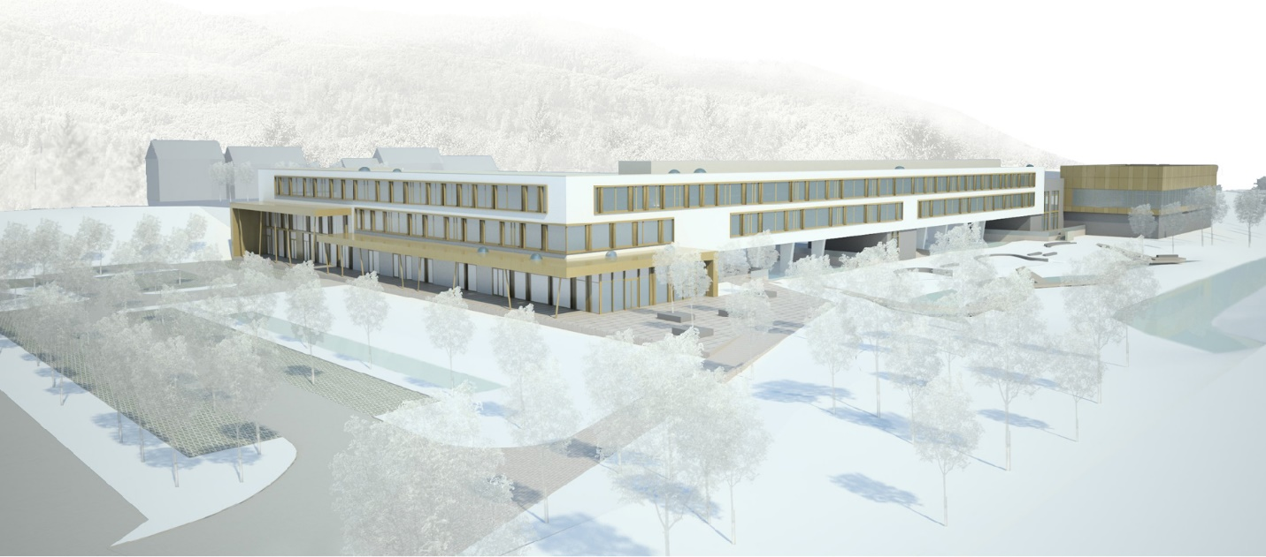

Contents
Edward Steichen International School: General Interest File 1
Introduction and background 6
The European Schools in Luxembourg 6
International schooling offer in the Grand Duchy of Luxembourg 7
International Baccalaureate (IB) – French/English 8
European Baccalaureate 8
French qualifications 9
German and Luxembourg qualifications 9
Elementary (nursery and primary) education in the private sector 10
Target pupil population 11
Pupil population in Luxembourg elementary education 11
First language spoken 12
Pupil population in the Lycée Edward Steichen catchment area 13
Pupil population in the secondary and future needs for an English language schooling offer 15
Schooling offered at the Lycée Edward Steichen 16
European schooling to be offered at Clervaux 17
Input of specific and innovative pedagogy 18
21st century competences 18
Digital Learning – MIICT 19
Future Hub: innovative learning of the sciences 20
Educational Support and Family Learning 20
Daylong operation 20
Educational and Careers Guidance 20
Exchanges with the business world and work experience and placements (internships) 21
Communication 21
Culture 21
Infrastructure 23
Operation and governance 23
Contacts 24
MENJE (Ministry of Education, Childhood and Youth) 24
Lycée Edward Steichen 25

Introduction and background
In 2013, the European School system celebrated the sixtieth anniversary of its setting up. After the entry into force on 23 July 1952 of the Treaty establishing the European Coal and Steel Community (ECSC), the High Authority’s officials and representatives quickly came to realise that a high-quality education needed to be offered to the children of staff of the European institutions.
The idea of offering children an education in their respective mother tongues took off. In September 1953, an association representing the educational and family interests of ECSC officials was set up. In October 1953, the first primary classes admitted 72 pupils in the district of Limpertsberg in Luxembourg-City. The European School system had been born.
Nowadays we know that the story of the European Schools is a success story. The system therefore has 13 schools located in six different countries, attended by some 27 000 pupils from nursery level up to secondary level.
Right from the outset the system was open not only to the children of officials of the Commission and the other European institutions, commonly called category 1 pupils, but also to categories 2 and 3 pupils, for whom school fees are payable. The system gradually opened up to allow the creation of types II and III schools.
In view of labour mobility in Europe and to give children of parents who are not EU officials the opportunity to join this tried-and-tested school system, the European Schools opened up their curricula and the European Baccalaureate to national schools in 2005, as recommended by the European Parliament. Accredited European Schools are schools offering a European education corresponding to the pedagogical requirements set for the European Schools but as part of the Member States’ national school networks, and thus outside the legal, administrative and financial framework within which the European Schools have to work.
At the present time, there are 13 Accredited European Schools, including one in the Grand Duchy of Luxembourg: Differdange International School (EIDE). Other schools are in the process of accreditation.
The Government of the Grand Duchy of Luxembourg intends to set up other Accredited European Schools in 2018, with the aim of widening and diversifying the range of state schooling offered in the country.

The European Schools in Luxembourg
In Luxembourg, with EU enlargement and hence the growing number of officials and other staff working for the institutions, the number of pupils on roll steadily increased. That meant that the first school, located on Boulevard de la Foire and officially opened by HRH Grand Duchess Charlotte on 11 December 1957, quickly became too small. First of all, the nursery school moved to Kirchberg. In 1994, the Chamber of Deputies voted through the law allowing the School as we know it today to be built. In 1997, the Board of Governors requested the Luxembourg Government to build a second school. The Luxembourg II School opened on temporary premises alongside the first school in 2004, and those were used to accommodate the nursery and primary school cycles. For organisational reasons the secondary classes were located in the first school.
For the beginning of the 2012-2013 school year, the European School, Luxembourg II was able to move to its new premises at Bertrange-Mamer. On 1 October 2012, the European School, Luxembourg II was officially opened.

With the aim of extending the range of Francophone and Anglophone classes offered in Luxembourg, on 16 May 2014, the Minister of Education, Childhood and Youth, Mr Claude Meisch, and the Secretary-General of the Board of Governors of the European Schools, Mr Kari Kivinen, signed a collaboration agreement to increase the capacity of the Francophone and Anglophone sections in Luxembourg. The two Luxembourg European Schools were thus able to admit around a hundred additional pupils to the Francophone and Anglophone sections at the beginning of the 2014-2015 school year. Those new places are open to children whose parents do not work for a European institution.
The Luxembourg State contributes financially to the setting up and operation of the additional classes, over and above the existing regulatory framework, thus allowing more so-called category III pupils to attend the Luxembourg European Schools, where they are enrolled in the new classes. The extension of the Francophone and Anglophone sections marked a first step in the Luxembourg government’s efforts to diversify the range of possibilities for education in different languages in Luxembourg, so as to cater for the growing heterogeneity of the pupil population.
In 2014 and 2015, all the legislative, administrative and financial steps having been taken to set up and operate an International School at Differdange, the law setting up that school was voted through by the Chamber of Deputies on 20 January 2016. The procedure to secure accreditation by the Board of Governors of the European Schools was completed in April 2017 with acceptance of the dossier of conformity, first by the Joint Teaching Committee at its February 2016 meeting, then by the Budgetary Committee at its March 2016 meeting and finally by the Board of Governors at its April 2016 meeting, in accordance with the provisions laid down in the Regulations on Accredited European Schools. The very first new school year started at EIDE on 12 September 2016. This great occasion was marked by an official opening ceremony attended by the Minister, Claude Meisch, and the Secretary-General, Kari Kivinen, and many VIPs. The range of schooling offered was thus widened and diversified in Luxembourg.
In addition, under the agreement signed with the two Luxembourg European Schools, a total of 9 subsidised classes currently operate, 4 at Luxembourg I and 5 Luxembourg II, in the French and English language sections.
On 15 October 2016, the total population of the European Schools as a whole was 26 691 pupils, representing an average growth rate of 3% compared with 2015, with markedly different situations according to the schools.
Moreover, 67.7 % of the total pupil population is on roll in the Brussels (46%) and Luxembourg (21.7%) Schools.
At the beginning of the 2016-2017 school year, the number of pupils on roll at the European School, Luxembourg I totalled 3 260, breaking down into 444 pupils in the nursery, 1 320 pupils in the primary and 1 496 in the secondary. The number of pupils on roll at the European School, Luxembourg II totalled 2 531, breaking down into 299 pupils in the nursery, 1 023 pupils in the secondary and 1 209 pupils in the secondary. The pupil population of the two European Schools is constantly growing. A 7.8% increase in the number of pupils on roll at Luxembourg II between 2015 and 2016 is to be noted. (Source: Facts and figures on the beginning of the 2016-2017 school year in the European Schools, doc. 2016-10-D-2).

International schooling offer in the Grand Duchy of Luxembourg
For a century now, immigration has played a decisive role in Luxembourg’s economic development. With its varied and well established international community, Luxembourg’s population comprises almost 47% (46.7% on 1 January 2016) non-Luxembourgers, of some 170 different nationalities.
The country’s official languages are Lëtzebuergesch (Luxembourgish), French and German, on account of the intensive exchanges with its neighbouring countries and of the country’s geographical location at the crossroads of the two main German-speaking and French-speaking areas. Luxembourgers’ language of communication is Lëtzebuergesch. The main language of communication between Luxembourgers and fellow citizens whose mother tongue is a foreign language is French.
The vast majority of children and teenagers are educated in state schools. There are a number of private schools offering either the same type of education as state schools or other linguistic or pedagogical variants.
As the historic seat of European institutions and of many international banks and companies, the Grand Duchy is in the process of putting in place a diversified schooling offer, in order to meet the needs and wishes of parents from different backgrounds. The fact is that primary and secondary education caters for very different pupil populations in terms of social origin, mother tongue, cultures and personal competences. Management of this diversity is one of the biggest challenges facing the Luxembourg school system. Alongside the normal Luxembourg system, the international offer, mainly in English, French and German, is particularly well suited to expatriates wishing to guarantee that their child is awarded a high-quality educational qualification which is valid beyond state borders.
The international schooling offer currently available in the GD of Luxembourg is as follows:

International Baccalaureate (IB) – French/English

State schools
- Lycée technique du Centre (IB in French)
- Athénée de Luxembourg (IB in English)
- Lycée Michel Lucius (IB in English)

Private schools
- International School of Luxembourg (IB in English)
- École Waldorf (IB in French)
- St George’s International School

European Baccalaureate

Differdange International School (EIDE)
This school opened in September 2016 and offers French, German and English language sections providing an education from the elementary level (nursery and primary school) up to the European Baccalaureate. EIDE is the first international state school in Luxembourg and is open to all pupils, without school fees.
The enrolments for the first two years of operation testify to the great interest shown in the new school by parents and pupils. They confirm the need for a diversified range of schooling options meeting the needs of an increasingly heterogeneous population. The EIDE will ultimately have an intake of around 1 400 pupils in total.

Luxembourg European Schools (ES)
There are two European Schools in Luxembourg, one on the Kirchberg Plateau (ES, Lux I) and the other at Bertrange/Mamer (ES, Lux II). The European Union languages are divided between the two, only the English, French and German sections being present in both schools.
European School, Luxembourg I – Kirchberg: Bulgarian, Dutch, Estonian, Finnish, Latvian, Lithuanian, Polish, Portuguese, Spanish and Swedish.
European School, Luxembourg II – Bertrange/Mamer: Croatian, Czech, Danish, Greek, Hungarian, Italian, Maltese, Romanian, Slovak and Slovene.

French qualifications

École privée Notre Dame Sainte Sophie (EPND)
The EPND offers years 6°, 5° and 4° [equivalent to secondary years 1, 2 and 3 in the ES system] of the French collège [lower secondary school].

Lycée Vauban
The Lycée Vauban follows the curricula of the French Ministry of Education. It comprises both a collège (6e- 3e – equivalent to secondary years 1-4 in the ES system), leading to the Brevet des collèges [certificate of general education) and a Lycée proper (2nde – Terminale – equivalent to secondary years 5-7 in the ES system), which leads up to the French Baccalaureate.

German and Luxembourg qualifications

The Lycée germano-luxembourgeois de Schengen at Perl caters for pupils coming from Germany and Luxembourg. It combines elements of the two school systems. The vehicular language used to teach most subjects is German. A few subjects are taught in French.

Elementary (nursery and primary) education in the private sector

Besides Differdange International School, which is a state school, and the European Schools, several private schools offer international schooling at the primary level:
- École française (French School)
- École Charlemagne (French)
- Les Poussins and Mini Collège nursery schools (French)
- École privée ND Sainte Sophie (French)
- International School of Luxembourg (English)
- École Maria Montessori (bilingual French and German)
- Scuola Materna Italiana (Italian)
- St George’s International School (English)
- Over The Rainbow (English)

The fact is, however, that all the international and European schooling offered is concentrated in Luxembourg-City or on the outskirts of the city (Centre and South of the country). No schooling for foreign children is offered beyond the capital, such as, for example, in the North district, despite the linguistic situation of the pupil population in that area. Thus multinational institutions and companies are currently hesitating to locate to that area of the country. An offer of high quality schooling is an important factor in the decision of a company, a foreign investor or scientific experts as to whether or not to set up in a region.
The following companies and institutions are to set up or extend their services in the Grand Duchy of Luxembourg by the end of the year: Amazon (500), SES (Société Européenne des Satellites – 150), Lombard International Trust (80), Nordea Bank and Nordea Investment Funds (20), Ferrero, ESM (European Stability Mechanism), Northern Trust, Husky, Paypal, LIST, FNR, The Carlyle Group, etc. The urgent need to increase the capacity of the International Schools is considered to be a serious problem in attracting and retaining a highly skilled labour force.
The table below shows the international schools and the early childhood education, pre-school education and primary education offered by them and the numbers and percentages of Luxembourg and foreign children on roll.
Breakdown of Luxembourg and foreign pupils by teaching level:

Target pupil population

Pupil population in Luxembourg elementary education

The above table shows the teaching level, the nationalities (Luxembourg, Portuguese, French, ex-Yugoslavian, Belgian, Italian, German and other), Cycle 1 – Early Childhood Education, Cycle 1 – Pre-School Education, Cycles 2-4 and the total numbers and percentages of foreign and Luxembourg pupils.

The proportion of nationalities (Luxembourg and others) and the first language spoken by the pupil at home are two particularities of Luxembourg education.
In Cycle 1 – Early Childhood Education, the proportions of Luxembourg and foreign pupils are 57.1% and 42.9% respectively. In Cycle 1 – Pre-School Education, the breakdown is 54.3 % - 45.7%. In Cycles 2-4, Luxembourg pupils account for 53.9% and pupils of foreign nationalities make up 46.1% of the pupil population.
Development of the ratio between Luxembourg pupils and foreign pupils:

First language spoken

The percentage of Luxembourg pupils whose first language spoken at home is not Lëtzebuergesch totals 33.4%. On the other hand, only 0.9% of pupils of foreign nationality use Lëtzebuergesch as the first language spoken at home.

Percentage breakdown of first foreign language spoken

It is clearly apparent that 54.9% of pupils in the North educational district who are enrolled in nursery and primary schools do not speak Lëtzebuergesch at home. In total 4 324 in the North educational district come from a country where German or French (L1, L2 or L3) and English (L2 or L3) are taught in secondary education.

Pupil population in the Lycée Edward Steichen catchment area

Breakdown by municipality (commune) or joint municipal authority (syndicat) and by teaching level in the catchment area:

Total | 209 | 11 | 476 | 26 | 1400 | 71 | 2085 | 108 | 6

Other target municipalities:

Total | 110 | 7 | 327 | 20 | 893 | 63 | 1330 | 90 | 7

Percentage of pupils of foreign nationality by municipality:

Elementary schools | Total number of pupils | Number of foreign pupils | % foreign pupils
Troisvierges | 355 | 168 | 47.32 %
Weiswampach | 123 | 54 | 43.90 %
Clervaux | 469 | 184 | 39.23 %
SCHOULKAUZ | 232 | 64 | 27.59 %
SISPOLO | 517 | 123 | 23.79 %
Wincrange | 389 | 85 | 21.85 %

Wiltz | 629 | 388 | 61.69 %
Vianden | 168 | 96 | 57.14 %
Bourscheid | 153 | 52 | 33.99 %
Tandel | 233 | 78 | 33.48 %
Goesdorf | 147 | 27 | 18.37 %

Pupil population in the secondary and future needs for an English language schooling offer
A considerable proportion of secondary school pupils come from monolingual families. At the same time the languages spoken at home show great linguistic diversity.
Practically a fifth (19%) of secondary school pupils come from bilingual families.
The fact is that Luxembourg monolingualism is declining (2005/06: 65.8% - 2013/14: 54.4%) and that there is great heterogeneity in pupils’ first language. A large proportion of pupils use a language other than Luxembourg’s official languages.
As regards the need to offer English language education (nursery, primary and secondary) in Luxembourg, the Ministry of Education, Childhood and Youth published the results of two surveys, conducted in 2013 and 2015 respectively, with the collaboration of several Chambers of Commerce (Luxembourg Chamber of Commerce, British Chamber of Commerce, Indian Business Chamber of Commerce, Ireland-Luxembourg Chamber of Commerce and American Chamber of Commerce).
In total, the human resources departments of some 300 national and international companies established in Luxembourg and 5 800 employees were invited to complete an online questionnaire.
The responses of the companies and of the employees are consistent and in agreement: they highlight the urgent need to widen the range of English language classes offered in both nursery/primary and secondary education.
The main findings can be summarised as follows:
- Each year, approximately 1 500 employees with 2 520 children are relocated to Luxembourg by companies, two thirds of them initially for short-term periods of employment.
- 27% of the employees who participated in the survey chose the Luxembourg state education system for their children.
- 26% of parents expressed the need for English language schooling to be offered in nursery and primary education; 18% pointed to the need for English language schooling to be offered at the secondary level.
- 76% agree that the financial aspect has an impact on their schooling decision.
- 60% think that schooling is a factor which can prevent a family from settling in Luxembourg. 87% believe that language is the biggest difficulty in the Luxembourg system.
- 51% consider that the language of tuition is one of the key factors in the choice of a school.
- 33% are seeking a multilingual schooling offer.

With the aim of widening, diversifying and making more flexible the range of state schooling offered by means of multicultural, multilingual and European education, it is therefore planned to set up an Accredited European School at Clervaux. The municipality of Clervaux, located in the north of the Grand Duchy of Luxembourg in the canton of the same name, is the second largest municipality in the country in teams of its area. Located 25 minutes from Nordstad, the north of Luxembourg’s central economic hub, the municipality of Clervaux is crossed by several major roads, including the Luxembourg-City – Ettelbruck/Diekirch – Belgium main road. The School is situated near the Luxembourg-City to Liège railway line.
The setting up of a European School in the north of the country is also intended to provide a response to the growing heterogeneity of the pupil population. It is the State’s responsibility to offer a state education system in which each pupil has a chance to succeed, irrespective of the language spoken at home. The increase in the number of education and training pathways (in terms of languages in particular) and of certifications are just some of the responses to the challenges thrown up the changing characteristics of school-age children.
Over and above efforts to integrate foreign pupils who reside in the country, the new European School offer matches the needs of children and teenagers residing temporarily in the Grand Duchy and set to continue their education in another country.
The European School will also target the inhabitants of the region who do not necessarily have previous multilingual experience but who wish to offer their children a varied linguistic and cultural education.

Schooling offered at the Lycée Edward Steichen
The schooling offered at Lycée Edward Steichen comprises the lower and upper levels of traditional (classical) secondary education, plus three cycles (lower, middle and higher) and the preparatory regime for general secondary education.
As regards educational guidance, the Lycée has a holistic and overall approach to the promotion of information and communication technologies in education.
The schooling offered is supplemented by various vocational training regimes which are all related to the field of construction and the conception, the execution, the operation and the redevelopment of construction works and of infrastructure.
In addition, the Lycée offers the IT division with the technician’s training regime, the IT specialists’ section with the vocational regime, the civil engineering division with the technician’s training regime, the building draughtsmen’s section, the masonry section, the photographers’ section, the chefs’ section and the sales advisers’ section with the vocational regime.
In the general secondary education branch, the complete cycle of the general technical division and the complete cycle of the natural sciences section will also be offered at Lycée Edward Steichen.
At the upper secondary level, the Lycée Edward Steichen offers the ‘Natural Sciences – Mathematics’ specialisation cycle, which will be supplemented by bio-informatics lessons, and the ‘IT and Communication’ section.
As a result of the fact that the Lycée Edward Steichen is the only Lycée where information and communication technologies are incorporated into its pedagogical project, and at all its teaching levels, and that the Lycée Edward Steichen offers, inter alia, teaching specialisations and vocational training courses, particularly in the information and communication technologies (ICT) area, it attracts pupils coming from all parts of the country and even from the Greater Region.
In view of the position of the municipality of Clervaux, which is at the northern tip of the north-south central axis, and of the geographical location of the canton of Clervaux, which borders on Belgium to the north and the west, on the German State of Rhineland-Palatinate to the east and on the cantons of Wiltz, Diekirch and Vianden to the east, the Lycée Edward Steichen contributes educationally, culturally and socially to the development of a rural area which is growing fast and to the Greater Region.

European schooling to be offered at Clervaux
The School will be incorporated into the Lycée Edward Steichen and will be called ‘Edward Steichen International School – Clervaux’. It will be a state school without school fees, on the same basis as other state schools.
The school in question will operate in accordance with the principles of an Accredited European School. Associated with the European School system through an accreditation agreement, it will offer an education based on the European Schools’ curricula. The education provided will lead to the European Baccalaureate (European secondary education) or will give access to international vocational training, which will also be put in place in several Luxembourg technical Lycées.
The education provided in the new school will adhere to the European Schools’ fundamental principles:
- to give pupils confidence in their own cultural identity – the bedrock for their development as European citizens;
- to provide a broad education of high quality, from nursery level to university-entrance;
- to develop high standards in the mother tongue and in foreign languages;
- to develop mathematical and scientific skills throughout the whole period of schooling;
- to encourage a European and global perspective overall and particularly in the study of the human sciences;
- to encourage creativity in music and the plastic arts and an appreciation of all that is best in a common European artistic heritage;
- to develop physical skills and instil in pupils an appreciation of the need for healthy living through participation in sporting and recreational activities;
- to offer pupils professional guidance on their choice of subjects and on career/university decisions in the later years of the secondary school;
- to foster tolerance, co-operation, communication and concern for others throughout the school community and beyond;
- to cultivate pupils’ personal, social and academic development and to prepare them for the next stage of education.
- to provide Education for Sustainable Development with a cross curriculum approach in line with European and international documents.
The Luxembourg Ministry of Education, Childhood and Youth will take responsibility for their administration, funding and staff in their entirety.

The schooling offered will consist of:
- The two-year European early education (nursery school) cycle.
- The five-year European primary education cycle.
- The seven-year European secondary education cycle.
Initially, the School will offer two language sections, namely a French section and a German section. In addition to the language of the section, pupils will choose a first foreign language from amongst English, French and German. The learning of Lëtzebuergesch as an integration language will be offered to pupils in the primary school and in the lower secondary school classes.
The plan is for the first classes to start operating by the beginning of the 2018-2019 school year.
In concrete terms, the plan is for the School to start up in September 2018 with:
- One French class and one German class in secondary year 1 (S1).
 |  | AES
7 | 2018
7 | 2018 | S1 DE/EN |  |  |  |  |  |  |  |  |  | S1 FR/EN
7 | 2018 |  |  |  |  |  |  |  |  | 20 |  |  |  |  |  |  |  |  |  | 20
6 | 2019
6 | 2019 | S2 DE/EN |  |  |  |  |  |  |  |  |  | S2 FR/EN
6 | 2019 |  |  |  |  |  |  |  |  | 20 |  |  |  |  |  |  |  |  |  | 20
5 | 2020
5 | 2020 | S3 DE/EN |  |  |  |  |  |  |  |  |  | S3 FR/EN
5 | 2020 |  |  |  |  |  |  |  |  | 20 |  |  |  |  |  |  |  |  |  | 20
4 | 2021
4 | 2021 | S4 DE/EN |  |  |  |  |  |  |  |  |  | S4 FR/EN
4 | 2021 |  |  |  |  |  |  |  |  | 20 |  |  |  |  |  |  |  |  |  | 20
3 | 2022
3 | 2022 | S5 DE/EN |  |  |  |  |  |  |  |  |  | S5 FR/EN
3 | 2022 |  |  |  |  |  |  |  |  | 20 |  |  |  |  |  |  |  |  |  | 20
2 | 2023
2 | 2023 | S6 DE/EN |  |  |  |  |  |  |  |  |  | S6 FR/EN
2 | 2023 |  |  |  |  |  |  |  |  | 20 |  |  |  |  |  |  |  |  |  | 20
1 | 2024
1 | 2024 | S7 DE/EN |  |  |  |  |  |  |  |  |  | S7 FR/EN
1 | 2024 |  |  |  |  |  |  |  |  | 20 |  |  |  |  |  |  |  |  |  | 20

The first nursery and primary classes will be offered as from the beginning of the 2019-2020 school year, in the school centres of the priority enrolment area of the Lycée Edward Steichen at Clervaux.
The range of language sections (English section) offered will be extended and adapted according to the needs established.
In the long term, the European School will have an intake of some 280 pupils in the secondary and some 280 pupils in the nursery/primary.

Input of specific and innovative pedagogy
As the European School will be integrated into the Lycée Edward Steichen, the two schools will cooperate in the interests of their mutual benefit.

21st century competences
The School will offer an education based on the European Schools’ curricula. Strong emphasis is also placed on the promotion of pupils’ personal development in a broadened socio-cultural context. In the light of the European Framework of Competences for Lifelong Learning, the school is seeking to develop in pupils all these key competences required for the 21st century.
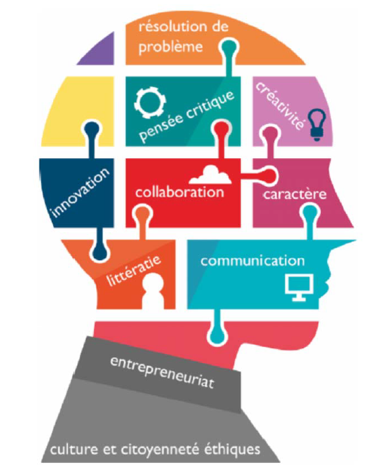
These competences are always associated with the same aim of best framing pupils’ development: their creativity will be promoted, so that their character and their entrepreneurship can be fully developed. They will be encouraged to look for innovation, within an education based on concrete problem-solving. Pupils will also be invited to develop by improving their communication and collaboration skills. Literacy, “the ability to understand and employ printed information in daily activities at home, at work and in the community to achieve one’s goals, and to develop one’s knowledge and potential” (OECD definition), will be at the heart of our efforts at all times. These educational requirements should lead pupils to develop an ethical culture and citizenship, but also the ability to engage in critical thinking, in an accepting and well informed way, additional requirements and assets in order to become fully integrated into our new century’s society.
Those ten competences [see diagram above] have a concrete impact on the education which we will offer to our pupils on a day-to-day basis:
- Teaching will involve dealing with authentic matters and issues in class, research and connectedness.
- Learning will be tailored to each pupil’s particular needs and will focus on the carrying out of projects within the framework of explicit teaching and learning by inquiry.
- Technology in all its forms will be highlighted, so that pupils will know how to use it properly and effectively.
- Assessment will highlight pupils’ strengths and weaknesses, so that they know how to direct their efforts effectively.
- Vocational – but also informal and experimental – training and learning will take the form of a variety of activities in many different areas. Visits, workshops, extra-curricular clubs, work experience (placements, internships), volunteering, community service, etc. Everyone will find here an activity corresponding to his or her main interests or will discover new passions, the engines of motivation in day-to-day life.
- The physical space which will be used for learning is undoubtedly one of the Lycée’s strong points. A new building provides the opportunity to make organisational arrangements in a flexible pedagogical environment. Learning studios, a makerspace, collaboration areas and project planning rooms will be created and fitted out.

Digital Learning – MIICT
The Lycée Edward Steichen has widened the concept of ICT (Information and Communication Technologies) to include that of MIICT (Media, Images and Information and Communication Technologies), firstly, to take account of the convergences between the computing area and that of the media (press, radio, television, multimedia publishing, the web) to which digital technology has led, as well as the increasingly commonplace use of the internet as an everyday working environment, and secondly, in the field of education, to bring together the areas of computing and of critical analysis of information (media education), whose development long proceeded independently.
With the use of MIICT, the priority aims of the Lycée Edward Steichen can be guaranteed, in particular:
- Developing self-awareness and self-knowledge, from the physical, intellectual, emotional and social angles, in order to act and to make personal choices.
- Becoming aware of the various communities and developing an attitude of openness to others and of one’s civic responsibility.
- Becoming aware of complexity and interdependences and developing a responsible and active attitude with a view to sustainable development.

Future Hub: innovative learning of the sciences

Future Hub is a label for Lycées which open up to technologies and to innovative learning of the sciences, and of computer science in particular.
Future Hub schools are characterised by the incorporation of a wide range of technological training and specialisation pathways into their schooling offer. The emphasis is on programming, management of very large databases, financial technology applications, etc.
The Future Hub label also seeks to innovate through its interpretation of school: a place for meeting and exchange but for production and discovery. Pupils have access to technological tools, robotic ‘toys’ and powerful IT networks and are guided through this network by qualified staff.
Digital competence centres are expected to create links with the economic players in their sector and their region. The different centres adopt a collaborative approach with business start-ups, innovative companies and research centres.

Educational Support and Family Learning
The School will offer a system of support for special needs pupils. The policy on educational support in force in the European Schools will be applied and put into practice by a multiprofessional team (psychologists, qualified instructors, resource teachers).
- As far as teaching and learning are concerned, differentiated teaching will be promoted.
- The support measures take the form of general, moderate or intensive support.
Over and above individual educational support, we consider that particular attention should be paid to ‘Family Learning’. Family Learning considers parents to be partners in education; they are recognised and valued as their child’s first educators and supported in taking on this role. As a result, the partnership between the different educational structures, on the one hand, the parents and family, on the other, the education and care structures, primary schools, secondary schools, adult education and civil society, represents an essential basis for children’s school success and enables a learning culture to be developed in families.
At the Lycée Edward Steichen, Family Learning will be incorporated into the adult education and training offered, so as to enable parents to develop their basic skills, their educational skills and their linguistic skills.

Daylong operation
In order to provide pupils with the best possible help in their personal development, the Edward Steichen European School is open from 7.30 to 18.00 and, in addition to compulsory lessons, offers provision outside school hours for homework, support and remediation. It also offers opportunities for pupils to develop in the cultural, social and sporting areas. Young talent will be promoted in extra-curricular activities, in collaboration with regional associations and/or institutions.
The School will prioritise openness to the outside world, inter alia through induction and introduction to the world of work provision (see work experience and placements (internships) below).

Educational and Careers Guidance
The aim of guidance is to support each pupil in the decisions which are going to determine his or her future. The Edward Steichen School has set itself the objective of organising a procedure which takes into consideration each pupil’s needs, wishes and capabilities. At the Edward Steichen School, guidance is customised, adapted to suit each pupil’s specific needs so that he or she is able to decide on his or her educational future, making a fully informed choice. Each pupil receives personalised support from a tutor, a member of the teaching team. It is the tutor’s responsibility to gradually map out with the pupil a robust and coherent plan for his or her educational future.
It should be noted that ‘bridges’ between the national system and the European system will be studied, in particular the possibility of providing another school-leaving qualification for pupils who are not aiming to reach the level required for admission to university.

Exchanges with the business world and work experience and placements (internships)
Thanks to the active mobilisation of the school community and of the companies and professional organisations in the region, they materialise in particular through:
- actions by business representatives at the Lycée in the form of thematic meetings;
- monitoring of and follow-up on corporate training programmes by educational staff;
- the Lycée’s investment within the framework of the school-parents-business network;
- regular exchanges with representatives of businesses and organisations in the economic region.
The Lycée attaches particular importance to relations with the economic fabric of Clervaux and the surrounding area. The gradual development of personal contacts with business leaders goes hand in hand with definition of the mutual needs to ensure better reception of pupils doing work experience and on work placements and hence, a better personal conception of the educational and occupational route.
With a real desire for openness to business and public authorities, the Lycée will thus offer practical and other work placements.
The purpose of work placements is to draw up a realistic occupational plan thanks to meetings with senior people who present their jobs. Work placements enable each pupil’s plan to be validated and the first steps toward an occupation to be taken, the objective being to support each learner’s occupational choice through the possibility of actually experiencing on the spot the practicalities of one or more occupations, to strengthen pedagogical action by focusing on the functional aspects of school learning and to facilitate integration of young people into training or into the labour market.

Communication
The variety of cultural and linguistic backgrounds of the pupils coming from the Clervaux area constitutes a rich resource which is conducive to openness to the world. It nevertheless remains a challenge to be overcome to instil in all these pupils a feeling of belonging and of pride in relation to the culture of the Lycée Edward Steichen.
Communication is one of the keys to learning at the Lycée Edward Steichen. It serves as a lever to activate pupils’ reflection and to engage them in a structured dialogue which helps them to make meaning, to deepen their understanding and to acquire new perspectives. At the Lycée Edward Steichen, the teachers seek to foster and sustain pleasure in speaking and learning in French, German, English and Lëtzebuergesch.

Culture
The Lycée Edward Steichen assumes responsibility for providing all pupils with instruction in and transmission of cultural values. It ensures that knowledge is built up and competences are acquired which enable each of them to develop his or her potential in optimum fashion.
Jointly with the development of intellectual faculties and the enrichment of minds, the Lycée Edward Steichen has adopted an even more wide-ranging strategy of development of the use of civic culture as a means of encounter and of social dialogue, in order to achieve cohesion and the rich values of society. Culture for everyone. The Lycée Edward Steichen attributes to civic culture the characteristic of being like pupils’ ability to inhabit and transform the world. Civic culture is identified as a means of incorporating understanding of democracy.
In view of the importance of education in art and in culture, of its transversality and of its multidisciplinary nature, civic culture and the arts are embedded in the standard schooling offered by the Lycée Edward Steichen, with various options and numerous cultural projects, in close partnership with established artists.

The Edward Steichen European School will be committed to establishing at the very core of its pedagogical project the methods of the Lycée Edward Steichen which are in line with the requirements of the education provided in the European Schools.
Through concrete implementation of the different social and pedagogical measures which have just been outlined, the Edward Steichen European School will guarantee real equality of opportunity for all its pupils, in terms of preparation for the European Baccalaureate, thus meeting the requirements to which it is incumbent upon the European Schools to adhere, in accordance with the directives of the Board of Governors of the European Schools.

Infrastructure
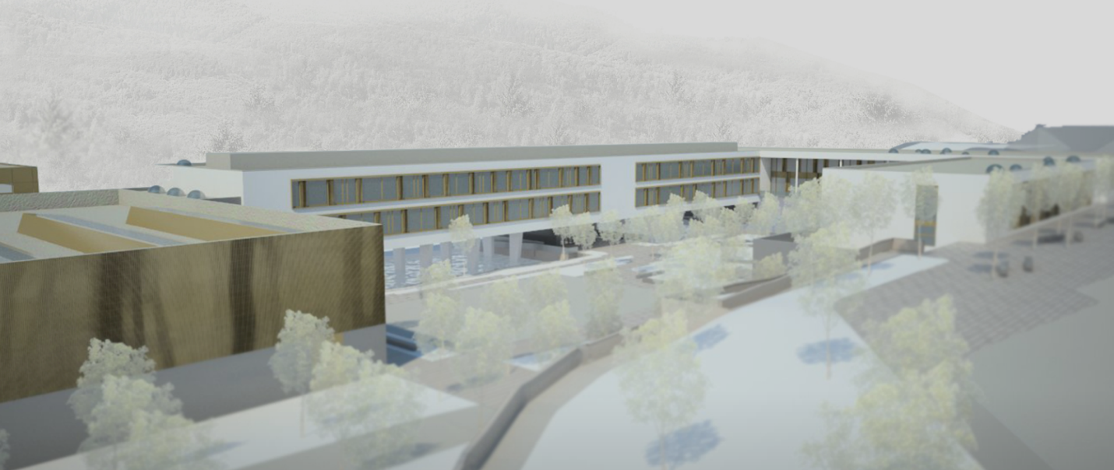

Edward Steichen Lycée/School will ultimately have an intake of some 2000 pupils.
The following structures are located on the School’s site.
Teaching structure
Classrooms - dedicated rooms (preparation, physical education, art education, science, geography, history, computing, music, social science, technical drawing, CAD design, BTSi (Higher Technical Certificate in Computing)) - laboratories (science, electrotechnical, telecommunications-network) - workshops (computing, cookery, electronics, electrotechnical, building trade, photography, general purpose) - makerspace.
Administrative structure
Management - secretariat - office - technical service - rooms available to the teaching staff
Reception facilities
Lounge - before and after school activities rooms - multipurpose rooms - school canteen - cafeteria - library - internet café - games room - psycho-social and educational support service - school medical service
Sports facilities
Sports halls - gym - swimming pool - outdoor sport
External facilities
The setting up of private or publicly managed boarding facilities on the School’s site is being analysed.

Operation and governance
The European School at Clervaux will be able to use the timetables, the provisions governing assessment, promotion and certification of pupils, the quality control methods and the networking of the European Schools. Arrangements are being made allowing pupils’ admission to the school to be regulated. The School will enjoy, within the limits of the accreditation rules, autonomy to introduce into the curricula specific to the school the Luxembourg language and aspects of history, geography, culture and literature. The Luxembourg context requires an adjustment in relation to the European Schools’ curriculum in order in particular to abide by the obligation to introduce the new ‘Life and Society’ course, which has replaced religion and ethics courses and moral and social instruction in all the years of secondary education.
The Head of the Lycée Edward Steichen will be assisted by Deputy Heads for management of the European School. The management is responsible for the introduction of and compliance with the curricula, for implementation of the educational policies and for the School’s school development plan.
The staff of the Schools comprises State civil servants and employees, part-time and replacement teachers, trainees and administrative and technical employees. Teaching will be done by native speakers or near native speakers in the language of tuition. They must be qualified to teach their subjects. The School will recruit and employ international teachers coming from abroad, as well as locally recruited teachers. Ultimately, the staffing needs – both teaching and administrative staff – of the Edward Steichen European School will amount to around 60-70 full-time equivalents.
During the setting up phase, the management of the Lycée Edward Steichen will be supervised and supported by the Luxembourg inspectorate of the European Schools. A steering group (management – inspectorate – teachers) will be set up to develop the school project. Suitable in-service training courses will be offered to teachers who are not familiar with the European School system. Close cooperation with National Schools, with the two European Schools in Luxembourg and with Accredited Schools is envisaged. Teachers’ attendance at the in-service training courses run by the European Schools has been budgeted for.
In the context of an Accredited European School, the National Inspectors of the European Schools will check the quality of teaching and of learning, in accordance with the rules and regulations of the European Schools, and within the framework of the accreditation procedure laid down by the Board of Governors. In tandem with the role of the Boards of Inspectors, the new School will also be responsible for quality assurance and for determination of the academic objectives and pedagogical aims in the way determined by the Board of Governors.

Contacts

MENJE (Ministry of Education, Childhood and Youth)

Max Wolff  Inspector of the secondary education of the European Schools  THE GOVERNMENT OF THE GRAND DUCHY OF LUXEMBOURG  Ministry of Education, Childhood and Youth  Secondary Education Department  29, rue Aldringen, L-1118 Luxembourg  Tel.: (+352) 247-75151; (+352) 621 569 284  E-mail : max.wolff@men.lu  www.men.lu | Viviane Rhein  Conseiller – Head of Delegation  THE GOVERNMENT OF THE GRAND DUCHY OF LUXEMBOURG  Ministry of Education, Childhood and Youth  Secondary Education Department  29, rue Aldringen, L-2926 Luxembourg  Tel.: (+352) 247-85131. Fax : (+352) 247-85130  E-mail : viviane.rhein@men.lu  www.men.lu

Lycée Edward Steichen

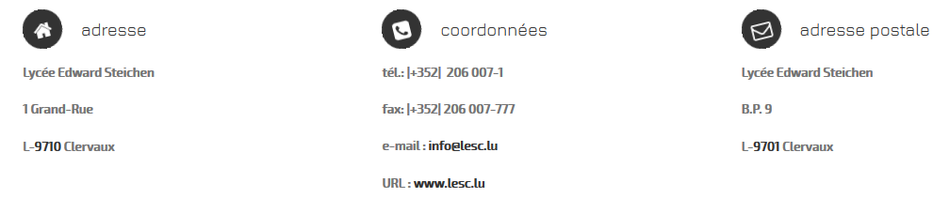

OPINION OF THE JOINT BOARD OF INSPECTORS
The JBI expressed a favourable opinion on the General Interest File submitted by the Luxembourg authorities concerning the request for the setting up of an Accredited European School at Lycée Edward Steichen at Clervaux (GD of Luxembourg).
The JBI considered that this File met the requirements of the first stage of the accreditation process defined at Mondorf in April 2005 and recommended that the BoG should approve it.

Statistics (and following ones) taken from Enseignement fondamental – Statistiques globales et analyse des résultats scolaires – MENJE (Ministry of Education, Childhood and Youth) – Statistics and Analyses Department – 2017 – ISBN 978-99959-1-086-0
Elementary education is organised in four learning cycles. Cycle 1, corresponding to pre-school education, extends over three years and is for 3-5-year-olds. The first year is optional. Cycles 2-4 correspond to primary education (cycle 2 comprises 6-7-year-olds, cycle 3 comprises 8-9-year-olds and cycle 4 comprises 10-11-year olds). Each cycle lasts two years.
The first language spoken is defined as the language most often spoken in the pupil’s family unit.
The national educational area is divided into four districts, namely Centre, North, South and East. These districts are subdivided into secondary catchment areas, which correspond in reality to secondary school priority catchment areas.
Chiffres Clés de l’Éducation Nationale 2013/2014 (Ministry of Education Key Figures 2013/2014); http://www.men.public.lu/fr/actualites/publications/themes-transversaux/statistiques-analyses/bildungsbericht/2015-band-1/index.html
ÉpStan 2013 – 5e/9e; Bildungsbericht Luxemburg 2015 – Band 2: Analysen und Befunde (Education Report Luxembourg 2015 - Volume 2: Analysis and Findings); http://www.men.public.lu/catalogue-publications/themes-transversaux/statistiquesanalyses/bildungsbericht/2015/band-2.pdf
http://www.men.public.lu/catalogue-publications/themes-transversaux/statistiques-analyses/offres-scolaires/english-schooling/en.pdf
Based on creativity – Designed to be a place of discovery, a makerspace is a creative and multidisciplinary space open to young people and to all other people who are interested in using new media creatively to carry out their own digital projects. The makerspace is equipped with machines which can be used by young people and by trainers: manual tools, computers, soldering irons, robots, 3D printer and more complex parts, such as a laser cutter and much more.

