|  |  |
| --- | --- |
| C:\Users\wayra.dafos\Desktop\Logo Schola Europaea - pour documents.jpg | Schola Europaea  Office of the Secretary-General  General Secretariat |

Ref.: 2016-02-D-4-en-2

Orig.: FR

General Interest File of the Brussels-Capital Accredited European School

Board of Governors of the European Schools

Meeting on 12-14 April 2016 – Copenhagen

**Opinion of the Joint Board of Inspectors**

**The JBI expressed a favourable opinion on the General Interest File submitted by the Francophone Belgian authorities concerning the request to set up an Accredited European School, the Brussels-Capital European School.**

**The JBI considered that this file met the requirements of the first stage of the accreditation process defined at Mondorf in April 2005 and recommended that the BoG approve it.**

*FEDERATION* Joëlle Milquet

*WALLONIE-BRUXELLES* VICE-PRESIDENT OF THE

*FEDERATION WALLONIE-BRUXELLES*

MINISTER OF EDUCATION, CULTURAL AFFAIRS AND CHILDHOOD

**Mr K. KIVINEN**

Secretary-General of the European Schools

Email: [kari.kivinen@eursc.eu](mailto:kari.kivinen@eursc.eu)

Brussels, 26 January 2016

*Our ref.: JM/FAB/ER/CL/12.01.2016-16412*

*Secondary Education Unit*

*Case managed by Claude LACHAPELLE (Tel.: 02-801 78 24)*

**Subject;** Support for the application from *ASBL Lycée Molière* in Brussels for

Accreditation as a Type 3 European School

Dear Sir,

Please find enclosed the letter of support sent to the President of *ASBL Lycée Molière* as part of the application for its accreditation as a Type III European School.

Trusting that you will duly receive it.

Yours faithfully,

**The Minister**

(signature)

**Joëlle Milquet**

Place Surlet de Chokier, 15-17 T +32 2 801 78 11 [milquet@gov.cfwb.be](mailto:milquet@gov.cfwb.be)

B-1000 Brussels F +32 2 801 78 43 milquet.cfwb.be

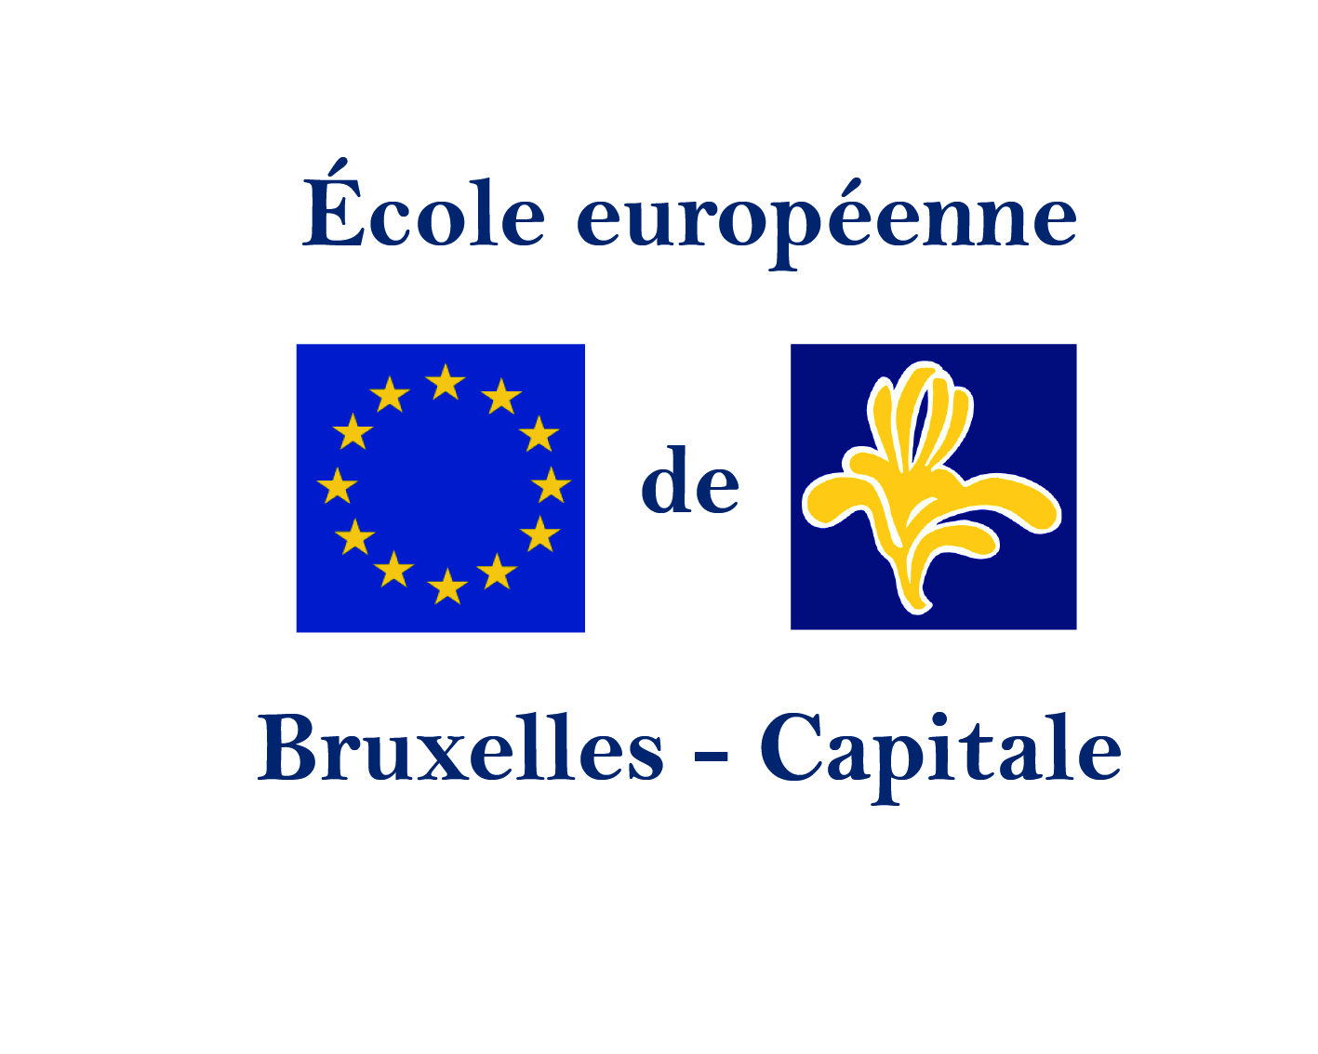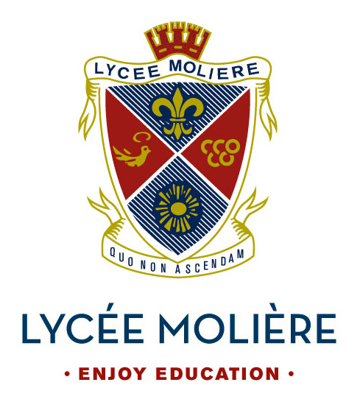 **Brussels-Capital**

Presentation File

&

**European School**

Contents

General Interest File of the Brussels-Capital Accredited European School……………… ……1

Introduction………………………………………………………………………………………………………………..6

Interest of an Accredited European School in Brussels………………………………………..……….7

A demographic need 7

A linguistic and European unification interest 9

Demand for high-quality multilingual education 10

Key to the text of the above two charts: 10

Need to respond to the institutions’ demand and to open up the system 10

The Accredited European Schools 13

*Europese School Den Haag* 13

*Europäische Schule RheinMain* 13

European School Copenhagen 13

The Lycée Molière, an appropriate solution…………………………………………………………..14

An exclusive status 14

A social orientation at the heart of the project 14

Input in the form of a specific innovative pedagogy 15

The Brussels-Capital European School: pattern of development and outlook…..16

Funding ..16

Infrastructure: the Argenteuil campus 17

The school’s development 18

Teaching staff 20

Financial plan 21

Operational break-even point as from the fourth year 23

Conclusion…………………………………………………………………………………………………………………24

# Introduction

Dear Sir,

Dear Madam,

**The Lycée Molière**, a secondary school which has been accredited since 1964, specialises in educating and supporting children and teenagers during their schooling and in their preparation for higher education and working life.

The Lycée, a school unique of its kind since it is officially recognised but not subsidised by the *Fédération Wallonie-Bruxelles* (Wallonia-Brussels Federation), is renowned for its innovations in the school area and for its sustained contribution to the quality of education in Belgium. It opened the first *Ecole des Devoirs* (supervised homework classes) in Brussels and was also one of the first schools to offer mixed classes and residential class trips to the countryside.

Many pupils from all parts of the world have been educated by the Lycée Molière in Brussels and there are even more Belgian pupils to have attended the school and who even nowadays are contributing their know-how and their knowledge in many different areas, such culture, the legal world, art, the theatre, music, the cinema, business and finance, educating, catering and chocolate-making, technology, industry, politics, e-marketing, sport, etc.

Today, with the development of Europe and demographic growth in Brussels, the Lycée Molière proposes, at the request of the Belgian delegation to the European Schools, to incorporate into its organisation a European Baccalaureate section alongside Belgian general secondary studies. It would initially comprise French, English and Swedish language sections.

You will find in this document a study on the advisability and appropriateness of opening an Accredited European School in Brussels, followed by a presentation of the Lycée Molière, its specific characteristics and the outlook for the European project and finally, a ten-year projection of the development of the Brussels-Capital European School.

I would be more than happy to provide you with further information should it be required.

Yours faithfully,



Félix de Merode  
President of the *asbl Lycée Molière*

# Interest of an Accredited European School in Brussels

Brussels owes its role as capital of the European Union to a combination of factors, amongst which are its location at the centre of Europe, its accessibility and the diversity of the languages which are spoken there. A large number of federations, of interest groups and of various companies have set up their offices in Brussels in order to stay abreast of and monitor the latest political developments and to participate actively in policy-making, by intervening as consultation partners. In addition, Brussels is the seat of leading international organisations such as NATO and EUROCONTROL.

Belgium has a population of approximately 11.2 million, almost 11% of whom are foreigners[1]. Brussels attracts workers from all parts of the world, coming from both European Community countries (14.5%), and non-member countries of the EU (11.8%)[2]. The population of Brussels is made up of 30% foreigners, the French being the largest community; Italians, Poles and Spaniards are also very well represented[3]. On account of the high concentration of foreigners, the city of Brussels has particularly substantial needs and responsibilities with respect to international education, and mainly European education.

Furthermore, Belgium has three language communities (Dutch-speaking, French-speaking and German-speaking) whose respective languages are all national languages.

In addition, many companies with a European or international dimension, such as Toyota, IBM and Coca-Cola, have set up business in the 19 *communes* (local authority areas) of which Brussels is composed.

## A demographic need

Although Brussels already has four European Schools, demand on the part of the European institutions is such that the number of officials awaiting a place in the European School system can be estimated today at 11 400[4].

Further to that finding, the Board of Governors of the European Schools made a request to the Belgian State, to the effect that a fifth European School be opened in Brussels, at the enlarged meeting of 16-18 April 2013[5] which was held at the *Palais d’Egmont* in Brussels. The Belgian State responded favourably to that request.

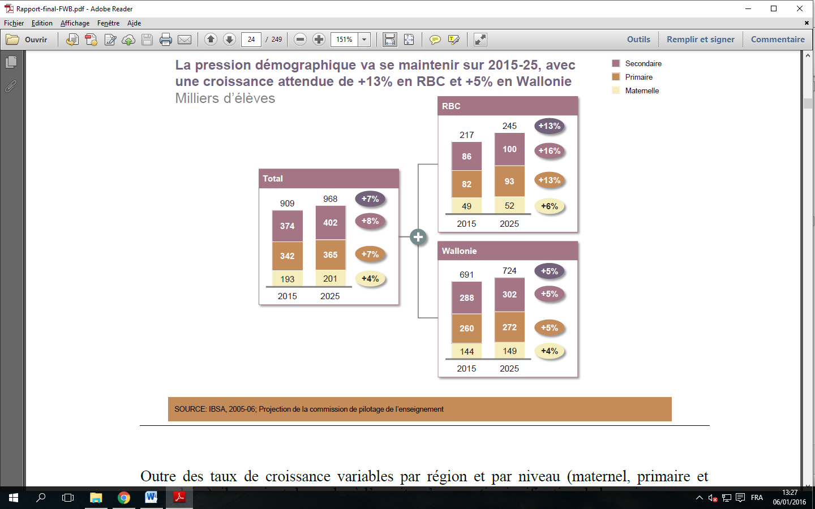

Key: Demographic pressure will continue in 2015-25, with expected growth of + 13% in the Brussels-Capital Region and of + 5% in Wallonia

Thousands of pupils

Primary

Secondary

Nursery

Source: *IBSA*, 2005-2006, Projection of the Education Steering Committee

Moreover, substantial sustained and growing demand for high-quality European education not intended solely for children of staff of the European institutions is to be seen. The people most interested are highly qualified individuals attracted by an international career in private sector businesses based in the Brussels region who are seeking for their children a school offering a European education. This applies to both nursery school age children and primary and secondary age children.

The reason is that the European Schools offer pupils not only a high level of instruction in their mother tongue but also guaranteed recognition in their country of origin of the upper secondary school leaving certificate.

A study by the McKinsey consultancy bureau shows that by 2025, 21 600[6] additional school places in total will be required for pupils in all age groups in the Brussels-Capital Region, in the Belgian education system alone.

## A linguistic and European unification interest

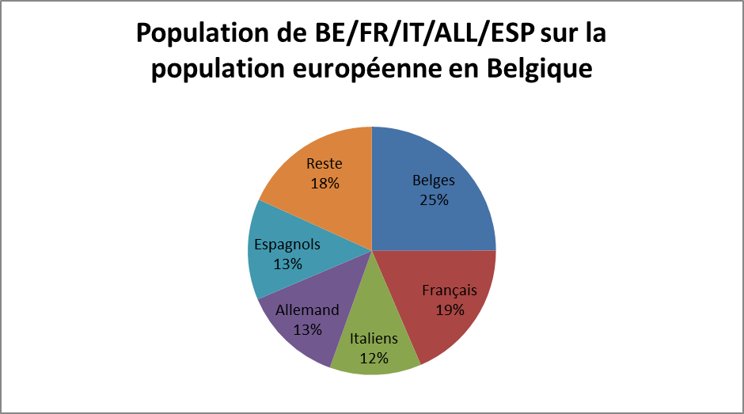The Brussels-Capital European School (EEB-C) will offer various working languages. On the school’s opening, the Château d’Argenteuil campus will offer English, French and Swedish language sections. With a view to the school’s future development, new campuses could also be opened, offering Italian and Spanish sections and other European language sections, the objective being to cater for demand from the greater part of the international population living in the Brussels-Capital Region and the surrounding area.

Key to the chart (clockwise): Belgians 25%, French 19%, Italians 12%, Germans 13%, Spaniards 13%, Others 18%

Thanks to the unique curriculum of the different language sections, the contents and the certificate of the European schooling system have the advantage of offering equivalence with the national school systems of the various Member States. In addition, they allow exceptional linguistic diversity to be shaped.

All European School students who have been awarded the European Baccalaureate are allowed access to the universities of the 28 Member States of the European Union. The certificate is also recognised outside the EU, something which allows students to continue their education in higher education establishments in other parts of the world.

Attention should be drawn to the excellent standard of attainment in foreign languages of pupils in the European schooling system. This enables students who have successfully completed their education in the European schooling system to continue their education in the widest variety of countries, but also to go on to careers in countries with several official languages.

## Demand for high-quality multilingual education[7]

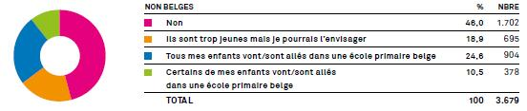

Primary

**Percentage of international**

**citizens living in Belgium who**

**intend to put their children into**

**a school in the Belgium system**

## Enquete sur le comportement - Inscription dans une ecole belge en secondaire.jpg

Secondary

## Key to the text of the above two charts: NON-BELGIANS % No

No

They are too young but I could envisage it

All my children are in/went to a Belgian primary/

secondary school

Some of my children are in/went to a Belgian primary/secondary school

## Need to respond to the institutions’ demand and to open up the system

Belgium is under an obligation to offer the European institutions the places required in its education system in order to cover their educational requirements. For those requirements, a distinction needs to be drawn between three functional categories:

* CAT I and II: Pupils whose parents are officials of the European institutions (CAT I) or who work for agencies linked with the European institutions (CAT II)
* CAT III: Pupils who not come into categories I & II. Those pupils are admitted to the European Schools in so far as places are available, according to an order of priority. The ordinary school fees set by the Board of Governors have to be paid for such pupils.

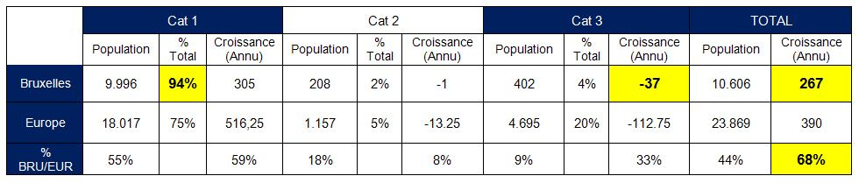

As can be seen from the above table, the percentage of pupils coming into ***Category I*** has been rising steadily for several years now and that category now accounts for over ***75%*** of the pupil population of the European School system as a whole.

In Brussels, as a result of demographic growth and the increase in demand from the institutions, the *CAT I* population now exceeds 94%, virtually destroying any chance of access for children coming into the other categories. This problematic situation is to be observed in the four Brussels European Schools, whose capacity will in the very short term have reached saturation point, as a result of fulfilment of the potential of the Laeken European School, as shown by the figure below.

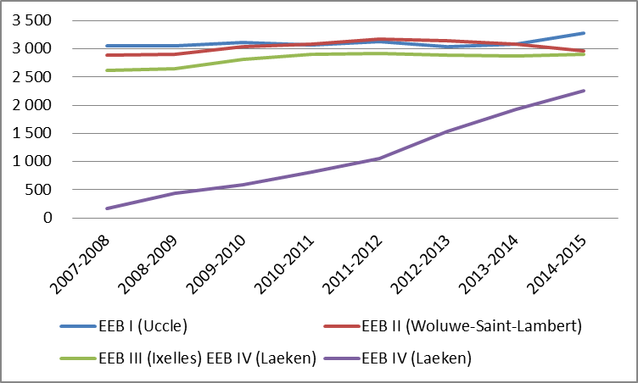

Education – Pupil population – *IBSA* – Updated on 07/05/2015

Although a number of international schools have been set up in Brussels, there is still a high level of demand for the opening of another inter- national school, given the cosmo- politan nature of the Brussels-Capital Region and the Province of Brabant-Wallon to the south. Whereas the Brussels European Schools (I-IV) have an intake composed almost solely of children of the staff of the EU institutions, other international schools, such as the International School of (ISB) or the German School of Brussels, are extremely limited in terms of language sections. The tuition fees charged by certain other schools located on the outskirts of Brussels, such as St John’s, mean that access to them is restricted to the most affluent sections of society[8].

As an Accredited European School, the Brussels-Capital European School would allow a chance to be offered to children not belonging to the first two functional categories of accessing a European-type education, thus going some way towards mitigating the effects of the unequal situation obtaining, which is often singled out as an issue by parents’ associations whose members are foreign nationals. The particularity of Accredited European Schools is the fact that they are not required to give priority for admission purposes to children of officials (Category I), something which enables them to open up access to the European Baccalaureate to people who, as can be seen from the inter-categories ratios shown on the previous page, are virtually sidelined in Brussels at the present time.

In doing so, Accredited European Schools, meet in the best and most consistent way possible the objective of *“open[ing] up the European Baccalaureate to pupils other than those of the European Schools, in response to the European Parliament’s resolutions”*, which is one of the three pillars of the reform of the European School System decided by the Board of Governors in 2009[9].

Twelve Accredited Schools have come into being since that decision of the Board of Governors in 2009. Amongst them, mention can be made of the notable example of the RheinMain School at Bad Vilbel in Germany, the pilot for which was confirmed by the Board of Governors at its meeting of 18 April 2013. In the three years since it became operational, the number of pupils on roll in the school has reached 1200, showing the public’s attraction to and enthusiasm for this type of school. The success of that project demonstrates the viability of the model, whose setting up in Brussels would mean that Belgium would rank amongst the countries pioneering the liberalisation of European education.

## The Accredited European Schools[10]

|  |  |  |
| --- | --- | --- |
| **Accredited European Schools** | **Member State** | **European Baccalaureate since** |
| [**Centre for European Schooling Dunshaughlin**](http://www.eursc.eu/index.php?id=223&l=1) | Ireland |  |
| [**Scuola per l'Europa di Parma**](http://www.eursc.eu/index.php?id=221&l=1) | Italy | 2009 |
| [**School of European Education Heraklion**](http://www.eursc.eu/index.php?id=224&l=1) | Greece | 2015 |
| [**Ecole européenne de Strasbourg**](http://www.eursc.eu/index.php?id=225&l=1) | France | 2014 |
| [**Ecole internationale de Manosque**](http://www.eursc.eu/index.php?id=249&l=1) | France | 2013 |
| [**European Schooling Helsinki**](http://www.eursc.eu/index.php?id=222&l=1) | Finland | 2013 |
| [**Europese School Den Haag**](http://www.eursc.eu/index.php?id=254&l=1) | Netherlands |  |
| [**Europäische Schule RheinMain**](http://www.eursc.eu/index.php?id=252&l=1) | Germany | 2016 |
| [**Tallinn European School**](http://www.eursc.eu/index.php?id=271&l=1) | Estonia |  |
| [**Europa School UK**](http://www.eursc.eu/index.php?id=280) | United Kingdom |  |
| [**European School Copenhagen**](http://www.eursc.eu/index.php?id=275) | Denmark |  |
| [**Scuola europea di Brindisi**](http://www.eursc.eu/index.php?id=281) | Italy |  |

## *Europese School Den Haag*

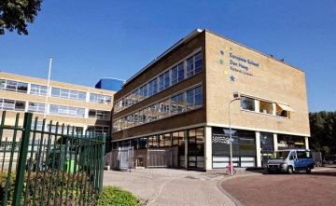The European School of The Hague opened in August 2012. The number of pupils on roll went up from 106 in 2012 to 673 in 2015.

## *Europäische Schule RheinMain*

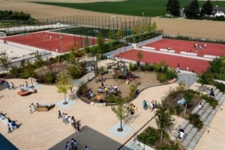The European School RheinMain opened in September 2012. The number of pupils on roll has gone up from 380 when it first opened to more than 1200 for the 2015-2016 school year.

**European School Copenhage**

## http://mipim2014.carlsbergbyen.dk/sites/default/files/styles/images-preview/public/images/ongoing_04_03.jpgThe European School Copenhagen opened in August 2014 and already has more than 140 pupils on roll. When it has become fully operational, the school is expected to have 900 pupils.

# The Lycée Molière, an appropriate solution

## An exclusive status

The *asbl Lycée Molière*, the non-profit-making association that runs the school, which is not subsidised by the *Fédération Wallonie-Bruxelles* but has been recognised since 1964, and that is chaired by Mr Félix de Merode, is piloting the ‘*Brussels-Capital European School*’ project. The Lycée Molière is the only private school in Belgium recognised by the *Fédération Wallonie-Bruxelles* and as such having the legitimacy and interest in embarking upon a procedure aimed at obtaining pedagogical accreditation from the Board of Governors of the European Schools.

It was on that basis, and with the shortage of places in the Brussels European Schools in prospect, as referred to in the first section of this file, that the Lycée Molière was contacted in 2013 by the *Fédération Wallonie-Bruxelles* delegation to the Board of Governors of the European Schools and by *CIPS* (*Comité Interministériel pour la Politique de Siège* – Interministerial Committee for Host Nation Policy) about envisaging the opening within its structure of a section preparing students to take the European Baccalaureate.

## A social orientation at the heart of the project

The full running costs of the Lycée Molière, as a non-subsidised school, are defrayed by pupils’ families through the payment of monthly school fees. The Lycée has nevertheless always prided itself on holding the position, amongst the private schools in Brussels, of the one which has kept school fees lowest, and it has retained that status up to the present day, by ploughing back in full any profits made to ensure the well-being of pupils and maintain the quality of educational provision, in accordance with its status as a non-profit-making association (*asbl* – *association sans but lucratif*).

In addition, the Lycée has always granted full or partial reductions in school fees to enable pupils experiencing difficulties at school to benefit from the education provided and from its unique remediation system, regardless of their socio-economic situation. 12% of pupils qualify for this exemption for the 2014-2015 school year. The Lycée has also put in place a system of scholarships funded by companies or private donors, who, with a philanthropic aim, step in and pay school fees for children from less affluent families.

One of the fundamental aims of the Brussels-Capital European School will be to maintain these partnerships between the business world, private sponsorship and the educational sector and also the contribution by more affluent pupils to the schooling of the least affluent, with the objective of catering for a significant percentage of pupils supported by a scholarship or exempt from school fees.

This approach would enable the generally very homogeneous social composition observed in the European Schools to be tempered and would thus allow the fundamental objective of the European schooling system, which seeks to promote understanding and agreement not only between national groups but also social ones, to be met.

## Input in the form of a specific innovative pedagogy

The Lycée Molière owes its reputation with the general public in Brussels to a unique form of pedagogy which is its hallmark. Thanks to small class sizes (10-20 pupils), pupils benefit from genuinely individual monitoring. This is further increased by two hours’ daily support provided at the *Ecole des Devoirs* (supervised homework classes), the first institution of this type in Belgium and a veritable model in the field.

The *Ecole des Devoirs* aims not just to help pupils to do their homework and study their lessons but also teaches them to use a real method of working which will be of use to them throughout their school and university career. Apart from seeking to incentivise pupils to work towards success, its objective is to spark in them a thirst for learning and a taste for producing good-quality work.

In addition, the Lycée specialises in catering for special needs pupils, in particular those suffering from learning difficulties such as dyslexia and dysphasia. Such pupils routinely receive daily support from a dedicated team and special arrangements allow them to follow the curriculum of the *Fédération Wallonie-Bruxelles*, at the same time taking account of their difficulties and leading them progressively to overcome them.

The Brussels-Capital European School will be committed to embedding the Lycée Molière’s methods as the focus of its pedagogical project, in line with the requirements of the education provided in the European Schools. It will offer support arrangements for special needs pupils; it will include the *Ecole des devoirs* system in its European schooling offer; finally, to ensure a high-quality personalised education, class sizes will be limited to 24 pupils and the sites to a maximum of 1200-1500 pupils[11].

Through concrete implementation of the different social and pedagogical measures just outlined and drawn directly from the Lycée Molière’s wealth of experience, the Brussels-Capital European School will guarantee for all its pupils genuine “equality of opportunity for pupils in terms of preparation for the European Baccalaureate[12], thus meeting the requirements which European Schools are expected to meet in accordance with the directives of the Board of Governors of the European Schools.

# The Brussels-Capital European School: pattern of development and outlook

## Funding

The main advantage of Accredited European Schools and the reason why this model is set for considerable development in the European Union countries lies chiefly in the legal, administrative and financial autonomy which is granted to them[13].

Thus, unlike Types I and II European Schools, the expenditure involved in their creation and running (infrastructure, remuneration and training of staff, organisation of the European Baccalaureate, etc.) is no longer borne by the Member State in which they are set up (unless it itself is the organising authority) but have to be defrayed solely by Accredited European Schools themselves.

All the costs associated with the Brussels-Capital European School will be covered by the school fees paid by pupils’ parents or their employers. The institutions of the European Union allow for an annual budget of €6000-€9000 for each child of their employees, according to the teaching level (nursery, primary or secondary). The School’s fees will be calculated in such a way as to correspond as closely as possible to that budget per pupil (whilst also guaranteeing the project’s viability and economic independence), in order to offer an education similar to that provided in the European Schools in terms of both curriculum and financial cost.

## Infrastructure: the Argenteuil campus

The Brussels-Capital European School, product of a partnership between the Lycée Molière and the Scandinavian School of Brussels, will initially be located in Waterloo, on the Argenteuil campus, which currently accommodates the Scandinavian School, Bogaerts International School and *Den Norske Skolen i Brussels* (the Norwegian School of Brussels). Approximately 500 pupils, aged between 2 and 19, currently attend school on the campus, which comprises the Château d’Argenteuil, a nineteenth century building, a number of buildings housing the academic facilities (laboratories, auditoria, sports halls and classrooms, boarding facilities, etc.) and a large play area and many sports fields. The whole of this infrastructure, located at the heart of a wooded park of over 10 hectares in area, offers an exceptionally fine setting in which to set up a large internationally-oriented school.

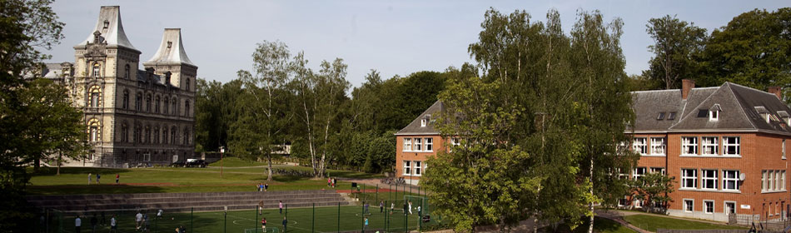

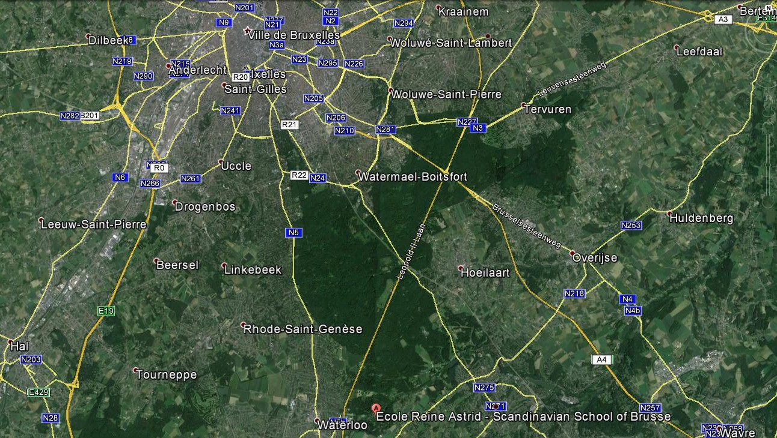

The campus, located in Waterloo, on the outskirts of the capital and a few hundred metres from a Brussels Ring Road exit, is easily accessible by car or public transport. A mobility plan is, moreover, being worked on by the local authorities and foresees the creation of a new motorway bridge and the introduction of shuttle services designed to increase the fluidity of transport linked with the campus.

## The school’s development

The Brussels-Capital European Schools is expected to have reached the full development stage around the tenth year following the beginning of the 2017-2018 school year in September 2017 (tables 1 and 2). At that stage, the school will have 1200 pupils on roll, divided out among 50 or so classes in the three cycles (nursery, primary and secondary).

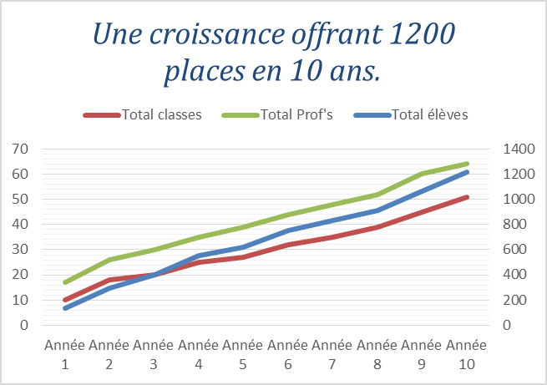

*Key:*

*Growth offering 1200 places in 10 years*

Total classes Total teachers Total pupils

Year ...

1 ...

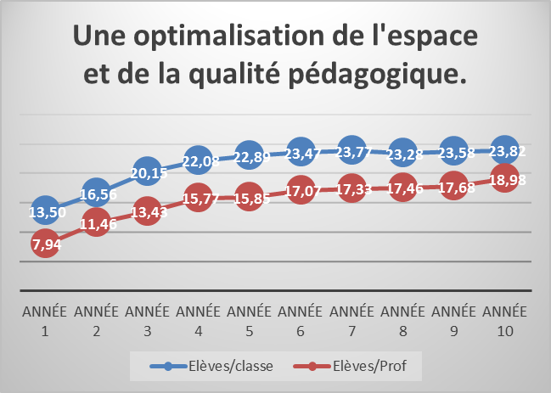

Key:

**Optimisation of space**

**and of pedagogical quality**

YEAR ...

1

Pupils/class Pupils/teacher

## Teaching staff

The choice of teaching staff is a very important factor when setting up a high-quality European School aiming at excellence in its results. Staff must be qualified to teach their subjects in one of the languages of the European Union Member State and have linguistic competences comparable with those of native speakers of their language of tuition[14].

The staff of the European School will be headed and led by an administrative and pedagogical team which already has experience in the European schooling system, in order to guarantee high-quality educational standards. Excellent relations with the existing Accredited European Schools, with the RheinMain School at Bad Vilbel in Germany in particular, will enable the Brussels-Capital European School to benefit from the guidance required to set up a soundly based curriculum, complying with the conditions laid down by the Board of Governors of the European Schools.

In addition, it will benefit from the unique experience of the teaching of the Lycée Molière and of the Scandinavian School of Brussels in the fields of remediation, implementation of innovative pedagogical solutions and catering for an international target group. A school system’s quality is indeed essentially dependent on its teaching staff. A good teacher is characterised by mastery of competences in the subjects to be taught, motivation for teaching, optimum communication and emotional intelligence skills, problem-solving ability, the ability and willingness to call oneself into question in mid-career, openness to team work, etc. The management team of the Brussels-Capital European School will take scrupulous care to ensure that its teachers have all those qualities and continue their professional development through in-service training.

Ultimately, the staffing requirements – both teaching and administrative staff – of the Brussels- Capital European School will amount to approximately a hundred full-time equivalent posts, thus contributing to boosting employment in Brussels and in its Region.

## Financial plan



See the next page for the text of the table in English.

Key to the text of the table on page 20:

*Unique high-quality education for all*

(Calculated on the basis of a total of 400 pupils)

EU COMPANIES PRIVATE Social 5%

CONTRIBUTIONS Pre-Prim.

Prim.

Second.

*The least affluent pay the operating expenditure. Commercial companies make up the difference.*

SCHOOL FEES Pre-Prim.

Prim.

Second.

*The parents of CAT. 1&2 pupils pay the difference of €2000 (excluding costs) between the EU contribution and the school fees charged.*

BREAKDOWN OF PUPILS ---> 32% 32% 32% 5%

EU Expat. Cat. 3 Social

No of pupils Pre-Prim.

Prim.

Second.

*A profit-free operating result by offering together an opportunity for all to receive a high-quality education*

School fees charged EU Expat. Cat. 3 Social

Pre-Prim.

Prim.

Second.

CONTRIBUTIONS EU Companies Parents Social

Revenue

Op. Expend.

*Operating result*

The investments will be financed by private funds through interest-bearing deposits, made by parents, and by credits. Day-to-day running costs will be covered by tuition fees. Annual tuition fees will vary in amount, depending on whether they are covered by parents, the European institutions or commercial companies. Equally as much importance should be given to economic independence as to social balance.

The contribution provided by international companies will thus be 15-20% higher than the contributions of children of employees of the European institutions or private contributors.

5% of the school’s pupils will quality for a 75-85% exemption from tuition fees, to enable there to be a social mix and access to a high-quality education for young people coming from disadvantaged socio-economic backgrounds.

The table on the next page shows that financial balance should, according to reasonable forecasts, be reached as from the fourth financial year.

## Operational break-even point as from the fourth year



# Conclusion

Here we will simply reiterate the main features of the Brussels-Capital European School project as set out in this file.

The Brussels-Capital European School intends to be:

- **The first Accredited European School in Belgium**, enabling the *Fédération Wallonie-Bruxelles* to be in line with the European dynamism sparked by this new model, which is successfully coming into being in many European Union countries.

- **The first fully self-funded European School**, without any financial contribution from the public authorities, **opening up European schooling** to children whose parents are not employed by the EU institutions.

- **A new European School in Brussels**, with **capacity to accommodate 1200 pupils** (and a possibility of increasing that capacity through new campuses from 2027) in three language sections (English, French and Swedish), enabling there to be a response to oversubscription in the existing four Schools, which is reaching saturation point.

- **An innovative European School**,in terms of **social mix** and **support for special needs pupils,** which provides **equality of opportunity** where the European Baccalaureate is concerned.

- **An important source of job creation**, with more than a hundred posts of teachers, administrative employees and technical staff due to be created by 2027.

1. [http://www.auswaertiges-amt.de/DE/Aussenpolitik/Laender/Laenderinfos/01-Nodes_Uebersichtsseiten/Belgien_node.html -](http://www.auswaertiges-amt.de/DE/Aussenpolitik/Laender/Laenderinfos/01-Nodes_Uebersichtsseiten/Belgien_node.html) 25/05/2014 (20.50)
2. ‘*Informations relatives au marché du travail concernant la région de Bruxelles’* (Information about the employment market in the Brussels Region) [- 26/05/2014 (https://ec.europa.eu/eures)](https://ec.europa.eu/eures) (12.45)
3. [http://www.deredactie.be/cm/vrtnieuws.deutsch/nachrichten/1.1554439 -](http://www.deredactie.be/cm/vrtnieuws.deutsch/nachrichten/1.1554439) 25/05/2014 (21.00)
4. This figure takes account of the most positive development (doubling of the population at the EEB IV and concurrent increase in numbers of 400 places per year) since the statement made by the Minister, Ms Simonet, on 15 May 2012 according to which only 43% of children of officials were being educated in the European system (*CRIc n°66*-Educ.13 (2011-2012)
5. Decision 2013-04-D-15-en-4 of 31 May 2013
6. *IBSA* (Brussels Institute for Statistics and Analysis) - June 2010 - Brussels-Capital Region; VG; CFB; Segec - McKInsey & Company
7. (Survey on the life of the international community in Brussels - www.blbe.be)
8. <http://www.stjohns.be/admissions/tuition-fees-2014-2015>
9. Annual Report of the Board of Governors of the European Schools (Ref.: 2011-02-D-39-en-2)
10. Accredited European Schools – Fact sheets (2015-08-D-3-en-1) Update of 10/11/2015
11. Should demand exceed those maximum numbers, additional campuses would be opened, designed, where required, to include new language sections.
12. Regulations on Accredited European Schools, Article 3: « Only schools which undertake to enhance and promote their European specificity, by guaranteeing firstly, to provide their pupils with the same type of education as that provided in the European Schools and secondly, equality of opportunity for pupils in terms of preparation for the European Baccalaureate, […]. »
13. Regulations on Accredited European Schools, Article 1: « Accredited European Schools are schools which, without forming part of the network of European Schools organised by the intergovernmental organisation ‘The European Schools’, offer a European education that meets the pedagogical requirements laid down for the European Schools but within the framework of the national school networks of the Member States and hence outside the legal, administrative and financial framework to which the European Schools are compulsorily subject.”
14. Regulations on Accredited European Schools, Article 6.