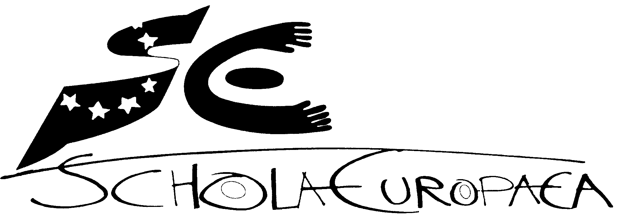 | European Schools  Office of the Secretary-General
Ref.: 2015-10-D-12-en-2
Original:

Report of the Budgetary Committee of the European Schools under the Czech Presidency - 2014/2015 School year
Board of Governors of the European Schools
Meeting on 1-3 December 2015 - Brussels

Introduction and thanks

I am very pleased to present my report as a Chair of the Budgetary Committee under the Czech Presidency of the European Schools during the academic year 2014 - 2015.
I would like to begin by expressing my great gratitude to all who contributed to the smooth conduct of the Budgetary Committee´s meetings.

I would like to thank to the General Secretariat´s entire team: Mr Kivinen, Mr Marcheggiano, Mr Escudero, Mr Beckmann, Mr Villatoro and Mr Bordoy and their teams and to Mrs Matundu Luzolo for the support and help that they have given me during the whole Czech Presidency. It was a pleasure to work with them.

Role of the Budgetary Committee

The Budgetary Committee´s main responsibilities are to decide all budgetary and financial questions and to address administrative and legal questions and give opinions for decisions at the Board of Governors. In additions to these responsibilities the Budgetary Committee define the general budgetary objectives for Type 1 schools and evaluate their implementation.

During the 2014 - 2015 school year, the Budgetary Committee met on 4 and 5 November 2014 and on 10 and 11 March 2015. During those meetings a number of various issues were examined. Due to the conclusions and decisions documents of the meetings of the Budgetary Committee that are produced by the Office of the Secretary-General, I would like to focus only on certain issues.

The Budgetary Committee had the opportunity to hear the report of the Chair of the Budgetary Committee for the year 2013-14, Report of the Court of Auditors for the financial year 2013, Annual report of the Financial Controller and Annual report of the IAS.

The Budgetary Committee focused on implementation and adoption of the 2014 and 2015 budgets of the European Schools and debated the 2016 European Schools preliminary draft budget. It also approved the new budget nomenclature which would allow better analysis and simplify the reading of the budget in the future.

Following the replacement of the original accounting system of the European Schools from January 1 by SAP system and integration of all financial systems, the new version of the Financial Regulation was approved.

Another long-term issue discussed at our meetings was Cost Sharing. The Cost Sharing principles have been established and the member states agree to respect those principles. But with regard to the creation of seconded posts in the European Schools, it is necessary to deal with the problem of future staffing of the schools, as part of Cost Sharing.

Sometimes it is difficult to reach a consensus as the various members and stakeholders are protecting their positions. This is the matter of creation of the European School, Berkendael, in Brussels when the Board of Governors did not approve creation of this school. On the other hand it was achieved a several partial successes. It was decided to create a Lithuanian section in the secondary cycle of the European School, Brussels II, starting in September 2015 and to an Estonian language section at the European School, Brussels IV for the beginning of the 2016-2017 school year in September 2016.

And of course, I would like to mention the amount of other successful work that has been during these two meetings done. The Budgetary Committee has examined and adopted number of proposals concerning general issues (e.g. Revision of the Gaignage criteria, Amendment to the Statute and to the Rules of Procedure of the Complaints Board, Amendment of the Rules of Procedure for the Budgetary Committee of the European Schools, etc.) personnel matters (for example Amendment of the Regulations for the Members of the Seconded Staff, General framework for in-service training for management staff, Revision of the salary scale of the AAS or Needs analysis of Educational Support coordinators) and proposals in the pedagogical field (for example Conceivable measures for highly talented pupils in Sports, Art or Music, New marking scale, etc.)

Conclusions

The Budgetary Committee faced in the school year 2014-2015 many challenges. A lot of work has been done and not all of tasks brought to a successful conclusion.

Although it is sometimes difficult to reach a consensus or to achieve an acceptable solution for all, the Budgetary Committee has to continue in its work to move the system of the European Schools forward.

The Czech Presidency obtained a lot of support from all stakeholders, the members of the Office of the Secretary General, the members of the Budgetary Committee, primary and secondary inspectors, the members of working groups, the schools, parents and other involved institutions. I would like to thank them all and express my best wishes to the colleagues of the Danish Presidency team.

Lucie Brumovská

OPINION OF THE BUDGETARY COMMITTEE
The Budgetary Committee took note of the Report and thanked Ms Brumovska for its quality and for her effective presidency.
The Committee recommended that the Board of Governors should approve it.

