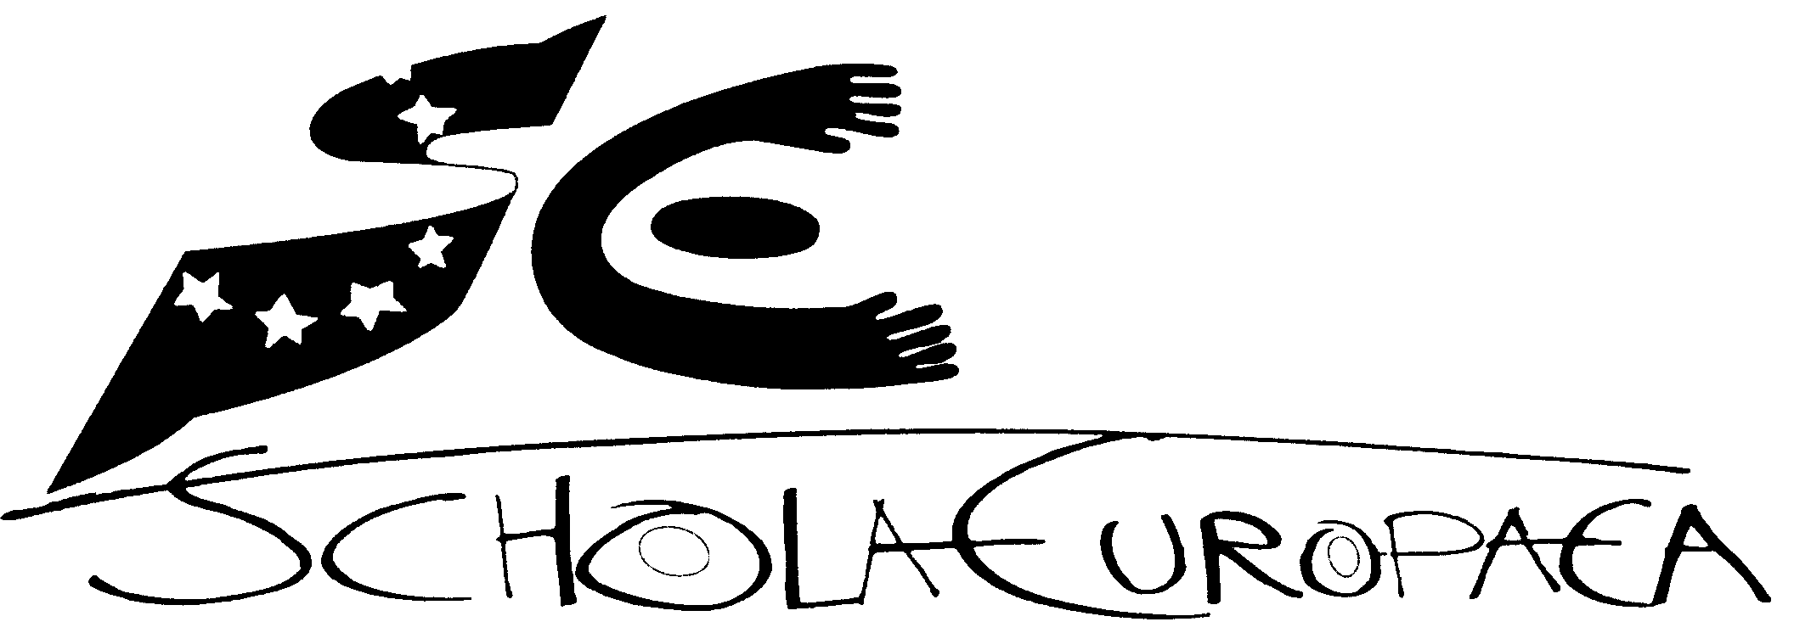 | Schola Europaea  Office of the Secretary-General  Human Resources
Ref.: 2015-02-D-25-en-2
Orig.: EN
REVIEW OF THE SALARY LEVELS FOR AAS IN ACCORDANCE WITH ARTICLE 25.2 AND 25.3 OF THE AAS REGULATIONS
Board of Governors
15 – 17 April 2015

- Introduction

According to Article 25.2 of the Service Regulations for the Administrative and Ancillary Staff (AAS) of the European Schools (hereunder ‘AAS Regulations’) “the salary levels for AAS have to be reviewed every six years by the Administrative Board of each school and by the Secretary-General for his staff under the authority of and within prior limits set by the Board of Governors”. Furthermore, it is stated that “the first such review should take place in 2012”.

Concerning the methodology and the possible limits of the review Article 25.3 of the AAS Regulations foresees that the review should take all the following factors into account:
- the salary scale for comparable posts in the country in which the school is situated;
- the need to ensure recruitment and retention of suitably qualified staff;
- the salary paid for the same posts in the European Schools in general, taking account of the correction coefficient;
- the budgetary resources/limitations which may be indicated by the Board of Governors.

- Current situation
In the years 2012 and 2013 the AAS Working Group tackled the issue and tried to provide the Board of Governors with a comprehensive review of the salary scales of the AAS Regulations.
Finally, the working group failed to provide the Board of Governors with a ‘cost neutral’ proposal as requested by some members of the Board.
Nevertheless, it was common sense in several Admin Boards that the lack of a comprehensive proposal should not hinder per se the Board of Governors to adjust the salary scales in accordance with the criteria laid down in Article 25.3 AAS Regulations in individual cases which deserve a solution in due time.

- Proposal
Based on the latest discussions in the Administrative Boards of the 14 European Schools and after consultation of the Representatives of the AAS it is proposed to review in a first step by applying the criteria of Article 25.3 of the AAS Regulations the salary scale of the occupational category ‘Nursery Assistant’ in the European School Bergen.

- Concrete proposal
It is proposed to upgrade the salary scale for the occupational category ‘Nursery Assistant” from the present salary rate to 80% of the salary of the occupational category ‘Secretary’ in the European School Bergen N-H.

- Reasoning

- General
The salary scale of the occupational category ‘nursery assistant’, appointed after April 2007, varies from € 1.872 - € 2.466 (salary rates of July 2012) at maximum. The salary scale of a nursery assistant appointed before April 2007 varies from € 1.949 - € 2.566 (salary rates of 1 January 2014). These scales are considerably lower than in all other European Schools.
In the other European Schools the nursery assistants have a salary scale of ca. 79% - 100% of the scale of a secretary. Since the job description for nursery assistants is similar in all European Schools, this should be reflected in their salary. It is therefore proposed to upgrade the salary scale of a nursery assistant to the level of 80% of the salary of a secretary in the European School Bergen.

- ‘Salary scale for comparable posts in the host country (Article 25.3 lit.a)
In the Dutch national system a class assistant only exists in special education. Scale 4 of the CAO-PO (child care and routine tasks in education) varies from
€ 1.585 - € 2.297. These amounts should be increased with ca. € 200 since Dutch class assistants are entitled to extra allowances as the end of year allowance and extra salary steps if the end of the salary scale has been reached.

- Need to ensure recruitment and retention of qualified staff (Article 25.3 lit. b)
The nursery assistants in a European School need more qualifications (extra language, pedagogical knowledge in multicultural environments) than the class assistants in the Netherlands.
The ES Bergen has experienced difficulties with the recruitment and retention of qualified staff. Last school year one of the nursery assistants wanted to work less than her contract because of the low salary. The other nursery assistant has an additional contract as part time teacher.

- Salary for comparable posts in the ES system (Article 25.3 lit. c)
The salary scales in the other European Schools are as follows (salary rates of July 2010, annexe 2, resource budgets 2015):

Alicante: € 2.386 - € 3.192
Bergen: € 1.857 - € 2.446
Brussels I, II, III, Mol: € 2.664 – € 3.885
Culham: € - – € -
Frankfurt: € 2.442 – € 3.141
Karlsruhe: € 2.417 – € 3.110
Luxembourg I, II: € 3.199 – € 4.797
München: € 2.417 – € 3.085
Varese: € 3.029 – € 3.876.

- Financial implications
The financial implications are as follows:
The monthly gross salary would increase by € 681 for three 50% nursery assistants.
The total impact on the budget 2016 would be: € 11.820, social costs inclusive.

- Conclusion of the Budgetary Committee
The Budgetary Committee supported the proposal but is asking for a more coherent approach for future amendments.

- Proposal
The Board of Governors is asked to approve the proposal which should apply as of 1. January 2016.

Annex

