Schola Europea

Office of the Secretary-General

General Secretariat

Ref.: 2014-11-D-7-en-1
Original

Creation of Estonian, Latvian and Slovak language sections and development of the Lithuanian section in the secondary cycle in Brussels
BOARD OF GOVERNORS OF THE EUROPEAN SCHOOLS
Meeting in Brussels on 2, 3 and 4 December 2014

- BACKGROUND
The December 2013 Board of Governors’ meeting was informed by means of a written communication (2013-11-D-22-en-1) about the official letter from the Estonian Minister of Education, Mr Aaviksoo, requesting that an Estonian section be created at the Nursery level at the European School, Brussels II. In the letter it was stated that the number of Estonian pupils in the school was constantly increasing, the vast majority of pupils being SWALS in the English and French sections. The request would be to open an Estonian section as from September 2014.
The April 2014 Board of Governors’ meeting decided not to create an Estonian language section in the nursery cycle at the Brussels II School as from 1 September 2014 because the school lacked the infrastructure required to accommodate it.
In view of the increase in the Estonian, Latvian and Slovak pupil populations in the Brussels Schools, it was decided at the meeting of the Budgetary Committee, held on 4 and 5 November 2014, to create Estonian, Latvian and Slovak language sections in the nursery cycle. In addition, on account of the growth of the Lithuanian section, which is already open in the nursery and primary cycles, its development should be continued in the secondary cycle.

- LANGUAGE SECTIONS AND SWALS IN BRUSSELS: Situation at the beginning of the 2014-2015 school year in September 2014
The number of pupils on roll in the four Brussels European Schools is also rising steadily. The Brussels I, II and III Schools are overcrowded despite the efforts made by the Central Enrolment Authority to distribute pupils across the four schools. One of the factors behind this overcrowding lies in the schools’ linguistic structure, the characteristics of which have an impact on the allocation of places in each of them.
- Language sections
The four Brussels Schools currently have 17 language sections, breaking down as follows:
Schools | DE | EN | FR | BG | CS | DK | EL | ES | FI | HU | IT | LT | NL | PL | PT | RO | SW | Total
BRU I |  |  |  |  |  |  |  |  |  |  |  |  |  |  |  |  |  | 8
BRU II |  |  |  |  |  |  |  |  |  |  |  |  |  |  |  |  |  | 9
BRU III |  |  |  |  |  |  |  |  |  |  |  |  |  |  |  |  |  | 7
BRU IV |  |  |  |  |  |  |  |  |  |  |  |  |  |  |  |  |  | 7
Total | 4 | 4 | 4 | 1 | 1 | 1 | 1 | 2 | 1 | 1 | 3 | 1 | 3 | 1 | 1 | 1 | 1 | 31

The DE, EN and FR sections are present in the four schools, the IT and NL sections in three schools and the ES section in two schools.
11 language sections (BG, CS, DK, EL, FI, HU, LT, PL, PT, RO and SW) are so-called single/sole sections, as each is present in only one school.
It should be noted that at the beginning of the 2014-2015 school year in September 2014 the situation was as follows:
- the Czech section is continuing its development in the secondary cycle, with the opening of secondary year 4 at the Brussels III School,
- the Bulgarian and Romanian sections, which are developing gradually, have opened primary years 3 and 2 respectively at the Brussels IV School,
- the Lithuanian section has been created solely for the nursery and primary cycles, at the Brussels II School.
Above those year groups, pupils belonging to those sections are SWALS.

- SWALS
SWALS have been distributed in the Anglophone, Francophone and German-speaking sections across the four schools. The Croat pupils at the Brussels IV School, the Estonian and Latvian pupils are at the Brussels II School, the Slovak pupils are at the Brussels III School and the Slovenian pupils are at the Brussels I School. In addition, Maltese pupils are in the Anglophone section of the Brussels I School.
SWALS in Brussels
Schools | HR | EE | LV | SK | SL | Total
BRU I |  |  |  |  |  | 1
BRU II |  |  |  |  |  | 2
BRU III |  |  |  |  |  | 1
BRU IV |  |  |  |  |  | 1
Total | 1 | 1 | 1 | 1 | 1 | 5

The overall situation in Brussels is challenging. The Nursery classes in all four schools are full and in some schools, including the Brussels II School, the Nursery classes are accommodated in the primary classrooms.

- PROPOSAL FOR CREATION OF LANGUAGE SECTIONS IN BRUSSELS

- The rules for creation of a language section
The criteria for the setting up of a language section were established by the Board of Governors in October 2000 (Document 2000-D-179).
The so-called ‘Gaignage report’ (Criteria for the setting up, closure or maintenance of European Schools, 2000-D-7510) provided indicative criteria for the creation of a language section:
- a minimum of 75 primary pupils from the 5th year after its opening;
- a minimum of 84 secondary pupils from the 7th year after its opening.
The figures adopted (75 pupils in the primary section and 84 in the secondary section) are applicable to the year groups as a whole in each of these sections
For number of Category I pupils to be minimum of 70% of the total number on roll in cities where Community Institutions and bodies are heavily concentrated (Brussels and Luxembourg at present) and 50% in other cases.”
Since the entry into force in 2002 of the Convention defining the Statute of the European Schools, the nursery cycle needs to be factored into the equation, with a minimum of 15 pupils from the 2nd year after its opening.

- Estonian, Latvian, Slovak and Lithuanian pupil populations
There has been steady growth in the Estonian, Latvian, Slovak and Lithuanian pupil populations over the past few years. According to the simulation produced, this growth is expected to continue in the near future (see ANNEXES 1 and 4).
At the meeting of the Administrative Board of the Brussels II School on 2 October 2014, the Secretary-General undertook to ensure that Estonian and Latvian sections would be created and that the Lithuanian section would be developed in the secondary. Similarly, at the meeting of the Administrative Board of the Brussels III School on 1 October 2014, the Secretary-General said that the creation of new sections would be discussed by the Steering Committee.
On 23 September 2014, the numbers of pupils in those language groups who are currently SWALS were as follows:
 | EE | LV | SK | LT
 | BRU II | BRU II | BRU III | BRU II
Nursery | 29 | 31 | 42 | 32*
Primary | 73 | 65 | 64 | 81*
Secondary | 42 | 51 | 37 | 72
Total | 144 | 147 | 143 | 185
*The Lithuanian language section is open in the nursery and primary cycles

- It can be concluded that there are sufficient numbers of Estonian, Latvian and Slovak pupils in the Brussels II and Brussels III Schools to justify the creation of sections for all those three languages.

- As regards the Lithuanian pupil population, there is already a Lithuanian section in the Nursery and Primary cycles of the Brussels II School, the numbers being as follows on 23 September 2014:
 | LT
 | BRU II
Nursery 1 | 16
Nursery 2 | 16
Primary 1 | 24
Primary 2 | 17
Primary 3 | 15
Primary 4 | 13
Primary 5 | 12

The Board of Governors’ April 2014 decision on the criteria for the continuity of language sections between the primary cycle and the secondary cycle provides that when, over a period of two to three consecutive years, the number of pupils from N1 to P5 is greater than 50, the Board of Governors should, on a proposal from the School’s Administrative Board, decide on the continuing existence of the language section in question beyond primary year 5. Those criteria are fulfilled in the case of the Lithuanian section already in existence (see ANNEX 4 – Table 1).
In addition, according to the projection of the development of the Lithuanian pupil population, there is a sufficiently large number of pupils to justify the creation of the Lithuanian language section in the Secondary cycle (see ANNEX 4 – Table 2).

- General comment
The increase in the SWALS population has become an issue of crucial importance. There are more than 50% SWALS in most of the Anglophone and Francophone classes at the Brussels II School. In the Anglophone nursery class there are 81% SWALS (see ANNEX 2). A solution to this situation needs to be found, as requested by the parents of the native speaker pupils in those vehicular language sections.
The creation of a Lithuanian section in the secondary cycle of the Brussels II School would reduce the percentage of SWALS in the Anglophone and Francophone sections in the long run.
Percentage of SWALS in the Anglophone section in the secondary cycle
BRU II |  | 2011-2012 | 2012-2013 | 2013-2014 | 2014-2015
S | 1 | 33% | 57% | 59% | 57%
 | 2 | 50% | 35% | 52% | 63%
 | 3 | 43% | 47% | 42% | 53%
 | 4 | 32% | 39% | 50% | 43%
 | 5 | 25% | 39% | 40% | 50%
 | 6 | 20% | 27% | 42% | 45%
 | 7 | 27% | 19% | 29% | 44%
S | Total: | 32% | 37% | 43% | 50%
The percentage of SWALS at the Brussels III School is slightly less critical (see ANNEX 3). In the Anglophone nursery class there are currently 35% Slovak pupils.

- COMMENTS OF THE STEERING COMMITTEE AND OF THE CENTRAL ENROLMENT AUTHORITY
- The Steering Committee discussed the proposal to create Estonian and Latvian sections (Nursery in September 2015) at the Brussels II School and the creation of a Slovak section (Nursery in September 2015) at the Brussels III School.
These proposals were not supported by the Steering Committee. The reasoning was very clear: the Brussels II School and the Brussels III School do not have the physical space required to create an additional full set of classes for the Nursery and Primary 1-5 levels.
The Steering Committee recommended that the Board of Governors should take a decision to create Estonian, Latvian and Slovak language sections at the Nursery and Primary 1 levels starting from 1 September 2015 at the European School, Brussels Berkendael, subject to the School’s creation.
The Secretary-General was also requested to inform the Central Enrolment Authority about the proposals and to contact the Estonian, Latvian and Slovak delegations in order to discuss these possibilities further.
The solution envisaged enables the following to be achieved simultaneously:
- preventing increased overcrowding of the Brussels II and III European Schools, to which accommodating new single/sole sections there would lead,
- allowing gradual relief of the overcrowding of those schools, which currently admit and accommodate those pupil populations as SWALS,
- ensuring the multiculturalism of the new European School, Brussels Berkendael, whose intake is not confined to pupils in vehicular language sections only.
- The Central Enrolment Authority last discussed the enrolment guidelines for the 2015-2016 school year on 24 October. The overcrowding situation, in the nursery cycle in particular but also gradually in the primary cycle, in all four existing European Schools has become critical. There is a need to use the resources available in the four schools and those of the Berkendael site, in order to lessen as far as possible the overcrowding of the schools as a whole.
Based on the discussions of the Steering Committee, the CEA proposes that the Berkendael school site be used, starting from 1 September 2015, for:
- English, French and German language Nursery and Primary 1-2 classes
- Estonian, Latvian and Slovak Nursery and Primary 1 classes – subject to the respective sections’ creation.
In addition, the Central Enrolment Authority proposes the creation of a Lithuanian Secondary 1 class at the Brussels II School.
It was also proposed, that all the Anglophone, Francophone and German-speaking pupils in the Nursery and Primary 1 classes at present should be able to apply for a transfer to the European School, Brussels Berkendael – including the pupils of the Brussels I School who are currently temporarily being accommodated on the Berkendael site.

- DISCUSSIONS WITH THE DELEGATIONS
After the Budgetary committee meeting the Secretary-General met the Estonian, Latvian and Slovak delegations and parents.
The discussions proved rather difficult. Even though there seems to be a common understanding of the need to create their own language sections for each of those countries, all the delegations would prefer the language section to be created in the school which their pupils are attending as SWALS at present. There is also a very strong reaction from the present nursery cycle parents, who are not in favour of their children’s transfer to any other school.
An alternative proposal has been formulated, which would involve creating new Estonian, Latvian and Slovak sections solely in the Nursery cycle at the European School, Brussels Berkendael starting from September 2015, with new enrolments only. In that case the present pupils, currently attending the Brussels II and III Schools respectively, would not be transferred, except on a voluntary basis. Should the Board of Governors approve this proposal, all families with groups of siblings in the Nursery 2 class or Primary years 1-4 would remain in their school as SWALS.
It is proposed that families who already at present have siblings in the primary years could remain in the same school with their groups of siblings – should they so wish.
It is expected that for a period of some years there will be parallel Estonian, Latvian and Slovak pupils at the European School, Brussels Berkendael in the Estonian, Latvian and Slovak sections and at the Brussels II School and the Brussels III School as SWALS.
The European School, Brussels Berkendael will have only the nursery and primary cycle. Estonian and Latvian pupils would receive their secondary education at the Brussels II School and Slovak pupils at the Brussels III School as SWALS, unless the Board of Governors were to decide otherwise.
It is clear from those discussions that the following need to be reconciled:
- the interest value and the advantages of creating single/sole language sections,
- the principle of continuity of schooling in a given language section,
- and the principle of protection of grouping and regrouping of siblings, as newly defined in the proposals for guidelines for the 2015-2016 Enrolment Policy drawn up by the Central Enrolment Authority (see point IV of document 2014-11-D-6-en-1)

- OPINION OF THE BUDGETARY COMMITTEE
The Budgetary Committee was informed about the difficulty of establishing a policy on enrolment in the Brussels Schools in December because the Belgian authorities had not yet taken an express decision on the possibility of creating a European School at Berkendael.
The Committee was also informed about the objective, should the Belgian authorities’ opinion be positive, of filling Berkendael with three sections (FR, EN and DE) and creating Latvian, Slovak and Estonian sections there by means of a transfer from Brussels II and Brussels III (which are overcrowded) to Berkendael.
Most of the delegations were in favour of the opening and creation of language sections at Berkendael as that would relieve the pressure on the Anglophone and Francophone sections and would reduce the number of SWALS, in addition to enabling overcrowding and insecurity to be lessened.
Whilst welcoming the creation of Latvian and Estonian language sections, Latvia and Estonia were not in favour of the transfer of pupils from Brussels II to Berkendael and called for an analysis of the impact of such a transfer on pupils and families.
France and Germany entered a scrutiny reservation with respect to the resources available to the European Schools and to the way in which cost sharing operated. The Commission took the view that the other European Institutions should also contribute to funding and pay their share.
The Budgetary Committee took note of the wish of most delegations to open a school at Berkendael to lessen the pressure on the other Brussels Schools, particularly Brussels II, and recommended that the Secretary-General should continue the discussions to confirm that the Belgian authorities agreed to the Berkendael site’s becoming available as quickly as possible in readiness for the beginning of the 2015-2016 school year.
The Budgetary Committee took note of the strong opposition expressed by the Latvian and Estonian delegations to the possible transfer of their pupils who were already on roll from Brussels II to Berkendael and requested the Secretary-General to find an alternative to Berkendael for the creation of Latvian, Estonian and Slovak language sections, so as to present it to the Board of Governors in December.

- PROPOSAL
The Board of Governors is requested to create
- An Estonian language section at the European School, Brussels Berkendael for the beginning of the 2015-2016 school year in September 2015, designed ultimately to cover the entire nursery and primary cycles, starting in September 2015 with the nursery cycle.

- A Latvian language section at the European School, Brussels Berkendael for the beginning of the 2015-2016 school year in September 2015, designed ultimately to cover the entire nursery and primary cycles, starting in September 2015 with the nursery cycle.

- A Slovak language section at the European School, Brussels Berkendael for the beginning of the 2015-2016 school year in September 2015, designed ultimately to cover the entire nursery and primary cycles, starting in September 2015 with the nursery cycle.
These new language sections should be created with new enrolments and respecting the principle of protection of grouping and regrouping of siblings (as defined by the proposals for guidelines for the 2015-2016 Enrolment Policy drawn up by the Central Enrolment Authority), to the effect that all new enrolments involving brothers or sisters in the upper nursery class or primary years 1-4 would be able to receive schooling as SWALS in the same school as their siblings, provided that the application was submitted during the first enrolment phase.
- A Lithuanian section in the secondary cycle of the European School, Brussels II, starting in September 2015 with secondary year 1.

ANNEX 1

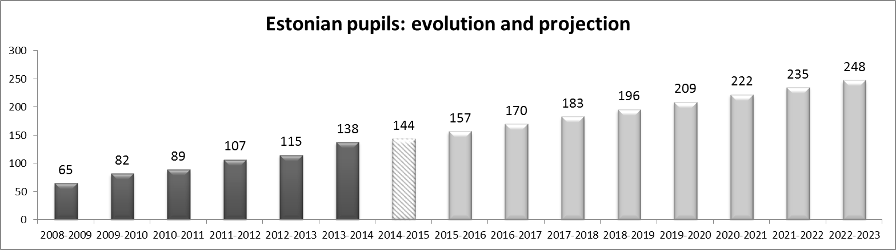

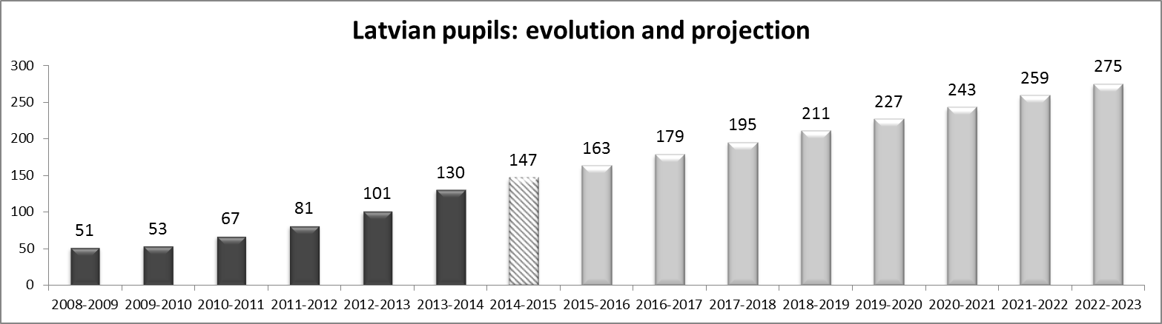

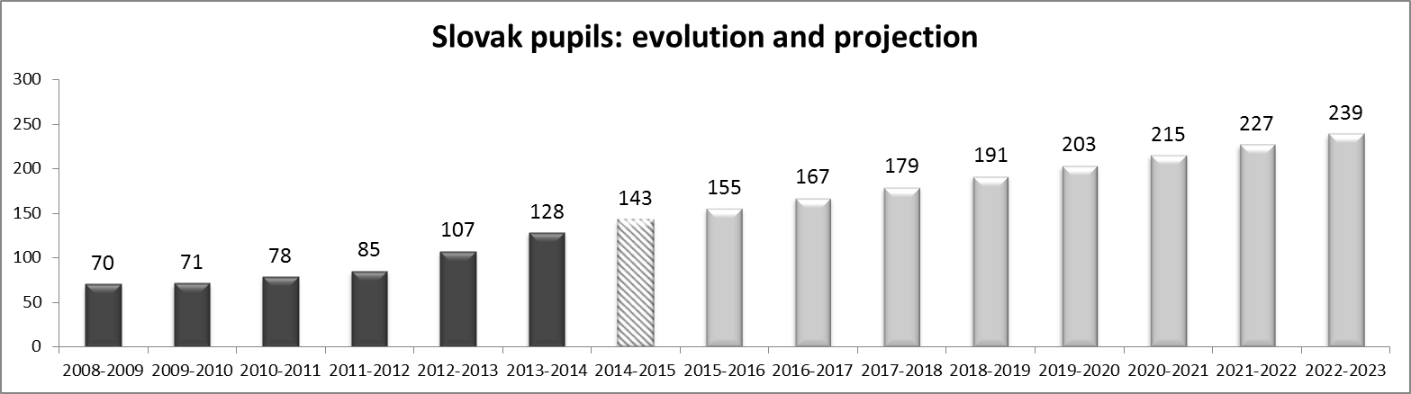

ANNEX 2
Percentage of SWALS in the Anglophone section of the Brussels II School:
 |  | 2011-2012 | 2012-2013 | 2013-2014 | 2014-2015
N | 1 | 80% | 55% | 75% | 78%
 | 2 | 38% | 82% | 65% | 83%
N | Total: | 50% | 68% | 69% | 81%
P | 1 | 37% | 33% | 71% | 52%
 | 2 | 39% | 42% | 36% | 73%
 | 3 | 31% | 41% | 55% | 33%
 | 4 | 35% | 34% | 45% | 57%
 | 5 | 42% | 38% | 37% | 42%
P | Total: | 37% | 38% | 46% | 49%

Percentage of SWALS in the Francophone section of the Brussels II School:
 |  | 2011-2012 | 2012-2013 | 2013-2014 | 2014-2015
N | 1 | 57% | 56% | 68% | 62%
 | 2 | 43% | 69% | 66% | 70%
N | Total: | 49% | 63% | 67% | 67%
P | 1 | 20% | 26% | 59% | 50%
 | 2 | 13% | 20% | 24% | 54%
 | 3 | 16% | 12% | 27% | 21%
 | 4 | 8% | 15% | 12% | 25%
 | 5 | 10% | 6% | 15% | 16%
P | Total: | 13% | 15% | 27% | 34%

ANNEX 3
Percentage of SWALS in the Anglophone section of the Brussels III School:
 |  | 2011-2012 | 2012-2013 | 2013-2014 | 2014-2015
N | 1 | 5% | 40% | 37% | 32%
 | 2 | 13% | 10% | 26% | 38%
N | Total: | 9% | 20% | 30% | 35%
P | 1 | 12% | 18% | 14% | 20%
 | 2 | 21% | 12% | 15% | 17%
 | 3 | 20% | 23% | 13% | 15%
 | 4 | 14% | 20% | 24% | 14%
 | 5 | 15% | 18% | 17% | 24%
P | Total: | 17% | 18% | 17% | 18%

Percentage of SWALS in the Francophone section of the Brussels III School:
 |  | 2011-2012 | 2012-2013 | 2013-2014 | 2014-2015
N | 1 | 23% | 19% | 28% | 26%
 | 2 | 17% | 22% | 25% | 23%
N | Total: | 20% | 21% | 26% | 25%
P | 1 | 14% | 22% | 25% | 20%
 | 2 | 4% | 14% | 19% | 23%
 | 3 | 7% | 6% | 14% | 8%
 | 4 | 4% | 9% | 8% | 7%
 | 5 | 4% | 4% | 8% | 6%
P | Total: | 6% | 10% | 14% | 13%

ANNEX 4
- Development of pupil numbers in years N1-P5 of the Lithuanian section of the Brussels II School since 2008-2009

- Development of the Lithuanian secondary cycle pupil population of the Brussels II School

