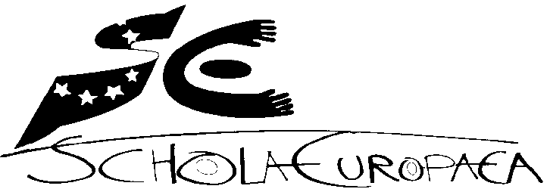 | European Schools  Office of the Secretary-General  Pedagogical Development Unit

Ref.: 2014-09-D-44-en-2
Orig.: EN

Report on school failures and repeat rates in the European Schools
APPROVED BY THE JOINT TEACHING COMMITTEE ON 9 AND 10 OCTOBER 2014 IN BRUSSELS

Introduction
In April 2013 the Board of Governors approved the document “Amendment of Article 61 of the General Rules: Promotion to the year above” - 2013-01-D-47-en-3 – with immediate entry into force from the 2013 session – written further to the amendments already approved in 2011 in order to clarify and standardise application of Article 61.
With the aim of viewing some of the consequences of this approval, this document provides some statistics on repeat rates since 2010 and their parallel with appeals lodged with Class Councils.

The document assembles
- II. School by school data on pupils repeating a year in 2010, 2011, 2012 and 2013 and the number of pupils who were supposed to repeat the year in 2012 and in 2013 but who left the school.
- III. School by school data on pupils repeating the year in 2014 and the number of pupils who were supposed to repeat the year in 2014 but who left the school.
- IV. School by school data for the 2013-2014 school year by year group, from nursery class 2 to secondary year 6
- V. School by school data for the 2013-2014 school year by section.
- VI. Data on the number and percentage of fail marks in relation to the total marks awarded at the end of the 2013-2014 school year by section – by subject, in S4 and in S5.
- VII. Data on appeals lodged with the Class Councils in 2010, 2011, 2012, 2013 and 2014.

Number and percentage of pupils repeating the year in 2010, 2011, 2012 and 2013

Number and percentage of pupils repeating the year in 2013-2014

Number and percentage of pupils repeating the year in 2013-2014, by school and year group

V. Number and percentage of pupils repeating the year in 2013-2014, by school and by section

VI. Number and percentage of fail marks in relation to the total marks awarded at the end of the 2013-2014 school year by section – by subject, in S4 and in S5
S4

S5

VII. Data on appeals lodged with the Class Councils in 2010, 2011, 2012, 2013 and 2014
 | Appeals against Class Council decisions
 | Administrative appeals | Allowed by SG | Rejected | Lodged after deadline | Contentious appeals lodge with Complaints Board | Dismissed or withdrawal
2009-2010 | 54 | 10 | 42 | 2 | 10 | 10
2010-2011 | 61 | 9 | 52 | 4 | 10 | 9
2011-2012 | 55 | 33 | 22 | 0 | 3 | 3
2012-2013 | 21 | 9 | 12 | 0 | 2 | 1 withdrawal  1 pending
2013-2014 | 34 | 14 | 19 | 2 | 2 | 1 pending

OPINION OF THE JOINT BOARD OF INSPECTORS
The JBI expressed a favourable opinion on the document ‘School failures and repeat rates in the European Schools’ and would monitor closely developments and trends in repeaters.
The JBI forwarded the document to the Joint Teaching Committee for its approval.

The document 2014-09-D-44-en-2 “School failures and repeat rates in the European Schools” is transmitted to the Board of Governors for its information.

