 | European Schools  Office of the Secretary-General  Pedagogical Development Unit
Ref.: 2014-01-D-17-en-3
Orig.: EN

Statistics on the integration of pupils with special educational needs into the European Schools in the year 2013
BOARD OF GOVERNORS OF THE EUROPEAN SCHOOLS

Meeting on 8 – 10 April 2014 in Sofia (Bulgaria)

OPINION OF THE JOINT BOARD OF INSPECTORS

At its meeting of 12 February 2014, the Joint Board of Inspectors took note of the document ‘Statistics on the integration of pupils with special educational needs into the European Schools in the year 2013’. A more detailed presentation would be given at the Joint Teaching Committee’s meeting.

OPINION OF THE JOINT TEACHING COMMITTEE

At its meeting of 13 and 14 February 2014, the Joint Teaching Committee scrutinised the document. It realised that the Schools needed to be able to devote more time and resources to the coordination of educational support. In order to do so, the Schools would necessarily require additional resources.
The Joint Teaching Committee would bring the document ‘Statistics on the integration of pupils with special educational needs into the European Schools in the year 2013’ to the Board of Governors’ attention. As regards the question of additional resources, the Joint Teaching Committee would request the Board of Governors to take a position on the subject.
The document would be presented to the Budgetary Committee for information at its March 2014 meeting.

OPINION OF THE BUDGETARY COMMITTEE

At its meeting of 11 and 12 March, the Budgetary Committee took note of the document and is forwarding it to the Board of Governors for its approval.

Introduction

The new Educational Support Policy came into force on 1 September 2013. This report brings to a close the provision of SEN support according to the document Integration of pupils with special needs (2009-D-619-en-3). In order to have a picture of the development of the indicators until the end of the provision under the previous policy, this report uses the same questions and structures as the previous years’ reports. Some terms have been changed in order to follow the new educational support policy entitled Policy on the provision of Educational Support in the European Schools (2012-05-D-14-en-7).

This report has been written on the basis of data gathered from the schools by means of an electronic questionnaire. The schools’ data were acquired on 15 November 2013. The data gathered by the schools were compiled by the OSGES and analysed by the support inspectors. The analysis and the draft report have been discussed in the Educational Support Policy Group.

The report refrains from interpretations, apart from the final chapter, which contains recommendations to be made in the opinion of the Educational Support Policy Group.

- Number of pupils with special educational needs in the European Schools

The total number of pupils in the European Schools has increased year on year, up from 22 788 (2010//2011) to 24 547 (2013/2014). At the same time, the number of pupils with special educational needs has increased from 619 (2010/2011) to 792 pupils (2013/2014). The total percentage of pupils with special educational needs has reached 3.23%.

Table 1. Percentage and number of pupils with special educational needs in the European Schools

2010/2011 | 2011/2012 | 2012/2013 | 2013/2014
2.72% | 2.74% | 2.94% | 3.23%
N=619 | N=640 | N=702 | N=792

The number of new Intensive Support Agreements in the 2013/2014 school year (15 November) was 123, while in the 2012/2013 school year (15 November) the number of new SEN agreements was 129.

Annex: Table 2. Number and percentage of pupils with special educational needs – development since the year 2010 up to 2013

- Pupils with special educational needs by school and by cycle

Brussels II has the highest percentage (5.2%) of pupils with special educational needs. At Munich and Karlsruhe the figure is more than 4.5%.

The lowest percentages of pupils with special educational needs are at Mol (0.4%) and at Bergen (0.9%). Alicante, Brussels IV, Culham, Frankfurt and Varese are also below average.
Chart 1. Pupils with special educational needs in the school

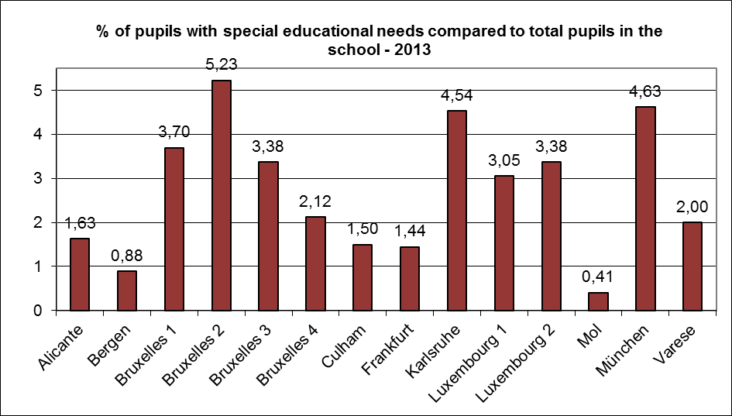

In most of the schools the percentage of pupils with special educational needs has increased slightly, the exceptions being Brussels III and Varese, where the percentages have decreased. The increase is worth mentioning at Brussels II (1.1%), Brussels I (0.8%), Karlsruhe (0.8%) and Luxembourg II (0.7%).

The total number of pupils with special educational needs in the nursery and primary cycles is 380 pupils and in the secondary 412 pupils (N/P 48 %; S 52%). The percentage of pupils with special educational needs in the nursery and primary cycle has increased a little compared with the previous school year, now being 3.2%. In the secondary cycle the percentage has increased from 2.9 % to 3.2%.

- Pupils with special educational needs by language sections

If different language sections are compared, the Anglophone, Czech, Finnish, Hungarian and Swedish sections have more pupils with special educational needs than the average.

The Danish, Dutch, German, and Portuguese sections are close to the average. The Lithuanian and Polish sections have approximately 1% of pupils with special educational needs.

Chart 2. Pupils with special educational needs by language section

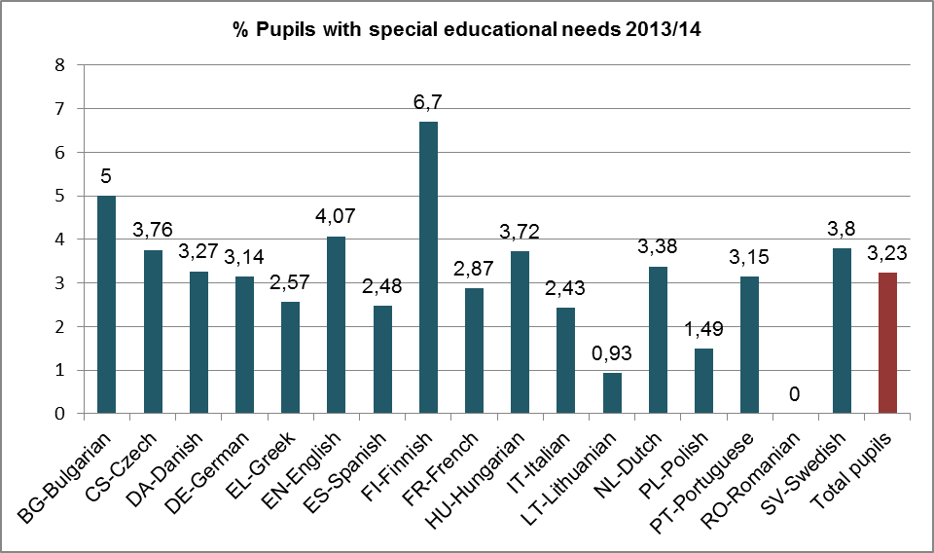

In the case of small sections the findings are not as statistically reliable as in big sections, a point which needs to be taken into account when reading the figures.

Annex: Table 3. Pupils with special educational needs by language section –development 2010/11–2013/14

- Pupils with special educational needs by category and cycle

The majority of pupils with special educational needs are in category I. In the nursery cycle almost all the pupils with special educational needs are category I. In the primary the number of pupils with special educational needs coming from category I is 85% and in the secondary it is 77%.

Overall, 13% of pupils with special educational needs are category III pupils even though they comprise 19% of the European Schools’ total population.

- Percentages of pupils with special educational needs by year group

The percentage of pupils with special educational needs is lowest in the nursery classes and rises in the primary years, decreasing again at the end of the secondary years. The curve showing the number of pupils with special educational needs throughout the whole system is normally distributed.
The number of pupils with special educational needs increases from year group to year group in the primary, being highest in P3-P5. In S1-S3 the number of pupils with special educational needs is still almost at the same level, but a declining trend is seen thereafter.

However, the number of pupils with special educational needs varies from year to year depending on the population in question. This can be seen in chart 1 by following a certain population from year to year (for example, from year group 3 to year group 4).

Annex: Chart 3. Percentage of pupils with special educational needs by class

- Diagnoses of pupils with special educational needs

There is an extremely wide range of disabilities for which appropriate help, support and compensation are expected to be provided under the educational support programme. The aim of the survey was to identify the most common reasons for seeking educational support.

The grouping of the diagnoses was created in cooperation with experts specialising in educational psychology in order to guarantee the correctness of the definitions of the different disabilities and disorders.

The most common diagnosis group is psychomotor impairment (50.0% of diagnoses mentioned). It includes diagnoses such as dyslexia, dyscalculia, dysorthography, dyspraxia and their combinations.

Approximately every fourth (26.5%) diagnosis is dyslexia. Dyslexia is the most common diagnosis in both the secondary and primary cycles. In the secondary cycle it is even more common than in the primary, accounting for 33% of all diagnoses. The other frequent diagnoses in the secondary and primary cycles are ADHD, ADD and combinations of different psychomotor disorders.

In the nursery cycle language disorders (16%), disorders on the autistic spectrum, dyspraxia and mental handicaps are the most frequent diagnoses.

High potential as a reason for ISA agreement has remained the same (26 agreements) as last year. Most of the agreements are in the secondary cycle at Brussels II and in the primary cycle in Karlsruhe.

There is a wide variety of other diagnoses, even though the number of cases is not very large.

Annex: Chart 4. Frequency of diagnosis per cycle

- Benefit of educational support

The progress made by pupils with special educational needs can be seen in the following summary:

Table 4. Promotion/Progress by cycle

Promotion/  Progress | NS | P | S | NS % | P% | S% | Total %
Normal promotion to the year above | 20 | 258 | 295 | 83.33 | 82.69 | 88.59 | 85.65
The pupil accompanies his/her year group, without promotion | 3 | 38 | 17 | 12.50 | 12.18 | 5.11 | 8.67
Repeating the year | 1 | 16 | 21 | 4.17 | 5.13 | 6.31 | 5.68
Total | 24 | 312 | 333 | 100 | 100 | 100 | 100

Nearly 86% of pupils with special educational needs were promoted normally to the year above and 9% accompanied their year group without promotion. There is no real change in comparison with the previous year’s results. The percentage of pupils repeating the year is also nearly the same as the year before, now being 5.7%.

Table 5. Promotion/Progression (total) 2011–2013

Promotion/  Progress | 2011 | 2012 | 2013
Normal promotion to the year above | 81.17% | 86.98% | 85.65%
The pupil accompanies his/her year group, without promotion | 12.50% | 7.58% | 8.67%
Repeating the year | 6.33% | 5.44% | 5.68%

- Termination of ISA agreements in the year 2013

For 121 pupils out of the total of 792, the contract was terminated, which is 19 more than a year ago. Most of the terminations of ISA agreements were in the secondary cycle (last year 59 agreements, this year 48). In the same year, 123 new contracts were signed.

In the case of 45% of the 121 terminated contracts, the support was either no longer needed or educational support was replaced by another form of support or internal differentiation in the classroom. This is a 10% increase in comparison with the year before.

In the case of 29% of terminated agreements, the pupil moved to a more appropriate school. This is slightly less than in the previous year and more common in the secondary cycle than in the nursery and primary cycle.

In the case of almost 16% of terminations, the reason was that the family moved away. This happened more rarely this year than the year before and is more common in the secondary cycle.
In 8 cases of terminated contracts the school declared itself unable to meet the child’s needs. This figure is a little higher than a year ago (5 cases), but lower than two years ago, when 11 cases were recorded. In relation to the total number of all European School pupils (24 547), the percentage is 0.03%.

Table 6. Reasons for termination, by cycle

How many pupils terminated the SEN programme in the year 2013 because: | Nursery %  (n=2) | Primary %  (n=35) | Secondary %  (n=84) | N+P+S
Is continuing with a different type of support | 0.0 | 2.5 | 11.6 | 14.0
Is continuing with internal differentiation in class | 0.0 | 3.3 | 1.7 | 5.0
Support no longer needed | 0.0 | 4.1 | 21.5 | 25.6
Parents' decision | 0.0 | 0.8 | 2.5 | 3.3
Family moved away | 0.0 | 5.0 | 10.7 | 15.7
Pupil attending a school better suited to his/her needs | 1.7 | 8.3 | 19.0 | 28.9
The school declared itself unable to meet the child's needs | 0.0 | 5.0 | 1.7 | 6.6
Other | 0.0 | 0.0 | 0.8 | 0.8
Total | 1.7 | 28.9 | 69.4 | 100.0

- Staff working in the educational support area

The number of teachers in the schools working in the field of educational support has increased further, up from 286 to 295 teachers. Most of the support teachers work in the secondary cycle, numbering 183, which is 9.6% more than a year ago. In the nursery and primary cycle 112 teachers work in the field of educational support.

In the year 2012 more than 89% of all teachers giving educational support were locally recruited. This year (2013) the number of locally recruited teachers has decreased, amounting to 83% of all support teachers.

Teachers comprise 74% of all staff working in the educational support area and personal assistants account for 19%. The number of assistants has increased by 14% compared with the previous year. Four assistants out of five (81%) work in the nursery and primary cycle.

Speech therapists and psychomotor therapists who still have a contract as teachers account for 4.3%. They were employed before the Directives for the organisation of paramedical support services for SEN pupils (2012-09-D-26-en-1) were introduced in the European Schools.

All speech therapists work in Brussels. Psychomotor therapists work mainly in Brussels (3 at Brussels, 1 at Luxembourg). There is no significant difference in the proportion of speech therapists and psychologists services between the cycles.

Table 7. Staff working in the field of educational support, by cycle

Staff providing support  (Number of persons per cycle) | Nursery & Primary |  | Secondary |  | N&P+S
Staff providing support  (Number of persons per cycle) | N=190 | % | N=207 | % | N=397 | %
Locally recruited teacher | 92 | 48.4 | 152 | 73.4 | 244 | 61.5
Personal assistant | 60 | 31.6 | 14 | 6.8 | 74 | 18.6
Seconded teacher | 20 | 10.5 | 31 | 15.0 | 51 | 12.8
Speech therapist | 7 | 3.7 | 6 | 2.9 | 13 | 3.3
Psychologist | 4 | 2.1 | 3 | 1.4 | 7 | 1.8
Psychomotor therapist | 3 | 1.6 | 1 | 0.5 | 4 | 1.0
Other | 4 | 2.1 | 0 | 0.0 | 4 | 1.0
Occupational therapist | 0 | 0.0 | 0 | 0.0 | 0 | 0.0
Total | 190 | 100.0 | 207 | 100.0 | 397 | 100.0

- Educational support time

The total amount of educational support per week is 152 635 minutes. This is 27% more than a year ago and 43% more than two years ago. The number of support minutes has grown more than the number of pupils receiving support. The number of educational support minutes does not distinguish support given in groups or individually.

Table 8. Evolution of educational support time and number of pupils with special educational needs 2010-2013.

School year | Support minutes | Increase from the previous year | Number of pupils with SEN | Increase in pupils with SEN
2010 | 89 220 |  | 619
2011 | 106 622 | 19.5% | 640 | 3.4%
2012 | 119 807 | 12% | 702 | 9.7%
2013 | 152 635 | 27% | 792 | 12.8%

69% of the support time was provided in the nursery and primary cycle, which is slightly less than a year earlier.

The support time given by seconded teachers has increased slightly in both cycles. The support time given by locally recruited teachers has decreased by 11% on the previous year. The increase in the assistants’ contribution has increased by 12%, now accounting for 50% of all the support time given. The assistants’ role in the nursery and primary cycle is even more significant than in the secondary cycle. There has been a decrease (1.7%) in support time given by therapists in the space of a year.

Table 9. Educational support time by cycle

Total amount of ISA support (in minutes) per week offered by… | Nursery & Primary |  | Secondary |  | N&P+S
 | N=104760 | % | N=47875 | % | N=152635 | %
Seconded teacher | 4950 | 4.7 | 2160 | 4.5 | 7110 | 4.7
Locally recruited teacher | 33475 | 32.0 | 29310 | 61.2 | 62785 | 41.1
Personal assistant | 61805 | 59.0 | 13960 | 29.2 | 75765 | 49.6
Speech therapist | 2040 | 1.9 | 1995 | 4.2 | 4035 | 2.6
Psychomotor therapist | 1095 | 1.0 | 45 | 0.1 | 1140 | 0.7
Psychologist | 1395 | 1.3 | 405 | 0.8 | 1800 | 1.2
Occupational therapist | 0 | 0.0 | 0 | 0.0 | 0 | 0.0
Other | 0 | 0.0 | 0 | 0.0 | 0 | 0.0
Total | 104760 | 100.0 | 47875 | 100.0 | 152635 | 100.0

Most of the support given was “less than 180 minutes per week”, as has been the case for the last three years.

The amount of “support between 181-360 minutes per week” has increased by 2.4% since last year. The amount of “intensive support (>600 minutes)” has increased again a little after last year’s slight drop.

Table 10. Amount of support by cycle

Number of pupils with special educational needs who receive support | Nursery |  | Primary |  | Secondary |  | N+P+S
 | N=23 | % | N=340 | % | N=409 | % | N=772 | %
0-180 minutes/week | 11 | 1.4 | 233 | 30.2 | 377 | 48.8 | 621 | 80.4
181-360 minutes/week | 2 | 0.3 | 56 | 7.3 | 13 | 1.7 | 71 | 9.2
361-600 minutes/week | 1 | 0.1 | 22 | 2.8 | 4 | 0.5 | 27 | 3.5
>600 minutes/week | 9 | 1.2 | 29 | 3.8 | 15 | 1.9 | 53 | 6.9
 | 23 | 3.0 | 340 | 44.0 | 409 | 53.0 | 772 | 100.0

- Costs per pupil

The total cost of educational support in the financial year 2013 was €4 782 810 (31.12.2013), which is €577 597 (14 %) more than last year (31.12.2012). In the same period the number of pupils needing educational support increased by 13% and the amount of support time given increased by 27%.

The average cost per pupil has remained almost the same, now being €6 039. This is just €49 more per pupil than in the previous year.

The costs per pupil are appreciably above average at Varese, Mol, Brussels IV, Culham and Brussels III. The number of pupils receiving educational support varies in those schools between 3 and 97 pupils.

The lowest average cost is at Frankfurt and at Munich.

Annex: Table 11. Cost per school and per pupil 2010-2013

Use of the educational support budget

The educational support budget is used mostly to pay the teachers’ salaries, which account for 76%, 2% less than a year earlier. The percentage of the budget used to pay assistants’ salaries remained the same as in the previous year, accounting for 18% of the support budget. The budget used for pedagogical material, including ICT for educational support purposes, remained exactly the same (4%) as the year before.
.
Nevertheless, there is a difference in use of the educational support budget between the schools and between the cycles. In general most of the budget in the secondary cycle is used for ISA teaching, while in the primary cycle the budget is used in more variable ways.

Table 12. Use of the ISA budget by cycle

Average of all schools | Nursery | Primary | Secondary | N+P+S
ISA teaching | 0.96% | 32.31% | 42.76% | 76.03%
ISA assistance | 1.36% | 10.86% | 5.94% | 18.17%
Pedagogical material for SEN (including ICT) | 0.05% | 2.22% | 2.00% | 4.27%
Other | 0.04% | 0.75% | 0.75% | 1.54%
Total | 2.40% | 46.15% | 51.45% | 100.00%

- Summary of the findings

In the year 2013 the percentage of pupils with special educational needs in the European Schools is 3.2%. According to the latest research, this is still less than the percentage of pupils with special educational needs in most of the European Union countries.

The percentage of pupils with special educational needs is slightly higher in the secondary cycle than in the nursery and primary cycle. 52% of all pupils with special educational needs are in the secondary cycle.

The percentage of category III pupils with special educational needs is lower than the total percentage of the pupils in that category.

Half of the diagnoses belong to the psychomotor impairment group, amongst which dyslexia is the most frequent diagnosis in both cycles. In the nursery the most common diagnosis is language disorders. Last year (2012) there was a marked increase in agreements based on pupils’ high potential. This year the number of such agreements has remained the same. These agreements are found in both the primary and the secondary cycle.

Most of the pupils with special educational needs were normally promoted, 9% accompanied their year group, while almost 6% repeated the year. This result is not greatly different from the result a year ago.

In the year 2013, 123 new agreements were signed and 121 agreements were terminated. The most common reason for termination of the agreement was that the pupil no longer needed support or the pupil continued with a different kind of support.

The total number of teachers working in the educational support area has increased in comparison with the increase in the number of pupils with special educational needs. The amount of support time given by seconded teachers has increased, while the teaching time of locally recruited teachers has decreased. The contribution of assistants has also increased, especially in the nursery and primary cycle.

More than two thirds of the support time was given in the nursery and primary cycle. This is slightly less than last year but still in line with the principle of early identification and the early intervention policy.

Most of the SEN budget is used to pay staff salaries.

Compared with the previous year, the total educational support budget has increased by 14%. At the same time the number of pupil with special educational needs has increased by 13%, the support time given has increased by 27% and the number of teachers working in the support area has increased by 3%.

The average cost per pupil with special educational needs has remained almost the same. From school to school the number of the pupils with special needs ranges from 3 to 97 and the average costs range from €2 657 to €11 941.

Recommendations

Because of the fact that the new Educational Support Policy in the European Schools has been in force for only a few months the recommendations are general ones and based on the development of educational support over several previous years. Experience of implementation of the new Educational Support Policy and of factual developments cannot be reported yet.

- The schools should continue to create guidelines and develop processes which support the early identification of pupils’ disabilities and difficulties.
- The schools should continue to create guidelines and develop processes for early interventions.
- Schools should create processes for exchange of information and good practices within and between the schools.
- Systematic training for coordinators and teachers, mentoring and coaching should be provided at both system level and school level.
- Systematic communication between the members of the schools’ management teams and the educational support inspectors should be ensured in order to harmonise implementation of the Educational Support Policy within the European Schools.
- The outcome and efficiency of educational support should be systematically analysed at both system level and school level.
Annexes:

Table 2. Number and percentage of pupils with special educational needs – development since the year 2010 up to 2013

School | SEN pupils  Nursery & Primary |  |  |  | SEN pupils  Secondary |  |  |  | SEN pupils  Total |  |  |  | Total pupils  in the school |  |  |  | %  SEN pupils
School | 2010 | 2011 | 2012 | 2013 | 2010 | 2011 | 2012 | 2013 | 2010 | 2011 | 2012 | 2013 | 2010 | 2011 | 2012 | 2013 | 2010 | 2011 | 2012 | 2013
Alicante | 5 | 3 | 3 | 10 | 6 | 7 | 7 | 7 | 11 | 10 | 10 | 17 | 1 037 | 1 027 | 1 052 | 1042 | 1.06 | 0.97 | 0.95 | 1.63
Bergen | 2 | 1 | 1 | 4 | 0 | 0 | 1 | 1 | 2 | 1 | 2 | 5 | 611 | 581 | 556 | 565 | 0.33 | 0.17 | 0.36 | 0.88
Brussels I | 44 | 41 | 37 | 45 | 41 | 44 | 50 | 69 | 85 | 85 | 87 | 114 | 3 073 | 3 131 | 3 040 | 3083 | 2.77 | 2.71 | 2.86 | 3.70
Brussels II | 53 | 59 | 68 | 75 | 35 | 43 | 61 | 86 | 88 | 102 | 129 | 161 | 3 091 | 3 176 | 3 144 | 3078 | 2.85 | 3.21 | 4.10 | 5.23
Brussels III | 74 | 70 | 68 | 67 | 59 | 46 | 48 | 30 | 133 | 116 | 116 | 97 | 2 901 | 2 919 | 2 892 | 2870 | 4.58 | 3.97 | 4.01 | 3.38
Brussels IV | 25 | 26 | 28 | 31 | 2 | 4 | 9 | 10 | 27 | 30 | 37 | 41 | 816 | 1 059 | 1 530 | 1932 | 3.31 | 2.83 | 2.42 | 2.12
Culham | 3 | 3 | 3 | 1 | 9 | 8 | 9 | 8 | 12 | 11 | 12 | 9 | 809 | 745 | 682 | 600 | 1.48 | 1.48 | 1.76 | 1.50
Frankfurt | 5 | 7 | 7 | 7 | 12 | 6 | 8 | 11 | 17 | 13 | 15 | 18 | 1 076 | 1 136 | 1 191 | 1247 | 1.58 | 1.14 | 1.26 | 1.44
Karlsruhe | 14 | 16 | 17 | 22 | 17 | 21 | 17 | 20 | 31 | 37 | 34 | 42 | 948 | 934 | 911 | 925 | 3.27 | 3.96 | 3.73 | 4.54
Luxembourg 1 | 43 | 43 | 40 | 43 | 43 | 53 | 37 | 42 | 86 | 96 | 77 | 85 | 3 460 | 3 579 | 2 715 | 2786 | 2.49 | 2.68 | 2.84 | 3.05
Luxembourg 2 | 16 | 18 | 16 | 23 | 0 |  | 36 | 48 | 16 | 18 | 52 | 71 | 952 | 957 | 1 965 | 2101 | 1.68 | 1.88 | 2.65 | 3.38
Mol | 1 | 2 | 2 | 1 | 3 | 4 | 1 | 2 | 4 | 6 | 3 | 3 | 807 | 767 | 744 | 738 | 0.50 | 0.78 | 0.40 | 0.41
Munich | 29 | 36 | 37 | 42 | 44 | 47 | 55 | 59 | 73 | 83 | 92 | 101 | 1 905 | 1 990 | 2 063 | 2183 | 3.83 | 4.17 | 4.46 | 4.63
Varese | 15 | 15 | 15 | 9 | 19 | 17 | 21 | 19 | 34 | 32 | 36 | 28 | 1 302 | 1 366 | 1 384 | 1397 | 2.61 | 2.34 | 2.60 | 2.00
Total | 329 | 340 | 342 | 380 | 290 | 300 | 360 | 412 | 619 | 640 | 702 | 792 | 22 788 | 23 367 | 23 869 | 24547 | 2.72 | 2.74 | 2.94 | 3.23

Table 3. Pupils with special educational needs by language sections

Language section | Pupils with special educational needs |  |  |  | All pupils |  |  |  | % Pupils with special educational needs
Language section | 2010/11 | 2011/12 | 2012/13 | 2013/14 | 2010/11 | 2011/12 | 2012/13 | 2013/14 | 2010/11 | 2011/12 | 2012/13 | 2013/14
BG-Bulgarian |  |  | 0 | 1 |  |  | 16 | 20 |  |  | 0.00 | 5.00
CS-Czech | 3 | 2 | 6 | 8 | 124 | 151 | 171 | 213 | 2.42 | 1.32 | 3.51 | 3.76
DA-Danish | 19 | 11 | 15 | 16 | 535 | 521 | 505 | 490 | 3.55 | 2.11 | 2.97 | 3.27
DE-German | 109 | 117 | 121 | 132 | 3954 | 4072 | 4149 | 4201 | 2.76 | 2.87 | 2.92 | 3.14
EL-Greek | 14 | 15 | 16 | 18 | 619 | 648 | 665 | 700 | 2.26 | 2.31 | 2.41 | 2.57
EN-English | 201 | 194 | 203 | 207 | 4974 | 5012 | 4994 | 5088 | 4.04 | 3.87 | 4.06 | 4.07
ES-Spanish | 35 | 34 | 38 | 39 | 1452 | 1491 | 1551 | 1573 | 2.41 | 2.28 | 2.45 | 2.48
FI-Finnish | 19 | 25 | 32 | 36 | 544 | 563 | 550 | 537 | 3.49 | 4.44 | 5.82 | 6.70
FR-French | 104 | 125 | 145 | 185 | 5586 | 5811 | 6134 | 6453 | 1.86 | 2.15 | 2.36 | 2.87
HU-Hungarian | 3 | 4 | 7 | 9 | 200 | 202 | 228 | 242 | 1.50 | 1.98 | 3.07 | 3.72
IT-Italian | 31 | 37 | 45 | 48 | 1873 | 1915 | 1931 | 1977 | 1.66 | 1.93 | 2.33 | 2.43
LT-Lithuanian | 0 | 0 | 1 | 1 | 72 | 87 | 106 | 107 | 0.00 | 0.00 | 0.94 | 0.93
NL-Dutch | 49 | 50 | 44 | 52 | 1598 | 1579 | 1537 | 1538 | 3.07 | 3.17 | 2.86 | 3.38
PL-Polish | 7 | 5 | 4 | 6 | 259 | 305 | 351 | 403 | 2.70 | 1.64 | 1.14 | 1.49
PT-Portuguese | 11 | 9 | 11 | 14 | 462 | 467 | 457 | 445 | 2.38 | 1.93 | 2.41 | 3.15
RO-Romanian |  |  |  | 0 |  |  |  | 33 |  |  |  | 0.00
SV-Swedish | 14 | 12 | 14 | 20 | 526 | 543 | 524 | 527 | 2.66 | 2.21 | 2.67 | 3.80
Total pupils | 619 | 640 | 702 | 792 | 22778 | 23367 | 23869 | 24547 | 2.72 | 2.74 | 2.94 | 3.23

Table 10. Cost per school and per pupil 2010-2013

School | Costs per pupil with special educational needs
School | 2009 | 2010 | 2011 | 2012 | 2013
Alicante | 7,422 € | 6,101 € | 5,777 € | 7,323 € | 6,587 €
Bergen | 1,985 € | 13,447 € | 15,298 € | 9,172 € | 5,204 €
Brussels I | 10,858 € | 8,453 € | 8,144 € | 6,151 € | 6,848 €
Brussels II | 5,181 € | 5,818 € | 6,482 € | 5,505 € | 4,900 €
Brussels III | 4,859 € | 4,802 € | 6,671 € | 5,877 € | 7,120 €
Brussels IV | 5,773 € | 8,887 € | 9,001 € | 8,004 € | 9,185 €
Culham | 5,533 € | 6,332 € | 5,891 € | 4,769 € | 7,545 €
Frankfurt | 5,623 € | 5,864 € | 6,126 € | 4,113 € | 2,657 €
Karlsruhe | 5,103 € | 5,153 € | 4,519 € | 4,535 € | 3,920 €
Luxembourg I | 12,030 € | 11,408 € | 8,655 € | 8,437 € | 6,749 €
Luxembourg II | 9,388 € | 10,616 € | 8,747 € | 4,078 € | 5,521 €
Mol | 10,191 € | 6,825 € | 4,171 € | 4,056 € | 9,385 €
Munich | 6,259 € | 5,195 € | 4,297 € | 4,235 € | 3,954 €
Varese | 18,347 € | 17,996 € | 12,248 € | 9,831 € | 11,941 €
Total | 7,735 € | 7,606 € | 7,100 € | 5,990 € | 6,039 €

Chart 3. Percentage of pupils with special educational needs by class

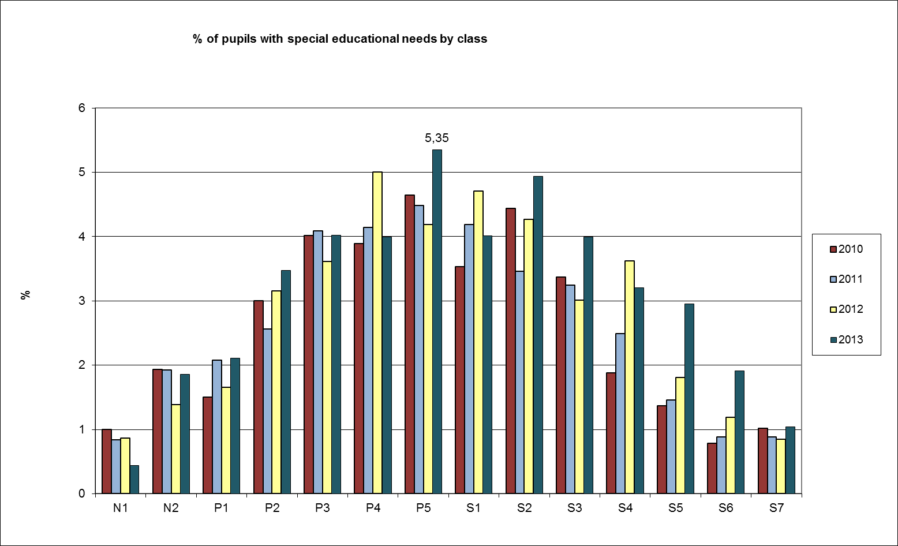

Chart 4. Frequency of diagnosis per cycle

