 | European Schools  Office of the Secretary-General  Human Resources Unit

Ref.: 2013-03-D-3-en-2
Original: EN

Admission of Children of UN Staff to the Brussels European Schools
Board of Governors

Meeting in Brussels on 16 – 18 April 2013

- Background

Following contacts initiated in April 2009 between the UN’s Under-Secretary-General for Management and Vice-President Kallas about the possibility of allowing children of UN staff posted in Brussels to be admitted to the Brussels European Schools and a letter from the Director of the European Commission’s Human Resources Directorate-General of 10 June 2011, on 19 July 2011, the Secretary-General of the European Schools met the Director of the UN/UNDP Brussels Office, who confirmed the request.

The UN/UNDP Brussels Office had expressed the hope that the children in question might be admitted as from September 2012 on the same terms as children of NATO officials (international civilian staff) in accordance with the Board of Governors’ 1987 decision. At its meeting of 26 and 27 October 2011, the Budgetary Committee approved the request for admission, provided that it did not lead to class division and that the school fees to be charged covered the real costs. The Committee also recommended to the Board of Governors that the fees paid by civilian staff of NATO should be reviewed.

On the basis of that opinion, at its meeting of 6-8 December 2011, the Board of Governors did not agree to the request for admission of children of UN staff to the Brussels European Schools on the same terms as those granted to children of NATO officials (international civilian staff) and a mandate was given to the ‘School Fees’ Working Group to review the school fees charged for children of NATO civilian staff, with a view to bringing the fee level into alignment with the cost of a pupil in the Brussels European Schools for the beginning of the 2013-2014 school year in September 2013.

In the light of the opinion of the Budgetary Committee and of the Board of Governors, the UN/UNDP Brussels Office presented in October 2012 a new request on the following basis:

- enrolment would be on the same terms as those for a category II pupil in the Brussels European Schools;

- the signing of a financing agreement for these pupils’ admission would not be required.

This proposal was discussed in the following meeting of the Budgetary Committee on 6 and 7 November 2012 and in the meeting of the Board of Governors in December 2012. Finally, a written procedure was launched in January 2013, but the proposal did not reach the required unanimity.

In the meantime the Board of Governors decided in December 2012 concerning the category III fees, based on different proposals prepared by the School Fees Working Group, to increase the annual adjustment of the fees by a one shot (between 20% to 30% depending on the school) and to foresee lower reduction rates for siblings for all pupils newly enrolled as category III pupils in the 2013/2014 school year (20% instead of 50% for the first sibling and 40% instead of 75% for the following siblings).

With this increase the school fees charged for children of NATO civilian staff, who have to pay double of the category III fees, will amount for children newly enrolled in the 2013/2014 school year to

- Nursery: €6.892,06
- Primary: €9.476,68
- Secondary: €12.922,72

and will be in consequence – in average – close to the cost of a pupil in the Brussels European Schools which amount to €10.675.

II. ‘New’ approach

Representatives of the UN/UNDP Brussels Office, expressing the wish to reiterate the UN request for admission of children of its staff to the Brussels European Schools, met with representatives of the Secretary-General of the European Schools on 27 February 2013 to discuss again the request.

In this meeting it was agreed to come back to the initial request to find an agreement with the UN similar to the agreement with NATO. For children of the NATO civilian staff the double of the category III fees are charged and the new reductions for siblings (20% for the first sibling and 40% for the following siblings) have to be applied.

It is assumed that this approach could find the necessary support in the Budgetary Committee and the Board of Governors since

- the conditions with respect to the amount of the school fees have substantially changed due to the decided increase of the school fees for pupils newly enrolled as category III pupils and
- due to the fact that such a decision would concern ‘other pupils’ as referred to in Article 1 paragraph 2 of the Convention defining the Statute of the European Schools and therefore would not require unanimity.

Article 1 paragraph 2 of the Convention defining the Statute of the European Schools states that ‘the purpose of the Schools is to educate together children of the staff of the European Communities. Besides the children covered by the Agreements provided for in Article 28 and 29, other children may attend the Schools within the limits set by the Board of Governors.’

The agreements mentioned in Article 29 of the Convention are category II agreements which require, according to the clear wording of Article 29 of the Convention, unanimity. Different from ‘Article 29 agreements’, the admission of ‘other pupils’ (category III pupils) has to be in the limits set by the Board of Governors. The decision concerning these ‘limits’ requires in accordance with Article 9 of the Convention ‘only’ a qualified majority.

The new proposal would affect according to the latest data around 30 potential pupils.

The children concerned are of several different nationalities and applications might be submitted for enrolment in the Dutch, English, French, German, Greek, Italian and Spanish language sections.

The admission of these pupils would be accepted provided that it did not result in class division and would be subject to the provisions of the Policy on Enrolment in the Brussels European Schools in force.

As the new approach could conflict the enrolment procedure already started for the 2013/2014 school year it is recommended that the agreement with the UN authorities should ‘enter into force’ as of the 2014/2015 school year.

III. Discussion in the ‘School Fees Working Group’

The ‘new’ proposal was discussed in the ‘School Fees Working Group’ at its meeting on 28 February 2013 and found the support of all delegations with the exception of Interparents, whose position against is purely due to the severe overcrowding conditions in the four Brussels European Schools. Interparents also questioned the privileged situation of UN staff in relation to other parents seeking for enrolment as category III.

Concerning the second point (privileged situation for UN staff) and without questioning the proposal to agree on the admission of children of UN staff, also the other Members of the Working Group underlined the need for the Board of Governors to agree a coherent admission policy so that requests can be considered in future from similar organisations with an international workforce.

IV. Opinion of the Budgetary Committee

The Budgetary Committee recommended to the Board of Governors to agree on the admission of children of the UN staff under the same conditions as the pupils of NATO civilian staff in the Brussels European Schools as of the 2014/2015 school year. The French delegation and Interparents did not support this proposal due to the severe conditions in the Brussels European Schools

V. Proposal

The Board of Governors is asked to agree on the admission of children of the UN staff under the same conditions as the pupils of NATO civilian staff in the Brussels European Schools as of the 2014/2015 school year.

Annex
Over view concerning the UN request

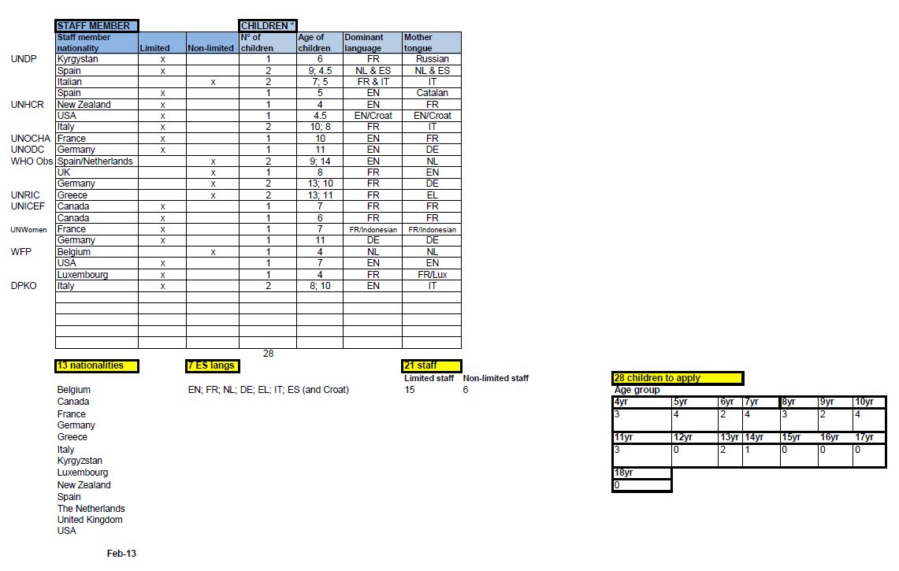

Doc. 2012-10-D-13-en-2.
Written Procedure No 2013/6.
Only staff with ‘international official’ status are concerned, the majority of such staff being in post in Brussels for three to four years on average.
See annex.

