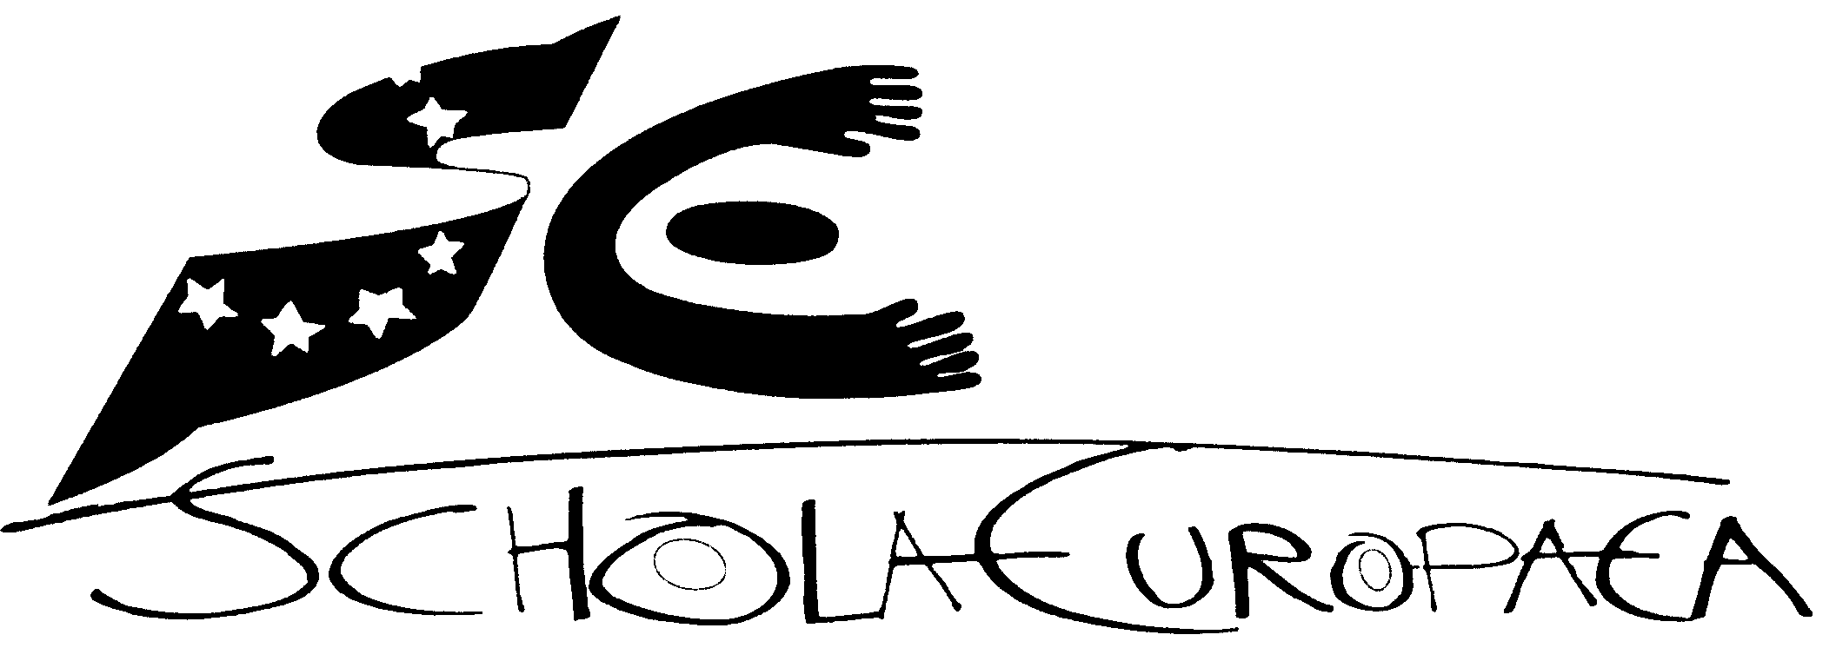 | European Schools  Office of the Secretary-General  Human Resources
Ref.: 2013-03-D-2-en-2

Orig.: EN

School Fees for the Children of the Civilian Staff of NATO
Board of Governors
Brussels, 16 – 18 April 2013

- Introduction

In April 2011 the Board of Governors mandated the Secretary General “to set up a Working Group to engage in general reflection on the funding of the European Schools system, in particular on the financial contribution of the categories other than category I’.
Furthermore, in December 2011 the Board of Governors mandated the ‘School Fees’ Working Group to review the school fees for children of NATO officials (international civilian staff) with a view to align the fee level with the cost of a pupil in the Brussels European Schools for the beginning of the 2013/2014 school year in September 2013.
Concerning the category III fees the Board of Governors decided in December 2012, based on different proposals prepared by the Working Group, to increase the annual adjustment of the fees by a one shot (from 20% up to 30%) and to foresee lower reduction rates for siblings for all pupils newly enrolled as category III pupils in the 2013/2014 school year.

- Main facts concerning the school fees for children of NATO officials

- General
Children of the civilian staff of NATO are pupils covered by an April 1987 decision of the Board of Governors involving particular rights (priority for admission purposes) and obligations (payment of specific school fees), so that they are akin to category II pupils. However, the Board of Governors clearly decided that unlike category II pupils, they would not be entitled to automatic admission but would simply have priority in relation to other category III pupils.

- Enrolment policy
Abiding by the decisions of the Board of Governors it is stated in Annex I of the “Policy on enrolment in the Brussels European Schools for the 2013-2014 school year” (2012-12-D-8-en-3) that
- the admission of children of the civilian staff of NATO cannot entail the division of a class;
- these applications are dealt with after the admission of category I pupils and of other category II pupils but before applications for the enrolment of category III pupils;
- for the 2013-2014 school year, places in the Brussels Schools will initially be awarded in compliance with the general enrolment rules.

In the current school year 2012-2013 in total 88 children of the civilian staff of the NATO are enrolled at the Brussels Schools.

Brussels I | 20
Brussels II | 48
Brussels III | 10
Brussels IV | 10
total | 88

3. Current school fees
Concerning the school fees for NATO officials the Board of Governors decided in April 1987 that the priority given to the children of the civilian staff of NATO “…would entail the payment of specific school fees.”
At present, these specific school fees amount for each cycle to double the fees charged for category III pupils. Moreover, the civilian staff of the NATO is entitled to the same school fee reductions for siblings as foreseen for other category III pupils.

For the 2012-2013 school year, the school fees payable for children of the international civilian staff of NATO are – provided that they were already enrolled in the 2012/2013 school year - will be the following:
- Nursery: €5,623,92
- Primary: €7,732.96
- Secondary: €10,544,94

For children newly enrolled in the 2013/2014 school year the fees will be in the Brussels Schools the following:
- Nursery: €6.892,06
- Primary: €9.476,68
- Secondary: €12.922,72

This increase results from the decision of the Board of Governors to increase the category III fees for newly enrolled category III pupils by a minimum of 20% and a maximum of 30% depending on the individual decision of the administration board of each European School. In Brussels the four Schools concerned agreed on a one shot increase of 25%.

- Discussion of the ‘School Fees’ Working Group
Taking in consideration that the annual average cost of a pupil in the Brussels European Schools amounts to €10,675, the School Fees Working Group considered a further alignment of the NATO fees not to be necessary at least in the short term.
One delegation questioned the privileged treatment of NATO civilian staff in relation to other parents seeking an enrolment as category III.

- Opinion of the Budgetary Committee
The Budgetary Committee recommended not change the fees for NATO civilian staff, because the school fees for these pupils are close to the real costs per pupil in the Brussels European Schools.

- Proposal
Due to the increase of the category III fees decided by the Board of Governors in December 2012 there is no need for further alignment of the school fees for NATO civilian staff to the average cost per pupil.

Annex I

 | Evolution of the number of enrolment demands for pupils of the NATO civilian staff
 |  |  |  | 4/03/2013
 | Demands for enrolment
 | School | 2010-2011 | 2011-2012 | 2012-2013
 | Bruxelles I | 2 | 4 | 7
 | Bruxelles II | 15 | 14 | 5
 | Bruxelles III | 6 | 1 | 10
 | Bruxelles IV | 1 | 2 | 3
 | Total | 24 | 21 | 25
 | Attributed places
 | School | 2010-2011 | 2011-2012 | 2012-2013
 | Bruxelles I | 3 | 1 | 7
 | Bruxelles II | 11 | 10 | 2
 | Bruxelles III | 6 | 3 | 7
 | Bruxelles IV | 4 | 7 | 9
 | Total | 24 | 21 | 25
 | Definitely accepted places
 | School | 2010-2011 | 2011-2012 | 2012-2013
 | Bruxelles I | 3 | 1 | 5
 | Bruxelles II | 11 | 9 | 1
 | Bruxelles III | 4 |  | 7
 | Bruxelles IV | 2 | 2 | 5
 | Total | 20 | 12 | 18

Annex II

‘One shot’ increase concerning category III fees
decided by the Administration Boards of the 14 European Schools

School | Percentage
Alicante | 25%
Bergen | 20%
Brussels I | 25%
Brussels II | 25%
Brussels III | 25%
Brussels IV | 25%
Culham | 20%
Frankfurt | 25%
Karlsruhe | 20%
Mol | 25%
München | 30%
Luxembourg I | 20%
Luxembourg II | 20%
Varese | 20%

For the details of the enrolments of the pupils of NATO civilian staff in the last years see the Annex I.
For the details see Annex II.
Interparents.

