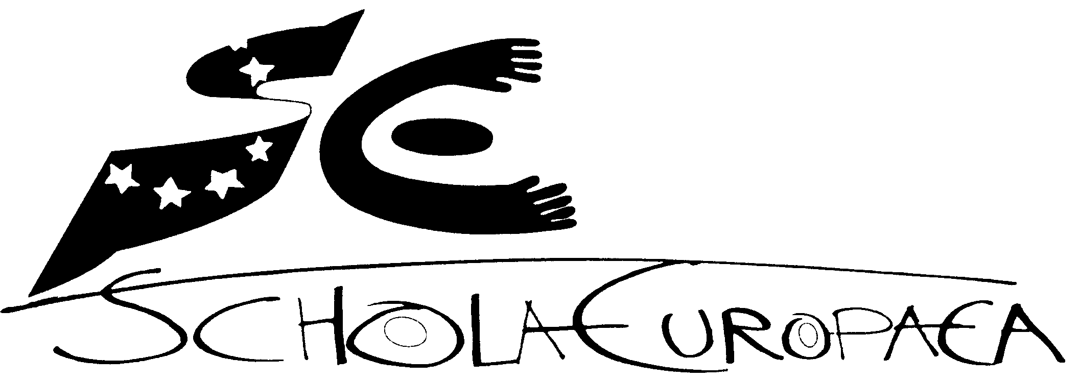 | Schola Europaea  Office of the Secretary-General  General Secretariat

Ref.: 2013-01-D-76-en-3
Orig.: EN

General Interest File – Europa School UK
BOARD OF GOVERNORS OF THE EUROPEAN SCHOOLS
Meeting on 16-18 April 2013 – Brussels

OPINION OF THE JOINT BOARD OF INSPECTORS (NURSERY, PRIMARY AND SECONDARY)

At its meeting 6 February 2013, the Joint Board of Inspectors scrutinised and discussed the General Interest File submitted by the UK authorities with respect to the request for the creation of an accredited type II European School at Culham (UNITED KINGDOM), offering nursery and primary schooling (P1-P2). The full primary cycle (P1-P5) will become effective as from the 2016-2017 school year. As from September 2017, Europa School UK will offer a full education for the secondary cycle (S1-S7), leading to the European Baccalaureate.

The Joint Board of Inspectors considers that this File meets the requirements of the first stage of the accreditation process as defined at Mondorf in April 2005 and recommends that the Board of Governors should approve it.

OPINION OF THE BUDGETARY COMMITTEE

At its meeting of 19 and 20 March 2013, the Budgetary Committee scrutinised and discussed the General Interest File submitted by the UK authorities with respect to the request for the creation of an accredited type II European School at Culham (UNITED KINGDOM), called Europa School UK. The full primary cycle (P1-P5) will become effective as from the 2016-2017 school year. As from September 2017, Europa School UK will offer a full education for the secondary cycle (S1-S7), leading to the European Baccalaureate.

The Budgetary Committee considers that this File meets the requirements of the first stage of the accreditation process as defined at Mondorf in April 2005 and recommends that the Board of Governors should approve it.

Background
Europa School UK: Providing multicultural, multilingual, European education
Oxfordshire has long been a European and international centre for scientific research. In 1960 a purpose-built fusion laboratory was opened in Culham, which is known today as the Culham Centre for Fusion Energy. Among other projects, the centre hosts the Joint European Torus (JET), which opened in 1978. To support the families of staff involved in the project, a European School was opened in the same year at a nearby site, also in Culham. The later diversification of the JET project and consequent reduction in category I pupils led to the decision in 2007 to phase out the European School over the period 2010 to 2017.
Given the continued popularity of the European School Culham and the pertinence to the region of the education offered there, attempts were made to reconstitute the school under a new funding arrangement. The first of these involving the rapid conversion of the school into an academy foundered in 2011, but a renewed attempt has given rise to the Europa School UK which opened its doors to great success in September 2012.
On the basis of a site sharing agreement with the European Schools Board of Governors and the Department for Education, the site owner, the Europa School UK will progress from the current position of covering the ages 4 to 7 years old to completing the full Primary Cycle in the 2016 to 2017 academic year, gradually replacing the European School which ceased to open new year groups in 2010. With the closure of the European School in 2017, the Europa School will take over the complete Secondary cycle at once.
The Europa School UK is funded by the Department for Education as a Free School and is able to choose any curriculum that can support the standards required by the Department. It seeks to offer a programme based on that of the European Schools, consistent with the Mondorf criteria and culminating in the European Baccalaureate.
The demand for a European Curriculum
Despite its imminent closure, the European School of Culham remains as popular as ever, oversubscribed, with new students always willing to take the place of any who leave. In offering to continue European School type education, the Europa School UK has begun also vastly oversubscribed. Currently, between the two schools, there are over 840 pupils on the site, evenly distributed over the age groups. There is enough demand for the Europa School to consider opening a third form of entry at some point in the future.
The reasons for this popularity were explored in research for the 2009 academy application and remain valid today. They include links to EFDA-Jet; European Commission; European Medicines Agency, European Space Agency, European Investment Bank; BG Group plc; BMW; COFACE; DHL International; Dow Agrosciences; European Centre for Medium Range Weather Forecasts; Land Rover; Peugeot Citroën Automobiles UK Ltd; Randstad Holding NV; Reckitt Benckiser; and Volvo Financial Services. The proximity of Oxford University is very influential and has attracted numerous research institutes to the area. Many staff from the University and from Harwell Science Park: n-Power; European Centre for Medium Range Weather Forecasts; Science Vale UK express interest in seeing European School education made available for their children.
Curriculum
While there are many “ex-patriot” families in the region, the state-funded nature of the Europa School UK has also attracted interest from local residents with no previous multilingual experience, but with a strong desire to obtain a diverse linguistic and cultural education for their children. In recognition of this variation in the profile of pupils entering the school compared with that of the European School, it was decided to favour a bilingual teaching approach from the point of entry. All pupils are currently taught 50% of the week through English and 50% through either German or French. The intention is to ensure by the end of Primary an ease of communication and a proficiency in understanding in either language, opening the door to various possible models to continue Secondary education in a way that will ultimately meet the requirements of the European Baccalaureate without incurring unsustainable costs.
The initial bilingual approach is seen as an opening to plurilingualism and already pupils are exposed to the third language through, for example, music lessons, with encouragement to share their knowledge of home languages other than the three vehicular languages of the school. Of the current intake of just over 160 pupils, half have English as a first home language. French and German are frequent home languages, but Arabic, Chinese, Danish, Dutch, Finnish, Greek, Hungarian, Italian, Polish, Punjabi, Russian and Spanish are also present. Many of the English-speaking children in fact have bilingual backgrounds. Some pupils will be operating in four languages between home and school.
The UK context demands certain adjustments to the European Schools programme, notably to respect the form of religious and moral education required within the UK system, to encourage a higher level of competence in IT and to meet the standards required for the Early Years Profile and the Phonics test. None of these are seen as harmful to the overall aim of providing a rounded and successful European education.
Given that much of the driving force behind the project comes from the scientific expertise and research gathered in Oxfordshire, it is natural that the school will favour the promotion of strong science education. In early years this will be focussed on gaining a sound foundation in Mathematics and the European Schools' programme is seen as an ideal basis for this. Over later years, while maintaining the emphasis on Mathematics, critical thinking skills will be encouraged along with the acquisition of sound research techniques and furthering of IT to include competence in programming. Local employers see the school not only as providing education for the children of their employees, but also as providing a future work force capable of furthering scientific research and cultural understanding. We anticipate a fruitful partnership including investment in the facilities of the school.
The exact path through to the European Baccalaureate for the intake of the Europa School has yet to be determined, but there will be a profound respect for the choices made by those current pupils of the European School who will finish their schooling with the Europa School. Efforts have already begun to seek the funding necessary to provide a mix of language teaching, which will meet their needs and take them through successfully to the Baccalaureate. Particular attention will be paid to those who will be half way through the Baccalaureate programme in 2017.
While the European Baccalaureate will be the preferred choice for 16 to 19 education for many pupils, consideration will be given to providing an alternative school leaving qualification for those who are not targeting university entrance level. The education system in England and Wales is undergoing change, with the extension of compulsory education to 18 prior to the Europa School taking on Secondary education, and changes for the current obligatory 16+ examinations. The school will work closely with the Department for Education to ensure that pupils of the Europa School are able to prepare properly for the European Baccalaureate within the ultimate framework chosen for England and Wales.
Teaching
The Europa School UK currently requires of teachers C2 level in the language in which they are teaching, along with qualified teacher status as recognised mutually within the European Union. Experience and qualifications from other European States are respected in establishing the correct point on the pay scale, which is that of the English state system. Teachers are also expected to offer to pupils a profound experience of the culture of countries in which the respective language is spoken and to enrich the pedagogical experience of the school by offering and accepting the benefit of their various training and experience.
Recruitment is open and conducted according to best employment practice. The Europa School welcomes applications from teachers with experience of the European Schools as well as the various national and international systems.
Support
The school also employs teaching assistants to operate in the classroom alongside teachers. They speak the same language as the teacher and reinforce an immersion approach to language acquisition. Their role is split between general support and supporting pupils with special educational needs. The school has additional support for these pupils along with training for staff from Oxfordshire County Council and where necessary the Health Service. While maintaining a challenging curriculum for all, the school seeks to be inclusive and cater for a wide range of ability and background.
Governance, funding and premises
The Europa School was established by a group of Trustees who remain the custodians of the founding vision of the school. The Governing Body is drawn from Trustees and Parent and Staff representatives and will incorporate others interested individuals according to need. The school is classified as a Free School and overseen by the Department for Education, particularly by its branch, the Educational Funding Agency. It is registered as a company, limited by guarantee in England and Wales. Funding is in proportion to pupil numbers and in line with the English state system. Additional funding is available for setting up the school, including the improvement of some facilities. The Europa School will, as a junior partner, share the site with the European School until 2017 with the option of taking over the whole site from that point forward. Those involved in the Europa School take a long-term view of its provision of education within the area, and recognise that it not only benefits from the incoming investment in Oxfordshire, but also, by meeting a clear need, provides an incentive for further investment.

Peter Ashbourne, Principal, Europa School UK
January 2013

