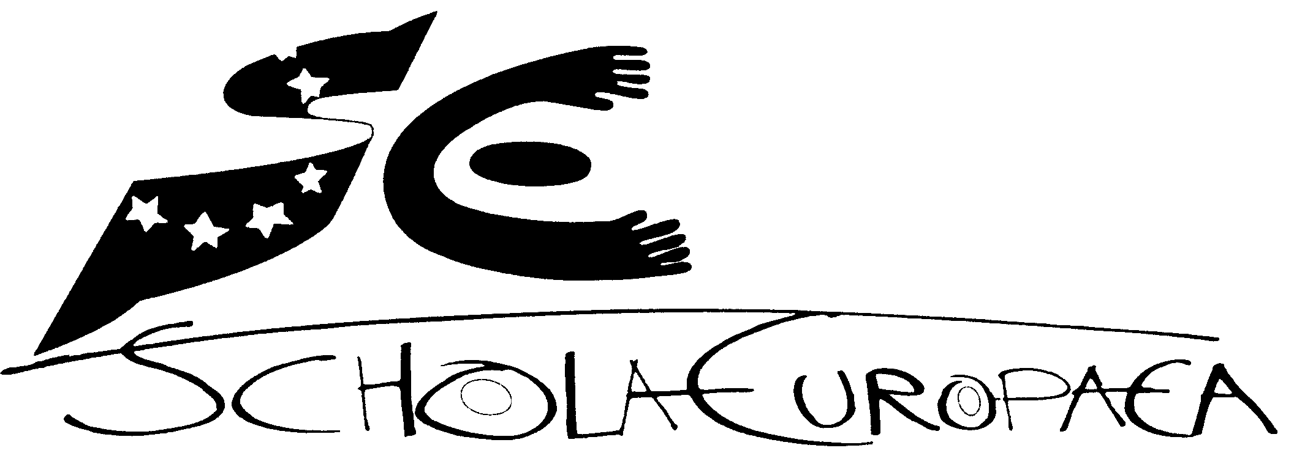 | European Schools  Office of the Secretary-General  Pedagogical Development Unit  European Baccalaureate Unit
Ref.: 2011-09-D-47-en-5
Orig.: EN

Structure for all syllabuses in the system of the European schools

APPROVED BY THE JOINT BOARD OF INSPECTORS AND THE JOINT TEACHING COMMITTEE AT THEIR RESPECTIVE MEETING OF 11, 12 and 13 FEBRUARY 2015

Immediate entry into force

General structure for all syllabuses in the system of the European schools

Competences are the basis for the European Schools’ syllabuses. Competences include knowledge, skills and attitudes that are appropriate to different contexts. They are fundamental for developing problem-solving strategies and critical thinking.

Subject-related competences as well as personal and social competences are defined in each syllabus.

The structure of the European School syllabuses is intentionally brief and precise.

1. General Objectives of the European Schools
The European Schools have the two objectives of providing formal education and of encouraging pupils’ personal development in a wider social and cultural context. Formal education involves the acquisition of competences (knowledge, skills and attitudes) across a range of domains. Personal development takes place in a variety of spiritual, moral, social and cultural contexts. It involves an awareness of appropriate behaviour, an understanding of the environment in which pupils live, and a development of their individual identity.

These two objectives are nurtured in the context of an enhanced awareness of the richness of European culture. Awareness and experience of a shared European life should lead pupils towards a greater respect for the traditions of each individual country and region in Europe, while developing and preserving their own national identities.

The pupils of the European Schools are future citizens of Europe and the world. As such, they need a range of competences if they are to meet the challenges of a rapidly-changing world. In 2006 the European Council and European Parliament adopted a European Framework for Key Competences for Lifelong Learning. It identifies eight key competences which all individuals need for personal fulfilment and development, for active citizenship, for social inclusion and for employment:

- Communication in the mother tongue
- Communication in foreign languages
- Mathematical competence and basic competences in science and technology
- Digital competence
- Learning to learn
- Social and civic competences
- Sense of initiative and entrepreneurship
- Cultural awareness and expression

The European Schools’ syllabuses seek to develop all of these key competences in the pupils.

The text above is identical for all syllabuses.

References to documents of the European Council or of other European institutions concerning aims, objectives, strategies and competences relating to the subject/subjects could be added.

2. Didactic Principles
The learning and teaching of the subjects is based on the following didactic principles:

- Integrated teaching and learning: Links and correlations among the different areas of the European School curriculum make learning a more comprehensive and meaningful experience.
- Active learning: Pupils gradually become responsible for their own learning process

These principles are applied through a variety of teaching and learning approaches and strategies, the use of differentiated teaching methods, and the use of a wide range of learning resources including digital tools and resources.

Didactic principles are provided as a guide for the learning and teaching of the different subjects.

3. Learning Objectives
This section sets out the main learning objectives and expected outcomes to be attained at the end of:

- Nursery cycle
- Each year of the primary cycle for L1 and Mathematics
- Primary cycle for other subjects
- S3
- S5
- S7

Progression should be outlined from one level to the next.

If desirable, key learning objectives and competences to be attained in each year can be recommended / highlighted in the continuum for any subject.

Greater alignment needs to be provided in the transitional years P5 - S1.

4. Contents
The relevant contents in each subject necessary to meet the learning objectives are outlined. Contents are sequenced per each year/cycle.

5. Assessment
The basis for assessment are the learning objectives for each year/cycle. Specific assessment criteria in relation to the pupils’ attainment are set for each subject. Assessment criteria must meet the principles of validity, reliability and transparency according to the Assessment Policy in the European Schools (Ref: 2011-01-D-61-en-4 Assessment Policy in the European Schools).

5.1. Attainment descriptors
Each syllabus should contain attainment descriptors for each cycle. The structure of the attainment descriptors for each cycle for all subjects will be based on the European Schools general marking scales.

6. Annexes
Annexes with comments, clarifications, further considerations and any other supporting documents may be added to the European Schools syllabuses when considered necessary or convenient. All primary syllabuses include general assessment criteria.

6.1. Sample Baccalaureate examination paper
Syllabuses for years s6 –s7 secondary education will contain a sample Baccalaureate examination paper.

DECISION OF THE JOINT BOARD OF INSPECTORS AND THE JOINT TEACHING COMMITTEE

At its meeting of 11 February 2015, the Joint Board of Inspectors approved this document and the related actions:

- Application of the document in all syllabuses that are under revision at the moment in both primary and secondary;

- Secondary Inspectors revise/rewrite/develop the syllabus for their respective subject(s) and define the competences (knowledge, skills, attitudes) to be attained by the end of each cycle, including subject-related attainment descriptors for the assessment for each cycle.

- Syllabuses including assessment criteria and subject-related attainment descriptors for the Secondary years 1-6 must be ready for approval in February 2017. Implementation will start in September 2017.

- Syllabuses including assessment criteria and subject-related attainment descriptors for the Secondary year 7 must be ready for approval in February 2018. Therefore, with effects on Baccalaureate session 2019. It can be implemented earlier if the inspectors responsible for the different subject consider it convenient.

- Adaptation of current syllabuses according to the document as soon as possible and information to directors/deputy directors/teachers about changes.

At its meeting of 12 and 13 February 2015, the Joint Teaching Committee took note of this document (2011-09-D-47) and approved the related actions by the way of the document “Competence-based syllabuses including assessment criteria and subject related attainment descriptors” ref: 2015-01-D-62-en-1. It is being sent forward to the Board of Governors for its information.

The related actions expressed in the document “Competence-based syllabuses including assessment criteria and subject related attainment descriptors” have been included now in the document 2011-09-D-47-en-5, by consequence the document 2015-01-D-62-en-1 is concluded.

