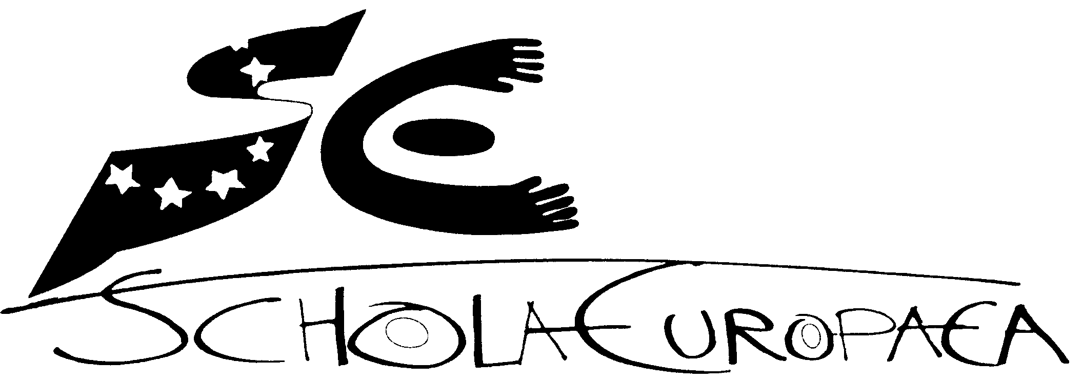 | Schola Europaea  Office of the Secretary-General
Ref.: 2008-D-305-en-2
Orig.: EN

Role of the boards of inspectors and areas of quality assurance within their fields of competences

Joint Board of Inspectors (Nursery, Primary and Secondary)
Meeting on 12th November 2008
Role of the boards of inspectors and areas of quality assurance within their fields of competences

- Introduction

In reference to chapter B3 of the Convention (8) the Boards of Inspectors (the Inspectorate) underline the importance of the functions described in this document. In addition to this the Boards have to face new challenges: the internal reform, the need of a holistic and well integrated quality assurance system for the whole ES system and the opening up of the system. Against this background and awaiting the outcome of the external evaluation of the Baccalaureate the Boards of Inspectors want to draw the attention to the following areas in particular.

- Internal reform

2.1 Governance (Role of the Boards of Inspectors)

The existence of two Boards of Inspectors is laid down in the Convention. The inspectors are convinced that given the specificity of both levels two separate Boards of Inspectors are necessary to guarantee the quality of all aspects of teaching and learning processes. At the same time the Boards of Inspectors are in process of strengthening the role of the Mixed Board of Inspectors.

For the further development of the quality of the work the Boards will provide a system of internal evaluation at regular intervals.

It will be a task for the boards of Primary and Secondary Inspectors in the future to continue the development of a unique European curriculum for European schooling. Inspector’s responsibility will be to harmonize and coordinate curriculum development and to oversee the implementation process of it in the schools type I, II and III

2.2 Autonomy of schools

The background of the role of the inspectorate in the autonomy process will be a clear and unambiguous description of autonomy of schools.

Pedagogical objectives
Regarding the increase of autonomy for schools the inspectorate aims to continue the development of syllabuses which reflect the general pedagogical objectives according to the frames given by the Board of Governors.
Schools take responsibility in setting their pedagogical objectives (cfr. Attainment contracts). The inspectorate assures that the pedagogical objectives of the school mentioned explicitly in the agreement contract are in line with the general pedagogical objectives. The inspectorate evaluates the implementation of these objectives on a school level including the internal planning processes.

Self evaluation
The inspectorate develops criteria for evaluation and self-evaluation. The inspectorate promotes a compatible approach between self-evaluation by the school and inspection on the basis of common criteria. The inspectorate should be frequently informed about the outcomes of the school advisory councils of the schools.

The monitoring by inspectors should complement the external scrutiny of attainment contracts undertaken by the central administration and budgetary organs of the system of the European Schools and should complement the statistical analysis of the results by the Baccalaureate Unit.

- Quality assurance system

The quality assurance in teaching and learning will be guaranteed by the Inspectorate in many ways. The Inspectorate is in charge to write frameworks, guidelines and other policy papers (LS, SEN, SWALS, Child protection) concerning important processes.
The Inspectorate will propose to the Board of Governors the means of maintaining and developing educational issues and to oversee the implementation of the Board of Governors decisions.

Quality of teaching and learning

The inspectorate is involved in:
- creation and suppression of posts in type I schools
- recruitment of national teachers and managers in type I schools

The inspectorate is responsible for:
- timetabling and decided upon by the Boards of inspectors of Primary and Secondary ;
- overall quality of the syllabuses (This means developing syllabuses, implementation and quality care. Quality and actuality of the syllabuses will be checked every 5 years.)
- verification of the professional qualifications of the locally recruited
- proposition of evaluation of pedagogical and director staff in type I schools
- periodically team inspections and follow-up inspections organised in type I schools;
- team inspections in type I schools and audits in type II/III schools harmonised as much as possible;
- the framework of in-service training in the type I schools;
- the spread of good practise within schools and in individual subjects;
- proposition of creation of working parties to support and improve quality

Baccalaureate

As the Baccalaureate is being externally evaluated this paragraph may have to be modified. For the Boards of Inspectors the following principles are essential :

- Inspectors are responsible for the quality of the Baccalaureate. They are directly responsible for the choice of the written exams.

- Inspectors guarantee the quality and the coherence of the organisation of the baccalaureate in all types of schools. Therefore every school will be inspected by secondary inspectors during the period of the written and oral exams. The Secondary Board of Inspectors decides about the nature of these inspections.

- The baccalaureate-unit is responsible for collecting the data and for elaborating the statistical analysis of the baccalaureate results. The inspectors evaluate these results from a pedagogical point of view in order to develop the quality of the baccalaureate exams.

Other responsibilities

The national inspectors should be aware of the latest development within their national educational systems

The inspectors should provide advice and support for parents and pupils on educational matters in type I schools

Induction of new inspectors

- Opening up of the system (specific aspects concerning type II and III schools)

The quality care of teaching and learning in the type II and III schools should be in line with the QA of the type I schools as much as possible, for instance by using the general inspection framework. The accreditation procedures involve a thorough review of files and dossiers submitted by applicants. In addition to this every two years the inspectorate audits type II and type III schools by teams of inspectors from different countries to ensure that the school involved will continue to conform to the standards. (see Article 6 of the Agreement contract).

The inspectorate is involved in :
- verification of professional qualifications of teachers on request from the school and in line with the signed agreement.;
- audits which will be harmonised as much as possible with the team inspections of type I schools;

The inspectorate is not involved in
- the creation and suppression of posts;
- the recruitment of teachers and managers or verification of professional qualifications;
- the evaluation of pedagogical staff and management including disciplinary matters;
- internal in-service training.

