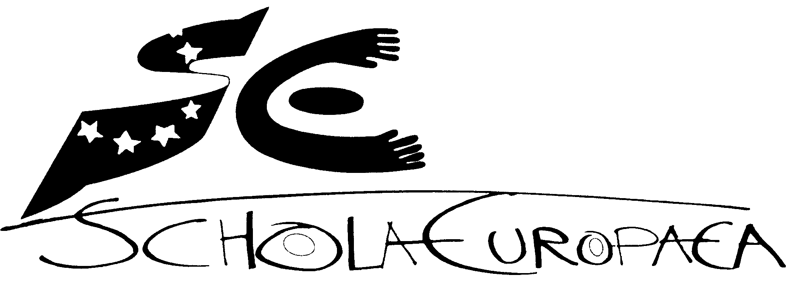 | Ecoles européennes  Bureau du Secrétaire général

Réf. : 2012-01-D-18-en-5
Orig. : EN

European School of Copenhagen – General interest file
Board of Governors of the European Schools
Meeting in Oxford on 18, 19 and 20 April 2012

OPINION OF THE JOINT BOARD OF INSPECTORS (NURSERY, PRIMARY AND SECONDARY)

At its meeting of 7 February 2012, the Joint Board of Inspectors scrutinised and took note of the General Interest File submitted by the Danish authorities concerning the application for the setting up of a type II accredited European School in Copenhagen (DENMARK), offering an all age-range education – nursery, primary and secondary – leading to the European Baccalaureate.

The Joint Board of Inspectors considers that this file meets the requirements of the first stage of the accreditation process defined at Mondorf in April 2005 and recommends that the Board of Governors should approve it.

OPINION OF THE BUDGETARY COMMITTEE

At its meeting of 13 and 14 March 2012, the Budgetary Committee took note of the General Interest File submitted by the Danish authorities concerning the application for the setting up of a type II accredited European School in Copenhagen, Denmark.

The Budgetary Committee considers that this file meets the requirements of the first stage of the accreditation process defined at Mondorf in April 2005 and recommends that the Board of Governors should approve it.
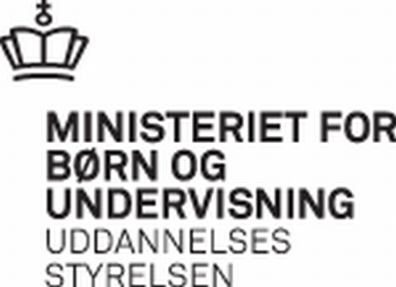
The Secretary-General of the European Schools, Mr. Kari Kivinen
kari.kivinen@eursc.org

Dear Mr. Kivinen 27-01-2012

As you may know the Danish Ministry of Children and Education is interested in increasing the number of school places in the region of Copenhagen in order to attract foreign employees.

It is therefore my pleasure to ask the Board of Governors for approval of an associated European School of type II in Copenhagen.

Please find enclosed the File of Interest.

Yours sincerely

Christine Antorini

File of Interest
Copenhagen 2012

1. Introduction

The regulation establishing the European Environment Agency (EEA), the European Environment Information and Observation Network (EIONOT) was adopted by the European Union in 1990 (Council Regulation, ECC, no. 1210/90 of 7 May 1990) and came into force in late 1993 immediately after the decision was taken to locate the EEA in Copenhagen. The agency commenced its official operation in 1994 and has now 32 member countries. Furthermore, there are two small European institutions in Copenhagen: The European Parliament Information Office (EPIO) and the European Representation Office in Denmark (ERO).

The EEA’s location in Copenhagen has elicited a need for a European School in Copenhagen, as the children of EEA employees are of European backgrounds. Additionally, the rising influx of expatriates to Denmark adds to the increasing need for international school places. A telephone survey performed in 2009 by the Municipality of Copenhagen revealed that international schools were short of 2000 school places for the children of foreign employees. Furthermore, a study conducted by Oxford Research revealed that 37 percent of the expatriates living in Denmark were considering moving due to the lack of international schools, making it difficult for international institutions, non-governmental organisations and companies to recruit foreign personnel with children ready for school. Thus, the urgent need for greater capacity in international schools is considered a serious problem in relation to attracting and retaining highly skilled labour. In order to prevent deterioration of Denmark’s competitiveness, close attention is being paid to meet the needs and demands of the international community in Copenhagen.

In coordination with the EEA, the Danish Ministry of Children and Education and the City of Copenhagen have taken the initial steps to apply for an accredited European School type II, offering a complete educational cycle that comprises nursery, primary and secondary education, resulting in the European Baccalaureate.

The European school will be collocated with the existing Danish school Sankt Annæ Gymnasium, which has a similarly high academic standard and international orientation as the European school. The collocation of the two schools will render beneficial settings such as creating greater interaction between the Danish and international students, thereby fostering synergy and a broader cultural understanding among the students, and furthermore provide a smoother arrangement for the European School to be established in Copenhagen in terms of locality and regulation.

2. Rationale
In order to alleviate capacity constraints, the Danish Parliament passed a new law in April 2010, allowing private international schools to open new subsidiaries located farther than walking distance from existing facilities. Even though such initiatives have created better framework conditions, the need for international schools in Denmark has not yet reached equilibrium. The rising demand for accredited international school places keeps outpacing the supply, which lessen the attractiveness for highly skilled workers with families seeking to Denmark. Adding to this, Danish companies are facing major challenges attributed to an aging workforce, and difficulties in attracting and retaining highly skilled labour in comparison to other OECD countries.

Number of pupils
Increasing demand for education that meets a curriculum of international standards has peaked with the rising employment at the EEA. The EEA estimates that its recruitment of personnel from different parts of Europe would be considerably easier, if it could provide an accredited European school and thereby make it easier for students to transfer to and from national school systems in other EU member states. The agency has grown tremendously over the last five years, from 65 to 200 employees with approximately 148 children under the age of 18 years. In November 2011, the total number of children rose to 165 when including the children of employees working at EPIO and ERO. There are 38 children in the age group 0-3 years; 34 in the age group 4-6 years; 51 in the age group 7-11 years and 42 in the age group 12-19 years.

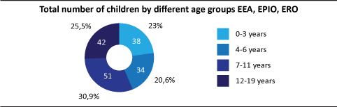

On the basis of the data made available by the European organisations, the Danish and English speaking children will stand out in number. There is an almost equal distribution of children with German and French as their mother tongue, which highlights the issue of making a decision that benefits and accommodates the further development of a European School type II. As part of the ongoing dialogue with the European organisations, further investigation is to be conducted internally in order to justify the choice of either French or German. However, the organisations have already announced that the choice of the third language section (French or German) should also find its justification in the total student number and the overall demand in one of the given language sections. The preferred third language choice of the European organisations will be announced in spring 2012 with the proviso that the implementation of the third language may start 2013 or postponed to a later date. A more perceptive implementation plan of the third language section will be made available in the Dossier of Conformity.

International Schools in Denmark

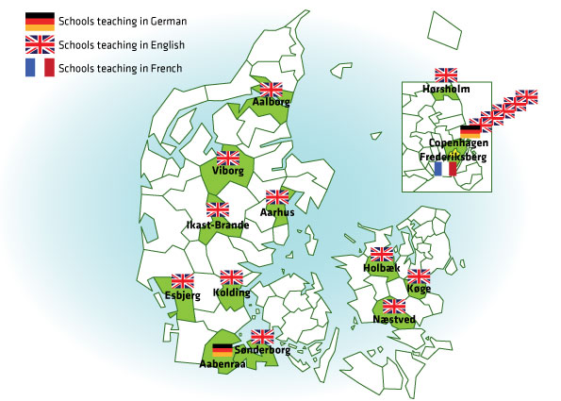
Denmark supports private schools with a relatively substantial government subsidy. In large part, international schools in Denmark are private and charge tuition fees, while some of the schools that offer the International Baccalaureate Diploma Programme are run by the state and are free of charge. Private tuition fees in Denmark range from 2.400 Euro to 17.000 Euro per year. At present, there are 22 schools offering international primary education and 15 offering the international upper secondary education. There are only one school (Copenhagen International School) in the Greater Copenhagen Area that are fully accredited to offer a full scale IB programme, covering the Primary Years, Middle Years and the IB Diploma Programme.

International schools in Copenhagen such as the French and German offer their own national programmes. In addition, there are several international schools, which offer an English curriculum equivalent to the ones in the US and the UK. Eleven of the international schools are located in and around the larger metropolitan area of Copenhagen and the remaining are located in Jutland. Within the metropolitan area of Copenhagen, there are currently 3323 pupils enrolled in private international schools.

The City of Copenhagen and the Øresund Region
The international magazine Monocle has ranked Copenhagen as the best city to live in due to its quality of life, transport infrastructure and the population’s respect for the environment. Copenhagen is a lively and open capital city with an active internalisation policy, focusing on creating the best framework conditions for the city’s international citizens and visitors. The city is located on the Western part of the Öresund Region, the water passage between Denmark and Sweden that connects the North Sea with the Baltic Sea. The opening of the Öresund Bridge in 2000 has diminished the importance of the national borders and promoted economic growth.

The Öresund Region has approximately 3.7 million inhabitants and it is expected that within the next 18 years, the region will receive another 300.000 new inhabitants and out of the total number, roughly 100.000 are expected to reside in Copenhagen. The Öresund Region has a profound concentration of leading research centres, with core competencies within medicine, biochemistry, biotech, information technology, environmental technology, food control and telecommunications. Moreover it is one of Europe’s leading university regions, as it has 12 universities with more than 150.000 students and 12.000 scientists, facilitating a dynamic transnational phase, transferring knowledge and employment opportunities between the Nordic regions. The Öresund Region adds value through innovative environment and high scientific output, and it is an important hub for economic activity and is well suited to compete in the global market within research, industry and innovation. With the Öresund Region’s growth and development, the demand for international school places is expected to rise simultaneously, as the number of newcomers with international backgrounds will increase.

Over time the number of international institutions and companies has grown significantly and the number of expatriates in Denmark has grown accordingly. Copenhagen hosts 197 international institutions, embassies and six UN offices. The number of work and residence permits has increased significantly since the beginning of 2004. In July 2010 the National Labour Market Authority registered 34.161 foreign workers in the metropolitan area of Copenhagen. Although foreign owned companies only represent 1 percent of the private companies in Denmark, almost one in five of all private employees work in a foreign owned company. Moreover, 65 of the world’s largest companies have set up regional headquarters in the Nordic countries, and 26 out of the 65 are placed in the Öresund Region, where the number of regional headquarters has doubled in the last couple of years. Further, a new agreement between the Danish and Swedish governments paves the way for the Öresund Region hosting a new European research facility known as the European Spallation Source (ESS) located 30 min. from central Copenhagen. The agency will be the first major pan-European centre for material research and life science employing 400 researchers. A final agreement on the status of ESS is still to be negotiated. As a result of continued internationalisation tendencies, further growth is anticipated in the total number of international companies and institutions in Copenhagen.

3. The School
The legal context
The Danish educational law does not cover the educational system of the European Schools type II, and the Ministry of Children and Education will therefore propose an act, amending the current legislation to enable the establishment and operation of a European School type II in Copenhagen.

Sankt Annæ Gymnasium (The Copenhagen Choir School).
The City of Copenhagen is planning to collocate the new European School type II with a well established public school, Sankt Annæ Gymnasium (SAG), also known as the Copenhagen Choir School. No previous experiences have been made on the process of collocating a Danish public school with a European school. Crucially, a great amount of attention will be paid to secure that the chosen solution appeases both school systems. The optimal result should be the most beneficial outcome for the new school. Therefore, no definite decision on the collocation will be taken until the City of Copenhagen is convinced that the physical integration of the two schools will be successful, with the core aim of securing excellent education that gives recognition to and promotes the expressions of these two main school traditions. The City of Copenhagen has formed a working group that will start looking into this matter and their recommendations will be noted in the Dossier of Conformity.

Sankt Annæ Gymnasium is known for choral singing of a high international standard, and has a long tradition for developing strong international ties. It is one of the most recognised and prestigious public schools in Denmark, providing education that spans from primary to upper secondary – leading to STX, the Danish examination after grade 12 - equivalent to the European Baccalaureate. With a proud tradition for music and academic excellence, SAG will render a beneficial setting for the European School type II in terms of a high academic standard and a vibrant, creative and internationally orientated learning community. The merging of the European School type II with an existing school in Copenhagen will enhance the network and friendships between the international and the local community, and also reduce preliminary expenses. In order to enable the establishment of a European School in Copenhagen, a change or an addition in the legislative and institutional framework may be required. The legislative and institutional framework grants the Sankt Annæ Gymnasium an exceptional authorisation and status compared to other public schools in Denmark. Hence the European school might create precedent in the integration with Sankt Annæ Gymnasium. The proposed Act will be incorporated into the Danish educational law and regulations, which at the same time comply with the criteria of a European School and education. The Act is intended to come into force in December 2012.

Educational vision
The aim of establishing a European School type II in Copenhagen is to offer a multilingual and multicultural education with high syllabi standards to foreign employees’ children and the children of Danish employees, especially the children of the EEA staff. Furthermore, the European School will increase the possibility for Danish children to enrol in the European educational system, hereby enhancing European and international competences among the Danish future workforce.

The European School will adhere to the fundamental principles of the European School syllabi, where students will meet high standards in all subjects. The instruction programme will be based on pedagogical methods that cultivate respect and tolerance, emphasising the understanding of and coping with different cultures and backgrounds. Furthermore, the vision of the school is to prepare the students to consolidate their role as European citizens in a democratic society - and within a larger global context.

Though Sankt Annæ Gymnasium and the European School hold separate syllabi, they both share the reputation as educating highly skilled and qualified students for higher educations. Sankt Annæ Gymnasium’s core values encompass creativity, professional competence, equality and international orientation and these values have been the driving force for maintaining a high educational standard. The collocation will be beneficial in the respect of consolidating an equal atmosphere, where children of international backgrounds can feel appreciated and at ease.

Education in the new school will adhere to the fundamental guiding principles of the European Schools:
- to give pupils confidence in their own cultural identity – the bedrock for their development as European citizens;
- to provide a broad education of high quality, from nursery level to university-entrance;
- to develop high standards in the mother tongue and in foreign languages;
- to develop mathematical and scientific skills throughout the whole period of schooling;
- to encourage a European and global perspective overall and particularly in the study of the human sciences;
- to encourage creativity in music and the plastic arts and an appreciation of all that is best in a common European artistic heritage;
- to develop physical skills and instil in pupils an appreciation of the need for healthy living through participation in sporting and recreational activities;
- to offer pupils professional guidance on their choice of subjects and on career/university decisions in the later years of the secondary school;
- to foster tolerance, co-operation, communication and concern for others throughout the school community and beyond;
- to cultivate pupils’ personal, social and academic development and,
- to prepare them for the next stage of education.

School Structure
In response to the categorisation of different accredited school types in the European School system this application describes a type II European School with the cycles of nursery, primary and secondary education leading to the European Baccalaureate Examination.

Pupils, languages and SWALS
Priority in the school will be granted to all children living in Denmark of staff from EU institutions and agencies, called category I children below. Schooling at the European School in Copenhagen for these children is free.
It is expected that a fully occupied European School constitutes approx. 900 students from nursery, primary to upper secondary school. The European School in Copenhagen guarantees that all category I students will receive mother tongue instruction. For category I children without a language section (SWALS- Students Without a Language Section), lessons in their mother tongue are guaranteed. This is attributed to the acknowledgement that mother-tongue can serve as a solid foundation for learning other languages, acquiring academic qualifications and furthermore as a building block for self-development. Students who do not fall under category I will receive mother-tongue teaching offered by the Municipality of Copenhagen, as the city already has an established system of mother tongue teaching. The Municipality of Copenhagen has a wide range of mother-tongue teaching comprising of 20-25 languages, offered to approximately 150 classes every year. Furthermore, Copenhagen has an established cooperation with surrounding municipalities, which means that in cases of too few enrolments, the municipalities can create cross-municipal classes.

The gradual expansion of the school will be accompanied by the parallel growth of pupils and staff. The new school expects to have three language sections: Danish, English and French/German. The teaching will be conducted by native or near native speakers. In the matter concerning mother tongue lessons, all teachers will be native speakers of the language. The school will recruit and hire international school teachers both from abroad as well as locally. In order to guarantee a competent teaching staff and the level of linguistic competence and quality, appropriate arrangements will be made with relevant educational institutions to ensure the right competence development of teachers.

Funding
The European school will be funded by both the Municipality of Copenhagen and the government in accordance with the current Danish public educational funding, where the Municipality of Copenhagen funds the operational costs for primary education and secondary, and the State funds upper secondary education.
It is the objective that the expenses of the European School are financed as follow: a) contributions from the EU for pupils of category I as mentioned above, b) contributions from the Municipality of Copenhagen and surrounding municipalities for students accepted, and c) contributions from the State to upper secondary education. The City of Copenhagen provides a building for the new school. In the first couple of years the school may reside in a temporarily vacant school building.
The Danish Ministry of Children and Education is aware of the fact that the contributions from the EU will only have an effect after the accreditation procedure has been completed.

File of Interest 2012
4. Admission and implementation plan
The registration and enrolment process at the European School type II in Copenhagen will be developed in several stages, beginning in August 2013. There will be an average of 25 students in each classroom, but the maximum children accepted per class will be 28. The school will give priority admittance for the children of postholders working for the EEA, EPIO and ERO in Copenhagen, also known as category I pupils. Despite the fact that a full school capacity will fall into place in 2017/2018, the considerable demand for international school places necessitates a provisional establishment of European school places, where the intention is to cover as many educational cycles as possible depending on the construction capacity available. However, if the City of Copenhagen succeeds to allocate more vacant school capacity before 2017/2018, a more ambitious implementation plan will be initiated. The provisional establishment will be based on three rounds of admission. The first round is the nursery cycle, which will commence in 2013 and only cover a one year period, complying with the national law and regulation. The second admission commence in 2014, permitting new primary students to be enrolled and the second round commence in 2016, permitting new secondary students. The overlapping permission for primary and secondary students designate two different periods of graduation. Students starting in 2013 will graduate in June 2026 and the new secondary students, starting in 2016 will graduate in June 2023.
Implementation Plan: Language sections - Danish, English and (French/German)

August 2013: Nursery (one year Nursery)
August 2014: Primary (P1)
August 2015: Primary (P2)
August 2016: Primary (P3), Secondary (S1)
August 2017: Primary (P4), Secondary (S2)
August 2018: Primary (P5), Secondary (S3)
August 2019: Secondary (S4)
August 2020: Secondary (S5)
August 2021: Secondary (S6)
August 2022: Secondary (S7)
August 2023: First European Baccalaureate session

5. Governance

As the European School will be integrated with the Sankt Annæ Gymnasium and funded by the host country, it will comply with the laws and regulation of the host country in the issues concerning the set up and function of the school board. The two departments of the school will be placed under the same School Board, but still function as two pedagogical autonomous entities. Each section of the school will have its own Deputy Director, while the two schools will share an overall Director.

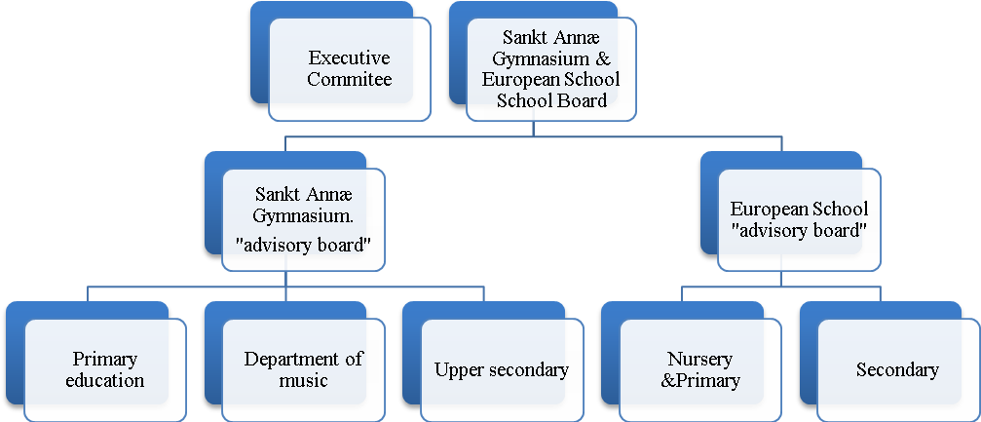

The overall School Board will consist of 17 members with the right to vote, and it is required that the members possess experiences and knowledge relevant for the schools’ educational and operational affairs. The members will consist of both professional representatives as well as parents of the students in order to ensure a democratic and diverse policy-making that advances the schools’ prospective performances as well as maintaining and developing the schools’ unique profiles. The regular term of each member is four years, following the regular election period of the municipality. It will be the role of the School Board to provide strategic guidance and to oversee effectively all the aspects of the schools’ operations, including matters regarding supervision, finance, policies and the monitoring of educational results – a task they hold together with the supervision authorities of the European Schools.

In order to ensure equal governance practices and responsibilities under one School Board, two “advisory boards” will be installed to supervise each school and supply support to the School Board. Sankt Annæ Gymnasium will have one advisory board, supervising the school’s three main educational sections; primary education, choral department and upper secondary education and likewise for the European School’s advisory board, supervising the school’s three main educational sections; nursery, primary and secondary educations. The advisory boards have no voting rights and will function as a reference unit to the School Board, assisting the Board in establishing priorities, rules and policies.
On behalf of the School Board an Executive Committee will be established to serve as an overseer of all planned activities both on operational and strategic level of Sankt Annæ Gymnasium and the European School. The members will be the two chairmen of the Advisory Boards (one from Sankt Annæ Gymnasium and one from the European School), the Director of the school and the five Deputy Directors representing each educational section of the two schools.

6. Quality and Supervision

In Denmark, municipalities are responsible for the overall quality and supervision of compulsory education while the Ministry of Children and Education sets the legal framework for compulsory education. However, the National Agency for Quality and Supervision has the mandate to monitor, evaluate and promote quality in the Danish school system in the case of mediocre educational performance. The Ministry of Education is responsible for the content of education in upper secondary education and for monitoring its quality (equivalent to S5-S7). In the context of a European School type II, the national inspectors for the European Schools will conduct the monitoring of the quality of teaching and learning in compliance with the European School regulations and within the framework of the accreditation procedure laid down by the Board of Governors. In tandem with the role of Board of Inspectors, the new school will also be answerable for the quality assurance, setting academic objectives and educational goals in the manner determined by the Board of Governors.

