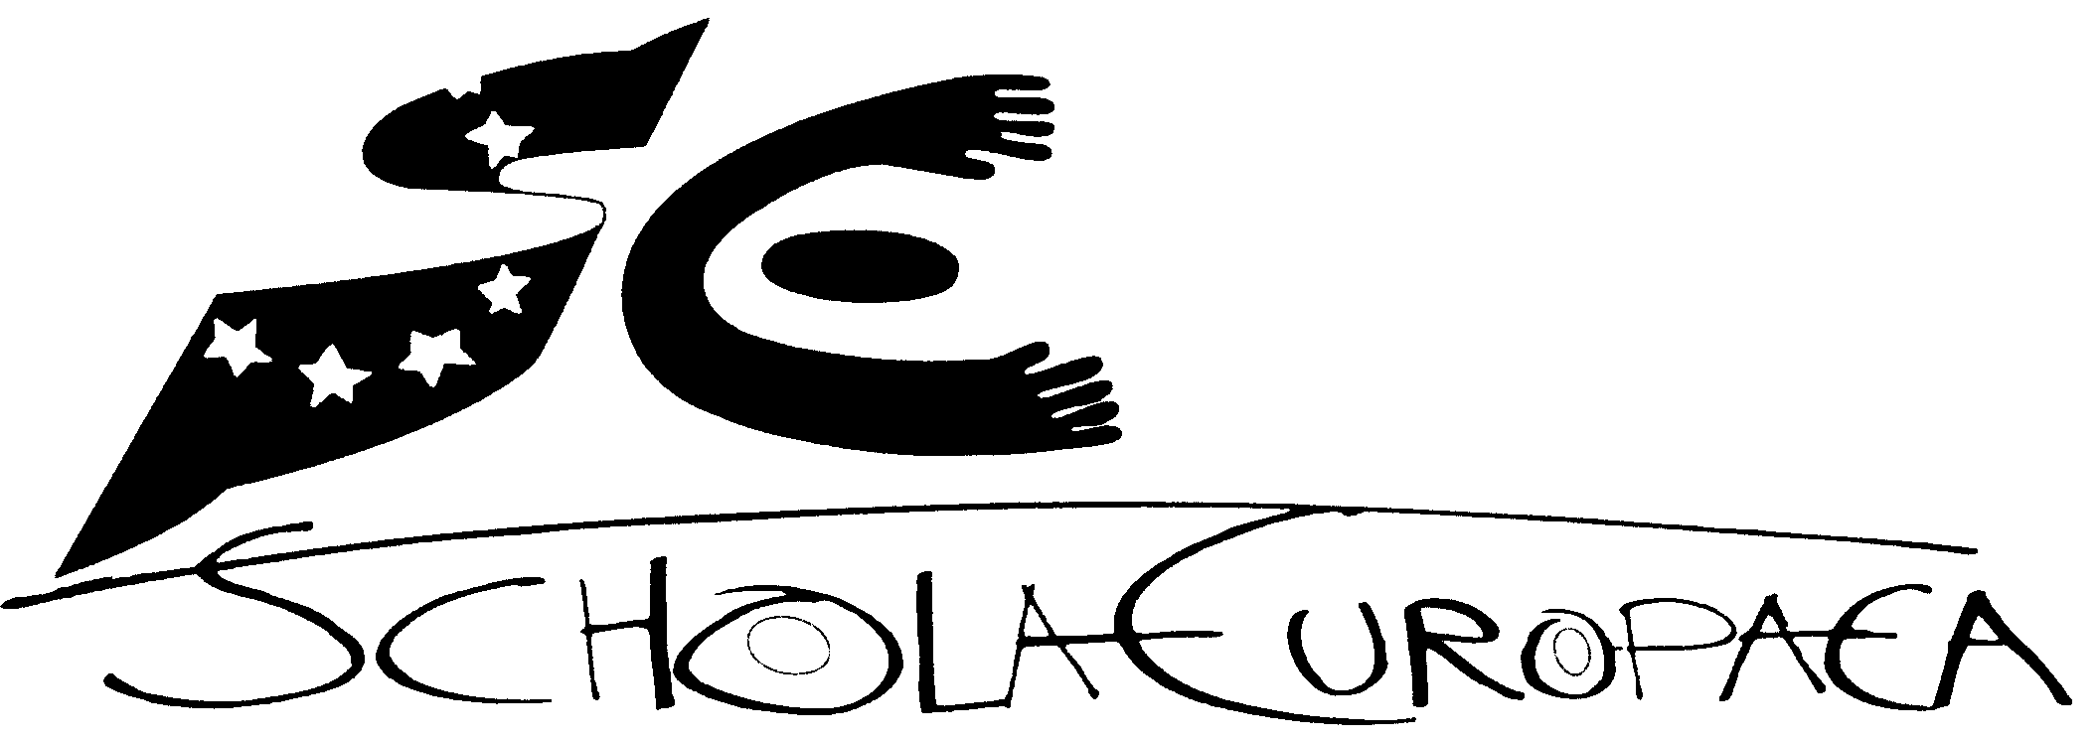 | Schola Europaea  Bureau du Secrétaire général  Secrétariat Général
Ref.: 2010-D-249-en-2
Orig.: FR

Dossier of Conformity for years 6-7 and Baccalaureate – European Schooling Helsinki

European Schools’ Board of governors
1st, 2nd and 3rd December 2010 in Brussels

Dossier of Conformity
European Schooling Helsinki
Years S6 and S7

FOREWORD
European Schooling Helsinki (ESH) is a unique school in Finland. ESH has a dual role: it is a state school but at the same time it belongs as an accredited school to the European Schools’ network.
A school cannot be established overnight, especially when the school is not part of the mainstream education system in the country. ESH needed a legislation of its own as well as careful planning as regards its educational and financial status. Preparations for the school began in the Ministry of Education in 2007 as soon as the decision was made that the European Chemicals Agency (ECHA) was to be located in Helsinki. The Ministry of Education prepared the Act and the Decree on the European Schooling Helsinki which passed the approval of the Government in December 2007 and in January 2008 respectively.
To seek for the accreditation into the European Schools’ system a Dossier of Conformity was prepared and the Board of Governors of the European Schools approved it in January 2008. The inspectors of the European Schools visited Helsinki and based on their positive report the accreditation was granted by the Board of Governors.
ESH started its first school year in August 2008. There were 27 pupils in the English and French sections. During the first year the number of pupils increased to 36. While waiting for the renovation of its own premises to be completed ESH was temporarily located in a school building where it shared all the necessary facilities with another school operating in the same building.
The second year of operation of the European Schooling Helsinki started in August 2009. The pupil number in the beginning of the school year was 53 and increased to 59 by the end of the spring term. During that school year (2009-10) ESH was able to move into the renovated premises of its own. The staff and pupils have been very pleased with the outcome of the renovation. They enjoy studying and working in a historical building equipped with modern technology situated in the very heart of Helsinki. There are five floors in the building, 44 class rooms of different sizes including three science rooms, two ICT rooms, language laboratory, art room and music room. There is also a canteen in the building as well as a gym and an assembly hall. The present facilities enable offering education for the whole range of pupils from the nursery level to the European Baccalaureate.
After moving to new premises ESH was featured in several newspapers and magazines as well as in the national television’s news program. There have been many visits of architects wanting to see the outcome of the renovation process of the prestigious building.
As from autumn 2010 the school has been able to enrol also other than category I pupils. The application period was organised in the previous spring when the school received 150 applications of which 80 could be accepted as pupils into ESH. The number of pupils at present (September 2010) is 180 of whom around 100 are category I pupils. All three language sections (English, French and Finnish) are in operation from nursery to the secondary class 5. The school offers 11 different L1-languages for Swals pupils. The school employs at the moment 19 full-time and 24 part-time teachers and 6 members of administrative staff.

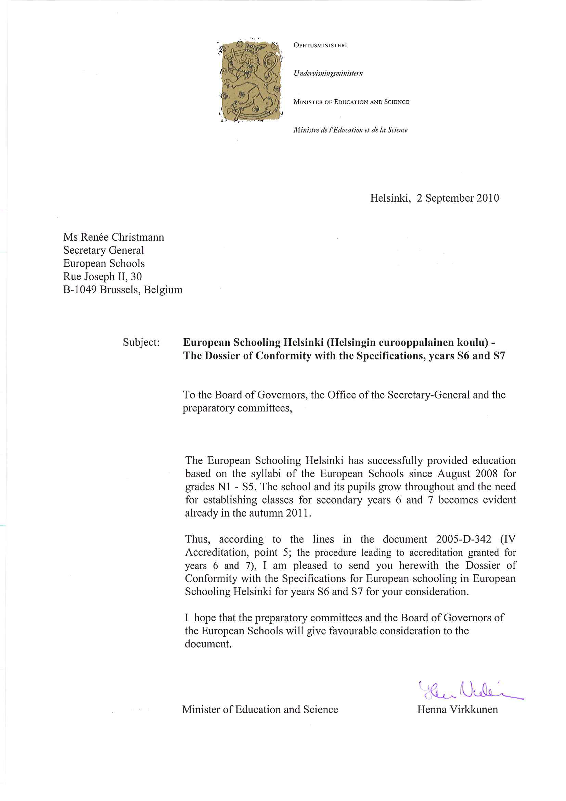

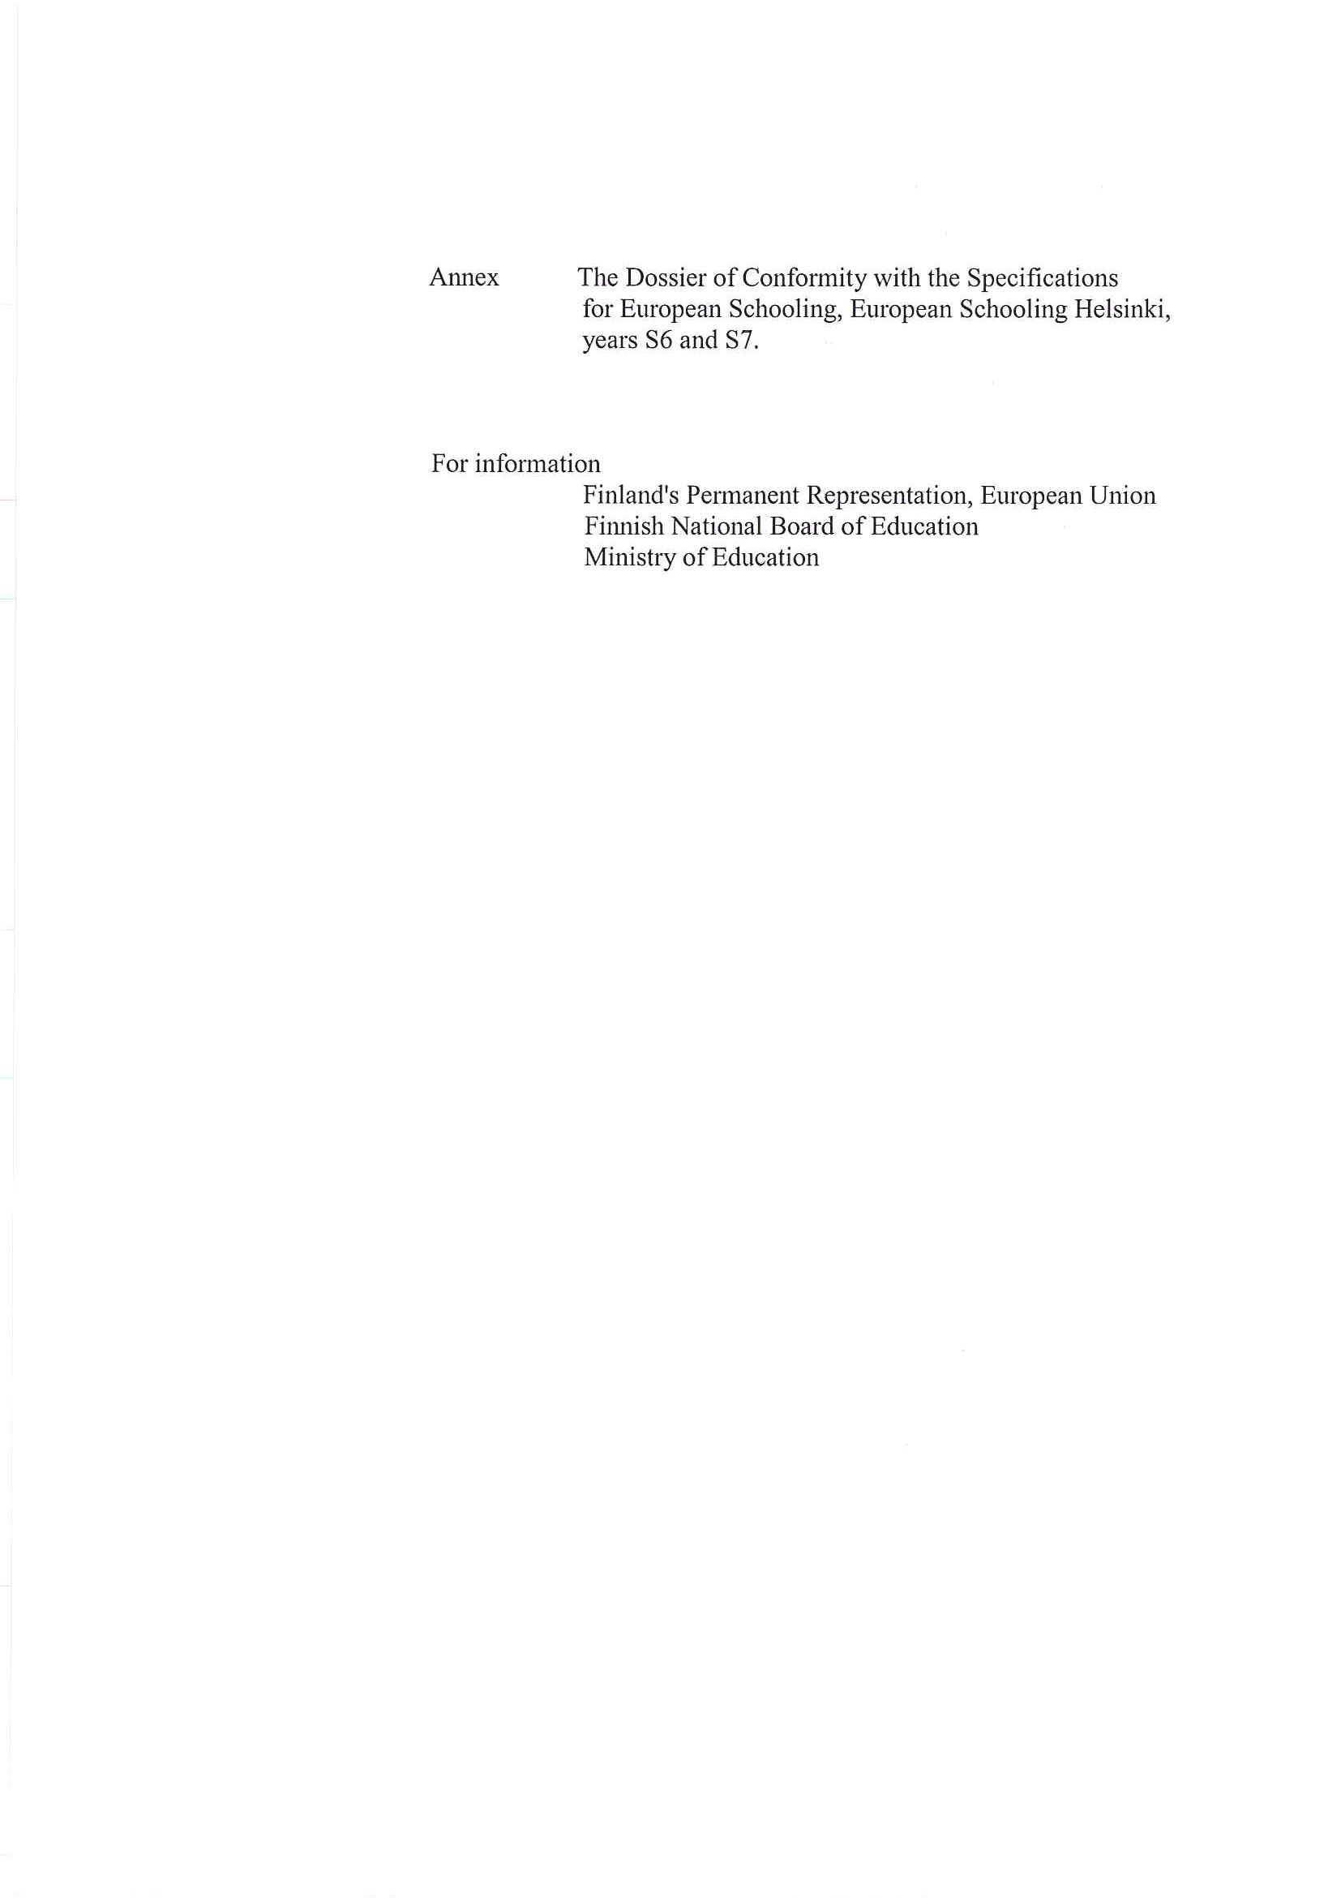
General information
- Name of the school: European Schooling Helsinki
- Address: Bulevardi 18 , FI – 00120 Helsinki
- Status:
- State (public sector) school | Yes X | No
- Supervisory body Finnish National Board of Education / Ministry of Education
- Independent (private sector) school | Yes | No X
recognised by:
- the national authorities | Yes | No
- the local authorities | Yes | No
- fully independent | Yes | No
- Funding
- public | Yes | No
- private | Yes | No
- mixed  The main funding is public (State of Finland), category II parents pay tuition fees. All parents pay for school food, text books and after-school activities. | Yes X | No
- Structure of the school
- Teaching levels - nursery | Yes X | No
- primary | Yes X | No
- secondary | Yes X | No
- Where applicable, links with other schools for teaching levels not catered for by the school itself: (please give details) | Yes | No X
- National state school | Yes | No
- National private school | Yes | No
- Other (please give details) ……………………………………….. | Yes | No
- Certificates prepared: end-of-term report in December, end-of-year report at the end of the school year in June.
- Recognition of the certificate(s) for admission to higher education | Yes X | No
  - in the country X
  - abroad X
- Total number of pupils: 180
- Number of pupils per teaching level:
  - nursery: 47
  - primary: 77
  - secondary: 56
- Management
  - Head: full-time
  - Deputy Head(s): full-time
  - Administrator (Bursar): full-time
  - Head(s) of teaching levels: no
  - Head(s) of department (by subject): no
  - Educational adviser: part-time
  - Others:
- Decision-making bodies
- Administrative Board | Yes X | No
Composition: Two members from the Finnish National Board of Education, one member from the City of Helsinki Education Department, teachers’ representative, non-teaching staff’s representative, parents’ representative, pupils’ representative; Director of the school acts as the secretary of the Admininistrative Board.
- Management Committee | Yes X | No
Composition: Director, Deputy Director, three teachers representing each cycle and each language section of the school.
- Advisory bodies
- Education Committees | Yes | No X
Composition:………………………………………………….
- Teaching Committees | Yes | No X
- Others ………………………………………………………… | Yes | No
- Reason for the introduction of European schooling
- Existence of a European Institution/Agency | Yes X | No
  - European Chemicals Agency (ECHA), the representation of European Commission, the Information Bureau of European Parliament
- Existence of an international institution | Yes | No X
  - If so, which one:………………………………………….
- Other reason:………………………………………………….
- Introduction of European schooling
- Introduction of European schooling in the whole school | Yes X | No
- Partial introduction of European schooling | Yes | No X
- Forecast of development…………………………………. | Yes | No X
- Organisation of European schooling (whether general or partial)
- Teaching levels planned:
- Nursery | Yes X | No
- Primary | Yes X | No
- Secondary | Yes X | No
- Language sections
- Number of language sections: 3
- Language(s) of the sections (L1): English, French, Finnish

- Number of pupils:
- Number of pupils: 180
  - by teaching level: …………………
- nursery: 47
- primary: 77
- secondary: 56
  - by category:
- Cat. I: 99
- Cat. II: 81 (note: Cat II = Cat II + III of the European Schools)
- Cat. III: 0
- Number of pupils per teaching level in each language section: | Section  EN | Section FR | Section FI | Total
- Nursery: | 17 | 12 | 18 | 47 | -
- Primary: | 31 | 27 | 19 | 77 | -
- Secondary: | 21 | 24 | 11 | 55 | -

- Number of pupils per year group in each language section:

 | EN | FR | FI | total
N1 | 12 | 6 | 7 | 25
N2 | 5 | 6 | 11 | 22
P1 | 9 | 5 | 12 | 26
P2 | 7 | 5 | 7 | 19
P3 | 6 | 8 | 0 | 14
P4 | 3 | 6 | 0 | 9
P5 | 6 | 3 | 0 | 9
S1 | 2 | 6 | 2 | 10
S2 | 4 | 5 | 2 | 11
S3 | 7 | 7 | 0 | 14
S4 | 4 | 3 | 3 | 10
S5 | 4 | 3 | 4 | 11
total | 69 | 63 | 48 | 180

- Pupils whose mother tongue is different from that of the language section in which they are enrolled
- Pupils’ mother tongues:
  - Mother tongue: Estonian Number of pupils involved: 2
  - Mother tongue: Dutch Number of pupils involved: 5
  - Mother tongue: Bulgarian Number of pupils involved: 1
  - Mother tongue: Italian Number of pupils involved: 10
  - Mother tongue: German Number of pupils involved: 2
  - Mother tongue: Spanish Number of pupils involved: 9
  - Mother tongue: Czech Number of pupils involved: 1
  - Mother tongue: Polish Number of pupils involved: 6
  - Mother tongue: Swedish Number of pupils involved: 3
  - Mother tongue: Slovak Number of pupils involved: 2
  - Mother tongue: Portuguese Number of pupils involved: 1
  - + Maltese as additional language: 1

- Specific tuition in the language of the section for pupils without their own language section | Yes X | No
- Provision of mother tongue teaching for pupils without a section in the language in question | Yes X | No
- by a teacher from the actual school | Yes X | No
- using distance learning techniques | Yes X | No
- in cooperation with the European Schools  under discussion | Yes | No
- in cooperation with other schools or with embassies | Yes | No X
- Provision of vehicular languages as L2 | Yes X | No
Which ones: FR X
EN X
DE X
- Tuition in the language of the country | Yes X | No
  - Status of this tuition:
- compulsory | Yes | No X
- optional | Yes X | No
  - Number of pupils studying the language of the country as:
- L1: 48
- L2: 0
- L3: 16
- L4: 4
- Subjects taught in L2 up to year 5
- history | Yes X | No
- geography | Yes X | No
- others: Economics | Yes X | No
  - from which year onwards: Human sciences from S3, history, geography and economics from S4
- Secondary years 6 and 7
- Teaching of history and geography in L2 (DE, EN or FR) | Yes X | No
- Learning of a L3 possible from secondary year 2 | Yes X | No
- Learning of a L3 possible before secondary year 2 | Yes | No X
- If so, from which year onwards:

- School development plan
- Objectives and pedagogical priorities:
- to strengthen pupils’ own linguistic and cultural identity;
- to ensure command of the mother tongue and high standards in foreign languages;
- to develop mathematical and scientific skills;
- to promote the knowledge required in social activities and the skills required to act as an informed citizen in a democratic society;
- to develop the competence that will help pupils to understand social, political, economic and ideological developments in their own countries, Europe and the whole world, from a historical point of view as well;
- to develop and encourage pupils’ own creative artistic expression and increase their knowledge of different arts and European culture;
- to develop pupils’ physical skills and promote adoption of a healthy lifestyle;
- to develop pupils’ media skills and content-related and technical skills in information and communication technology (ICT);
- to offer pupils guidance on further studies and career choices;
- to cultivate pupils’ growth in terms of personality, social capabilities and knowledge and skills, thus creating conditions for well-being and lifelong learning
- European dimension: European dimension is enhanced through European hours, different projects and events organised in the school, cooperation between language sections, in language teaching as well as in history and geography teaching, and through links with schools abroad.
- Curriculum
- Syllabuses up to secondary year 5 (inclusive)
- National (health education, religious education, ICT, Finnish L3, Swedish L3) | Yes X | No
- European Schools (all others) | Yes X | No
- mixed (please give details)……………………………………… | Yes | No X
- specific (please give details)…………………………………… | Yes | No X
- Teaching of religion | Yes | No X
- compulsory | Yes | No
- optional  In the European Schooling Helsinki religious education is being taught instead of religion. The syllabus is the same for all pupils. | Yes | No
- Teaching of ethics: included in religious education | Yes | No
- compulsory | Yes | No
- optional | Yes | No
- European schooling in secondary years 6 and 7 | Yes | No
- Anticipated date of organisation of the first year 6 | 2011-12
- Application for accreditation for these years currently before the Board of Governors | Yes X | No
- Teaching organised in cooperation with a fully-fledged European School | Yes | No X
- Teaching exactly following the European Schools’ syllabuses  * health education, religious education, ICT, L3 Finnish and L3 Swedish have been prepared by national authorities | Yes X* | No
- Preparation of candidates for the European Baccalaureate | Yes X | No
- Wish to organise the European Baccalaureate in the school | Yes X | No
- Anticipated date of organisation of the first European Baccalaureate session | 2013
- Career or higher education options guidance organised in secondary years 6 and 7 | Yes X | No
- Which: Educational advisers will give orientation lessons
- Teaching materials and equipment
- School books and textbooks | Yes X | No
- national: in the Finnish section
- specific: other sections (+ Intermath, Eurobio)
- Computers | Yes X | No
- Multimedia libraries | Yes X | No
- Library books/works of reference | Yes X | No
- Scientific experimentation equipment/apparatus | Yes X | No
  - Others: Interactive whiteboards
- Weekly timetables
  - By teaching level:
- nursery: daily 8.15 – 14.30
- primary: P1-2: daily 8.15 – 14.30, P3-5 daily 8.20 – 14.20 (Tue, Thu) or 8.20 – 15.10 (Mon, Wed, Fri)
- secondary: daily 8.20 – 14.20 / 15.10 / 16.15 depending on class level
  - Length of periods (in minutes) by teaching level:
- nursery: 30 min
- primary: 30 min (P1-2), 45 min (P3-5)
- secondary: 45 min
  - or number of hours allocated to subjects par term/semester or year:
- School calendar
  - number of school days per year: 180
  - division of the school year into:
- terms | Yes X | No
- semesters | Yes | No X
  - breakdown of school holidays: one week in October, approx. three weeks at Christmas, one week in February, one week at Easter
- Assessment of pupils
  - frequency of reporting (school reports): At the end of both terms (= twice a year)
  - type of assessment
- formative | Yes X | No
- summative | Yes X | No
- class councils | Yes | No X
- Provision for SEN (special educational needs) pupils
- Special equipment | Yes X | No
- Specialist staff (part-time) | Yes X | No
- Learning support
- Extra tuition | Yes X | No
- Catch-up classes | Yes X | No
in which subjects: L1, L2
- Individualised lessons | Yes X | No
- Small group lessons | Yes X | No
- Links with the European Schools system
- Links with the European Schools system | Yes X | No
- Links with one European School in particular | Yes | No X
  - which one…………………………………………………………..
  - in which areas: links with European Schools have been created on adhoc-basis: teacher-teacher contacts, teachers visiting European Schools etc.; teachers participate in the in-service training organised by the European Schools when appropriate
A Comenius project will start in autumn 2010 with Strasbourg, Culham, Manosque, Parma and Dunshaughlin.
- Information for pupils and guidance | Yes X | No
  - provided by: class teachers, tutors, part-time student counsellors, admin staff
  - from which year: primary 5
- Staff
- Specific management, if applicable: | Yes | No X
- Head teacher (for each teaching level) | Yes | No
- Department head(s) | Yes | No
- Others | Yes | No

- Teaching staff
- Number of teachers
  - Number of teachers for European schooling: 19 full-time, 24 part-time
  - Number of teachers recruited specially for European schooling: all full-time
  - Number of teachers from the host school involved in European schooling: n/a
- Teachers’ status: Civil servants
- Length of contracts: One year to permanent
- Teachers’ remuneration
- National authority of the host school responsible for remuneration | Yes | No X
- School itself responsible for remuneration | Yes X | No
- Recruitment of teachers
- Recruitment of teachers organised in cooperation with the educational authorities of the country in which they are qualified and registered to teach | Yes | No X
- Involvement of European School inspectors in the recruitment of teachers  *the inspectors are contacted when recruiting permanent staff | Yes X* | No
- Involvement of national inspectors in the recruitment of teachers | Yes X | No
- Teachers’ qualifications
- Teachers are native speakers of the language in which they teach  * 95 % of the full-time teachers, 85 % of all teachers | Yes X* | No
- Teachers are holders of the academic and professional qualifications required to teach the subject in question in the country or countries (case of a language spoken in several countries) in the language of which they teach  * 100 % of the full-time teachers, 72 % of all teachers | Yes X* | No
- Evaluation of teachers’ performance | Yes X | No
- by the Head | Yes X | No
- by the national inspectors of the subject | Yes | No X
- by European School inspectors | Yes | No X
  - frequency: once a year
- In-service training of teachers | Yes X | No
- by whom: the school, national teacher organisations, Finnish National Board of Education, European Schools
- frequency: varies
- Administrative and ancillary staff
  - number: 8 full-time, 1 part-time
  - posts: director, deputy director, bursar, school secretary, ICT-support, 2 nursery nurses, caretaker, after-school coordinator (part-time)
  - qualifications: according to the requirements of the post
- Medical and nursing staff………………………….. | Yes X | No
Please give details: 2 school nurses (part-time), school psychologist (part-time), medical checks by a visiting doctor
- Buildings and facilities
- Purpose-built or specially fitted out premises for European schooling  (if partial schooling - where applicable) | Yes X | No
  - Area: 5 262 m2
  - Number of classrooms
by teaching level:
- nursery: 5
- primary: 11
- secondary: 20
- libraries | Yes X | No
- gymnasia | Yes X | No
- ICT rooms (2) | Yes X | No
- art rooms (1) | Yes X | No
- music rooms (1) | Yes X | No
- others:…………………………………………………………… | Yes | No
- Number of specially equipped laboratories for science lessons: 3
- Number of computers in classrooms: 1-4 in each class room, 16 in each ICT room, 4 in the library, 10 in the secondary corridor, 45 laptops
- Extra-curricular activities
- Activities offered:
- in the school | Yes X | No
- outside the school | Yes | No X
  - organised by
- the school | Yes X | No
- parents | Yes | No X
- free of charge | Yes | No X
- charge made | Yes X | No
- Communication with parents
- Means:
- school reports | Yes X | No
- meetings | Yes X | No
- mail | Yes X | No
- internet | Yes X | No
- newspaper | Yes | No X
- Frequency of meetings: twice a year
- Type of meetings or interviews: parents’ evenings, individual meetings with teachers
- Funding of European schooling
- By the supervisory body | Yes | No
- state (public sector) | Yes X | No
- private (private sector) | Yes | No
- national authorities | Yes | No
- local authorities | Yes | No
- School’s own funds | Yes | No X
- Parents: school food, text books, after-school activities | Yes X | No
- European Commission | Yes | No X
- European Agency or Institution: contribution to school health services and after-school activities | Yes X | No
- International Institution | Yes | No X
- Financial burden-sharing arrangements: n/a

Recommendation of Mixed Board of Inspectors
At their meeting on 6th October 2010, the Mixed Board of Inspectors familiarised themselves with the dossier of conformity presented by the Finnish authorities concerning opening years 6 and 7 and the Baccalaureate of the European Schooling Helsinki. In their opinion, this document meets the requirements of the second phase of the agreement process drafted in Montdorf in April 2005
The Mixed Board of Inspectors brings to the attention of the Board of Governors the dossier of conformity presented by the European Schooling Helsinki. It recommends its approval with a view to following the agreement process.

