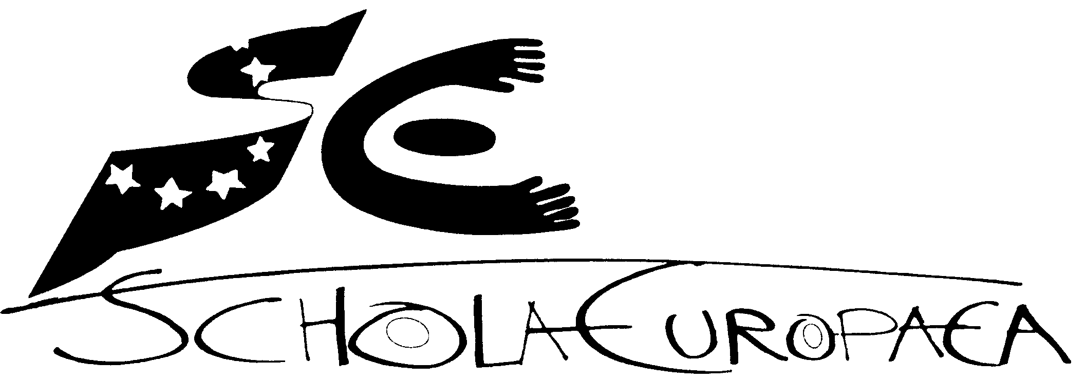 | Schola Europaea  Office of the Secretary-General  Baccalaureate Unit
Ref.: 2009-D-609-en-2
Orig.: EN

REPORT OF THE CHAIRMAN OF THE 2009 EUROPEAN BACCALAUREATE EXAMINING BOARD
Board of Governors of the European Schools
Meeting on 2, 3, 4 December 2009

OPINION OF THE JOINT TEACHING COMMITEE:

At its meeting of 7 October, the Joint Teaching Committee gave a very favourable reception to the Report of the Chairman of the 2009 Baccalaureate and declared itself in favour of modernisation of the Baccalaureate.
PROPOSAL:
The Joint Teaching Committee would bring the Report of the Chairman of the 2009 Baccalaureate to the attention to the Board of Governors and proposes that it recommend to the ‘Reform of the European Baccalaureate’ Working Group that it should take account, in continuing its work, of the recommendations made in the Report.

The European School
2009 Baccalaureate

Mats Ekholm
President of the European Baccalaureate 2009
Professor of Education at Karlstad University
Karlstad, Sweden

Contents

Contents | 4
Summary | 5
Introduction | 6
An effective working system | 6
A critical view on a well functioning system | 10
The mixture of external and internal influence on  the content of the examination | 15
The way to construct examination papers and orals.  Accumulation of items for future use | 19
Characteristics of the examinations of today  - old fashioned and non-uniform | 20
The rules of the game and distribution of responsibilities between the school and the central office | 22
References | 24
Annex 1 | 25
Annex 2 | 26

Summary

A report is given based on the experiences of the European Baccalaureate made on a round trip to all European Schools during the examination period in June and July, through studies of examination tasks and analysis of the examination outcomes. The Baccalaureate of the European Schools has an efficient organisation that fulfils the requests that they are facing. Time limits are kept for the construction of examination tasks and for the distribution of examination papers and correction sheets to schools. The distribution of examination papers to external examiners works well and the logistics around the use of external examiners for written papers as well as for the orals is taken care of in excellent ways. The Baccalaureate at the European Schools is a well working and well organised system for the examination of the students on the premises that exist.

A critical review is presented for this well functioning examination system. The contents of the examination tasks are looked upon through the lens of the ambitions that the European Union has spelled out for schools in its Reference Framework of the Lisbon Strategy. To an astonishingly small extent the examination tasks care for the eight core ambitions of this strategy. The use of the first language and of a second language is covered to some degree which also goes for parts of the competencies that the students have in mathematics and in natural sciences. Digital competence, learning to learn, sense of initiative and entrepreneurship, cultural awareness and expression and learning to learn are examples of ambition areas that have disappeared in the examinations. A school knowledge template has been used to illuminate what areas that the examination items succeed in measuring. Most items that the students have faced during the written part of the examination have been classified into five categories. In mathematics and natural sciences little effort was given to test the competence of the students to take a stand. In these subjects a dominant part of the written examination dealt with the competencies that the students have acquired to use the tools of the disciplines. The examination items used in geography, history and philosophy show a broader coverage of the knowledge that the students have acquired. The optional examination tasks that are presented to the students during the examination create variations that lead to conclusions that students are not passing the same Baccalaureate.

The mixture of external and internal assessment is scrutinized. Comparisons are made between markings made by the teachers and the external examiners as well as between preliminary marks and final marks. The changes in markings that follow from the use of external examiners constitute a small percentage of the initial marking. The question is raised whether the costs for the external assessment during the written as well as the oral examination are worth their price. The use of the term external for the second examiners is questioned. A fair amount of second examiners are selected from earlier teachers in and school leaders of European Schools and do not represent a true external perspective when acting during the examinations. The inspectors are not either an external force as they are deeply involved in the management of the system. The European Baccalaureate is perceived as less external than it wants to be with a low degree of uniformity and it is also seen as an old fashioned variant of examinations.

Based on the critical review of the European Baccalaureate several proposals are made for future use. The internal perception of the Baccalaureate needs to be changed from being loaded with a large amount of external inputs to a view that it is mainly an internal affair. A more professional approach to the construction of tasks for examination use is recommended. A more comprehensive approach towards the examination procedures is recommended so that the European Baccalaureate will mean the same thing in the future. The examinations need to be based on the Reference Framework of the Lisbon Strategy for the European Union. Some kind of template for the content of school subjects is recommended to be used when constructing tasks for examination. The European Schools are asked to stop the use of restricted paper and pencil tests. The use of digital techniques and other means that are used in realistic situations need to become more common. The European Schools are asked to adjust their examination routines to the demands to cover broad aspects of student knowledge. Assessments need to be made in an adjustment to the kind of knowledge that the students develop and not restricted to ritualised examination periods. A recommendation is given that the European School system trusts school directors, educational advisers and teachers to conduct the European Baccalaureate. The financial resources that until now have been used for a common use of second examiners during written and oral examinations instead ought to be used for randomly sampled second examinations of student achievements and for a larger involvement of universities in the analysis of the outcomes of the examination system as well as in the construction of examination tasks. The European Schools are recommended to restrict their rules for how students with special needs will be met during examinations to a simple article that says that the school needs to adjust to the needs of the student.

Introduction

I have served as the president of the Baccalaureate of the European Schools 2009. In March I met the inspectors of the secondary level and received the examination papers during an intense day in Brussels. To understand how the examination system is working in practice I made a quick roundtrip to all the schools during the written examination period in the beginning of June and during the last days of June and in the beginning of July during the oral examinations (the schedule of the roundtrip is presented in Annex 2). Four appeals against the examination outcomes have also been presented to me. Based on the insight of the examination procedures, the content of the examination papers, the orals and some facts of the outcomes of the examination I will present my appraisal of the actual system and some reflections on its quality. I will also discuss some future possible development areas of the European School Baccalaureate.

An effective working system

The Baccalaureate of the European Schools has an efficient organisation that fulfils the requests that are laid out in the Convention of the Statute of the European Schools and in the Regulations for the European Baccalaureate with its annex Arrangements for implementing the regulations for the European Baccalaureate. The inspectors that are responsible for the production of the examination tests together with selected schools, teachers and experts delivered the tests on time. The special unit for the Baccalaureate at the Office of the Secretary General of the European Schools in Brussels printed out the examination tests and delivered them safely to the schools and in due time so that the schools could carry out the written examinations.

The special unit also sent out the correction guidelines via e-mail to the schools so that they were available just before the actual written examination was finished.

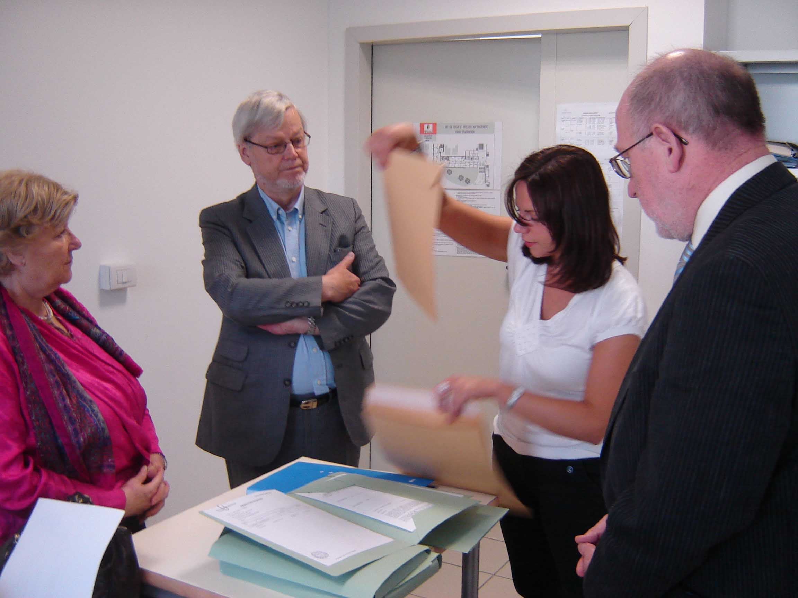

Well supervised opening of examination papers.

The logistics of the examination, the written as well as the oral part, were taken care of in the most competent way by the directors, deputy directors and the educational advisers at the school level. Localities were kept quiet and calm during working hours.

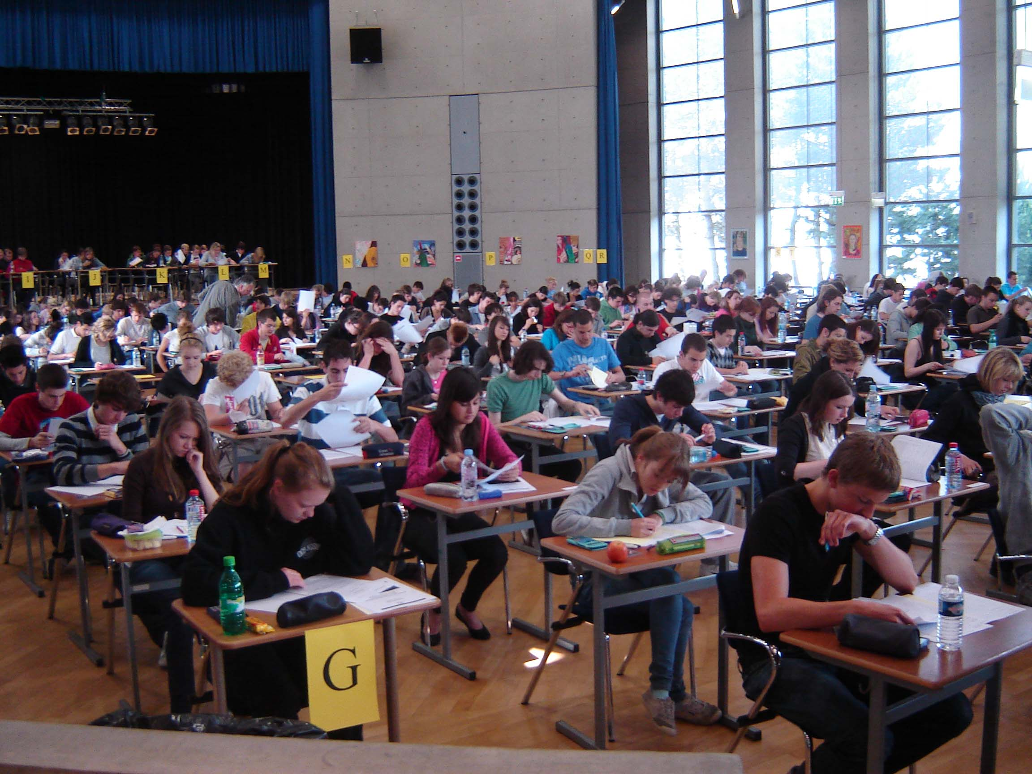

An environment for a maximum of achievements.

Rules, routines and time schedules were communicated in effective ways beforehand and at the beginning of the actual examination. Problems that occurred during examination periods, such as students coming late, surprising items that came up in the exam papers, illness etc., were well taken care of by the school directors, sometimes helped by inspectors. The correction at the schools was quickly made by the teachers and the examination papers were delivered to the European School I in Brussels where the external examiners assembled during the middle of June to make a second assessment of the work of the students on the basis of written criteria.

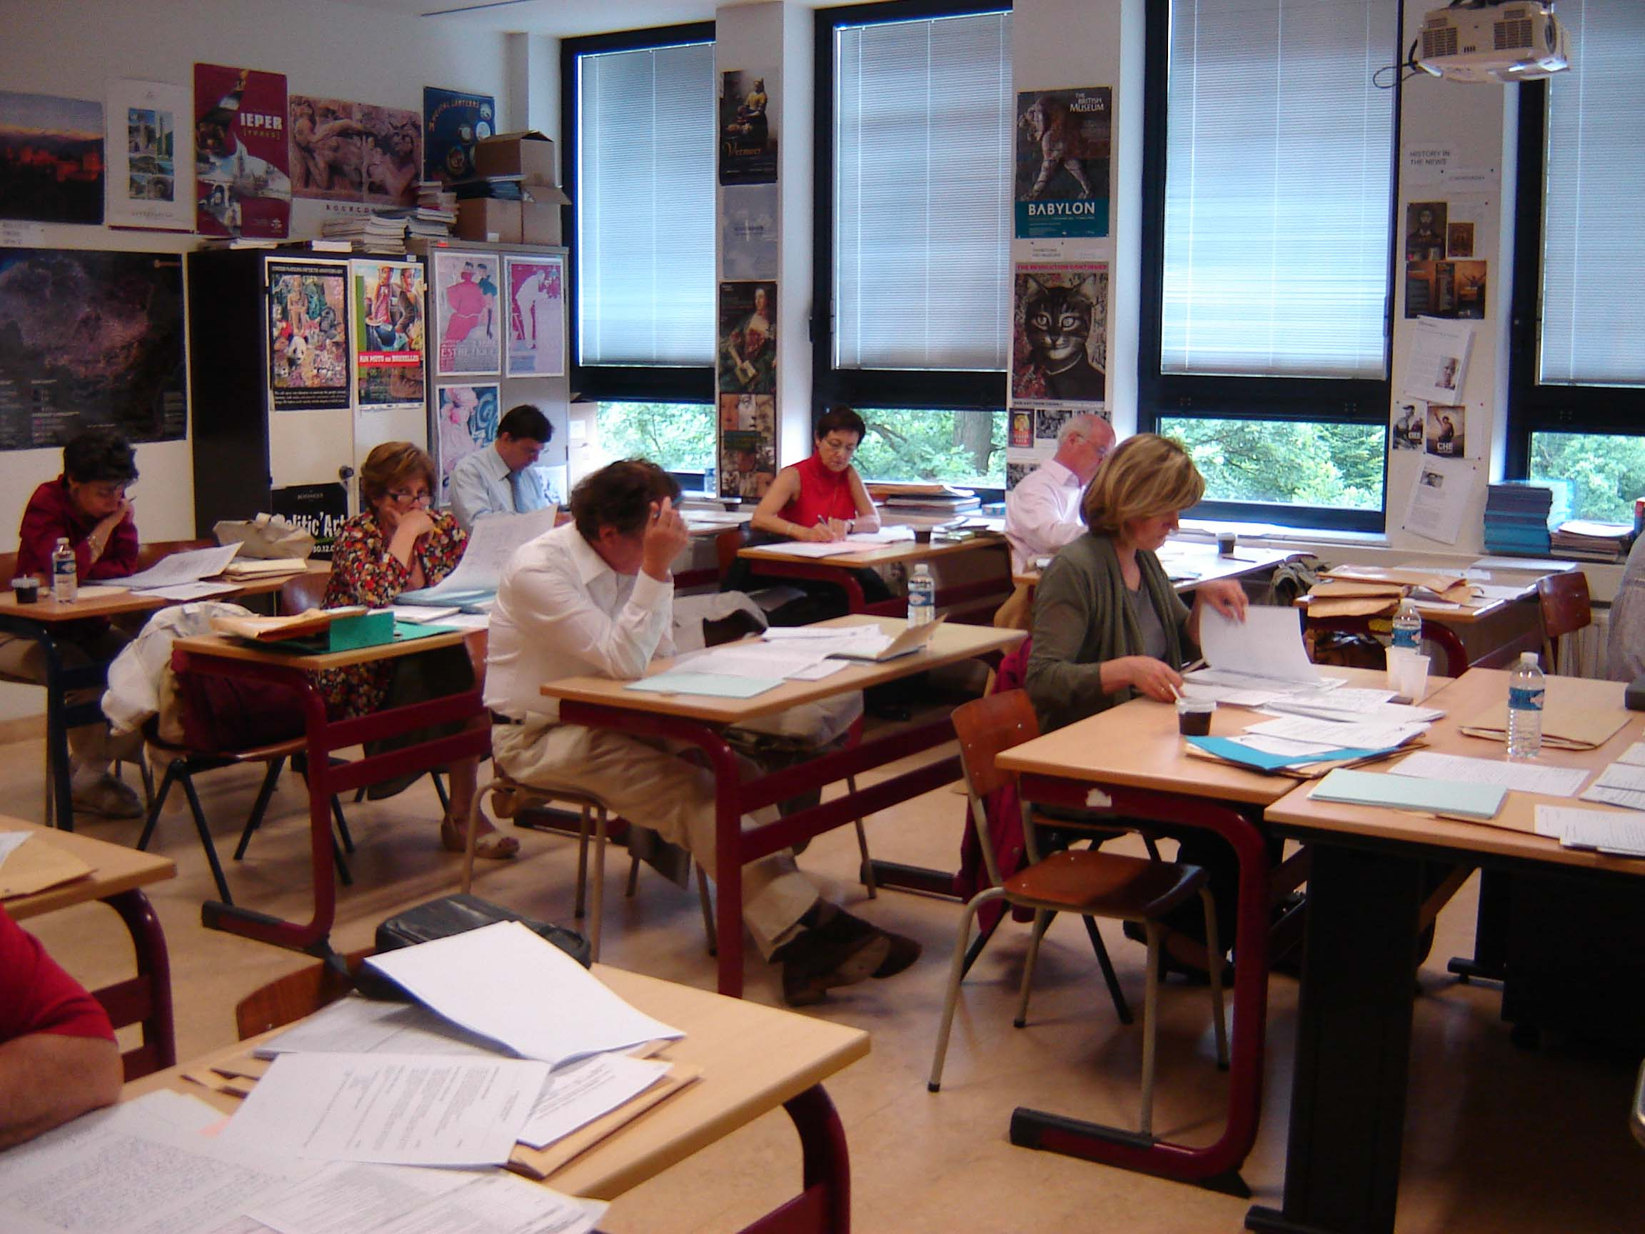

Second assessment of examination papers.

The questions for the oral part of the examination were produced in good time and the external examiners were in place together with the teachers to listen to the students and make up their minds about the value of the students’ achievement.

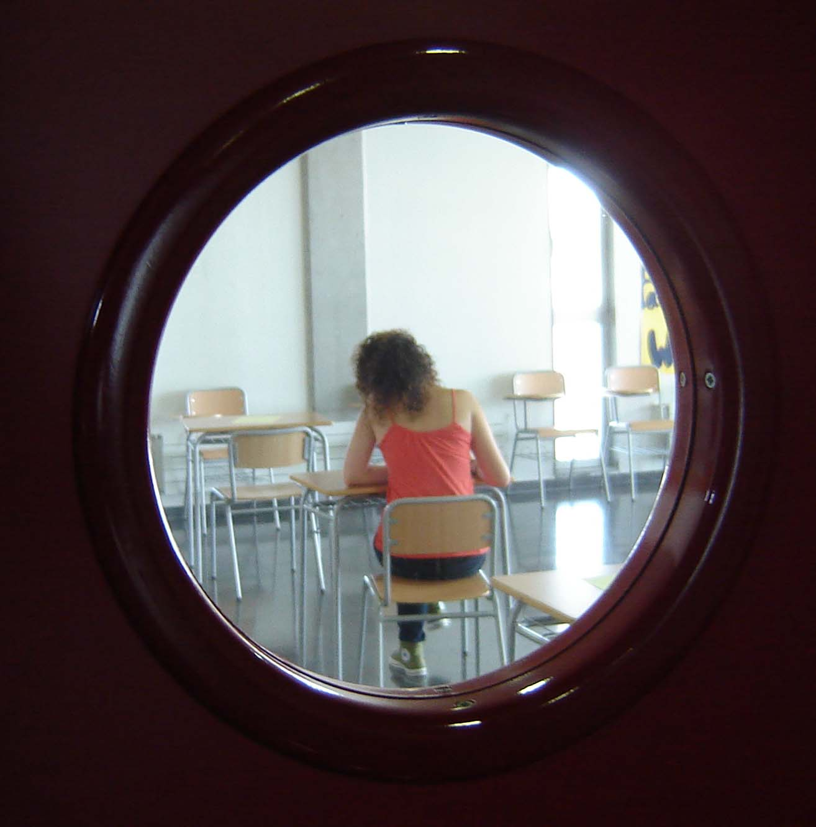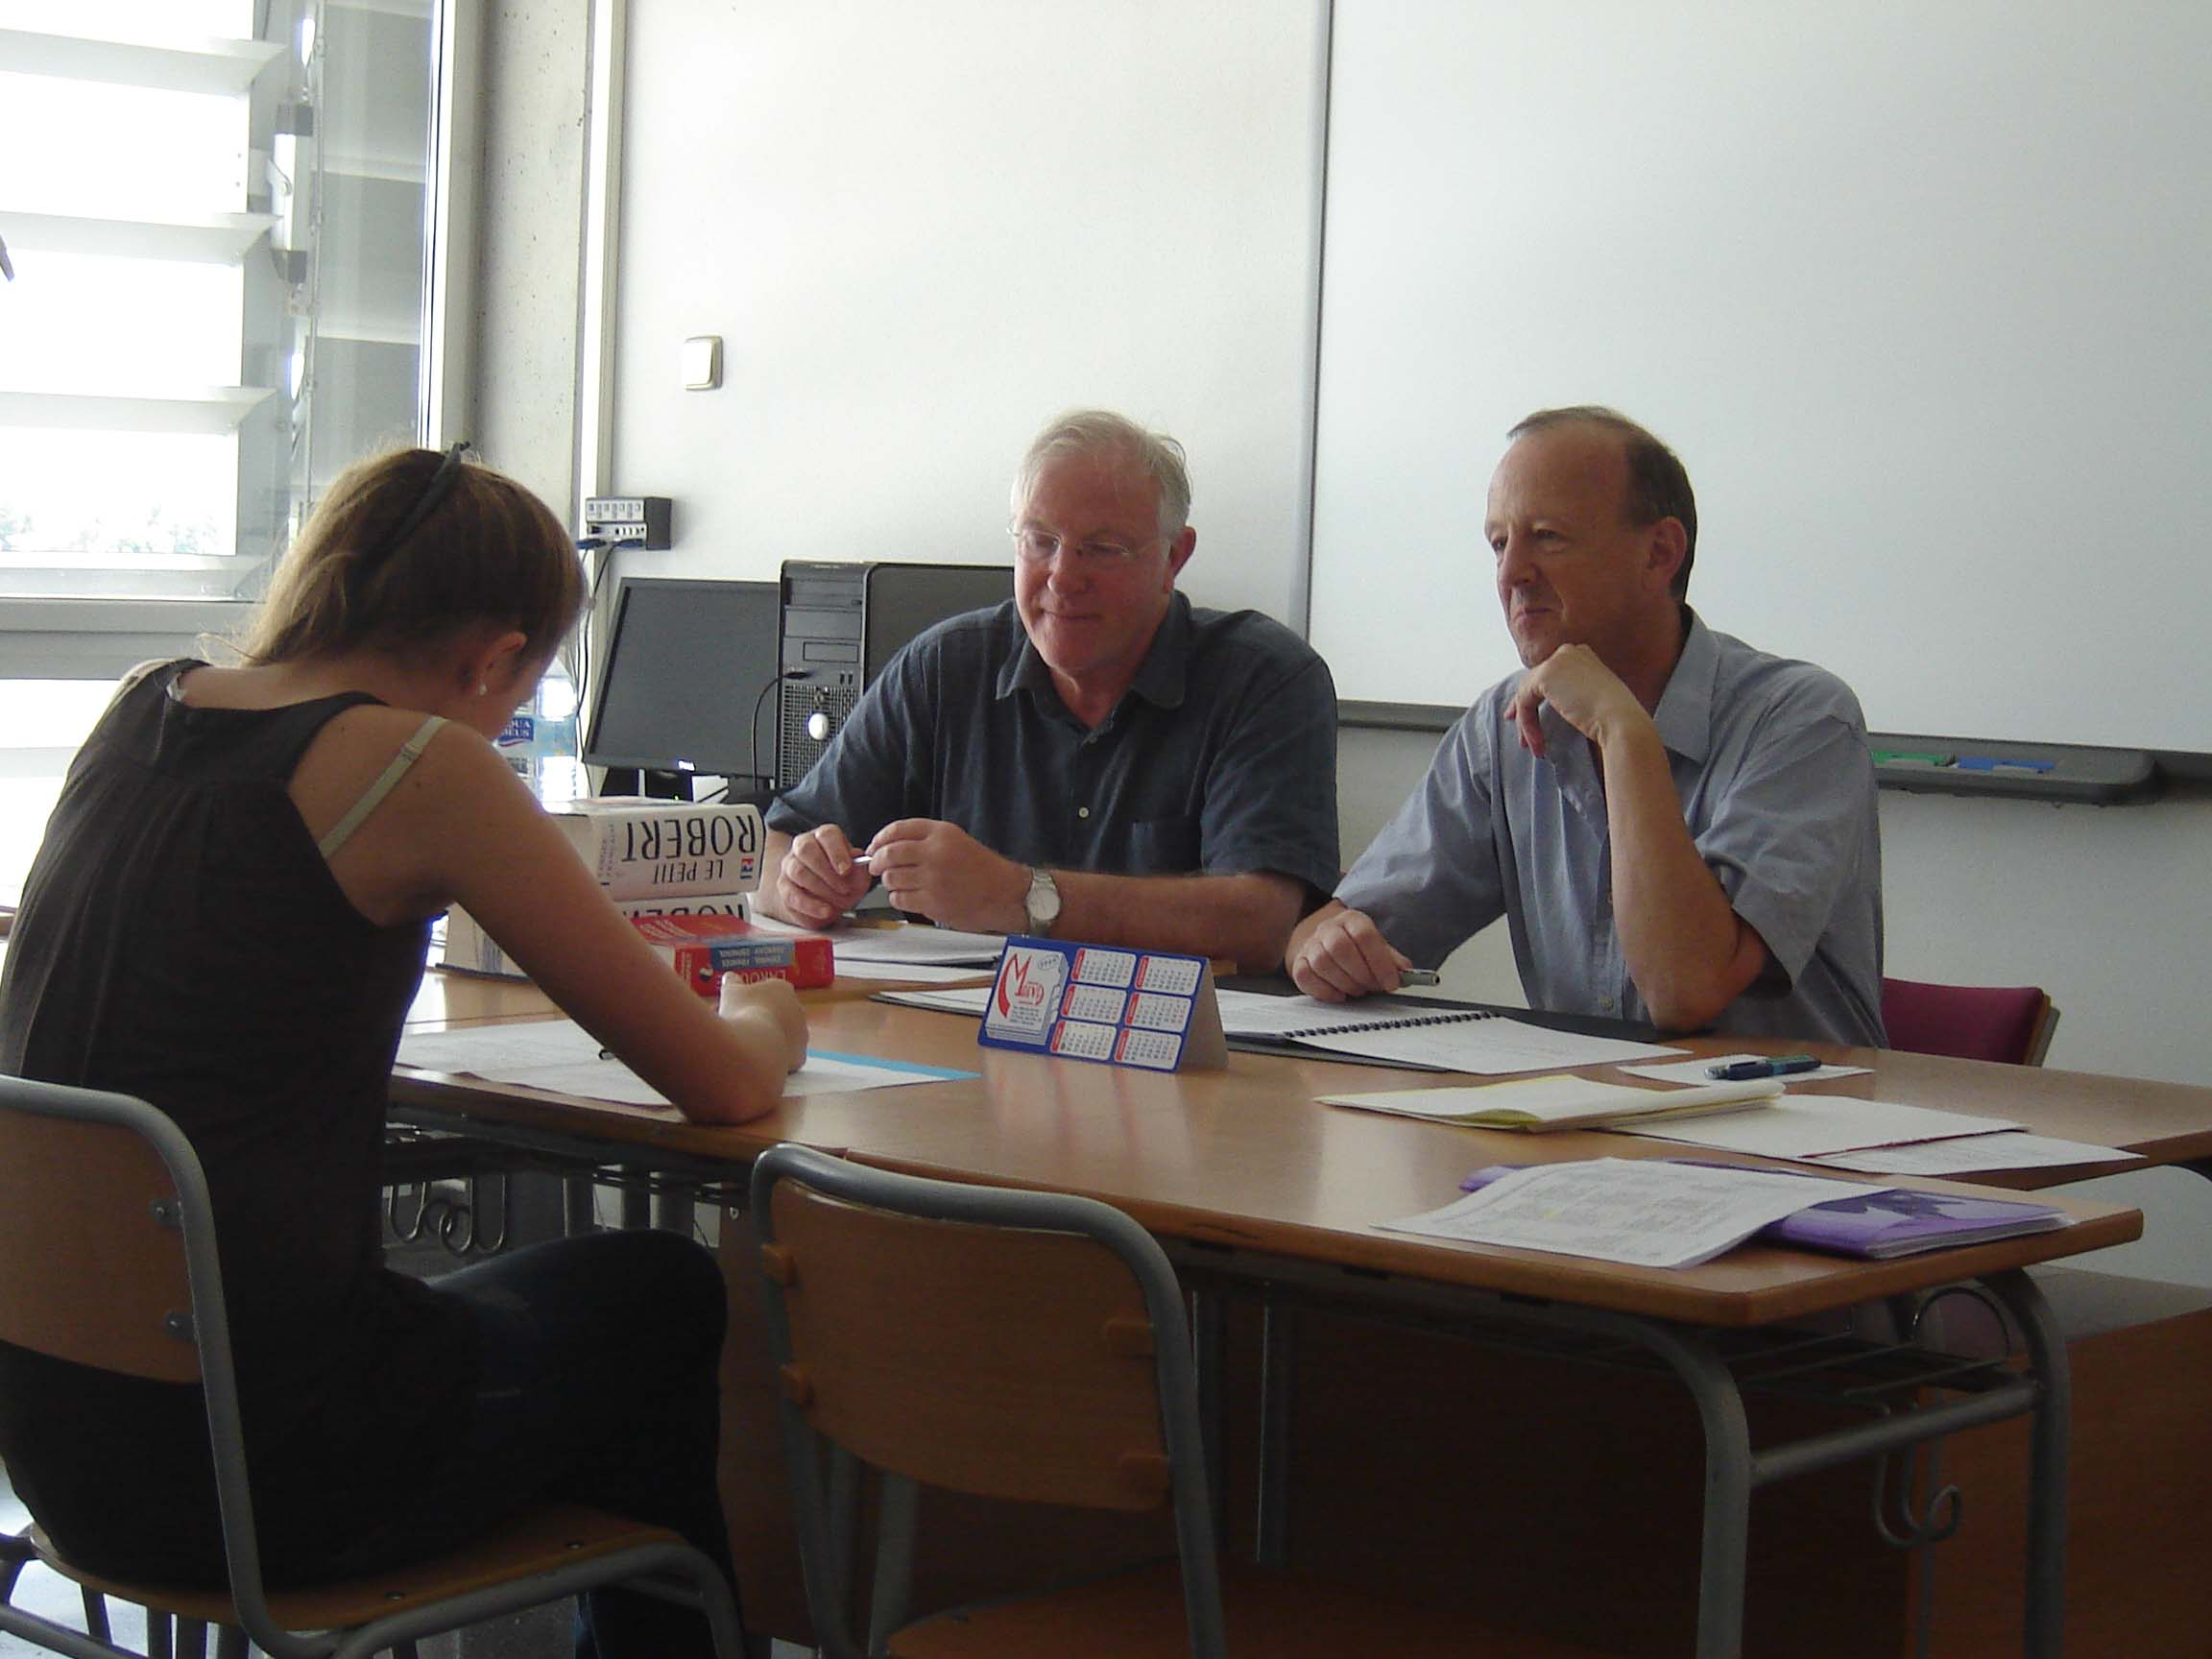

Preparing and conducting the orals.

The rules for the marking of the students made it obvious for which students a third opinion was needed for the evaluation of the written examination. The ways to find a third evaluator worked effectively. The deliberation processes at the schools worked well and the rules for what limits there are for granting the European Baccalaureate were evident.

All in all I can conclude that the Baccalaureate at the European Schools is a well working and well organised system for the examination of the students on the premises that exist.
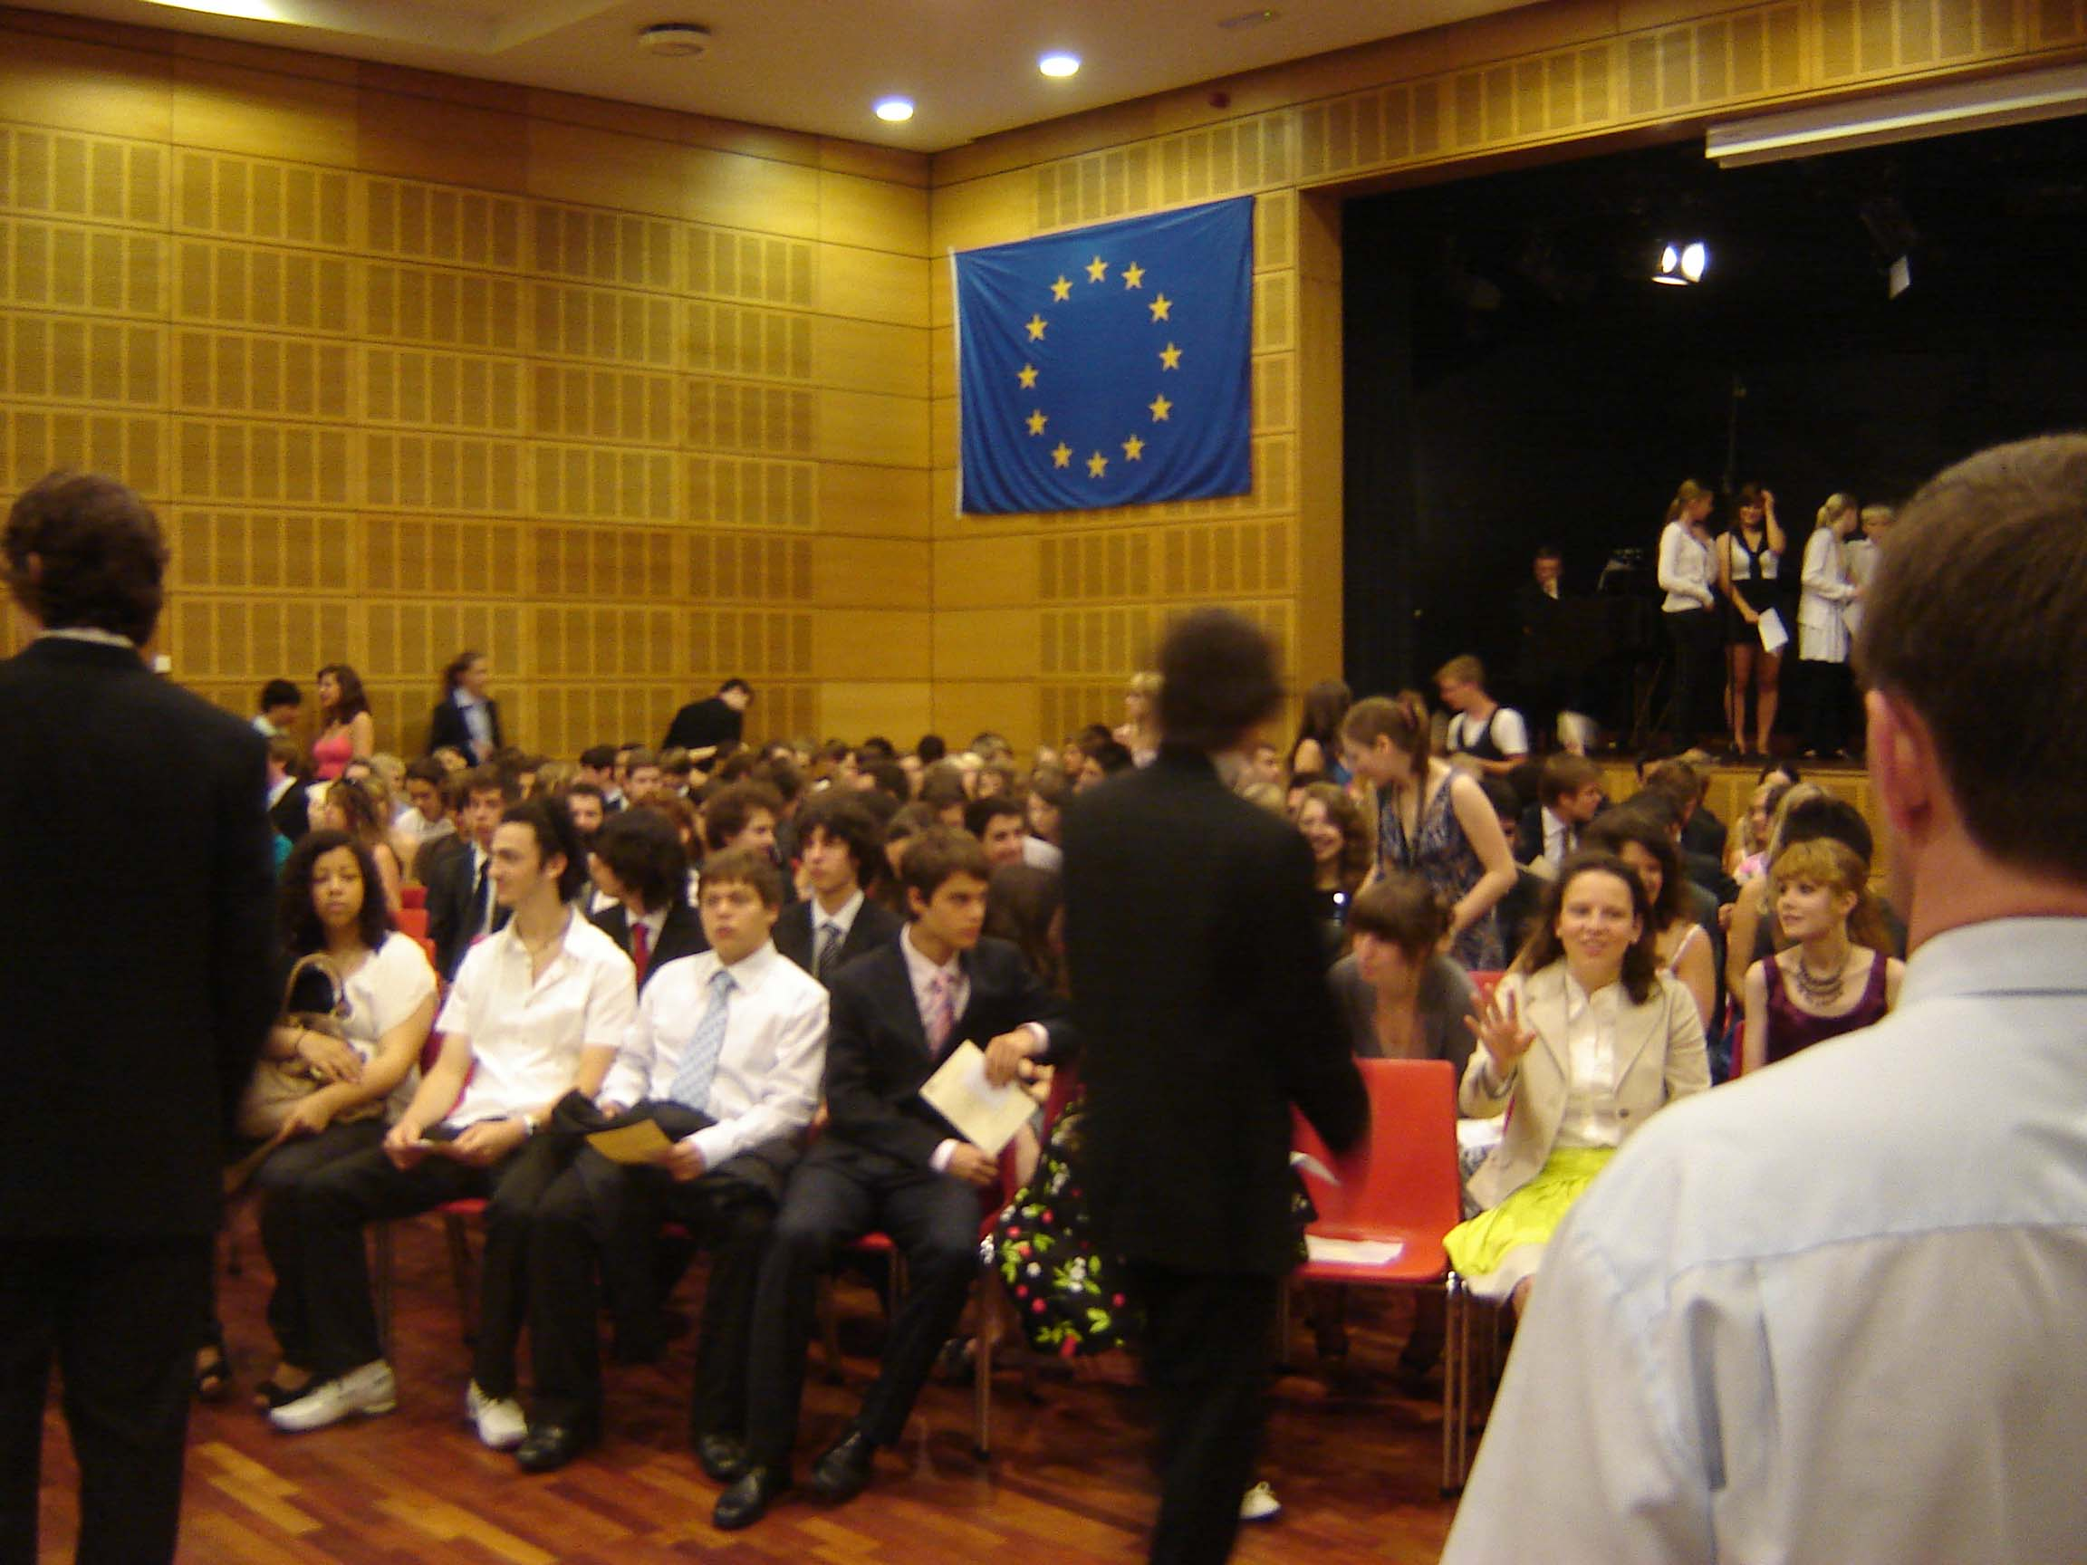

Proclamation and a day of freedom.

A critical view on a well functioning system

The Baccalaureate of the European Schools is constructed to create respect among universities in the world. Having passed this examination should give an entrance to any higher educational institution. According to the Convention defining the statute of the European schools, holders of the European Baccalaureate as a minimum, shall in their member state enjoy all the benefits attached to the possession of the diploma or certificate awarded at the end of secondary school education in that country. They shall be entitled to seek admission to any university in the territory of any Member State on the same terms as nationals of that Member State with equivalent qualifications (Article 5: 2 a and b). To be able to value if the examination has the high quality that is needed to reach this standard I have observed the Baccalaureate of the European Schools with some basic conditions of the education within the European Schools in mind and especially with some of the prerequisites of good examinations in mind as well.

The European Schools are owned and driven by the European Union. As such they are official educational establishments jointly controlled by the governments of the member states of the European Union. In 2000 the European Council in Lisbon concluded that a European framework should define the new basic skills to be provided through lifelong learning. These skills are to be seen as a key measure in Europe’s response to globalisation and to the shift to knowledge-based economies. These conclusions have been restated several times during the last decade and a re-launched Lisbon-strategy was approved in 2005. It is a humble expectation that the education within the schools owned and driven by the European Union is coloured by these principles and especially that one can find traces of these principles in the way the control of the learning is conducted.

The Reference Framework of the Lisbon-strategy (EU 2006) sets out eight key competences: communication in the mother tongue, communication in foreign languages, mathematical competence and basic competences in science and technology, digital competence, learning to learn, social and civic competences, sense of initiative and entrepreneurship and cultural awareness and expression. The key competences are all considered equally important, because each one of them can contribute to a successful life in a knowledge-based society. Several of the competences overlap and interlock: aspects essential to one domain will support competence in another. The EU (2006) states that competence in the fundamental basic skills of language, literacy, numeracy and in information and communication technologies (ICT) is an essential foundation for learning, and learning to learn supports all learning activities. There are a number of themes that are applied throughout the Reference Framework. Critical thinking, creativity, initiative, problem solving, risk assessment, decision taking, and constructive management of feelings play a role in all eight key competences that one would expect to see tested in an examination within schools under the control of the European Commission and the Member States..

Apart from finding these qualities covered by the education given in the European Schools and thereby in the European Baccalaureate, I also expected that the examination instruments would be based on some kind of comprehensive view on the knowledge that one wants to measure through the testing of the students. The level of knowledge that the students of the European Schools are expected to reach during their school years is defined in the syllabi of the subjects. To be able to construct knowledge tests from the content of the syllabus helps to characterize its content. There exist many structures one can use for such a characterization such as for instance the one developed by Bloom and others (Anderson and Krathwohl, 2001, Bloom, 1956, Krathwohl, Bloom and Masia, 1975). I was prepared to find one or two of these in use among the responsible constructors of the examination papers that I could use for my critical review. However I did not find that this kind of instrument of thought was in use among the inspectors or the teachers that had contributed to the production of items to the written examinations. I therefore decided to review the content of the written examinations with the help of a generic template that I have used in similar contexts (Ekholm, 1992, Lindstedt, 2007) to catch the knowledge descriptions and the content of knowledge tests. The assumptions behind this template are that knowledge can be used to interpret the relations between cause and effect and thereby it becomes an instrument of action. Knowledge is developed by the use of predictions, changes and understanding; all processes that students need to master to be able to learn on their own. What students are expected to learn within school subjects through their schooling years might be described in terms of:

- information that they need to know about within the subject (info)
- tools that they need to master within this field (tool)
- covenants that exist about the basis of the subject (cov)
- coherences between cause and effect that exists within the field in focus (coher)
- standpoints that you need to take to be able to use the subject knowledge that you have acquired (stand)

Within the info-category one finds facts like indication of time for an event, the name of an inventor, the location of a place. Within the tool-category one finds abstract as well as concrete instruments. It might be a mathematical formula, a cutter or a microscope. The cov-category contains the agreements and conventions that a knowledge territory is founded on. The axioms of geometry, the rules of spelling and grammar belong here. Within the coher-category one finds the relation between what comes first (cause) and what follows (effect) and in the standpoint-category the knowledge acquired is used for decisions based on ethical, moral, personal or other kinds of considerations.
To be able to discuss the quality of the Baccalaureate of the European Schools I have read through the items that the students met during the written examinations. As the examination of the first language of the students follows a harmonized strategy, I have chosen to analyze the content of only one such effort. I chose the examination items used in Swedish as that is my own home language. I have classified each item of the exam papers using the five categories mentioned above and also related the content of the examination items to the Lisbon-strategy. When classifying the items I have decided which one of the categories that is dominant for the item and marked it as such a category. Many items measure more than one quality so the classification simplifies the picture. In Table 1 this simplified classification of the content of the written examinations is presented.

The classification of the items of the examination papers shows that very few items in a dominant way measure the way in which the students comprise the covenants of the school subjects. However there are many items that actually measure the way in which the students comprise the covenants of the subject area at the same time as the item mainly is concentrated to catch one of the other qualities that I have covered by the use of the chosen category scheme. In some subjects the items to a lesser degree are focused on the way in which the students are able to use the knowledge that they have built up for making standpoints in different situations where they are expected to use what they have learnt at school. In many subjects the examination

Table 1. Classification of items used in the Baccalaureate examination papers 2009 into five categories: acquainted information (info), knowledge tools (tool), subject covenants (cov), coherence between cause and effect (coher) and standpoints taken (stand). Percentage of items within each subject.

Subject | info | tool | cov | coher | stand | (No of items)
Arts | 0 | 71 | 0 | 14 | 14 | (7)
Biology | 29 | 39 | 0 | 32 | 2 | (62)
Chemistry | 38 | 41 | 0 | 16 | 6 | (71)
Geography | 24 | 12 | 0 | 44 | 20 | (25)
History | 42 | 11 | 0 | 21 | 26 | (19)
Mathematics | 3 | 96 | 0 | 0 | 3 | (38)
Philosophy | 10 | 20 | 10 | 10 | 50 | (10)
Physics | 12 | 71 | 0 | 14 | 4 | (51)
Swedish | 8 | 58 | 0 | 8 | 25 | (12)

items are mainly concentrated at measuring the way the students can use the tools that exist within the subject areas. In some of the subjects a fair amount of the items are concentrated on the coherence of cause and effect that the students have developed. In some other subjects this measurement seems to be of low interest to the assessors.

When analysing the content of the examination papers I have acted as if all items of every paper are solved by the students. I did so to be able to show what content there is in the written examinations. In the practical situation the examination papers are however treated in another way. In Article 3 of the Arrangements for implementing the regulations for the European Baccalaureate it is stated about the Nature of examinations that a high degree of uniformity is stipulated. In 3.3.1 it says that “All written examinations will be the same for all candidates …” which led me to think that every student that participates in the Baccalaureate testing was going through the same procedure and that a European Baccalaureate was comparable between the different individuals. In reality the Baccalaureate is designed in another way. Within several of the subjects the students are asked to make choices between the different items analysed above and thereby compose their own Baccalaureate examination paper. In Art the students choose either a theoretical or a practical task by answering four questions and analyse, explain and interpret artistic goals and artistic methods referring to given illustrations or by producing a series of sketches and a final piece of art on a given theme. In Language I the students choose either to make a literary analysis of a short text or an analysis of a poetic piece or to write an essay on a more free basis. In Philosophy they choose one out of three broad topics. In Geography they combine one compulsory task with one choice from a menu of three courses. In Biology the students choose between two questions that measure their understanding of physiology, genealogy and evolution so that they make their own examination paper that varies in eight different ways. In the subjects where the students make their own choices the examinations are not the same for the different students as the assessment of the written products follows rather different norms.

The items measure different qualities of the knowledge that the students have conquered and thereby the examination is uniform to a lesser degree than I expected. During my visit to the European Baccalaureate I found to my astonishment a non-uniform way to examine students that are proposed to have passed the same examination. I also understood that my interpretation of Article 3 was looking too much at the opening of the article and too little on the middle of it “…irrespective of the language section to which they belong…”. Reading the article with this as the main message instead of the comparativeness of the examination in mind reduces the ambitions of the European Schools. The schools seem to stay with the ambition to create equality between language sections and translations and do not strive to keep an examination system in which each subject can contribute to a highly reliable exam that can be trusted by others.

I have used the categorization of the items of the written examinations and my direct observations of the oral examinations as a ground to value to what extent the European Baccalaureate covers the ambitions of the European Union. The quality of the students´ communication in mother tongue and in foreign languages is measured to a limited degree with heavy emphasis laid on skills to communicate by writing. For a student with five written examinations and four orals the twenty minutes that the four oral examinations take correspond to less than 8 % of the total time used for the kind of testing that the examination is based on. The way to communicate is also highly restricted in its form. The communication is mainly limited to the way you formulate yourself in examination papers and leaves out any other form of communication, such as writing an article for a newspaper, preparing a memorandum for a steering committee, arguing within a political party or formulating a letter to an older relative. Of course all other ways to communicate except for written communication are left out of the testing that is the core of the strategy for examination that rules the European Baccalaureate.

The way the examination covers mathematical competence and basic competences in science and technology is concentrated on the use of the tools within these branches of sciences. Internal teacher criticism is given to the examination tasks that they do not initiate enough of the reasoning of the students, so that the assessment of their way to attack the problems introduced could be based more on their scientific reasoning than is now the case in the European Baccalaureate. The current items are too concentrated on controlling that the students master the tools of the respective science and too little concentrated on the understanding that the students have of processes and relations between the constructions that the sciences build on.

The Reference Framework of the Lisbon Strategy demands that schools develop cultural awareness and expression among the students. In the European Baccalaureate this is covered to a lesser degree mainly through the way the students understand parts of the literature in their mother tongue, how some of them reason in philosophy and for the students that have chosen arts in the way they express themselves by drawing and painting. There are many other ways to get insights into the ways that the students have developed cultural awareness and cultural expressions that is avoided in the strategy used for the European Baccalaureate. Some of them build on more frequently appearing cultural productions than novels and poetry such as films, musicals, television series just to mention a few. The cultural expressions that could be called upon to assess the quality of the learning of the students are also numerous such as playing instruments, creating videos, making exhibitions.

The Lisbon strategy also demands that schools stimulate the students to develop digital competences as well as social and civic competences. Schools are expected to stimulate the students to become willing to take initiative and show entrepreneurship. None of these qualities is frequently controlled through the examination papers or the oral examination of the European Baccalaureate. By the use of the traditional design of the examination some of the qualities are actually avoided being taken into account. The digital competencies will not be checked when a couple of hundreds of students are placed in one room only equipped with a pen and asked to use their brains. As can be seen in Table 1 few subjects contain examination items that request that the students take a stand, which means that the basis of social and civic competences rarely will be assessed. There are no items in the many examination papers that the students have met in June 2009 that ask them to explain how they would act to learn something new. The examination does not control how the students have learnt to learn. In the Lisbon strategy some qualities are mentioned that should colour what goes on in schools and that one also may expect to find traces of in ambitious examination strategies. The Reference Framework mentions critical thinking, creativity, initiative, problem solving, risk assessment, decision taking and constructive management of feelings to play a role in all key competences. Indirectly several of these qualities are measured by the strategy of examination that is used in the European Schools. Critical thinking is covered in some of the subjects, solving of already formulated problems is well covered and constructive management of feelings is at large present all the time during the examination period. In most subjects creativity is not noticed which also goes for initiatives, risk assessment, decision taking and problem formulation.

The review of the content of the examination tests shows that they in an uneven way contain items that have a possibility to measure what the students have learnt during the school years. They are also not constructed to measure what they could be expected to measure when one takes into consideration the ambitions that the European Union holds for schools within the union. To be able to measure the many qualities that the schools are asked to stimulate their students to develop, it appears to me that the European Schools need to discuss other ways to assess the knowledge that the students have developed than their tradition has happened to prescribe. If the European Baccalaureate stays with the present solution on how to assess the achievement of the students one needs to establish the fact that the Baccalaureate only signals to Universities and other interested parties about a minor part of the learning of the students. The way to test the knowledge that is used since long in the European Schools does not seem to be the most adequate when one looks at the demands that the schools face from their commissioners. I see it as necessary to find out other ways to examine the students, than to use concentrated examination periods, mainly containing paper and pencil tests. A much richer variety of assessment procedures needs to be used and the assessments can be made over much longer periods than today.

The mixture of external and internal influence of the content of the examination.

The weight given to internal assessment in the Baccalaureate of the European Schools is very high. The Baccalaureate Working Group (BWG) takes the view that this weight is too heavy in the actual practice. The BWG have reasoned about another order where the influence of the external assessment would be raised. After having looked into the system for the Baccalaureate of the European Schools and studied the reports of the University of Cambridge (Cambridge, 2009) and the 2008 President of the Baccalaureate where the balance between external and internal assessment are discussed, I note that the overweight for internal assessment is even greater than it usually is described. Some of the assessment actors are less external than they appear in the rather subtle discussions that have been held in the Cambridge report, in the 2008 Baccalaureate President’s report as well as by the BWG to raise the degree of external influence in the examination process. In these discussions inspectors, who are responsible for the production of the items of the written exams, are seen as external forces. In the correction process the people that assemble in Brussels to make a second correction of the examination papers are seen as externals. In the orals, the assistant assessor is seen as external.

As far as I have been able to collect information about the degree of the external power of these different parties it has to be seen as rather poor. The inspectors are deeply involved in the European Schools as they employ some of the teachers, they are responsible for the production of syllabi and they are responsible for the in-service training of the teachers. They also act as protectors of the European Schools in relation to their home states in different situations. When they work with the construction of the written examination they ask for help from external experts but they receive proposals that they feel obliged to use from the schools that have been asked to contribute. Their role in the construction of examination papers is important and central, but it is not possible to see them as external forces working with the Baccalaureate. During the examination periods they act as vice presidents of the Baccalaureate who are expected to take decisions when problem arise, which emphasizes that they carry the school system on their shoulders. The external experts that are used as second correctors as well as assistant assessors during the orals are to a high degree (more than 50%) chosen among former teachers and school leaders of the European Schools. These former teachers are very well acquainted with the norms about teaching and examination that exist within the European Schools which is both a strength and a weakness. As they are familiar with the content of the learning they do not need to communicate very much about the content, but at the same time they are so familiar with what is going on in the schools that they share the expectancies on the students and the views on their achievement with the actual teachers, which makes the assessment less free from internal “European school teacher thinking”. To be seen as schools with a respectable transparency that allow a high degree of external insight and review of the achievement of the students as well as of the teachers, a larger number of external reviewers is needed in the European Schools. If the current system with a very large loading of internal reviewers (called external) is kept the reputation of a high quality examination system might be hollowed out.

One way to illustrate the tightness in values that exists between the different examiners is to look at the difference between the final marks that are given and the preliminary ones. To realize to what extent variations between final and preliminary marks are large or not, I have chosen to relate the variation to the space of variation that exists in the marking system of the European Schools. The average final marks in 2009 had a mean at 76.44. The highest final marks that were reached in the schools were 98.48 and the lowest 46.12, which gives a width of variation among the 1 477 students that the statistics cover at 52.36. The average preliminary marks landed at 77.30 and the width of variation of these marks were somewhat larger than for the final ones (54.00). I have calculated the difference between the preliminary marks and the final marks for every student that participated in the Baccalaureate 2009. The average difference between the two marks is 0.92. To get some understanding of what value there is in this correction one can relate the change to the average preliminary marks (77.30) out of which the change represents 1.1%. This is a very small adjustment of the marks that obviously in their preliminary version have come very close to the final ones. The small adjustment of the preliminary marks is a stable pattern over the years. Examining the outcomes of the European Baccalaureate over the last six years in this way one finds that the change of the preliminary marks varies between 1 and 2 % of the preliminary marks (source: European Schools, 2008, p 26).

Table 2. Difference between average final and preliminary marks in the European Baccalaureate 2004 to 2009 (scale 0.00 – 10.00) and expressed as percentage of the average preliminary marks.

 | 2004 | 2005 | 2006 | 2007 | 2008 | 2009
Diff final mark – prel mark | +.13 | -.07 | -.15 | -.11 | -.06 | -.09
Diff as % of prel mark | 2 | 1 | 2 | 1 | 1 | 1

Only once during the six years has the adjustment of the preliminary marks gone in the direction that the final marks became higher after the written and oral examinations have been held. The small changes of the preliminary marks of the European Baccalaureate are a very stable pattern where the contribution by the whole arrangement of written and oral examinations is to adjust the preliminary marks to a very small extent.

Maybe an effect of such an ambitious examination system is underestimated by the used relation. If one instead relates the difference between final and preliminary marks to the width of variation among the final marks in 2009 it represents less than 2 % (1.8%) of that variation. The same relation between the average difference between final and preliminary marks and the width of preliminary marks is a little smaller (1.7%). Whatever comparative ground I seek I cannot find any measure of the observed change between final and preliminary marks that convinces me that there is anything else than a minor shift of the preliminary marks. To make this very small change of the preliminary marks almost 200 external reviewers have been checking the assessments that the teachers have made of examination papers to a cost of about 225 000 €, more than 200 external reviewers have co-operated with the teachers during the orals to a cost of about 290 000 € and 27 inspectors have made their contribution by being on hand during an examination process that goes on over four weeks to a cost of about 75 000 € (European Schools, 2009-D19).

Another way to illustrate the closeness between the external reviewers and the teachers of the schools is to calculate a correlation between the final marks and the preliminary ones. I have used Spearman’s method for rank correlations (Siegel, 1956) that varies between -1 and 1, where 0 means that there is no correlation between two measurements, +1 means that the rank order is identical between the rank ordered students and – 1 that the rank order is identical but reversed. The value of this correlation measures +.96. This very high correlation value shows that the preliminary marks are very close to the final ones. The degree of closeness between the assessments that the teachers alone make, respectively when they have met the external reviewers´ views, is reflected for the European Schools in Table 3 where the rank correlation coefficients for each school is calculated.

Table 3. Spearman’s rank correlation coefficient (r_{s}) between final marks and preliminary marks for the twelve European Schools 2009.

 | Al | Be | Br1 | Br2 | Br3 | Cu | Fr | Ka | Lu | Mo | Mu | Va
r_{s} | .95 | .94 | .96 | .96 | .96 | .91 | .94 | .96 | .96 | .95 | .96 | .93

As can be seen in Table 3, in each of the schools there is a very high agreement between the final and the preliminary marks. The rank order between the students that can be made on the basis of the final marks is almost the same as if the base is the preliminary marks.

Eight of the twelve schools have a correlation coefficient that is .95 or .96 which tells us that the rank order between the students based on the final marks is almost identical with the one that is made on the basis of the preliminary marks. Only in one school, Culham, does a small deviance from the strong pattern of closeness appear. But also in this school the rank order between the 60 students based on final marks is almost identical with the one that is made on the basis of preliminary ones.

The change between final and preliminary marks is however not largest at Culham as one could think when analysing the closeness between final and preliminary marks. In Diagram 1 the differences between final marks and preliminary ones are calculated for each of the twelve schools.

Diagram 1. Difference between final marks and preliminary marks for the twelve European Schools.

The largest discrepancy between the final and the preliminary marks is found in Alicante followed by Bergen and Brussels 2. In Munich and in Brussels 3 the changes between the preliminary and the final marks are almost non-existent. The differences between the final marks and the preliminary marks that are shown in Diagram 3 for the schools can also be expressed in percentages of the final marks of each school. The changes between the average of the final and preliminary marks are 0 % for Brussels 3 and Munich. It is 2 % for Brussels 2,.3 % for Bergen and 4 % for Alicante. For all the other schools the change is 1 % of the final marks compared to the preliminary ones.

The way in which the system of external reviewers works may be of greater value for certain subjects than others as the difficulty to assess the quality of the student achievement may vary with the subject. To illustrate the variation in assessment for different school subjects I have compared the assessment made by the teacher in four subjects of the written examination – Biology 4 hours, History 4 hours, Language I, Language III and Mathematics 5 hours – with the assessment made by the external reviewer. In Table 4 the outcomes are presented.

The pattern is almost uniform for the five sampled subjects. In all of them but History the external reviewer lowers the marks of the teacher. In all of them the average change that the external reviewers make of the teachers´ assessment is about the same size as for the change of preliminary marks into final ones. The change calculated as a percentage of the teacher’s marking is for Biology 4 %, for History 3 %, for Language I 2 %, for Language III 1 % and for Mathematics 1 %. The smallest difference between the external reviewer and the teacher is found in mathematics. In this subject four out of six tasks are compulsory for the students and they have to choose two out of

Table 4. Assessment made by teachers and external reviewers of the written examination papers in Biology 4 hours (N = 292), History 4 hours (N = 301), Language I (N = 1 362), Language III (N = 545) and Mathematics 5 hours (N = 690). Mean of the markings made by the separate reviewers, mean of differences in judgement, standard deviation of the differences, maximum and minimum of differences and width of variation of differences in assessment between the two reviewers.

School  subject | The teacher | The external | Difference | Standard deviation | Diff max | Diff min | Width max - min
Biology | 6.98 | 6.73 | .25 | .71 | 1.9 | -1.7 | 3.6
History | 7.39 | 7.58 | -.19 | .90 | 2.1 | -2.0 | 4.1
L I | 7.39 | 7.25 | .14 | .83 | 2.0 | -2.0 | 4.0
LII | 7.72 | 7.62 | .10 | .69 | 2.0 | -2.0 | 4.0
Maths | 7.24 | 7.16 | .07 | .56 | 1.9 | -1.8 | 3.7

three optional tasks, which means that the test is close to being the same for each student. The tradition that is followed in the mathematical test does not allow very much freedom in the judgement of the reviewers which leads both to a smaller mean of differences as well as more narrow standard deviation between the teachers and the external reviewers. But as can be seen in Table 4 the width of differences between the two parties might be as large as for other subjects. Looking into the subject details of the system of the European Baccalaureate one does not find any strong divergence from the dominant pattern –in the way they work within the European Schools external reviewers are in place mainly to confirm the assessments made by the teachers. It is possible that if the European Schools were using teachers that work in upper secondary schools or universities of member countries as external assessors, the quality of the review system would profit.

Using the information about the role that inspectors and external reviewers have when the written as well as the oral examinations are carried out, I find the Baccalaureate more heavily internally loaded than it ought to be if it in the long run is to create respect among universities assuming that the European Schools continue with the same routines. To be able to adjust the balance between internal and external impact on the European Baccalaureate a first step is to realise that the present composition mainly is an internal affair with very little external input.

The way to construct examination papers and orals. Accumulation of items for future use.

As the brief analysis that has been made of the different examination papers shows, only a small part of the broad knowledge that the students are expected to develop through their last school years is assessed through the examination paper and the orals. The way in which for instance the Biology papers are constructed, where the students are asked to make three choices which leads to eight versions of one examination paper, creates a situation in which the examination becomes less equivalent than necessary to be fair to the different students. The examination loses its reliability. Students that choose different examination tasks are assessed on different grounds and I have doubts that one can talk about one European Baccalaureate in some of the subjects. I have argued for a more professional approach to the construction of examination tests than the one used today. I would like to see tests that take the Reference Framework of the Lisbon Strategy seriously and are based on some kind of template for school subjects to be able to cover the richness of the learning of the students.

During the years that the European Baccalaureate has been in place inspectors, experts and teachers at different schools have proposed numerous items to be used in examination papers. If the European Schools are to continue with the present strategy for knowledge testing I also would like to see a much more systematic way not only to make the tests but also to store the constructed but not used items. During my journey through the European Baccalaureate I stubbornly asked inspectors, teachers and school leaders where all the proposals that have been made during the years are kept. The answer was that they were not kept and there has not been any thought of categorizing and storing them for future use. This is a pity as a lot of work has been invested into this area during many years. The investment has not paid off as the organization has not taken care of its own efforts in a systematic way. But, as I have declared above, my recommendation is that the European Schools, as soon as possible, leave the present Baccalaureate model to better meet the challenges of the Reference Framework of the Lisbon Strategy and to answer to students´ entitled need to present the learning they have gone through. I think that the system of the European Baccalaureate also needs to adjust to the demands made by modern universities to have access to transparent declarations of school results.

There are several ways that the European Schools can try to follow to get recognised and respected by tertiary education establishments and by the labour market. The use of a subject specialist coming from the university world for the construction of tasks of examination is one way. To spend money on this kind of construction by people who have it as their professional speciality to produce educational measurements has been profitable in several countries within the Union. When measurements are made by people from universities it becomes more easy for the seats of learning to trust the quality of the examinations. The quality of the measurements usually also is raised as the tasks are produced by people that have more time to use for the construction work than teachers and inspectors of the European Schools do.

Another way to reach appreciation and respect from universities is by inviting professional researchers and their students from the universities to analyse the examination of the acquisition of knowledge at the European Schools. Each year the office of the Baccalaureate collects and stores an impressive amount of data about the students and their study results. A small portion of these data is analysed and presented within the European School world. By inviting universities to make an analysis new information about regularities in the system might show up that can be used internally to improve the construction of tasks used in the Baccalaureate. It is obvious that when universities start to analyse this kind of information they will disseminate what they find within their circles, which also will raise the degree of knowledge about European Schools among the universities. It might be strategic that the inspectors of the European Schools take an active part in such analysis led by universities. They might make an analysis of their own as well as initiate studies that university staff and students can get involved in. To be able to stimulate this kind of work in co-operation with the world of universities the financial regulations within the European Schools need to be adjusted to modern ways of financing necessary for supporting measures and developing strategies.

Characteristics of the examinations of today – old fashioned and non-uniform.

The way that the European Baccalaureate of today is designed and practiced seems to me to have led to several common norms that are contra productive in relation to the aim of making the examination well respected and transparent. When looking at the outcomes of the use of external reviewers of the written examinations one easily can see that these press down the marks of the students at the one-shot test that they assess. As this mechanism is a well known phenomenon in the European Schools I find that there is a high probability that teachers of the schools and the external reviewers follow the same norms as human beings do in similar situations. It seems to me that the two parties act as when someone is asking for money in a system that tries to keep the costs down. In that situation the people that are responsible for the distribution of money have to keep a tight grip on the costs. Their role is often to say no or at least to say that it is enough with less than asked for. The one that needs the money bids for a little more than they really need to use, as they know that the bid will be bargained down. Thereby they hope that the bargaining will end on the realistic level that they actually need.

In the case of the European Schools many of the teachers probably assess the achievement of their students a little higher as they know that the external reviewers anyhow will assess the students a little lower. Thereby they raise the probability for the student to reach a mark that is close to the one that the teacher has assessed to be the true one on the basis of a much longer history of achievement than the one-shot examination occasion creates as a basis for evaluation of the student.

The strong concentration on one single and important assessment occasion that comes out of the Baccalaureate procedure in several subjects has led to a restricted understanding of what is important in the learning of a subject. During the last school year students are trained for the test by repeating former tests, studying the items used there and solving them. The pre-test done at the beginning of the spring term is to a great extent a replica of former examinations tests, which makes it a tight overture to the final examination of June. The preparation for the tests is not only intense; it creates an excitement that lasts for months. On the basis of earlier tests students, together with their teachers, judge what chances there are that certain topics will be covered in the examination tests and concentrate on a few of them. Some incidents during the examination period this year can illustrate. When the examination test in Economics was not close to the expectations held by teachers and students, protests were raised on a broad front. In this subject the test was constructed correctly according to the rules of the Baccalaureate. Two of the alternative items covered what had been studied during year 6. Teachers, students and parents expected that all items would only cover what had been studied during the last year. The rules prescribe one thing but the practice of the European Schools presents another, which led to the protests. In the test of Philosophy the questions covered the work of another philosopher than expected by a teacher and his student which led to confusion among the school leader, teacher, student and inspector in one of the schools.

The “budget game” between teachers and external reviewers, training for the test and the narrow selection of test content weakens the quality of the European Baccalaureate. The strong emphasis that is laid on an ancient design of the testing situation – paper, pen, no support material except calculators – has led to an over use of this kind of testing situation at other moments of testing during the school years. We do testing like this to prepare you for the Baccalaureate, is an argument that is heard during earlier school years. When looking at the ways that the knowledge of the school subjects are put into practice outside school, one will be struck by the fact that seldom is one left alone with only a paper and a pen. It might be a wise move by the European Schools to use a much richer variety of applications for the assessment of the quality of knowledge among the students.

To choose some kind of template for knowledge territories, such as the one practiced in Table 1 in this text, can be of help when new situations for assessment are created. A richness of assessment methods is needed when the entire quality of a student’s learning is to be covered. Today’s digital solutions contain many possibilities to simulate situations where the knowledge of the students may be tested in more realistic circumstances than used at present. Such an enriched menu for the examination might contain forms such as problem solving in digitally simulated situations, laboratory work, production portfolios, project work, case analysis, presentation with the use of different media, to mention some of the possibilities that are used in other educational organisations.

To a surprisingly low degree the European Schools use the digital techniques in the work connected to the Baccalaureate. There is no storing of examination items, students are not producing text on computers which would facilitate the reading by the teachers and the distribution of the examination papers is not done via the internet, to mention just a few examples of what could be done within the present traditional ways for the examination. During my visit to the examinations I had the feeling that the European Schools actually try to avoid using modern equipment. I was truly astonished to find specific rules for what students with special needs were allowed to do and not to do to be able to participate in the examinations. When students have special needs schools have to adjust to these and it would be sufficient to have one article that says so. To create detailed rules for all the differences that exist among young people will also become impossible in the European Schools. The special needs´ condition that exists among young people has to be tackled in its own way and I propose that the European Schools restrict themselves to such a simple rule and trust the school directors and the teachers to use their common sense and creativity to solve problems that might arise from some special needs of the students.

The rules of the game and distribution of responsibilities between the school and the central office.

Article 5.2 of the Convention defining the Statute of the European Schools and the 19 articles of the Regulations for the European Baccalaureate is the basis for the examination system. Together with these 19 articles the fifteen articles presented in Arrangements for implementing the regulations for the European Baccalaureate give a detailed description of how the examination shall take place. There is an on-going reform of the Baccalaureate. I have tried to put forward several proposals on how to improve the European Baccalaureate and within the reformation group many other proposals are put forward. Whatever result there will come out of a reformation of the Baccalaureate there will be a need for regulations. The formulations of the present articles are clear and express the expectancies of how the examination procedures shall be conducted in a detailed way. They are possible to follow in practice and overall give freedom enough to solve unforeseen problems that might appear when students, parents and teachers interact in the schools.

The regulations of the European Baccalaureate of today are constructed for use at the school level. I suppose that future regulations that will come out of a reform of the European Baccalaureate will be constructed in the same way – to be used at school level. In 2009 the examination system to a large and costly degree distrusts that the regulations can be practised as stipulated. The presidency of the Baccalaureate, represented by myself and all the inspectors, are present in all schools to closely supervise the practise of the articles. All assessments made by teachers are controlled by external assessors that are controlled by the inspectors.

As far as I have seen, the people that are appointed as school leaders, educational advisors and teachers are highly capable to follow the guidelines that are expressed in written regulations. One sign that this happens is the stable level of the pre bac results (7.6 to 7.7 during the last five years) that only show one or two percentage of divergence compared with the final results. When needed the school staff is also highly capable of adjusting the practice to realities in the spirit of the articles. They are well worth to be met by trust instead of today’s mistrust when examining the students. The control of the use of the articles can be made to a much lower cost than today. The on-site presence of the inspectors during the whole examination period can be totally reduced. The schools might need to consult the inspectors when more delicate problems arise. This can be met with a system where the inspectors can be reached for consulting when needed for the schools via phone or e-mail during the intense examination period.

The knowledge that the students of the European Schools conquer during their school years is in many ways of such a nature that they are worth a better destiny than to be controlled through a condensed set of examination items that are dealt with during some stressful days in June. The knowledge of the students needs to be assessed during longer periods, by the use of more realistic procedures than via paper and pen tests and in other situations. The control of the quality of the assessment of the teachers can be made by a system for sampling of the assessed material. To combine for instance a sample of 15 % of the assessed examination tasks with an open professional dialogue about assessment norms available for all the teachers of the European Schools can produce a climate where the quality of the European Baccalaureate can be respected. The money that would be made free by these changes could be used to finance for instance the production of examination tasks and analysis of what quality the learning of the European School students has in relation to other students.

References.

Anderson, L.W. and Krathwohl, D.R. (ed) (2001) A taxonomy for learning, teaching, and assessing: a revision of Bloom's taxonomy of educational objectives. Longman, New York.
Bloom B. S. (1956). Taxonomy of Educational Objectives, Handbook I: The Cognitive Domain. New York: David McKay Co Inc.
Ekholm, M. (1992) Kunskap som hållfast konstruktion. (Knowledge as sustainable construction) in Lärarförbundet (1992) Vägar till kunskap. Lärarförbundet, Nordisk Bokindustri. Stockholm.
EU, (2006) Recommendation of the European Parliament and of the Council of 18 December 2006 on key competences for lifelong learning (2006/962/EC) p 13, Official Journal of the European Union.
European Schools, (2009) Draft Report on the 2009 European Baccalaurate. Office of the Secretary General, Baccalaureate Unit, Ref: 2009-D-19-en-1.
European Schools (2008) Draft report on the 2008 European Baccalaureate. Bord of Governors, meeting on 20 and 21 January 2009. Office of the Secretary-General Baccalaureate Unit. European Schools. Brussels.
Krathwohl, D. R., Bloom, B. S., & Masia, B. B. (1973). Taxonomy of Educational Objectives, the Classification of Educational Goals. Handbook II: Affective Domain. New York: David McKay Co., Inc.
Lindstedt, E. (2005) Kunskapsprov. En beskrivning av vad lärarkonstruerade prov mäter. (Knowledge Test. An Analysis of Teacher-made Tests) Teacher Education, University of Karlstad. Karlstad.
Schola Europaea (2008) Arrangements for implementing the regulations for the European Baccalaureate. Ref: 2008-D-58-EN-2. Office of the Secretary-General Baccalaureate Unit. European Schools. Brussels
Siegel, S. (1956) Nonparametric Statistics for Behavioral Sciences. McGraw-Hill Book Company. New York.

Annex 1.

Mats Ekholm (1944) is Professor of Education at the University of Karlstad, Sweden.

Education.
Doctor of Philosophy 1976 at the University of Gothenburg. Dissertation about Social development in schools.
Docent at the University of Gothenburg in 1977.
1990 - 1998 Professor of Education at the University of Gothenburg and from 1999 at the University of Karlstad

Positions.
From 1968 to 1976 in different positions working as researcher at the University of Gothenburg.
1976 to 1990 Director of the National School Leader Education at the National Board of Education in Stockholm.
From 1990-1998 Professor at the University of Gothenburg. From 1999 and onwards Professor of Education at the University of Karlstad, Sweden.
1999-2002 Director General of the National Agency of Education of Sweden.
2003 Director General of the Swedish National Agency for School Improvement
2004-2005 Director General at the Ministry of Education, Stockholm

Mats Ekholm has been working for several Swedish authorities and research councils. He has also worked within the Council of Nordic Ministers, the OECD, the Council of Europe, UNESCO, and for the ministries of Education in Denmark, Estonia, Indonesia, Sri Lanka, Nordreihn-Westfalen. He has been member of the governing board for the OECD Centre for Research and Innovation in Education (CERI). He was also member of the Strategic Management Group that co-ordinates the work of OECD Educational Committee and CERI. He has worked together with several other authorities in Sweden and other countries.

Mats Ekholm has been involved in research on the importance of school climate for the social and cognitive development of students since the late 1960´s. During the years he has also specialized in research on school improvement from a managerial perspective but also in research on school development more with a natural longitudinal perspective in mind. He has made numerous evaluation studies within the field of education. He is the author of more than 180 scientific texts. He has published several books and articles for an international audience and for the Swedish market. Most books deal with school development, social development and school organization.

Professor Mats Ekholm
University of Karlstad
Romstadsvagen 13
S-65342 Karlstad
Sweden

Telephone +46 702 61 44 53
e-mail: Mats.Ekholm@kau.se
Annex 2.

Days and places for the visits at the European Schools during the examination period made by the President of the European Baccalaureate 2009.

Date | Place
June 3 | Parma, Italy
June 4 | Varese, Italy
June 5 | München, Germany
June 6 | Culham, England
June 7-8 | Luxemburg
June 9 | Frankfurt, Germany
June 10 | Karlsruhe, Germany
June 11 | Mol, Belgium
June 12 | Bergen, The Netherlands
June 14-17 | Brussels, Belgium
June 28-30 | Alicante, Spain
July 1-3 | Brussels, Belgium

See Annex 1 for a brief presentation.

